Live demonstration via Excel:
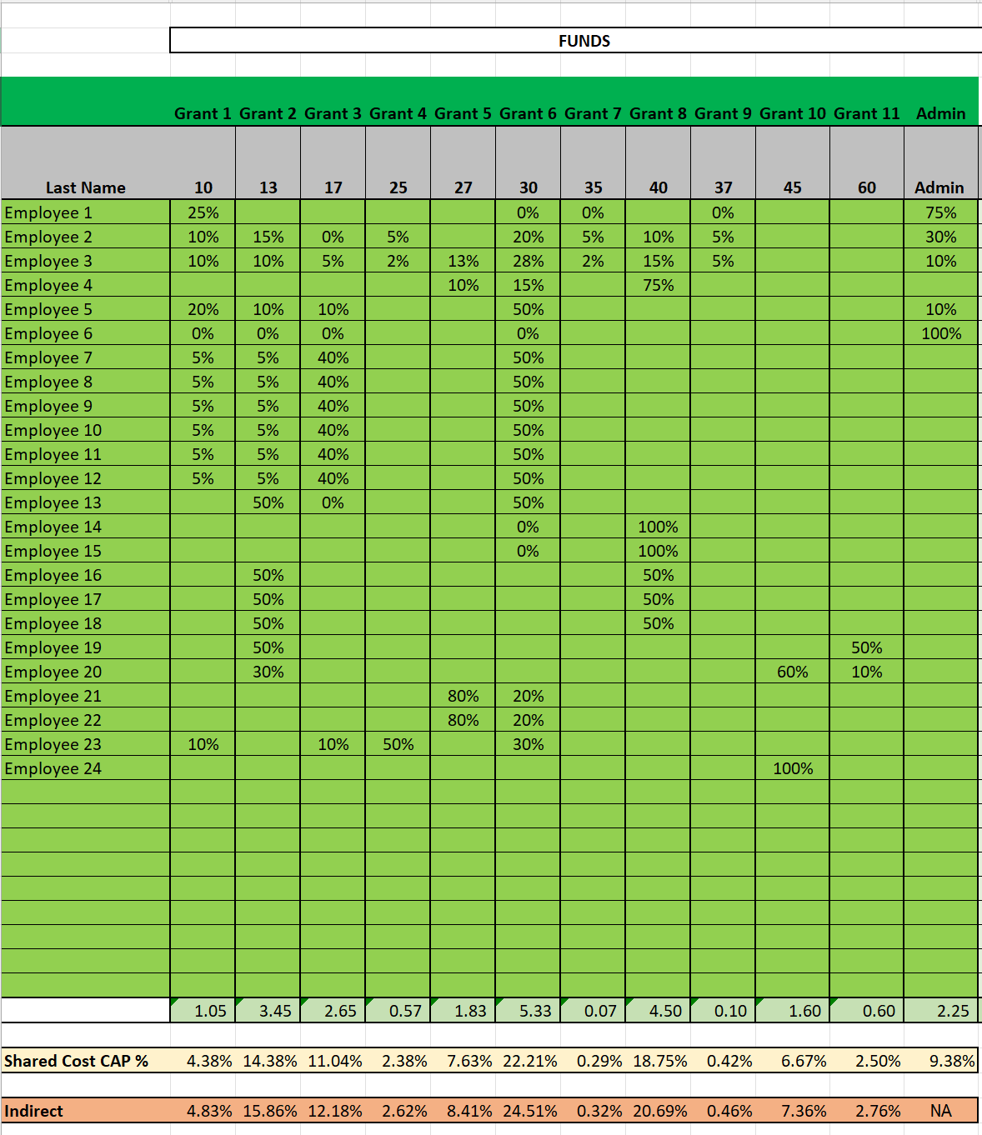
Demonstrate- How each employee’s allocation affects the final shared cost percentages. Even small changes in employee effort can significantly impact the final allocation of percentages applied across grants and programs.
- Employee allocations should be supported by timesheets, personnel activity reports, or documented time studies.
- Allocation percentages should reflect actual work performed and the programs benefiting from that work.
- As staffing, programs, and organizational activities change, allocation percentages may need to be updated.
- Cost allocation is a dynamic process and should not remain unchanged simply because it has been used historically.
- Each employee's total allocation should equal 100%. Allocations exceeding 100% may indicate duplicate charging or errors in the allocation methodology.

Discussion Questions
- When should allocation percentages be recalculated?
- How significant must an organizational change be before the allocation basis is updated?

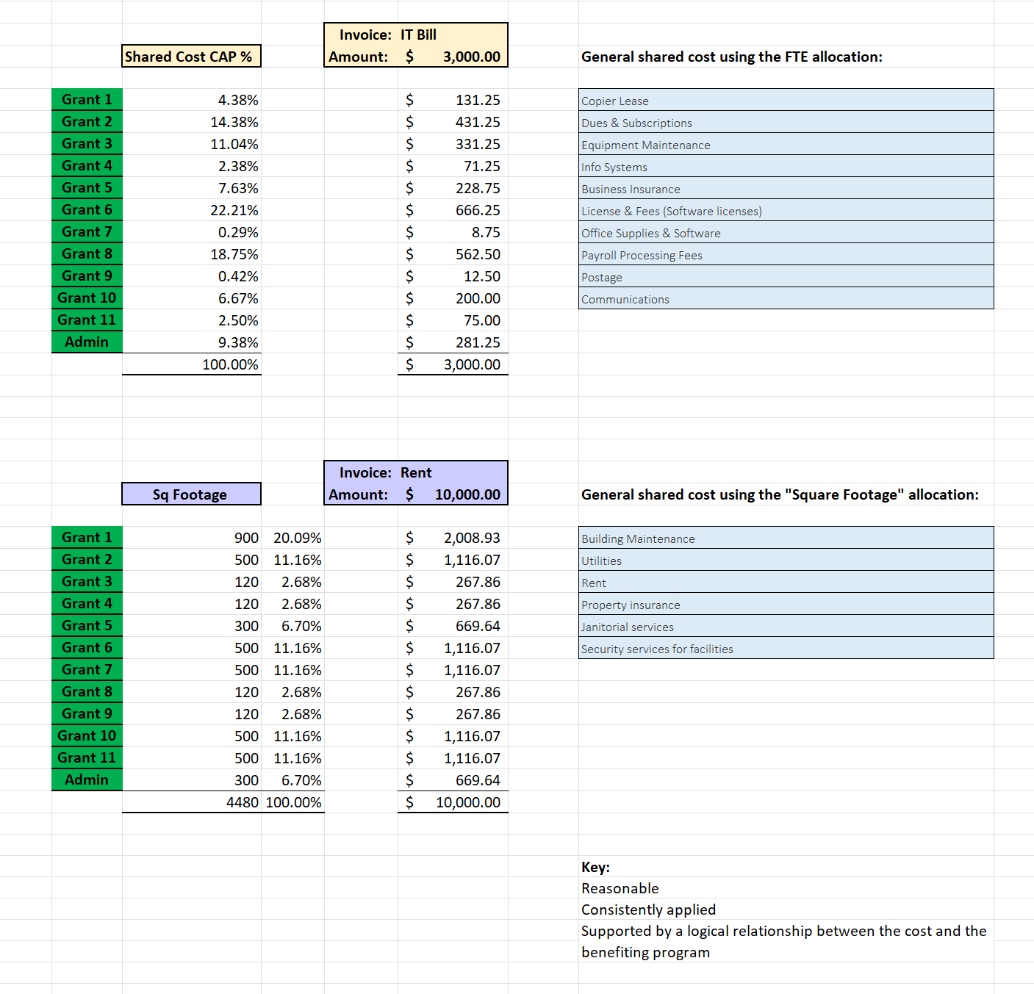
This tab teaches how to take one shared bill and divide it across grants using a logical basis, like FTE allocation or square footage. Attendees should recognize the relationship between allocation bases and the benefiting programs.
Discussion- how the previous tab feeds this tool.
Demonstrate the calculations.
Understand why different types of costs may require different allocation methodologies. Have a discussion how always using the same base may skew the allocation if the base is not appropriate and the relationship between cost and benefit are not correct.
These allocations may be programed into their accounting software (distribution codes).

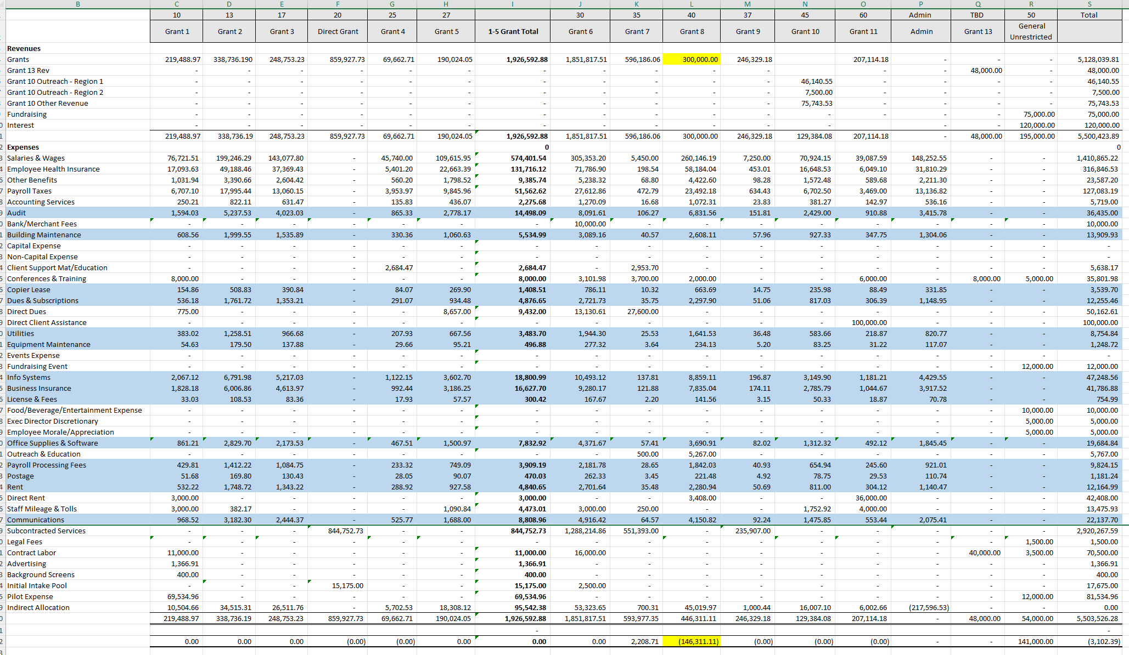

This looks at the whole organization and how allocations and changes in FTEs can affect a full organization. We can demonstrate the ripple effect of cost allocation decisions.
Discussion Topics- An approved grant budget establishes the maximum amount that may be charged to a grant. It does not automatically make costs allocable to that grant. Actual charges must still follow the organization's approved cost allocation methodology and reflect the benefit received.
Discussion Topics- Just because there are available funds, does not mean you can charge that to the grant and bypass the allocation plan. Grants that go over still need their fair share of the cost. Equitable and consistent is our goal.
Shared costs should be allocated based on the benefit received and the approved allocation methodology. The availability of grant funds should not determine how costs are assigned. Programs that benefit from shared services should receive their equitable share of costs, even when a grant is over budget, or another grant has funds remaining.

Discussion Questions
- Should costs be shifted simply because one grant has available funding?
- Does an overspent grant still need to receive its fair share of indirect costs?
- What happens if the agency reallocates costs solely to avoid a deficit?

Scenario
One grant has exceeded its budget. Management suggests excluding the program from future indirect allocations because "there's no money left to charge."

Discussion Questions
- Does a program stop benefiting administrative support once its budget is exhausted?
- Would excluding the grant shift its share of costs to other funding sources?
Cost allocation is not about making the “numbers work”. It is about distributing costs equitably, consistently, and based on documented benefits received across the entire organization.

