

Rhode Island Department of Human Services

Community Action Plan (CAP)/Funding Application

for
COMMUNITY SERVICES BLOCK GRANT (CSBG) FUNDS
FFY 2026

Background & Purpose

Background

The Rhode Island Department of Human Services (RI DHS) has assured the United States Department of Health and Human Services (US DHHS) that the Community Services Block Grant (CSBG) Program will be administered in Rhode Island according to federal law and current CSBG regulations.

Section 676(b)(11) of the federal CSBG Act requires States to assure they will “secure from each eligible entity in the State, as a condition to receipt of funding” a community action plan inclusive of a community-needs assessment. Toward this end, these application guidelines are issued to facilitate the development of Community Action Plans (CAPs).

Purpose

The Community Action Plan (CAP) serves as a roadmap demonstrating how Community Services Block Grant (CSBG) eligible entities plan to deliver CSBG services. The CAP identifies and assesses poverty related needs and resources in the community and establishes a detailed plan, goals and priorities for delivering those services to individuals and families most affected by poverty. CSBG funds may be used to support activities that assist low-income families and individuals, homeless families and individuals, migrant or seasonal farm workers and elderly low-income individuals and families by removing obstacles and solving problems that block the achievement of self‐sufficiency.

At a minimum, the CAP must include the following:

- A workplan with administration and programmatic objectives, activities, and performance outcomes, including relevant detail on each project to be funded; and
- A CSBG budget

Each workplan should be built around the Results Oriented Management and Accountability (ROMA) process and consider the following questions:

- Is the Need/Goal, Strategy Statement of each program, initiative, etc. included in the CAP clearly stated?
- Do the services and strategies included in the CAP clearly tie back to the needs identified in the agency’s community assessment?
- Do the selection National Performance Indicators (NPIs) allow the agency to monitor progress toward meeting their goals? (ex. – A shelter program has the main goal of helping families obtain housing but only selects the outcome measure: “number of households experiencing homelessness who obtained safe and temporary shelter.” The program should also utilize the outcome: “number of households who obtained safe and affordable housing.”)
- Does the description identify measurement tools/processes to adequately track selected outcome(s)? (ex. An agency providing financial literacy classes using the outcome measure “number of individuals who achieved and maintained capacity to meet basic needs for 90 days) but has no means to follow-up with class attendees for 90+ days)

All CSBG-funded activities must address the purposes and goals as identified in Section 672 (1)(2) of the Community Services Block Grant Act. Allowable activities are identified in Section 676 along with assurance 676(b)(1).

Community Action Plans must adhere to the following federal laws, regulations, and guidance:

Compliance with Federal Law: To comply with the Community Services Block Grant (CSBG) Act, Public Law 105‐285, Section 678B (11) eligible entities must complete a CAP, as a condition to receive funding through a Community Services Block Grant. Federal law mandates the eligible entities to include a community‐needs assessment in the CAP for the community served.

Compliance with CSBG Organizational Standards: As described in the Office of Community Services (OCS) Information Memorandum (IM) #138, dated January 26, 2015, CSBG eligible entities will comply with implementation of the Organizational Standards effective January 1, 2016. Additionally, States reported on the development and implementation of the Standards to OCS beginning January 1, 2016.

State Plan and Application Requirements: As required by the CSBG Act, Public Law 105-285, states are required to submit a state plan as a condition to receive funding. Information provided in the CAP by eligible entities is included in Rhode Island’s State Plan.

State Accountability Measures: Alongside Organizational Standards, the state will be reporting on State Accountability Measures in order to ensure accountability and improve program performance. Information provided in the CAP may be used to meet the requirements of the measures.

In order to have a uniform and simplified approach in the development of your agency’s CSBG proposal, we are asking that you present your proposal according to the following guidelines/instructions.

The remainder of this guidance has been organized into the following sections:

- Required Documents & Application Checklist
- Instructions: Application Narrative
- Instructions: Work Plan, Service Delivery System, and Coordination of Resources
- Instructions: Line-Item Budget
- Instructions: Budget Justification/Narrative
- Instructions: Assurance Statements and Authorized Individuals
- Attachments
  - Appendix A – Work Plan, Service Delivery System, & Coordination of Resources Template
  - Appendix B – Line-Item Budget Template
  - Appendix C – Budget Justification/Narrative Template
  - Appendix D – Assurance Statements & Authorized Individuals

Required Documents & Application Checklist

☐ Narrative Introduction and Agency Mission (Executive Summary) – 1-2 pages
☐ Narrative Summary of Needs Assessment – 1-2 pages
☐ Narrative Description of Gaps and Linkages
☐ Workplan, Service Delivery System, & Coordination of Resources completed on provided template – Appendix A

☐ Line-Item Budget completed on provided template – Appendix B
☐ Budget Justification/Narrative completed on provided template – Appendix C
☐ Signed Assurance Statements and Authorized Individuals – Appendix D
☐ Indirect Cost Agreement or Certification of No Indirect Cost Agreement, if applicable
☐ Organizational Structure and Staffing (Organizational Chart)
☐ Board of Directors with Addresses, phone numbers, organized by tri-partite groupings with start and end dates. For any vacant positions, list the length of vacancy and provide a projected timeline for filling the position

☐ Current By-laws with board approval date
☐ Current personnel policies with board approval date
Instructions: Application Narrative

The Application Narrative will include the following components:

- Introduction and Agency Mission (1-2 pages)
- Needs Assessment Summary (1-2 pages)
- Description of Gaps in Service and Linkages to Address Gaps in Service

Your narrative should be concise and to the point. Please use the following guidelines for each component summary:

Introduction and Agency Mission
Summarize on one or two pages, an executive summary that briefly describes the purpose and goals of your agency’s CAP. Include a brief description of the agency (basic information, size, etc.), a description of the process used to develop the CAP and the stakeholders who participated, a description of how the process address CSBG mandates, the Organizational Standards, and the ROMA framework, and a description of the agency’s mission and how it is used in guiding the agency’s decision, actions, and programs.

Needs Assessment Summary
Summarize on one or two pages an analysis of the critical and major community needs. Your summary should include a description of the qualitative and quantitative data used to support the identified needs, a description on how data was collected and analyzed, and a summary of how your community’s needs have changed/evolved from prior assessments.

Gaps & Linkages
Describe any gaps that exist in services in your area (needs identified versus services available). These gaps should be identified, in part, by using the results of the Community Needs Assessment and other data available and by comparing it to the services provided by your agency and other agencies. Describe the linkages that your agency has or will develop to address identified gaps, where possible.

Instructions: Work Plan, Service Delivery System & Coordination of Resources
Refer to Appendix A for the required Work Plan, Service Delivery System, & Coordination of Resources template.

The Work Plan template has been organized by the service and indicator categories included in the Administration for Children & Families, Office of Community Services, Community Services Block Grant Annual Report 3.0.

For each identified domain, agencies will be asked to provide a brief narrative description of identified community needs as well as a description of the agency’s overall work in this domain.

Based on the community needs, the agency will be asked to develop one or more statements of need, the identified level of need (individual, family, or community), and the desired outcome of addressing the identified need. Need statements should be brief, but more than one word, and should be descriptive enough to determine specific services that could be offered to achieve the desired outcomes. Need statements should not identify services to be offered. The desired outcome should be directly connected to the identified need and represent the change that your agency would like to see as a result of implementing the services and/or strategies identified within your work plan.

In the tables following the need statement(s) and outcome(s), agencies will be asked to identify the services (individual/family) to be offered and/or strategies (community) to be implemented by the agency, as well as the performance indicators that will be measured, and the targeted results for each. The services, strategies, and indicators align directly the Annual Report 3.0 for each domain.

Finally, agencies will be asked to provide a description of the measurement tools/processes that will be implemented to track results for each indicator.

The workplan contents have been aligned to support Results Oriented Management Accountability (ROMA) and to prepare agencies for submission of the annual report.

An example work plan for the “employment” domain can be found on the first tab of the template and is labeled “example.”

In addition to the work plan sections, agencies must also complete the tabs for Service Coordination and Service Delivery.

If additional space is required within any table throughout the Work Plan template, agencies can add additional rows by right-clicking on the far-left hand side of the last row of the table:



From the resulting menu, select “insert” and an additional row will be added to the table above the final row.

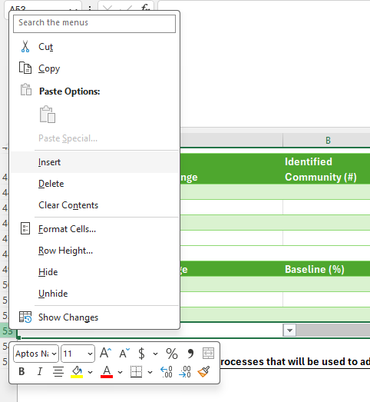

Instructions: Line-Item Budget

A detailed line-item budget describing all anticipated expenditures should be a part of this application along with a Budget Narrative/Justification. Refer to Appendix B for the Line-Item Budget Template. All budgeted and actual expenses must comply with the cost principles 2 CFR Part 200 or any other applicable federal regulations.

Note: Agencies that choose to charge indirect costs to the CSBG either through a Federally negotiated indirect cost rate or by applying the de minimis rate of 15 percent must submit a current indirect cost agreement or certification that the agency does not currently have a negotiated indirect cost rate (certification enclosed).

Instructions: Budget Justification/Narrative
Complete the Budget Justification/Narrative Template found in Appendix C to align with budgeted expenses in the line-item budget template.

When using the Budget Justification/Narrative Template, if additional space is required for any budget section, rows can be added to the table by using your mouse to hover over the far-left hand side of the last line in the table and clicking the “+” symbol:

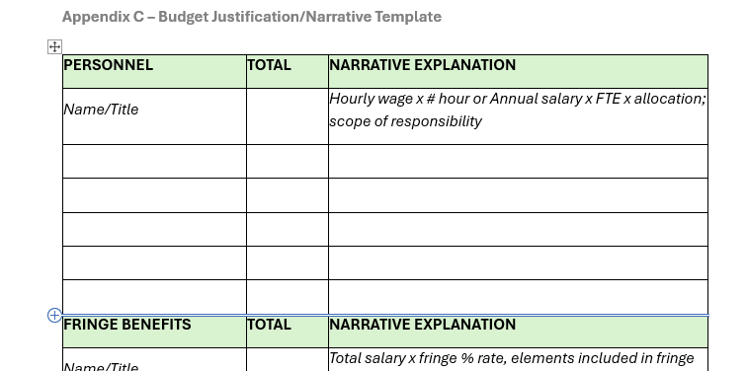

Each section of the Budget Justification/Narrative Template includes one or more italicized descriptions of the information that should be included. These descriptions should be deleted and replaced with agency-specific entries based on the line-item budget.
The below guidance follows the order of the line-item budget template and provides descriptions and examples for each section.

Salaries and Wages: Provide the hourly rate x # of hours or the annual salary x allocation charted to CSBG (if applicable) and justification for each position listed in Salary and Wages. Each justification should include title, name and scope of responsibility. Note: Salaries charged cannot exceed the Executive II Salary Cap for the applicable year.

Fringe Benefits: Provide a detail of the elements that comprise the fringe benefits, for example, FICA, worker’s compensation, health insurance, retirement contributions.

Consultants: This description should include the name of the consultant, organizational affiliation, nature of services rendered, duration of consultation, rate of compensation and performance measures
Example:
Sue Smith, PhD, Psychologist for RI Hospital @ $150.00 per hour for 200 hours
Dr. Smith will provide technical assistance with reports, data collection and infrastructure of the ABC Home .

Equipment: Defined as tangible, non-expendable personal property that has a useful life of more than one year and an acquisition cost of $10,000 or more. All equipment reimbursement requests should list the item requested, number needed and how the equipment is used to meet the projected activities. Note: This amount would be excluded from the indirect cost rate calculation

Supplies: Individually list each type of supply, cost per unit, quantity or cost per month and provide a justification for its use within the Program.

Example:
Office supplies -$1,200 – consists of essential items used daily such as printing paper, pens, printer ink and instructional material. The cost is based on last year’s monthly program expenses required to run the Program effectively.
Postage - $365 – stamps for outreach approximately 500 mailers

Travel: Provide a narrative describing the travel staff members will perform and why it is necessary for the project objectives. The narrative should include the anticipated number of personnel traveling, length of stay and travel costs i.e. airfare, lodging, transportation and per diem. Note: all travel should be booked according to the 2CRF 200.475, then organizational travel policy, or State Travel policy whichever is more stringent.

Example:
Employee 1 – Travel to annual Program conference in Las Vegas. Costs included:
Lodging 3 nights @ $300/night = $900
Airfare - $1500 (estimated based on travel website)
Per Diem - $150 (3 days/2 meals a day @ 25 each)
Employee 2 – $670 - Mileage to local trainings and conferences -Mileage rate not to exceed State reimbursable rate.

Other: Individually list any category not listed in the budget and provide a justification related to program activities and methodology to determine cost.

Examples:
Rent (cost $2000/mo. x sq ft usage 50% x months 12) = $12,000
Utilities (cost $300/mo. x usage 50% x months 12) = $1,800
Equipment Lease (cost $200 x months 12) = $2,400

Indirect costs: A copy of the most current indirect cost agreement must be provided. If the organization does not have an established indirect cost rate, they can choose to elect the de minimums rate of 15% of Modified Total Direct Costs (MTDC); certification must be provided.

Modified Total Direct Cost (MTDC) means all direct salaries and wages, applicable fringe benefits, materials and supplies, services, travel, and up to the first $50,000 of each subaward (regardless of the period of performance of the subawards under the award). MTDC excludes equipment, capital expenditures, charges for patient care, rental costs, tuition remission, scholarships and fellowships, participant support costs, and the portion of each subaward in excess of $50,000. Other items may only be excluded when necessary to avoid a serious inequity in the distribution of indirect costs and with the approval of the cognizant agency for indirect costs

More examples of budget items that can be used in calculating the MTDC
- Travel – Costs associated for project related travel for personnel, such as milage reimbursement, conference costs, etc. (Reimbursement for travel to anyone who is not a payroll employee would not fall under this category)
- Materials and supplies – costs of goods and materials that will be used directly for the project (can include small equipment items as long as they are under $10,000 and used directly for project)
- Services – Contracted services used to support the project. These can include consulting services, interpretation/translation services, specialized equipment rental services for equipment needed directly for the project, etc.
Examples of budget items that cannot be used in calculating the MTDC
- Equipment – Tangible, non-expendable property that has a cost of $10,000 or more and a useful life of more than one year. Items could include printers/copiers.
- Capital Expenditures – Long term investments in assets such as land, buildings, heavy machinery, vehicles, that are expected to provide benefits for several years. This also includes costs related to upgrades/updates to such items as well as technology (hardware/software) that has a useful life of more than one year and benefit the company long-term
- Rental costs – expenses related to renting space used by nonprogram staff
- Equipment rental
- Tuition remission, scholarships, and fellowships
- Participant support costs – this includes items such as direct payments to participants for assistance, stipend payments, bus passes, participant training expenses, medical expense payments, etc.

Provide a narrative example of the direct cost base and indirect cost rate used to determine total indirect costs.

Example:

$100,000 ($57,000 salary + $10,000 fringe + $30,000 supplies + $3,000 travel) MTDC x 15% de minimis = $15,000

Instructions: Assurance Statements & Authorized Individuals

Agencies must read and agree to each of the Assurance Statements as outlined in Appendix D, which assure compliance with the requirements of the CSBG program. Agencies must also identify all individuals who will be authorized to sign official documents (i.e. contracts, checks, etc.) relating to CSBG on behalf of the agency. Appendix D must be signed and returned with your agency’s application packet in order for the packet to be considered compete.

