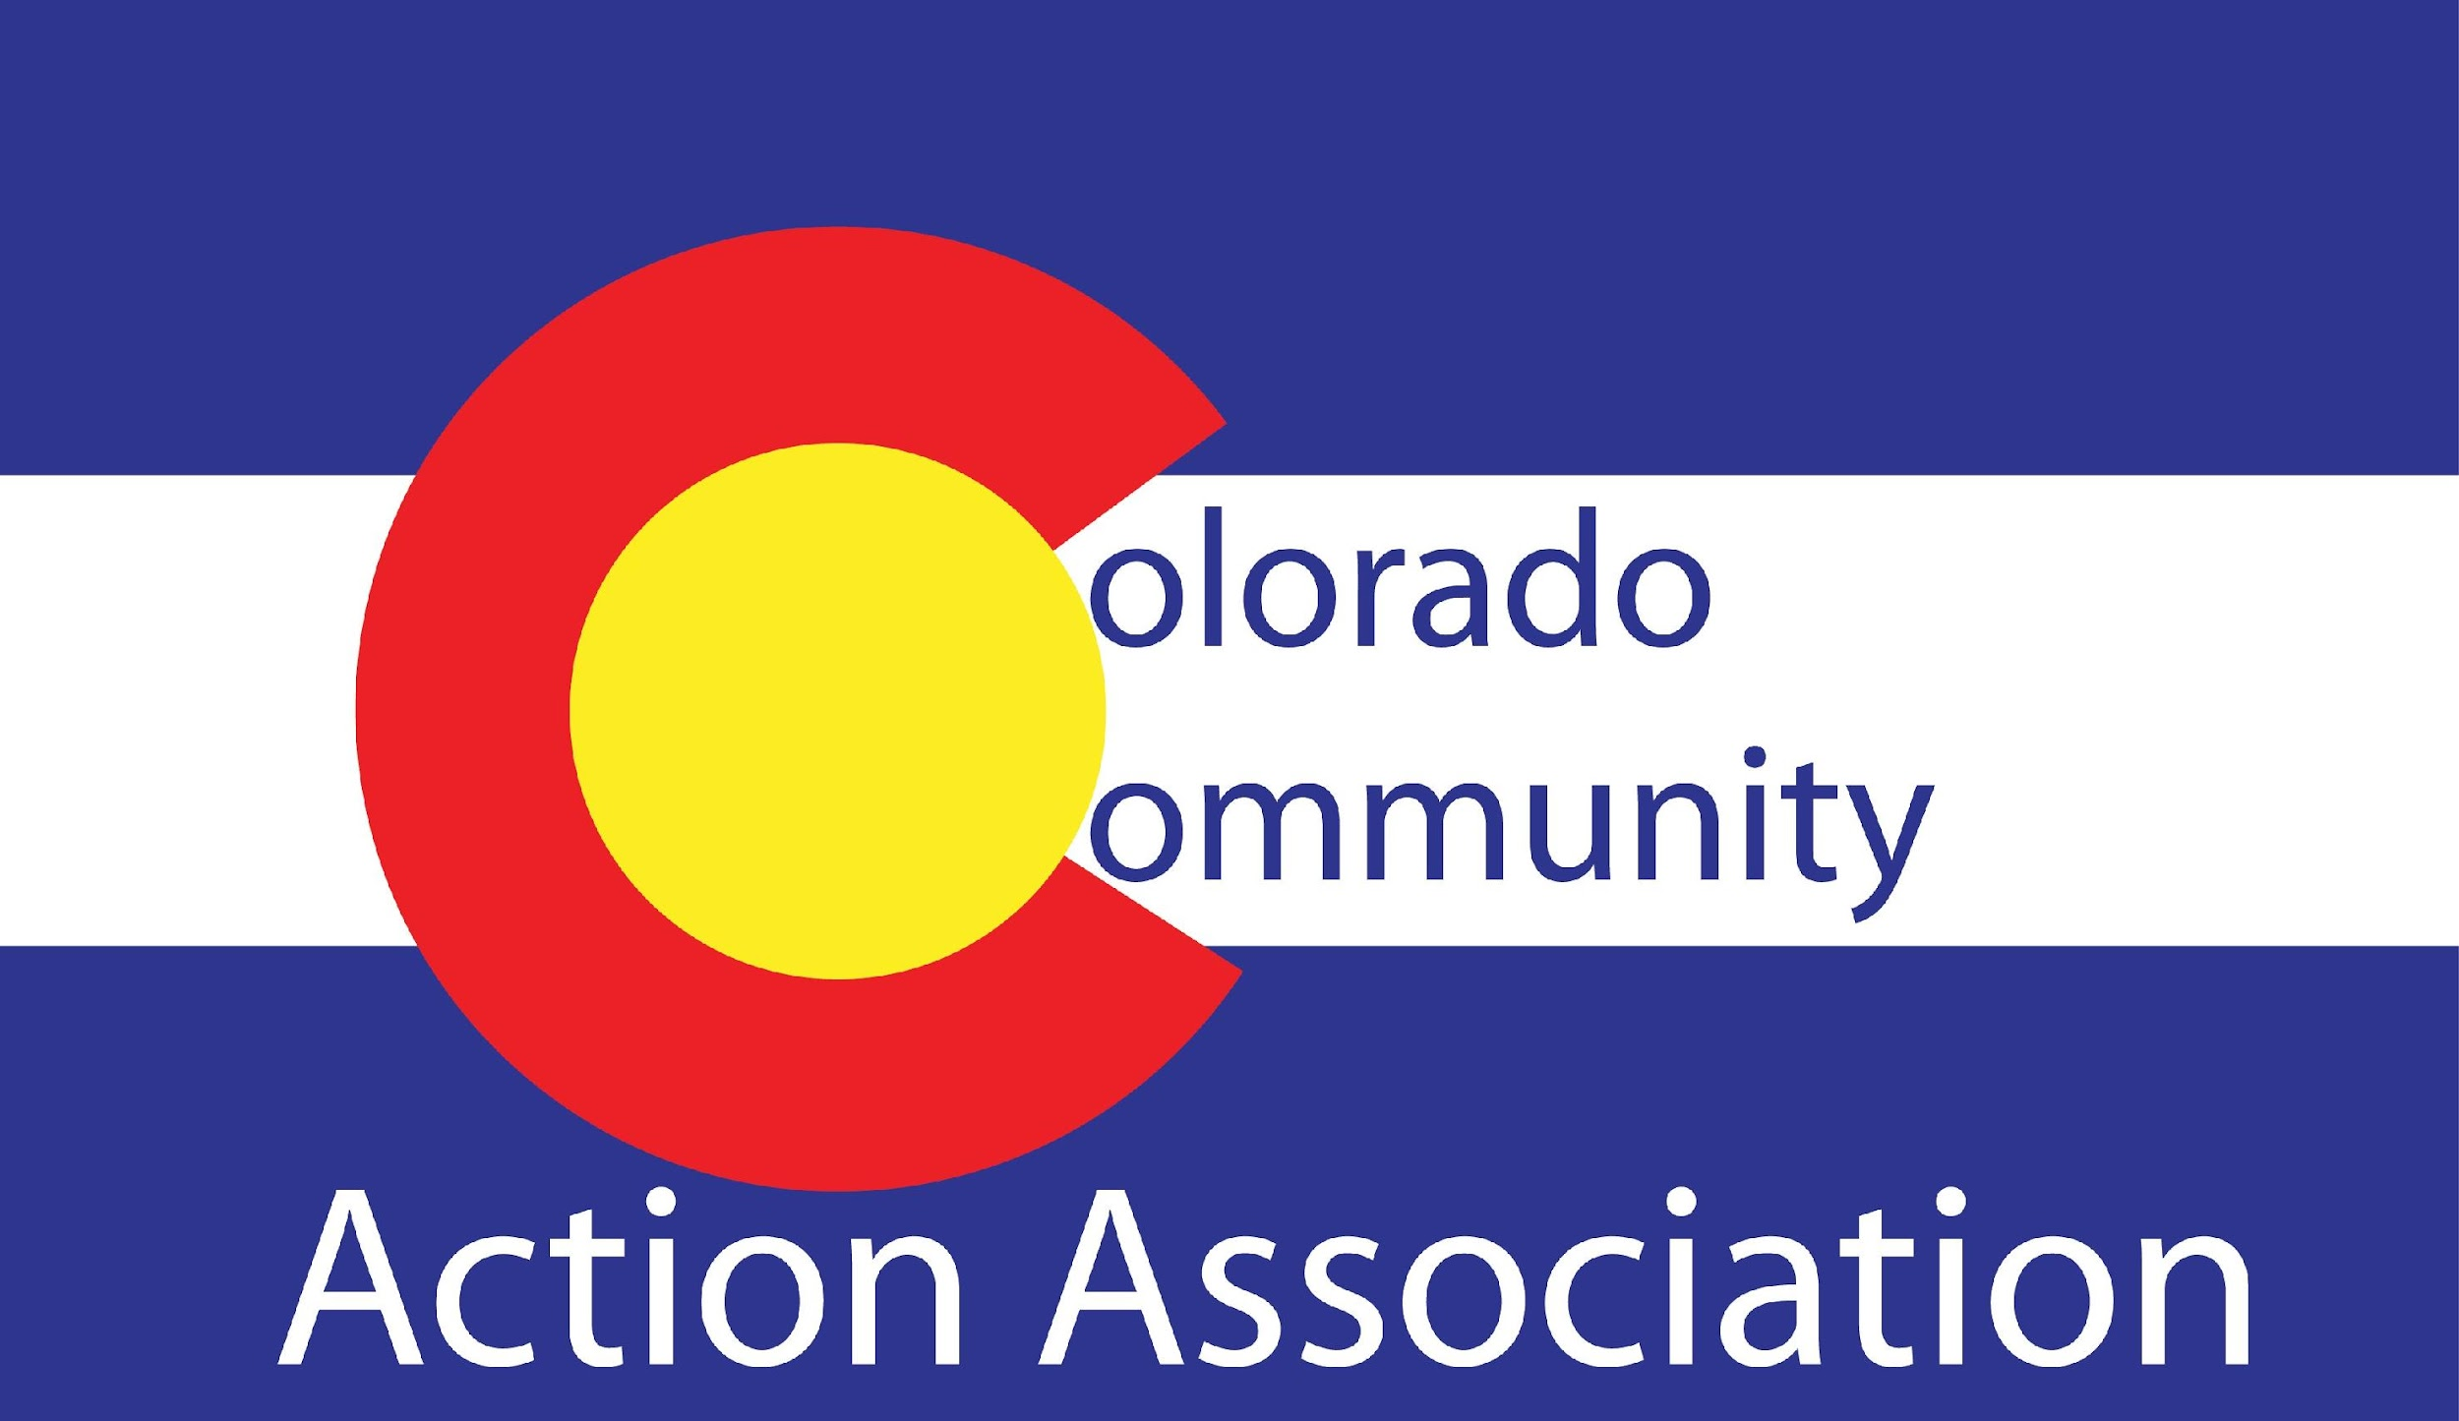

ROMA Nationally Certified Implementer / Trainer Needs Assessment, Community Action Plan and Strategic Plan Review Certification
Revised May 2023
As part of Organizational Standard 4.3, agency Community Action Plans and Strategic Plans must “document the continuous use of the full Results Oriented Management and Accountability (ROMA) cycle or comparable system (assessment, planning, implementation, achievement of results, and evaluation) ... having used the services of a ROMA-certified trainer (or equivalent) to assist in implementation.

I, , being a Nationally Certified ROMA Trainer or Implementer, certify that I have reviewed and assisted in the implementation of
(Agency/Department) 2024-2026 Community Needs Assessment, Community Action Plan and/or Strategic Plan. I further certify that ______ (Agency/Department) has demonstrated compliance to ROMA. Compliance is documented using the Colorado ROMA Certified Trainer Review Tool.

Signature

Date

Agencies: Please submit a copy to the Colorado Organizational Standards System under Organizational Standard 4.3. Retain a copy for compliance

