Appendix 1.b. – Community Benefits Plan Template

Community Benefits Plan
Control Number
[Recipient Organization Name]
[Project Title]
[Topic Area]

How to Use
The instructional red text is for reference only and may be removed in the final version of the Community Benefits Plan. If needed, supplemental guidance is available in Appendix D. Please complete the following sections, indicating at least one SMART milestone for each overarching category (Partnerships, DEIA, Justice40, and Workforce).

Notice of Restriction on Disclosure and Use of Data:
Pages [list applicable pages] of this document may contain confidential, proprietary, or privileged information that is exempt from public disclosure. Such information shall be used or disclosed only for evaluation purposes or in accordance with a financial assistance agreement between the submitter and the Government. The Government may use or disclose any information that is not appropriately marked or otherwise restricted, regardless of source.

The header and footer of every page that contains confidential, proprietary, or privileged information must be marked as follows: “Contains Confidential, Proprietary, or Privileged Information Exempt from Public Disclosure.”

In addition, every line and paragraph containing proprietary, privileged, or trade secret information must be clearly marked with double brackets or highlighting.

Partnerships
Formal partnerships with other organizations and service providers can enhance outcomes for beneficiaries and workers.

- Describe the organizations already engaged with you in a formal partnership. Examples: Local governments, Tribal governments, labor unions, social support organizations, community colleges, registered apprenticeship programs, or other workforce education and training organizations serving workers with barriers to quality training and employment.
- Describe any formal agreements with any of the organizations described above that will enhance outcomes for beneficiaries and workers.
- Describe organizations you plan to engage if successful.

Measuring Diversity, Equity, Inclusion, and Accessibility (DEIA)
A DEIA plan helps organizations set goals for creative partnerships that bring diversity of thought and experience from various communities to the table.

- What are your goals for staff and partner DEIA? Successful plans will describe the overall approaches to retention, engagement, professional development, and career advancement of individuals from a variety of backgrounds, cultures, abilities, etc.
- What actions do you plan to take to work towards these goals?
Examples: Participating in career day/recruiting events at minority-serving institutions (MSIs); hiring individuals from the communities you work in; paying interns; offering or participating in mentorship or apprenticeship programs; conducting pay equity analyses; etc.
- How will your project incorporate DEIA? Examples: [#] engagement events in disadvantaged communities; [%] of units completed in disadvantaged communities; [#] partnerships with minority serving institutions (MSIs); contracts with woman, veteran, and/or minority-owned businesses; etc.

Justice40 Initiative
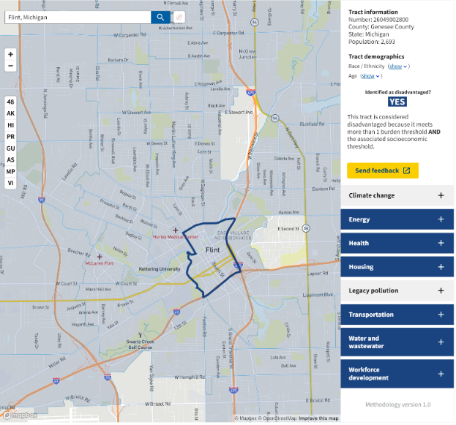
- Attach a screenshot of the project area(s) using the Climate and Economic Justice Screening Tool (CEJST) to identify which disadvantaged communities fall in the anticipated project area. Briefly describe the project area. An example screenshot is provided below.

EXAMPLE DESCRIPTION: The project will focus on multifamily buildings in downtown Flint, Michigan, though workforce recruitment will take place in surrounding neighborhoods, most of which are identified as disadvantaged.
- Describe how your team plans to engage community members living in disadvantaged communities. How does your organization plan to build trust within the community? What methods will you employ to reach the community? How will you measure engagement? How will community feedback influence the project?
- What applicable quantifiable, measurable, and trackable benefits will your project generate for the identified community? CEJST can help identify areas of need in the disadvantaged communities you aim to engage. Applicants may consider using any of the relevant DOE Justice40 Initiative benefits outlined below.
  - Benefits include (but are not limited to) measurable direct or indirect investments or positive project outcomes that achieve or contribute to the following in disadvantaged communities: (1) a decrease in energy burden; (2) a decrease in environmental exposure and burdens; (3) an increase in access to low-cost capital; (4) an increase in high-quality job creation, the clean energy job pipeline, and job training for individuals; (5) increases in clean energy enterprise creation and contracting (e.g., minority-owned or disadvantaged business enterprises); (6) increases in energy democracy, including community ownership; (7) increased parity in clean energy technology access and adoption; and (8) an increase in energy resilience.

Investing in America’s Workforce
- How will your project improve career opportunities for the weatherization workforce? Examples: above average pay and benefits, pre-apprenticeship training that leads to placement in registered apprenticeship, other paid training and skill development that will lead to wage increases and worker advancement in the industry.
- Describe how your workforce development efforts will benefit the disadvantaged communities in your project area. Examples: # of training opportunities available in disadvantaged communities; access to job opportunities; business opportunities for local residents; recruitment efforts, including quality pre-apprenticeship programs, geared towards local workers, particularly those living in disadvantaged communities; provisions to pay wages and benefits at or above the prevailing rate.
- Describe any plans to recruit or engage groups underrepresented in the home energy performance and energy efficiency workforce such as: minorities, women, veterans, individuals with disabilities, opportunity youth, returning citizens, and individuals who are socioeconomically disadvantaged. Examples: Encourage development of programs that recruit women to WAP, including providing services such as childcare, transportation, etc.
- Describe the Applicant’s plan to support worker organizing and collective bargaining. Applicant should add or delete commitments (and re-number appropriately) to reflect their specific plan.
Commitment C1.1: A commitment to negotiate a Project Labor Agreement (PLA) for construction activity.
Commitment C1.2: A pledge to remain neutral during any union organizing campaigns.
Commitment C1.3: Intention or willingness to permit union recognition through card check (as opposed to requiring union elections).
Commitment C1.4: Intention or willingness to enter binding arbitration to settle first contracts.
Commitment C1.5: A pledge to allow union organizers access to appropriate onsite non-workplaces (e.g., lunch rooms).
Commitment C1.6: A pledge to refrain from holding captive audience meetings^{[1]}.
Commitment C1.7: Other supportive commitments or pledges. [Describe]

- List any labor unions supporting the project and any commitments made to those partners.

Minority-serving institutions (MSIs) are federally recognized Title IV colleges and universities that enroll high concentrations of minority students. Seven categories of MSI are defined in US law under Title III of the Higher Education Act of 1965.

