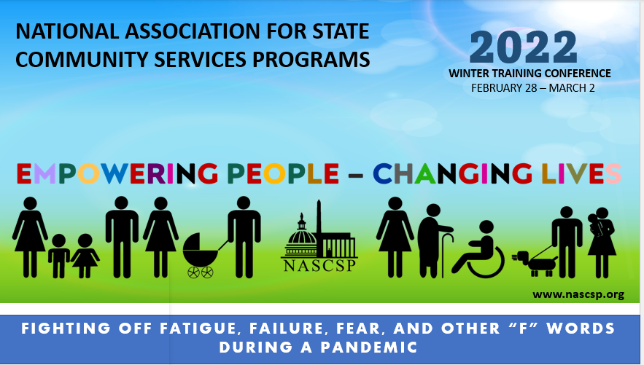
Handouts

March 1, 2022
- Gentle reminder that stress and body response talk can “bring up stuff.” Take the breaks you need, to notice and stay grounded in case you’re “feeling” anything.

- Container-Compartmentalization Coping Skill
  - Not “stuffing it”- but creating a place to “put it away” for a period of time
- Plight of the Administrator- notice the “hats” and balancing act.

- Decision Fatigue and Mental Depletion

- Secondary Traumatic Stress, Compassion Fatigue, Vicarious Trauma

- Burn out

- Circle of Influence

- Brain “digestion” of memories
Trauma is stored in our memories differently than ordinary experiences

- Get to know your nervous system

- Stress Cycle Completion

- Things I can do when we have a Minute or Less?

- Nervous System Reset Skills

- Build a Desk Kit

- Transitions

- Healthy Mind Platter

- Moving forward

- Self-Care Action Plan

One thing I think I’m doing well is ________________________________________?
One thing I can do differently after today is ________________________________?
One longer term goal is _________________________________________________?
Something I’m thankful for is _____________________________________________?
