PY-2023
Volume I – IHWAP
Program Operations Manual



The Program Operations Manual is the policy manual of the Illinois Home Weatherization Assistance Program (IHWAP).
The information and directives in this manual supersede information and directives of past IHWAP program manuals. This manual outlines the requirements, necessary steps and details of operating a successful weatherization program.

Issued: July 2022

SECTION I - PROGRAM OVERVIEW 6
Purpose 6
Legislative Background 6
How the Program Works 9
Overview of the DOE Rules and Regulations 10
Overview of IHWAP Program Manuals 11
SECTION II --PROGRAM ELIGIBILITY AND BENEFITS 13
IHWAP Eligibility 13
Applicant 13
Income Eligibility 14
Re-Weatherization 16
“For Sale” Status or Foreclosure 16
Non-Stationary Campers, Trailers and Sheds 17
State Supplemental Energy Assistance 17
Determining Household Income 17
DOE Weatherization Definition of Income 17
Funding Restrictions and Options 19
Funding Limits 19
Utilizing 3 Funding Sources 20
Maximizing Spending of DOE Funding 20
Desk Auditing 21
Average Weatherization Cost 21
Using the Retrofit Measures’ Savings to Investment Ratio to Prioritize Work 22
Overall Project SIR Requirement 22
“Buy Down” Options 23
Non-Program Contributions 23
Additional Work 23
Joint Funded Projects 24
Categories of Weatherization Measures 25
IHWAP Mechanical Waivers 29
IHWAP 80% Efficiency Heating System Waiver Process 30
Heating System and Water Heater Replacements/Health and Safety 30
Mobile Home Water Heaters 31
Appliance Repairs/Replacement 31
Historical Preservation Review 31
Procedure for Full Section 106 Review by the SHPO 34
FORMS AND EXHIBITS for SECTION II - PROGRAM ELIGIBILITY 36
SECTION III –OUTREACH AND CLIENT EDUCATION 48
Outreach 48
Coordination and Referral 48
Client Health and Safety Education 49
Hazardous Conditions Notification 51
Enhanced Safety Protocols for Field Workers, Crews, and Contractors 59
FORMS AND EXHIBITS for SECTION III - OUTREACH AND EDUCATION 61
SECTION IV – INTAKE 67
IHWAP Priority 67
Prioritizing the Waiting List 68
Pre-Application Through the Helping Illinois Families website 69
General Instructions for Intake of Applications 69
IHWAP/LIHEAP Application Instructions 70
Eligibility 74
Required Documentation 76
Income Documentation 76
Ownership Documentation 78
Rental Properties 79
LAA Staff Applications for Assistance 80
FORMS AND EXHIBITS for SECTION IV - INTAKE 81
SECTION V - DETERMINATION 92
Determination of Client Eligibility 92
Assuring Documentation is Present 92
Reviewing and Validating the Application Form 92
Verifying Household Income Information 92
Determination of Building Eligibility 93
Re-determination of Eligibility 93
SECTION VI: WORK AUTHORIZATION 94
Client Notification 94
Prioritizing Households 94
Extenuating Circumstances 95
IHWAP Timelines 95
FORMS AND EXHIBITS for SECTION VI - WORK AUTHORIZATION 98
SECTION VII – PROGRAM REQUIREMENTS 102
Training 102
Program Requirements: Training and Certification Program (TCP) 102
Continuing Education Classes 103
Training and Certification for Quality Control Inspectors 103
Training for Contractors and Crews 104
Reimbursing Weatherization Staff for Technical/Trade School or Community College Tuition 105
LAA Staffing Requirements 105
Agencies Considering Crews for Implementing Weatherization Services 107
LAA Coordination 108
Compliance Monitoring and Reporting 108
Monitoring by OCA, General Monitoring Procedure 109
The Quality Assurance Monitoring Process 110
Monitoring Determinations 111
Quality Control-Quality Assurance 113
Production 113
Production-Related Costs 113
Procurement Process 114
Assessing the Overall Health of Local Administrative Agencies’ Weatherization Program 114
Performance 115
General IHWAP Requirements 115
Disregard for IHWAP Policy and/or Client Health and Safety 117
Use of IHWAP Funds for Out of State Travel 118
FORMS AND EXHIBITS for SECTION VII - PROGRAM REQUIREMENTS 119
SECTION VIII - ASSESSMENT 123
Assessment Overview 123
Required Color Photographs 123
Refrigerator/Freezer Replacement 123
Deferral/Walk-Away Policy 125
Health and Safety Plan 126
Health and Safety Guidance (Specific Hazards) 127
Immediate and Potentially Hazardous Conditions 129
Radon Consent 129
Weatherization Plus 130
FORMS AND EXHIBITS for SECTION VIII - ASSESSMENTS 132
SECTION IX – Final and In-Progress Inspections 140
QCI-Certification Requirement for DOE Funds 140
Evaluating and Confirming the Initial Assessment 143
Mechanical Documents 143
Architectural Documents 145
In-Progress Inspections 149
FORMS AND EXHIBITS for SECTION IX - FINAL INSPECTION 151
SECTION X FILING SYSTEMS 166
IHWAP Subject Files 166
Weatherization Client Files 168
FORMS AND EXHIBITS for SECTION X - FILING SYSTEMS 173
Section XI - Multi-Family Project Procedures 181
2-4 Unit Multi-Family Projects 181
Shelters, Single Room Occupancy, and Group Homes 181
5+ Unit Multi-Family Projects 181
Outreach and Application Process for Multi-Family Buildings 183
Pre-Application Activities 184
Multi-Family Project Process 185
Phase 1: Determining Multi-family Project Eligibility 185
Phase 2: Assessment and Energy Modeling of Multi-family Buildings 189
IHWAP Multi-Family Energy Assessment 189
Project Description 195
Energy Audit Modeling 195
Phase 3: Completion of Multi-Family Projects 198
Procurement of Custom Measures for Multi-Family Projects 199
Renewable Energy in Multi-Family Projects 199
FORMS AND EXHIBITS for SECTION XI - MULTI-FAMILY PROJECT PROCEDURES 200
SECTION XII - INVENTORY CONTROL 208
Inventory Control 208
Inventory Tracking 208
FORMS AND EXHIBITS for SECTION XII - INVENTORY CONTROL 212
SECTION XIII –PROGRAM REPORTING 214
SECTION XIV - FISCAL PROCEDURES 217
Cash Requests 217
Cash Request for Weatherization Plus Measures 217
Budget Modifications 218
De-obligation of Grant Funds as a Result of Insufficient Production 218
Fiscal Monitoring 219
Equipment 219
Crew-Based Agency/Contracting Operating Policies 220
FORMS AND EXHIBITS for SECTION XIV - FISCAL PROCEDURES 226
SECTION XV HEARINGS, APPEALS, and CLIENT COMPLAINTS 235
The Informal Conference 235
The State Review 236
The Formal Hearing 236
FORMS AND EXHIBITS for SECTION XV - HEARINGS AND APPEALS 238

SECTION I - PROGRAM OVERVIEW

Purpose
The Illinois Home Weatherization Assistance Program (IHWAP) enables low-income families to permanently reduce their energy bills by making their homes more energy efficient while increasing the comfort of their homes. Additionally, IHWAP addresses some home health and safety issues especially where they are connected to indoor air quality. Historically, IHWAP does not complete other home improvement or rehabilitation that does not meet these goals. However, in PY2023 IHWAP will be piloting Weatherization Plus, which includes various home improvements such as roof replacement, addressing deferral issues, healthy home measures, and solar energy.

Legislative Background
The Illinois Energy Conservation and Production Act of 1976 established the Illinois Home Weatherization Assistance Program. The Illinois Department of Commerce and Economic Opportunity (DCEO), through the Office of Community Assistance (OCA), utilizes three funding sources to issue IHWAP grants to Local Administering Agencies (LAAs), who administer the weatherization program throughout the state of Illinois. IHWAP funding comes from U.S. Department of Energy (DOE) Weatherization Assistance Program, the U.S. Department of Health and Human Services (HHS) Energy Assistance Block Grant, and Illinois State (State) Supplemental Energy Assistance Funds.
With respect to Weatherization Assistance Program grant funds administered the by the U.S. Department of Energy (DOE), use of these funds is governed by Federal statute and implementing regulations set forth in Title 10, Code of Federal Regulation, Parts 440 (10-CFR-440) and Title 2, Code of Federal Regulation, Chapter II, Part 200 (2-CFR-200), as well as periodic grant guidance from DOE.
IHWAP grant funds originating either from the U.S. Department of Health and Human Services Energy Assistance Block grant (HHS) or State Supplemental Funds (State) are primarily governed by the same Federal statute and implementing regulation which define the use of the DOE Weatherization Assistance Program. However, DCEO reserves the right to establish rules and procedures for HHS and State Grant Funding that achieve energy efficiency and ensure home health and safety for low-income Illinois households that differ from the DOE Weatherization Assistance Program rule and regulation. Examples of rules for HHS and State Grants that DCEO authorizes include, but are not limited to (also see HHS/State Funding Allowance table on Page 40):
- Using State funds to address potential deferral issues with a home and/or implement healthy home opportunities.
- Replacement of existing 80% EFE and below furnaces with 95% EFE units without the SIR requirements; however, the units must be tested, and the efficiency accurately recorded in WeatherWorks.
- Replacement of existing 90% EFE appliances 15 years or older with 95% EFE appliances without the SIR requirements.
- Clean/Tune heating and cooling systems, and minor repairs, as an appropriate Incidental Repair cost.
- Heating System replacement for Health and Safety reasons using any of the 3 funding sources is allowable, on a case-by-case basis, with State approval (see WPN 11-6; still in effect as of WPN 17-1).
- Replacement of existing Packaged Terminal Air Conditioner (PTACs) 10 years or older with Package Terminal Heat Pumps or mini-splits without the SIR requirements.
- Replacement of natural gas or propane water heaters that are 10 years or older without the SIR requirements. Replacements must be Energy-Star rated, preferably power-vent units.
- Replacement of electric water heaters that are 10 years or older without the SIR requirements. Replacements must be Energy-Star rated, preferably Heat-Pump units.
  - Be sure that the PMI for space requirements is met, especially for closet and/or mobile home installations.
  - Water Heater replacement for Health and Safety reasons is allowable using any of the 3 funding sources, on a case-by-case basis, with State approval
- Replacement of existing central A/C units that have a SEER rating less than 10.0 or are older than 10yrs without the SIR requirements. Replacements must be Energy-Star rated with a minimum SEER of 15 (14 SEER for mobile homes).
  - Any LAA that has contractors installing 14 SEERs designed to meet 15 SEER minimum requirement must include the Air-Conditioning, Heating & Refrigeration Institute (AHRI) engineering report or the measure will be considered a disallowed cost.
- Replacement of existing Window A/C units that have an EER less than 8.0 or are older than 8yrs without the SIR requirements. Replacements must be Energy-Star rated.
When two or more window/wall A/C units are being utilized in a dwelling, and the existing duct system will support a central A/C unit, it may be permissible for the LAA to call for a central A/C unit following IHWAP policies. Window units can be replaced with a central air conditioning system if the following conditions are met:
- When two or more window/wall air conditioning units are being used in a home AND the combined cooling capacity is equal to or greater than 24,000 Btus (2 tons)
- All units have EERs of 8.0 or lower or are older than 8 years,
- The existing duct system will support a central air conditioning system, and
- The home’s existing electrical system can meet the power needs of a central air conditioning system.
If there is a situation when a home has 2 or more window units that meet the age/SEER replacement requirement and are 2 ton or larger in combined cooling capacity, and there are other window units that do not meet the requirements, the window units with the 2 ton of capacity can be replaced by a central A/C unit. All window units being replaced by the central A/C should be removed from the premises and taken to a recycling facility.

- Repair or Replacing gas ranges/ovens/stoves when they present a Health and Safety concern;
  - State review and approval is required. DOE funds are no longer allowed for range/oven/stove replacement.
- Replacement of refrigerators and/or freezers that are pre-2010 with Energy Star replacements without the SIR requirements.
  - No more than a combination of 4 units may be replaced.
  - Existing refrigerators must be 7 cubic feet or larger to be eligible for replacement.
  - Existing refrigerators must be within the thermal boundary to be replaced; manufacturer warranty issues outside the thermal boundary. Refrigerators located in garages, enclosed porches and other unconditioned areas will no longer be eligible for replacement
  - The model number, year, brand, style, and kWh/Yr. from the database must be recorded in WeatherWorks, even if there is no replacement occurring.
      - If you are unable to locate the model in the database, please note in WeatherWorks and select the closest appliance based on kWh consumption.

- Installing Smart Thermostats or replacing existing programmable/set-back thermostats with Smart Thermostats.
- Attic, Wall, and/or Foundation Insulation Measures, including the Box Sill, that do not obtain an SIR at/above 1.00.
- Replacing windows &/or doors under air-sealing. When a window or door is damaged beyond repair, or when it is an ineffective air-barrier they can be replaced when the air leakage is quantified. Window/Door replacement under air sealing can only be done with HHS or State funds; DOE funds cannot be used to fund window/door replacement under air sealing. This is a two-step procedure per window or door. More details on this procedure are in the Categories of Weatherization Measures section (air sealing).
- Any measure or other weatherization activity deemed appropriate to IHWAP’s goals of energy efficiency and home health and safety that may be identified by either revision of this manual or by issuance of IHWAP Procedure or Technical Memorandum.
The serial number, model number, manufactured date (if available), and manufacturer of existing furnace, A/C, water heater, or refrigerator/freezer must be included in all assessments and WeatherWorks (provide in assessor notes). A photo of the equipment nameplate that includes this information should also be included in the assessment document. This information is needed to verify that an appliance is eligible for replacement under the age requirements provided by HHS/State replacement rules or to identify missed opportunities during desk audit reviews. If the equipment nameplate is illegible (and client cannot provide any documentation of when equipment was purchased) and the date cannot be determined, take a photo of the illegible nameplate and appliance, and reach out to your weatherization specialist for guidance. The age of equipment should be from the manufacturing date to the date the work order is issued. For example, if a central AC unit has a manufactured date of September 15, 2012, it can be on a work order issued after September 15, 2022. If this verification information is not provided in the assessment and WeatherWorks, any costs incurred for replacement of these appliances may be disallowed.
Common Sense Approach - Assessors will also need to use sound judgement and in selecting retrofit measures to include in the work order; just because a measure meets the HHS/State funding allowances does not mean that those measures should automatically be called for in the work order. For example, while smart thermostats are an allowable under HHS/State rules, it may not make sense to install these thermostats at a senior’s home if they do not understand how to use the technology. As another example, if a homeowner has an electric water heater that is just 10 years old and is in very good condition, the Agency should not automatically include it for replacement, especially if it would require OCA approval to go beyond 2 pots of funding.

How the Program Works
The Illinois Home Weatherization Assistance Program is administered through a network of 34 Local Administering Agencies (LAAs) that provide weatherization services in each of the State’s 102 counties. Sub-grantees provide energy conservation services by subcontracting work to local contractors and/or with their own trained installation crews.

IHWAP has helped thousands of low-income households save energy and money, although the best way to save energy varies from home to home. WeatherWorks determines which measures to install depending on the composition and condition of the dwelling to be weatherized.

These measures may include, but are not limited to:
- Air-sealing structural cracks, holes, and bypasses with weather-stripping, foam, and caulking;
- Insulating attics, walls, foundations, box sills, and/or floors;
- Repairing windows and doors;
- Replacing missing and/or non-repairable windows or doors when their replacement significantly reduces air infiltration;
- Replacing heating and cooling systems when doing so results in increased energy efficiency;
- Clean, tune, or repairing heating and cooling systems when doing so results in improved operation of those systems for low income households;
- Baseload measures such as LED lamps, energy-saving replacement refrigerators and /or freezers, faucet aerators, and low-flow showerheads;
- Install Health and Safety items such as mechanical ventilation, limited moisture control, smoke detectors, carbon monoxide detectors, and fire extinguishers (when applicable);
- Make Incidental repairs when those repairs enable installation of weatherization measures or will protect the effectiveness of weatherization measures after their installation.
The Weatherization Program has six basic steps:
- An Illinois resident applies at a Local Administering Agency (LAA) by completing an application for the program. (See Section II – PROGRAM ELIGIBILTY AND BENEFIT)
- The agency determines if the applicant household is income-eligible and prioritizes the household for energy audit and weatherization work. Additionally, the agency determines if the applicant household’s home is eligible for weatherization. (See Section II – Program Eligibility and Benefit and Section IV – Intake).
- Agency weatherization staff conducts an energy audit, also known as an assessment; enters the audit information into an energy modeling software program that calculates what measures will save more energy dollars for the household than cost IWHAP to install. The results are printed on a Work Order. (See Section VI – ASSESSMENTS).
- HVAC (Heating Ventilation and Air Conditioning) measures identified in the work order are installed by a HVAC contractor who will also inspect the furnace to make sure that it is safe and in good working order and make health and safety repairs as necessary.
- An experienced weatherization crew and/or a contractor will install weatherization measures listed on the work order using quality materials that meet federal standards. The Architectural Crew and/or Contractor will also complete work on the building shell to reduce conductive and/or air infiltration heat losses.
- A final inspection is completed by a Certified Quality Control Inspector to ensure that the work is complete and correct. (See Section IX – FINAL INSPECTION).

Overview of the DOE Rules and Regulations
The Illinois Home Weatherization Assistance Program (IHWAP), with designated exceptions, operates under the United States Department of Energy (DOE) rules and regulations. See 10 CFR, Part 440 - Department of Energy Rules.
It is the responsibility of the Local Administering Agency (LAA) to be familiar with these rules and to understand their own accountability in administering the Weatherization Program.
The U.S. Department of Energy’s rules and regulations (10-CFR-440) are divided into the following sections:
440.03 Definitions
440.12 State Application
440.13 Local Applications
440.14 State Plans
440.15 Sub Grantees
440.16 Minimum Program Requirements
440.18 Allowable Expenditure
440.19 Labor
440.21 Standards and Techniques for Weatherization
440.22 Eligible Dwelling Units
440.24 Recordkeeping
440.26 Incentive Fund
440.27-440.29 Performance Fund
440.30 Administrative Review
Appendix A - Standards for Weatherization Materials
DOE’s Weatherization Assistance Program (WAP) regulations and rules provide the foundation for States to follow while carrying out the Weatherization Program, but the Department of Energy also allows each State to establish their own procedures and policies to implement their individual WAP programs. This manual provides Illinois’ LAAs with the policies and procedures for implementing the Weatherization Assistance Program in the State of Illinois.
The management of the Weatherization Assistance Program also requires a working knowledge of the procurement regulations established by the Department of Energy contained in 2-CFR-200. These federal regulations are summarized in Section II of the Volume II - Illinois Home Weatherization Assistance Program, Procurement Manual.

Overview of IHWAP Program Manuals
Sub-Grantees must comply with all IHWAP requirements, policies, and procedures as set forth by DCEO including, but not limited to, IHWAP Program Manuals, Procedure Letters, Technical Assistance Memoranda, written directives, and/or any other guidance.
IHWAP provides Program Manuals to the Local Administrative Agencies to administer the weatherization assistance program. These manuals make up the Illinois Home Weatherization Assistance Program’s (IHWAP) policies and procedures.
The information and directives found in these updated manuals supersede the information and directives of past IHWAP Program Manuals, IHWAP Procedure Letters, and/or IHWAP Technical Assistance Memorandum.
The following is a list of the IHWAP Program Manuals and a description of their use:
Volume I – Illinois Home Weatherization Assistance Program, Program Operations Manual {Updated for PY-2020}
The Program Operations Manual is the policy manual of the Illinois Home
Weatherization Assistance Program (IHWAP).
The information and directives in this manual supersede information and directives of past IHWAP program manuals. This manual outlines the requirements, necessary steps, and details of operating a successful weatherization program. This manual will be updated on an as-needed-basis.
Volume II - Office of Community Assistance Procurement Manual {Updated in PY-2019}
This manual is a guide to the Grantees to provide general information on procurement regulations, sample procedures, and best practice information.
Volume III - Illinois Home Weatherization Assistance Program, Field Standards Manual {Last updated in PY-2019}
This manual provides the standards for installation of weatherization measures, materials and equipment for LAA Assessors, subcontractors, crews, and Final Inspectors. In addition, it outlines the standards, best practices, and quality of workmanship for the work done by the program. The Field Standards Manual is used to identify properly completed weatherization measures as well as weatherization measures that were missed. The Assessor, Contractor &/or Crew, Final Inspector, and State Monitor are required to have this manual in their possession during all phases of the weatherization process. This manual will be updated in accordance to updates to the SWS.
Volume IV - Illinois Home Weatherization Assistance Program, Assessment/Energy Audit Manual {Planned for update for PY-2020}
Details the IHWAP assessment / energy audit policy, procedures, and methods for completing the assessment and final inspection of homes to be weatherized. Similarly, OCA Weatherization Staff use this manual to determine if policy, procedures, and methods were followed in an assessment completed by the LAAs. The Assessor and Final Inspector are required to have this manual in their possession when completing assessments and final inspections.

Program Manuals Availability Requirements
These manuals were written based on the current programmatic rules, policies, and procedures at the time of distribution. Please reference all subsequent Procedure Letters, Technical Assistance Memos, and/or News Bulletins to assist you in performing your job to the fullest. The program manuals can be found online at:
https://ceo.partner.illinois.gov/OEA/OEA_LAA/default.aspx.
Hardcopies and/or electronic copies of all current IHWAP Manuals, Procedure Letters, Technical Assistance Memos, and News Bulletins must be readily available to all agency weatherization staff for their reference during each stage of the Weatherization Process.
Grant Agreements
The sub-grantee’s signature of acceptance on the Grant Agreement(s) serve as its certification under oath that the sub-grantee has read, understands, and agrees to all provisions of the agreement(s). The sub-grantee further acknowledges that the award of grant funds is contingent upon this agreement.
Any sub-contractor(s) contracted by the sub-grantee shall also be subject to, and conform to, all applicable terms and conditions of the Grant Agreement.

SECTION II --PROGRAM ELIGIBILITY AND BENEFITS

IHWAP Eligibility

Applicant
Every individual in the household is an applicant. Each applicant must be legal
resident of Illinois and either a citizen of the United States or a qualified alien. A qualified
alien is a non-citizen whose status (at the time the customer applies for, receives, or attempts
to receive a Federal public benefit) on the date of their entry into the U.S. is listed below:
• Lawfully admitted permanent resident (LPR) under the Immigration and Nationality
Act (INA);
Eligibility: Permanent Residents previously admitted under a status in the Refugee group,
have eligibility determined the same way as the Refugee’s group without regard to work
quarters.
• Asylee granted such status under section 208 of the INA;
• Refugee admitted to the U.S. under section 207 of the INA;
Eligibility: Non-citizens who have been certified as a victim of trafficking by the Office of
Refugee Resettlement (ORR), have eligibility determined in the same way as Refugees,
without regard to qualified alien status. See Section 305.13, Qualified Aliens Eligible Without
Restriction.
• Non-citizen whose deportation is being withheld under section 243(h) of the INA
(Note: after April 1, 1997, withholding of deportation is under section 241(b)(3));
• Parolee paroled into the U.S. under section 212(d)(5) of the INA for a period of at least
1 year;
• Conditional entrant into the U.S. under section 203(a)(7) of the INA as in effect prior
to April 1, 1980;
• Cuban or Haitian entrant under section 501(e) of the Refugee Education Assistance
Act of 1980;
• Amerasian immigrant under section 584 of the Foreign Operations, Export Financing,
and Related Programs Appropriations Act of 1988 (usually the children of Vietnamese
women and Americans present in Vietnam during the Vietnam War era); or
• a battered immigrant spouse, battered immigrant child, immigrant parent of a battered
child or an immigrant child of a battered parent:
- with a petition pending under 204(a)(1)(A) or (B) or 244(a)(3) of the INA;
- who is no longer living in the same household as the abuser; and
- who can establish a connection between the battery and the need for SNAP 8 benefits. Examples include, but are not limited to, the following situations in which
benefits are needed: to enable the applicant to become self-sufficient, to escape the
abuser to ensure the safety of the applicant because the applicant has lost financial
support or his or her home in leaving the abuser, or because of a disability that was a
result of the abuse.

If an alien refuses to document their status, they are ineligible. United States citizenship will
be documented by applicant’s statement.

Qualified alien status must be documented by one of the following:
- Immigration and Naturalization Service (INS) Form I-551* (Permanent Resident
card*, see pages 8-12 of Form M-396). (Note: INS Form151 Alien Registration
Receipt Card is no longer acceptable evidence of permanent residence.)
- INS Form I-327 Permit to Re-Enter (a passport booklet for lawful permanent resident
aliens; see page 15 of Form M-396).
- INS Form I-94, arrival and departure record. This form must be annotated with one
of the following terms or a combination of terms: refugee, parolee, paroled, asylum,
annotated with 204, 207, 208, 212(d) (5), 243 (h), or 244 of the INS Act.
- INS Form I-688. This form must be annotated with a reference to section 210 (a) of
the Immigration and Nationality Act. Note: Form I-688A or B is not acceptable.
- Violence Against Women’s Act applicant needs a I-797 receipt in order to show
eligibility (to prove VAWA beneficiary)
- An I-360 Violence Against Women’s Act self-petition (to prove VAWA beneficiary).
- Refugee Travel Document (INS Form I-571) as proof of status for refugees (see page
15 of Form M-396).
*If the I-551, Permanent Resident card, has an expired date, the LAA should accept
the card as proof of qualified alien status (if the person has no other current
documentation), but the LAA must:
• keep notes in the customer file and in the App Comments section of
LIHEAP.net,
• refer the applicant to CSBG staff who will assist the customer in finding the
necessary resources to help get the card renewed, and
• not provide Energy Assistance benefits if the applicant comes back in the
subsequent program year and still has an expired card.

Income Eligibility
Eligibility for weatherization services is also based on household income. 100% of the client files will be verified for income eligibility by the local agency staff. A minimum of 10% of the client files are also monitored by the State staff for proper documentation. Household income maximums are detailed below. The determination of household income is based on an applicant household's income for the past 12 months. There also is categorical eligibility for:
- LIHEAP clients (in last 12 months),
- a household which contains a member who has received cash assistance payments under Title IV or XVI of the Social Security Act at any time during the 12-month period preceding the determination of eligibility for weatherization assistance, or

- HUD means-tested programs including:
  - Community Development Block Grants (CDBG)
  - HOME Investment Partnerships Program (HOME)
  - Lead Hazard Control & Health Homes Program
  - HUD Multi-family Assisted Properties
  - HUD Public Housing
  - HUD Vouchers
  - HUD-VASH Vouchers (VA Supportive Housing)
  - Low-Income Housing Tax Credit.

2023 IHWAP INCOME ELIGIBILITY GUIDELINES
Poverty Income Levels
See WPN 22-3
Household Size | 200 % Annual Income  State, HHS & DOE Funds
1 | $27,180
2 | $36,620
3 | $46,060
4 | $55,500
5 | $64,940
6 | $74,380

Household Size | 200 % Annual Income  DOE & HHS Funds | 60% of State Median Income  State Funds
7 | $83,820 | $82,755
8 | $93,260 | $84,594
9 | $102,700 | $86,433
10 | $112,140 | $88,272

- 200% level: For each household member over 10 add $9,440.
- 60% of State Median Income (State): For each additional member above 10 persons, add $1,839. This is per guidance provide from U.S. HHS information memo # LIHEAP-IM-2022-04.
Weatherization assistance will only be provided to:
- Eligibility for IHWAP is limited to households at or below:
- 200%: DOE, State (for clients with utilities that pay into SLIHEAP and fewer than 7 in HH) and HHS grants can be utilized/braided for those clients who fall in the 0 - 200% range of the Poverty Income Level.
    - There would still be a $8,000 max on labor/material and a max of $1,750 for health/safety per funding source.
    - Approved income-qualified clients qualify for two pots of funding using any combination of the three funding sources (DOE/HHS/State). There would be a $16,000 max on labor/material and a max of $3,500 for health/safety.
    - The funding source with the highest cost designations will be considered the primary funding source and will have a $8,000 material and labor max limit and a $1,750 health/safety max limit. The two remaining funding sources can be combined, as 1 pot of money, for a max limit of $8,000 materials/labor and $1,750 health/safety.
        - For example, if there is a job with $16,000 of M/L costs that meet the braided cost rules, with $5,000 of retrofits with an SIR of 1.0 or greater, an LAA could allocate $8,000 to HHS (or State) as the primary fund, $5,000 to DOE, and $3,000 to State (or HHS).
- A family unit that contains a member who has received cash assistance payments under Title IV or XVI of the Social Security Act or applicable state or local law during a 12-month period preceding the date of application for weatherization assistance (such people are categorically eligible for assistance and automatically qualify for weatherization eligibility); and
- A household that received services under the Low-Income Home Energy Assistance Program (LIHEAP) within the past 12 months.

Re-Weatherization
Previously weatherized homes are eligible for additional weatherization assistance, regardless of funding source, when more than 15 program years have passed from the program year of its previous weatherization, or those previously weatherized homes damaged by fire, flood, or Act of God as specified in 10 CFR 440.18 (f) (2) (ii). For example, a home that was weatherized in PY 2010 will not be eligible for weatherization again until PY 2026 (and based on income eligibility and the priority ranking system). Local Weatherization agencies must keep a card file, tracking system, or spreadsheet of previously weatherized units to ensure that ineligible units are not re-weatherized. The LAA should document (add to notes on first page of assessment) in client file the program year of previous weatherization.

“For Sale” Status or Foreclosure
A home may not be weatherized if a LAA knows that the unit is for sale, or in the process of being sold. This would include a sign in the yard or other public posting. If the LAA discovers that the home is listed “For Sale” during the process of Weatherization, all work should be stopped, the homeowner should be notified, and the Job should be closed out. The process should be well documented with narrative and/or digital photos in the file.

Also, a home that is in the process of legal foreclosure is not eligible for Weatherization assistance as well. However, the client’s receipt of a potential foreclosure or foreclosure notice is not the start of foreclosure proceedings/judicial foreclosure process and does not affect Weatherization eligibility. These details should also be documented in the IHWAP client file.

Non-Stationary Campers, Trailers and Sheds
Non-stationary campers, trailers, and sheds are not allowed to be weatherized. The use of a post office box for a non-stationary camper or trailer cannot be substituted for a mailing address.

State Supplemental Energy Assistance
IHWAP State Grant funds, a.k.a. State Supplemental Energy Assistance funds, may only be used for clients that meet the IHWAP eligibility requirements and the following additional criteria:
1. Have either primary or secondary utility accounts that participate in the collection of the 48¢ per month meter charge in accordance with the recent electric utility deregulation legislation.
2. Household income is at or below the current Poverty Guidelines required for State WX Grant.
3. Is a homeowner or renter.
4. Is a current LIHEAP recipient or is eligible for LIHEAP assistance.

Determining Household Income
If the household has been determined “Income-Eligible” in LIHEAP within the previous 12 months, the U. S. Department of Energy (DOE) regulations automatically allow the application to be eligible for IHWAP as well. When not using an existing LIHEAP approved application, or eligibility from entities listed in D.2 below, IHWAP uses the DOE definition of household income.

DOE Weatherization Definition of Income
A. INCOME: Income means Cash Receipts earned and/or received by the applicant before taxes during applicable tax year(s) but not the Income Exclusions listed below in Paragraph C. Gross Income is to be used, not Net Income (WPN 17-3).
B. CASH RECEIPTS: Cash Receipts include the following:
1. Money, wages, and salaries before any deductions;
2. Net receipts from non-farm or farm self-employment (receipts from a person's own business or from an owned or rented farm after deductions for business or farm expenses);
3. Regular payments from social security, railroad retirement, unemployment compensation, strike benefits from union funds, worker’s compensation, veteran’s payments, training stipends, alimony, and military family allotments;
4. Private pensions, government employee pensions (including military retirement pay), and regular insurance or annuity payments;
5. Dividends and/or interest;
6. Net rental income and net royalties;
7. Periodic receipts from estates or trusts; and
8. Net gambling or lottery winnings.
C. INCOME EXCLUSIONS: The following Cash Receipts are not considered sources of Income for the purposes of determining applicant eligibility:
1. Capital gains;
2. Any assets drawn down as withdrawals from a bank;
3. Money received from the sale of a property, house, or car;
4. One-time payments from a welfare agency to a family or person who is in temporary financial difficulty;
5. Tax refunds;
6. Gifts, loans, or lump-sum inheritances;
7. College scholarships;
8. One-time insurance payments, or compensation for injury;
9. Non-cash benefits, such as the employer-paid or union-paid portion of health insurance;
10. Employee fringe benefits, food or housing received in lieu of wages;
11. The value of food and fuel produced and consumed on farms;
12. The imputed value of rent from owner-occupied non-farm or farm housing;
13. Depreciation for farm or business assets;
14. Federal non-cash benefit programs such as Medicare, Medicaid, Food Stamps, school lunches, and housing assistance;
15. Combat zone pay to the military; and
16. Child Support, as defined below in Section E.
17. Reverse mortgages; and
18. Payments for care of Foster Children
D. PROOF OF ELIGIBILITY: Grantees and Sub Grantees are reminded that proof of income eligibility and the associated documentation will be included in the client file.
1. Availability of Supporting Documentation: For purposes of review and audit, each client file must contain an application from the client that contains the required demographics and income for the entire family living in the residence. The file must also contain evidence provided by the subgrantee that the client is eligible for weatherization assistance services. This evidence may include, but not limited to, a memorandum from a third-party certification office stipulating the income levels of the family or source documentation for each income source listed on the application. These documents can be stored electronically or retained in hard copy for each client (New - see WPN 17-3).
2. Eligibility Determined by Outside Agency/Program: If income eligibility is determined by an outside agency or program, i.e., Low-Income Home Energy Assistance Program (LIHEAP) or the U.S. Department of Housing and Urban Development (HUD), then copies of the eligibility documentation can be a statement of LIHEAP eligibility or a copy of the HUD building list. This documentation must be retained in the client file.
3. Self-Certification: After all other avenues of documenting income eligibility are exhausted, self-certification is allowable, but evidence of the various attempts at proving eligibility must be contained in the client file, including a notarized statement signed by the potential applicant indicating that he has no other proof of income.
E. CHILD SUPPORT: Child Support payments, whether received by the Payee or paid by the Payer, are not considered sources of Income to be added to the payee income or deducted from the payer income for the purposes of determining applicant eligibility.
1. Payee: Where an applicant receives child support from any state program or individual during an applicable tax year, such assistance is not considered Income for the purposes of determining eligibility.
2. Payer: Where an applicant pays child support through a state program and/or to an individual, such assistance is not deducted from income for the purposes of determining eligibility.

Funding Restrictions and Options
DOE Weatherization: Funding made available through grants received from the U.S. Department of Energy (DOE).
- Freezers are not an allowable retrofit measure for DOE. However, up to two refrigerators may be replaced/installed if they both achieved an SIR at/above 1.00.
- Clean and Tune heating system maintenance is not allowed with DOE weatherization grant funds as an Incidental Repair Measure but may be allowed as a Health and Safety Measure with proper documentation and pre-approval.
- Heating System and Water Heater replacements are allowable for Health/Safety reasons using all 3 funding sources, including DOE funds, (see WPN 11-6, still in effect per WPN 17-1) but must have State Approval.
- All retrofit measures must have an SIR at/above 1.00.
- Stove and Oven replacement is no longer allowable with DOE funds, only health and safety corrections are allowable with DOE funding. If a Stove or Oven replacement is needed to correct a health and safety issue, State and HHS funding are the only allowable funding options.
HHS and State Weatherization: Funding made available through grants received from the U.S. Department of Health & Human Services (HHS) or through State Supplemental Funds (State). Please refer to pages 7 to 10 for the allowable exceptions. State funding is not required to be combined with Federal funds.

Funding Limits
Braiding DOE and HHS: If a client is eligible for DOE and HHS only, there would be a $8,000 max for Materials and Labor (which includes all retrofit measures, air-sealing, and a max of $700.00 for Incidental Repairs) and a $1,750 max for Health and Safety per funding source.
Braiding DOE, HHS, & State: For clients who eligible for DOE, HHS, and State weatherization, funds may be braided up to the maximum cost limits per funding source. Only 2 pots of money from any combination of the 3 funding sources can be used with a limit of $16,000 for Materials & Labor (which includes all retrofit measures, air-sealing, and a max of $1,400.00 for Incidental Repairs) and a $3,500 max for Health and Safety.
- The idea is to address the building shell and HVAC retrofits with DOE funds first, when they SIR at/above 1.00 and while budgets allow, and to use State or HHS funds for the remainder of the desired measures.
- If DOE funds are not available HHS and State funds may be combined. A max of $16,000 for Materials and Labor, $3,500 for Health and Safety Measures, and $1,400 for Incidental Repairs which are included in the Material/labor limits (see page 14).
- There will be no un-necessary improvements (“gold-plating”) that are beyond the scope of weatherization. The SIR priority ranking must still be followed. Window &/or Door replacements still must obtain an SIR at or above 1.00 or meet the criteria listed under air-sealing. Any measures installed that are deemed unnecessary or not meeting replacement criteria shall be considered a disallowed cost.

Utilizing 3 Funding Sources
In rare instances, and to best serve our most vulnerable clients, 3 pots of money may be utilized up to the full limits per funding source (i.e.: $8,000 M/L x 3 = $24,000 and $1,750 H/S x 3 = $5,250 for a total of $29,250) as long as they qualify for all 3 funding sources. Measures that can be installed with HHS or State funds include window and/or door replacements (when meet 250 CFM air sealing requirement); roof repairs, partial roof replacements, and electrical upgrades. Those measures or other weatherization activity deemed appropriate to IHWAP’s goals of energy efficiency and home health and safety.
- When 3 funding budgets are to be considered a state review and approval process is required. The LAA must submit proper justification and photos justifying their request. All requests must be sent to your Weatherization Specialist and copied to the Weatherization Program Manager.

Maximizing Spending of DOE Funding
As stated above we believe retrofits should be addressed with DOE funds first when possible. Given that DOE funds are the most difficult to spend and often leads to significant carryover each year, it is critical to spend DOE funds whenever possible. OCA wants to encourage LAAs to increase their spending of DOE funds per unit.
OCA analysis of PY2019 measure spending found that of all M/L cost associated with measures with an SIR of 1.0 or greater, only 39% of the cost was paid from DOE funds. Furthermore, the Adjusted Cost Per Unit (ACPU – includes material, labor, and program support cost) for DOE funding have been significantly below the DOE limit the last several years. The ACPU was $3,193 in 2018 and $4,103, well below the DOE limit which has been over $7,000 over the last few years.
When possible, LAAs should use DOE funds on measure with an SIR of 1.0 or greater and use as much DOE funds as possible for H&S measures (only using DOE funds when have also used DOE funds on retrofits and keeping in mind that Agencies must stay within Average H&S Per Unit for DOE funded projects).
While Agencies are limited to $16,000 for material/labor based on the funding limit of two pots of funding, Agencies are allowed to spread this over all three funding sources (assuming the client is eligible for all funding sources). Agencies should take advantage of using three funding sources to allocate as much M/L cost and H&S cost to DOE as possible.

Desk Auditing
Every braided-funded job, with the ‘flexible’ funding allowances, is required to have an in-house agency review utilizing the IHWAP Desk Audit Form. The in-house agency review should be completed by the weatherization coordinator or an assessor/final inspector other than the assessor who performed the assessment.

The completed form must also be submitted to your State Tech for an additional review during a probationary period as determined by your State Tech. Once the State Tech has completed their review they will make one of the 3 determinations: Approved, Pending, Denied.
The intent of the desk audit review by the State Tech is to ensure compliance with braided funding policy. An approval of a desk audit is not a blanket approval for all measures included in the audit; the State Techs do not have all the information on the project and are therefore not going to find all the potential issues with an audit.
The probationary period has been reset for PY-2023 to ensure IHWAP Program compliance. A minimum of 10 Desk Audits must be Pre-Approved by your Tech before independent desk auditing is granted. When submitting desk audits for OCA pre-approval, the following information should be provided to the Agency’s weatherization specialist:
- completed desk audit form
- SIR report
- Footprint map of home
- Manual J (if requesting new heating or cooling system).
This desk audit pre-approval begins July 1st for all new PY-2023 jobs (including jobs with HHS or State Carryover funding). No work can commence on a project until approval has been granted on the project by your assigned State Tech during this probationary period.
IHWAP does not intend for the State Techs to review more than the 10 desk audits unless issues continue to be found with the audits. Once an agency has been given self-review status, the State Techs will not continue reviewing all desk audits for that program year. State Techs will perform random desk audits throughout the remainder of the year to ensure compliance is continuing throughout the program year; if issues are identified during random desk audits, LAAs will be notified.

Average Weatherization Cost
For DOE funds only the average Material/Labor Costs for Retrofits, Air-Sealing and Incidental Repairs may not exceed $5,932 per unit. This does not include Health and Safety costs. The change in the average cost is a result of DOE’s increase in the ACPU (Average Cost Per Unit - which in DOE’s definition includes program support) from an average of $7,669 to $8,009 per unit for PY-2023. The average Health and Safety cost is $1,323. The average costs apply to DOE only; not HHS or State Funds.

Using the Retrofit Measures’ Savings to Investment Ratio to Prioritize Work
The WeatherWorks system will use the building energy model to generate a Savings to Investment Ratio (SIR) for each Retrofit Measure proposed to be installed. The SIR reflects the potential savings in energy costs of that measure over the cost to install that measure. The WeatherWorks Energy Audit will also rank from highest SIR to lowest SIR each Retrofit Measure. Only retrofits with an SIR at/above 1.00 can be paid for with DOE funds and the SIR Priority ranking must be followed.
The sizes, efficiencies, quantities, equipment and/or materials to be installed must be accurately and truthfully inputted into the WeatherWorks System. There are no circumstances that justify entering inaccurate and/or untruthful data to achieve a desired result. Any measure installed with an SIR generated with inaccurate and/or untruthful data will be considered a disallowed cost.
The goal is that the shell is fully addressed (air-sealed and insulated) and that the HVAC is properly addressed. There will be no un-necessary improvements (“gold-plating”) that are beyond the scope of weatherization. Window &/or Door replacements still must obtain an SIR at or above 1.00 or meet the criteria listed under air-sealing.

Overall Project SIR Requirement
In addition to calculating an individual Savings to Investment Ratio (SIR) for proposed Retrofit weatherization measures WeatherWorks will calculate an Overall Project SIR for the entire weatherization project. Each weatherization project must have a WeatherWorks calculated Overall Project SIR of 1.0 or greater.
All the proposed weatherization retrofit, air sealing, and incidental costs funded with DOE, HHS, or State funds are included in the Overall Project SIR Calculation. Health and Safety Costs are not included in the Overall Project SIR calculation. The calculation can be found on the WeatherWorks SIR Screen (Overall SIR is “SIR – Current Work Order”).
If the project SIR is below 1.0, then the coordinator/assessor must begin removing measures from the project. Any combination of measures with an SIR < 1.0 can be included in the project scope as long as the overall project SIR remains at 1.0 or above.

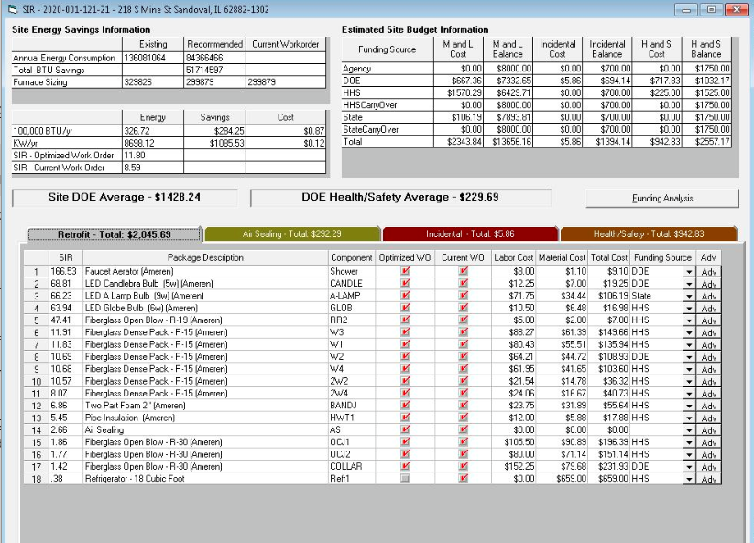

“Buy Down” Options
“Buy downs” are no longer an option in single-family homes for increasing the SIR of measures to 1.0.

Non-Program Contributions
When cost ceilings are exceeded, a non-program contribution is required. If the per unit cost ceiling is exceeded at no fault of the homeowner, the Local Administrative Agency (LAA) is liable for the exceeded costs. IHWAP funds cannot be used to pay costs in excess of allowable costs. Non-program contributions are reported on the “Cost Reporting Screen” of the WeatherWorks Energy Audit as “Agency Costs”.

Additional Work
If the client or landlord wishes to have additional work done, above the standard weatherization measures, the additional work must be negotiated separately with the contractor(s). Any additional work to be completed on a dwelling, that is beyond the scope of weatherization and negotiated separately, must be completed after the weatherization work is final inspected and considered complete. The client or landlord is required to pay 100% of any additional work that is beyond the scope of weatherization. The additional work is not the responsibility of the LAA and therefore is not part of the final inspection of the home. Client complaints about additional work completed on the home or building as part of a separate agreement with the weatherization contractor is solely the responsibility of the homeowner.
Because the additional work represents a separate agreement between the homeowner and the contractor, the additional work is not to be entered into the WeatherWorks System and is not reported on the Cost Reporting Screen of the WeatherWorks Energy Audit.

Joint Funded Projects
OCA, Commonwealth Edison, Peoples/Northshore Gas, Nicor Gas, and Ameren Illinois have arrived at an agreement that will allow for joint funding of projects. The utilities have agreed to co-sponsor the costs for measures at a fifty percent contribution. In order for an LAA to utilize utility funding, the home or unit must receive service from one of the utilities mentioned above. Commonwealth Edison, Peoples/North Shore Gas, and Nicor Gas are funding 50% of the cost of all costs associated with a job (including the administrative and program support cost). Ameren Illinois is only funding specific measures. LAA/Utility agreements should be referenced with respect to the allowability of measures from a utility perspective.
If Utility contributions are associated with a measure, only grant costs for the measure will be represented in WeatherWorks. Measures will still be prioritized by ranking SIR for DOE funding. All HHS and State funded exceptions to the SIR of 1.0 or greater will be prioritized below ranking measures with positive SIRs of 1.0 or greater.
All utility funding will be tracked outside of the WeatherWorks system. If an LAA is utilizing utility funding on a project, the LAA shall represent the measures for that home in a separate catalog that incorporates only the grant funding for measures. The separate catalog should represent fifty percent of the procured costs for measures impacted by utility contributions. The catalog should be clearly named in a manner that identifies utility funding is associated. Example: Utility BCMW Crews.
LAAs must also allocate staff time appropriately for joint funded projects. If a weatherization project is funded at 50% by utility contributions, the staff time and other overhead expenditures related to the project should be allocated at 50% to the grant and 50% to the utility.
Use of grant purchased equipment shall be permitted in the following priority. 1.) IHWAP/LIHEAP Grant purchased equipment is used on grant funded weatherization/furnace projects; this includes grant and utility co-funded projects. 2.) When all grant funds are expended, the equipment can be used by other federal programs if the equipment is no longer needed by the IHWAP/LIHEAP Program. 3.) If no other federal programs are using the equipment, then the equipment may be used by non-grant related programs (rental fees at a fair market rate will apply and be paid back to the local weatherization program).
Please see the rental prices for equipment associated with weatherization assessments/final Inspections and heating system assessments/final inspections in the Exhibits. The Illinois Association of Community Action Agencies (IACAA) and the Office of Community Assistance have negotiated rental prices for equipment; these prices are in alignment with market prices for the equipment.
After OCA grant funding is expended, or before OCA grant funding is available, it is permissible to complete utility-only weatherization/furnace projects with grant purchased equipment. If grantees complete this work utilizing solely utility funding, these rental fees must be charged to the utility for any equipment used that were purchased with IHWAP/LIHEAP grant funds. The rental fees should be recorded as program income in the current grant of the fund originally used to purchase the equipment, and the proceeds should be utilized in the IHWAP. Clear records and documentation of the equipment rental transactions must be maintained and available for review by OCA monitors, and the receipt and expenditure of the equipment rental proceeds must be clearly identified in the reconciliation submitted for that grant.
Additionally, costs for any weatherization staff (program support) or administrative staff associated with weatherized homes funded with only utility money must be properly allocated to the corresponding utility fund.
If it is determined that an LAA does not follow joint IHWAP/utility funding rules (ex. including not creating a utility catalog in WeatherWorks, intentionally having incorrect prices in utility catalog, charges for measures not installed, charging labor inappropriately, equipment use, etc.) IHWAP may prohibit the LAA from conducting joint funded projects.

Categories of Weatherization Measures
There are four categories of weatherization measures installed and/or applied in the Illinois Home Weatherization Assistance Program:
- Retrofit Measures;
- Air Sealing Measures;
- Incidental Repair Measures;
- Health and Safety Measures;
- Weatherization Plus Measures.
Retrofit Measures
Any measure that produces an energy savings is a Retrofit Measure. All Retrofit Measures generate a Savings-to-Investment Ratio (SIR) and only the measures that have an SIR at/above 1.00 may be installed with DOE funds. The Retrofit Measure MUST include all the tasks that are necessary to install the measure.
- An example would be that a replacement heating system would include the furnace, mounting blocks, plenum, wiring, any transition ductwork, etc. These items would all be detailed and listed separately within a retrofit package and would be included in the SIR calculation.
  - Retrofit Measures are also known as Energy Conservation Measures (ECMs) and the terms may be used interchangeably throughout this manual.
Central &/or window/wall air conditioning units are an energy conservation retrofit that should be assessed and calculated for replacement. If two or more window/wall A/C units are being utilized in a dwelling, and the existing duct system will support a central A/C unit, it is permissible for the LAA to call for the central A/C unit following IHWAP rules and policies.
When an existing lightbulb can simply be replaced with an LED lightbulb, replacing the lighting fixture is prohibited. Installers should also avoid using diode LED fixtures where replacement of burned-out LED lightbulbs requires replacing the entire fixture.
If an Agency wants to install measures that are more efficient than the standards (ex. R-60 attic insulation instead of R-49, 17 SEER central air conditioner instead of 16 SEER, tankless water heater instead of power-vented energy star storage water heater), they must calculate and document the SIR for the two options and can only call for the measure with higher efficiency than the standard if it has a higher SIR than the other measure.
- For example - If an Agency wants to consider going beyond the minimum standard of R-49 for attic insulation and instead install R-60, they will need to calculate the SIR for R-60 insulation and for R-49. If the R-60 insulation has a higher SIR than the R-49, then the Agency could consider going beyond the minimum standards and install R-60. If R-60 is being installed, the client file must include the SIR report for both options to document that the SIR for R-60 is higher than R-49.
Air Sealing Measures
Air Sealing Measures stop outside air or conditioned inside air from penetrating the thermal boundary of the home. The effectiveness of these measures is determined by measuring air movement through the thermal boundary before and after the installation of the air sealing measures with a Blower Door. WeatherWorks’ energy modeling function uses air leakage estimates to calculate a single Air-Sealing SIR rating for the home. Because of this, all air infiltration measures installed on the home are combined to generate a single SIR value. However, the combined SIR is not relevant for determining whether air sealing qualifies for DOE funding; DOE funds can be used for air sealing measures regardless of the SIR.
- Some examples of Air-Sealing measures would include weather-stripping, caulking, foam sealing, installing thresholds, door sweeps, sash locks, and/or sealing ducts that are located outside of the thermal envelope.
  - Per DOE guidance, no more than half of a tube of caulk can be called for to air-seal the interior or exterior, not both, of a window or door without proper justification and photo documentation.
  - Failure to follow this policy could lead to a disallowed cost(s). Procurement Bid Sheets must be set up to reflect this mandate. LAAs can round up the number of tubes of caulk when addressing an odd number of windows or doors.
    - Example: You have 5 windows that you are proposing to interior air-seal, you would take 5 divided by 2 (2½) and round up to 3 tubes of caulk.
- Replacing windows &/or doors under air-sealing. When a window &/or door is damaged beyond repair or when it is an ineffective air-barrier they can be replaced under air-sealing, on a case-by-case basis, with State review/approval. They must first be entered as a retrofit to see if they SIR at/above 1.00;
  - Replacing windows &/or doors under air-sealing. When a window &/or door is damaged beyond repair or when it is an ineffective air-barrier they can be replaced when the air leakage is quantified. This is a two-step procedure per window or door.
      - The first step is to run the blower door with the house set up in “winter” conditions and record the existing blower door reading.
      - The next step is to seal the window or door opening that you are seeking to replace and run the blower door a second time to gauge the air leakage of the sealed window or door. If the air leakage reduction is 250 CFM-50 or greater per window and door than that unit may be replaced under air sealing.
        - This equals roughly 25 square inches.
      - Each window &/or door that is being considered for replacement must be measured separately. Cumulative readings are not allowed and could lead to a disallowed cost scenario. Photographic and written documentation must be submitted to your State Tech for review and approval. All correspondences must be placed in the client file for review and auditing purposes.
      - A missing or severely damaged window that cannot be effectively masked off may be replaced under air-sealing, on a case-by-case basis, with State review/approval;
      - Supporting photo documentation and narrative justification must be submitted;
      - In instances where there is an existing bilco/storm cellar-type door with no basement door, a door may be installed under air-sealing on a case-by-case basis, with State review and approval. The idea behind this is to complete the pressure boundary;
      - Storm window repair or replacement cannot be considered as an air sealing measure. They must be considered as a retrofit and must have an SIR of 1 or more to be eligible.
        - Photo documentation is required in the Client File
      - During WeatherWorks data entry, make sure to enter the window or door replacement as an air sealing measure and not as a retrofit measure.
Health and Safety Measures
These measures are defined as weatherization work that protects the Health and Safety of the client, their family, as well as the IHWAP workers.
The Health and Safety maximum limit of $1,750, per funding source, on any one unit, which may not be exceeded unless a waiver is approved by DCEO/OCA. If braided funding is used an additional $1,750 is allowed per funding source, for a maximum of $3,500.00.
Examples which may be paid under Health and Safety are:
- Installation of Smoke Detectors and Carbon Monoxide Detectors; Fire Extinguishers may only be installed in homes where solid fuel sources are utilized.
- Installation/Repair of exhaust fans in kitchens and bathrooms;
- Lead Safe Weatherization (LSW) work;
- Correcting/Repairing leaking fuel supply lines;
- Correcting/Repairing improper or ineffective Water Heater venting;
- Installing water heater discharge pipes when they are missing;
- Remediation of conditions that may lead to or promote biological concerns and unsanitary conditions (Addressing bacteria and viruses is not an allowable health and safety cost. Where severe mold and moisture problems are so severe they cannot be resolved under existing health and safety measures and with minor repairs the building is deferred);
- Minor electrical repairs/upgrades necessary for weatherization measures and where the health and safety of the occupant is at risk;
- Minor correction of moisture and mold creating conditions when necessary to ensure the long-term stability and durability of the weatherization measures and the clients long-term health and safety;
  - This would include gutter or downspout work necessary to keep rainwater out of the dwelling to stop or prevent mold/moisture/mildew conditions per DOE’s SWS.
  - This also would include sump pump repairs, replacement, and covers necessary to keep seepage water out of the dwelling to stop or prevent mold/moisture/mildew conditions per DOE’s SWS.
    - Sump pumps may be installed when none exist.
- Heating System and Water Heater repair and/or replacement within the allotted budget
- An air conditioning system, usually a room/window unit, can also be installed when it is medically necessitated, with supporting and approved documentation from a medical professional: i.e.: Licensed doctor. All replacements must be Energy Star Rated.
- Other measures required to correct CAZ Depressurization issues.
- Asbestos testing where limited and prescriptive (abatement or removal is not permitted; however, encapsulation may be allowed in some circumstances).
Incidental Repair Measures
An Incidental Repair Measure is a weatherization measure that is necessary for the effective performance or preservation of a Retrofit Measure (ECM). Incidental Repair measures are separate and distinct from Retrofits and/or Health and Safety measures; however, these measures must support a Retrofit Measure and not merely desirable home repair.
The maximum cost limit for Incidental Repair Measures is $700 per funding source, on any one unit, which may not be exceeded unless a waiver is approved by DCEO/OCA. If combined funding is used an additional $700 is allowed, per funding source, for a maximum of $1,400.00.
Examples of Incidental Repair Measures are:
Repair or replacement of heating system ductwork: Repair or replacement of heating system ductwork may be an incidental repair only if associated with a heating system replacement (and documented as such). If a heating system is not being replaced, repair, replacement, or sealing of ductwork could be justified as an air infiltration reduction measure where the work is intended to save energy lost through air leakage and substantial air leakage outside of the building envelope is established. In some instances, duct sealing could also be considered Health and Safety, if the work is being done to alleviate a combustion safety issue, due to duct pressure imbalance.
Minor roof repair- necessary to install insulation;
Exterior or interior wall repair when necessary to install insulation;
Ceiling repair when necessary to install insulation;
Clean and Tune of will be allowed under the incidental budget using State or HHS weatherization grant funds. However, before doing so the agency must first consider whether the Clean and Tune can be properly expensed as a Health and Safety Measure as allowed under all IHWAP grant funds.
Weatherization Plus Measures
Weatherization Plus measures go beyond the traditional weatherization measures. These are home improvements that:
- address deferral issues that would otherwise require the homeowner to pay for improvements before the house could be weatherized,
- protect retrofits that would be at risk if house left in current condition;
- incorporate simple healthy home measures; and/or
- further reduce electricity costs by adding solar photovoltaic systems (maximum of 3 kW per home).
Only State funds and DOE Readiness funds can be used for weatherization plus measures (DOE Readiness funds cannot be used for solar retrofits). The weatherization plus maximum expenditure limit is $30,000 for single family owner-occupied homes and $15,000 for owner-occupied mobile homes (rental homes and multi-family buildings are not eligible for weatherization plus, with the exception that solar installations can be considered for multi-family). OCA approval is required when total weatherization plus measure costs exceeds $5,000. Utility funds shall not be used on Weatherization Plus Measures. It is not OCA’s expectation that utilities will contribute 50% of the costs on Weatherization Plus activities.
Some examples of weatherization plus measures include roof repair or replacement, mold remediation, foundation repairs, plumbing repair/replacements, repair/replace/auger sewer lines, gutter repair/replacement/additions, grading exterior to alleviate flooding in foundation, pest removal, replace old dirty carpet with hard surface flooring, and repair/add mobile home skirting. A complete list of eligible weatherization plus measures is included in the Forms and Exhibit of this Section. More details on the assessment and documentation of weatherization plus measures is included in Section VIII (Assessments).

IHWAP Mechanical Waivers
There are no Mechanical Cost Limits in IHWAP. However, DCEO/OCA still expects the LAAs to exhibit due diligence when procuring mechanical work to ensure that the prices remain reasonable. The Mechanical Cost Limits for LIHEAP have been updated and are still in effect.
A waiver request is required to install an 80% furnace. Supporting documentation and photos must be submitted to your State assigned Tech for review and approval purposes and the IHWAP Program Manager (in case the Tech is out in the field, for re-assignment purposes) for review and approval. Missing and/or lack of the proper documentation will only delay the approval process.
A conversion furnace is defined as a furnace that was previously converted from the original fuel source prior to the weatherization assessment. Conversion, in this context, does not refer to converting from one fuel type to another at the time of weatherization.
A waiver request is also required in a situation when an Agency is calling to replace a heating system that was replaced in the LIHEAP Emergency Furnace program within the last five years. Since the LIHEAP Emergency Furnace program requires high efficiency furnaces be installed when possible, the Agency would need to provide an explanation of why a 95% heating system can now be installed.

IHWAP 80% Efficiency Heating System Waiver Process
There are certain situations when a high efficiency heating system cannot be installed, but a new 80% EFE heating system must be installed. When requesting an 80% EFE heating system waiver, you must submit a complete IHWAP Mechanical Waiver Form following the instructions and requirements on the form. Mechanical Waiver Requests are to be submitted to your assigned State Tech and the IHWAP Program Manager for approval. Correspondences of the request and all responses must be placed in the client file. Failure to entirely complete the IHWAP Mechanical Cost Waiver will require the LAA to re-submit the request and will delay its processing.
All 80% EFE Heating System Waivers must include the following information:
- Client Name, Address, and complete Job Number;
- A complete listing of other weatherization measures to be completed on this home (include all architectural work);
- A complete description of why the 80% EFE heating system waiver is needed,;
- Description of other options that exist if the waiver is not granted (changing fuel sources, heating system types, etc.);
- Digital photos of the existing conditions clearly showing why the waiver is required;
- All costs for the waiver, listed and detailed, separated by labor and material;
- Contractor name and address;
- Funding source;
- Agency Name
- Program Designation (Weatherization)
- Comprehensive (computer-generated) Heat Load calculation, i.e., Manual J Calculation.
- Assessor’s name & date of assessment.
- Make/model and serial number of old heating system.
- Make/model, BTU of the new equipment proposed.

Heating System and Water Heater Replacements/Health and Safety
Heating System and Water Heater replacement for Health and Safety Reasons is allowable with all 3 of the funding sources. A waiver request to exceed the Health/Safety limits must be submitted for review/approval.

Mobile Home Water Heaters
Mobile home water heaters need to be in separate Combustion Appliance Zone (CAZ) with vent and combustion air to the outside. The LAA may use a portion of the Health and Safety funding to separate the mobile home water heater from the conditioned portion of the dwelling. A Hazardous Condition Form shall be completed and given to the client if the proper type of water heater is not installed in the house. If funds are not available to separate the combustion appliance zone, then the hazardous condition form shall be completed, and home deferred until repair is made.

Appliance Repairs/Replacement
IHWAP only allows the repair or replacement of the following items when they are damaged or leaking: gas lines, sediment traps, flexible connectors, or gas shut off valves. Appliance repair applies to gas dryers, gas stoves, water heaters, heating systems, or any other gas appliance and is part of the Health and Safety costs.
If any of the above items (such as existing flex line, missing gas shut off valve, etc.) are discovered at the time of assessment and are not damaged or leaking, the client must be given a completed Hazardous Conditions Notice and informed of the potential health and safety problem. A copy of the completed Hazardous Conditions Notice must be placed in the client file (See Section X - Filing Systems).
If a flue liner supports a retrofit measure for a new water heater, then the cost is included in the cost of the Retrofit. If the flue liner is NOT being installed because of the Retrofit, then it should be included in the Health and Safety costs.
- Example: A flue liner for an orphaned water heater due to a new furnace install would be Health/Safety measure. A flue liner installed for a new water heater would be an incidental repair, or the costs would be included in the SIR calculation for the water heater retrofit.
Note: Under no circumstances may an un-vented gas space heater be repaired or installed with IHWAP funds. Existing un-vented gas space heaters must be removed from the dwelling before any Weatherization work can begin. If the client refuses removal of the space heater, the home must be deferred, and a Hazardous Conditions Form should be completed.

Historical Preservation Review
Prior to the expenditure of federal funds to weatherize any building 50 or more years old, the local IHWAP agency is required to comply with Section 106 of the National Historic Preservation Act (NHPA). Section 106 applies to historic properties or sites that are listed on or eligible for listing on the National Register of Historic Places. To fulfill the requirements of Section 106, the LAA must contact the State Historic Preservation Officer (SHPO) to coordinate the Section 106 review as set forth in 36 C.F.R. Part 800. These reviews should be conducted on any dwellings that are over 50 years old and will be completed with any funding from DOE or HHS weatherization grant funds.
IHWAP and Illinois SHPO have a written agreement detailing the types of activities that do not affect a historic property and that if weatherization work on a property falls within the agreement, the LAA does not need to perform any further Section 106 review. Any IHWAP dwelling that is 50 or more years old and will be weatherized with federal funding (DOE or HHS) is subject to a potential Section 106 review by the SHPO. The Weatherization Measures exempt from this review are listed below Weatherization Measures Exempt from Section 106 Reviews.
- For example - To be exempt, any replacement or repair work for primary windows, doors and door frames must closely match the existing paint or substrate (surface) and framing. Any IHWAP measure that will be funded with Federal weatherization grant dollars (DOE WAP or HHS LIHEAP) on a home 50 or more years old, that is not listed below in Weatherization Measures Exempt from Section 106 Reviews, will need a full Section 106 review by the Illinois State Historic Preservation Officer (SHPO).
IHWAP LAAs are encouraged to learn where the historic neighborhoods are located within their service territory. Also, be aware that many individual homes may have historic status as well.
The LAA must document the Historic Review process for each weatherization job. The procedure is straightforward:

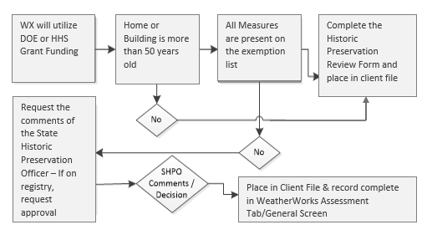

Weatherization Measures Exempt from Section 106 Reviews
All Illinois Home Weatherization Assistance Program (IHWAP) work will be done in accordance with applicable local building codes or the International Building Code, where applicable. In accordance with 36 CFR 800.3(a) (l), the following IHWAP work has been determined not to cause effects on historic properties:
Exterior Work
- Air sealing of the building shell, including caulking, weather-stripping, and other air infiltration control measures on windows and doors, and installing thresholds in a manner that does not harm or obscure historic windows or trim.
- Thermal insulation, such as non-toxic fiberglass and foil wrapped, in walls, floors, ceilings, attics, and foundations in a manner that does not harm or damage historic fabric.
- Blown in wall insulation where no holes are drilled through exterior siding, or where holes have no permanent visible alteration to the structure
- Removable film on windows (if the film is transparent), solar screens, or window louvers, in a manner that does not harm or obscure historic windows or trim.
- Reflective roof coating in a manner that closely resembles the historic materials and form, or with materials that restore the original feature based on historic evidence, and in a manner that does not alter the roofline, or where not on a primary roof elevation or visible from the public right-of-way.
- Storm windows or doors in a manner that does not harm or obscure historic windows or trim.
- Replacement or repair of primary windows, doors and door frames that closely resemble existing substrate and framing.
- Repair of minor roof and wall leaks prior to insulating attics or walls, provided repairs closely resemble existing surface composite.
Interior Work
Special Note: IHWAP work to interior spaces where the work will not be visible from the public right of way; no structural alterations are made; no demolition of walls, ceilings or floors occurs; no drop ceilings are added; or no walls are leveled with furring or moved, should be automatically excluded from SHPO review. This work includes:
Energy efficiency work within the building shell:
- Thermal insulation in walls, floors, ceilings, attics, crawl spaces, ducts and
- Foundations.
- Blown in wall insulation where no decorative plaster is damaged.
- Plumbing work, including installation of water heaters.
- Electrical work, including improving lamp efficiency.
- Sealing air leaks using weather stripping, door sweeps, and caulk and sealing major air leaks associated with bypasses, ducts, air conditioning units, etc.
- Repair or replace water heaters.
- Adding adjustable speed drives such as fans on air handling units, cooling tower fans, and pumps.
- Install insulation on water heater tanks and water heating pipes.
- Install solar water heating systems, provided the structure is not visible from the public right of way.
- Install waste heat recovery devices, including water heaters, condensing heat exchangers, heat pump and water heating heat recovery systems, and other energy recovery equipment.
- Repair or replace electric motors and motor controls like variable speed drives.
- Incorporate other lighting technologies such as dimmable ballasts, day lighting controls, and occupant-controlled dimming.
Work on Heating and Cooling Systems:
- Repair or replace heating systems, including furnaces, oilers, heat pumps, vented space heaters, and wood stoves.
- Repair or replace cooling systems, including central air conditioners, window air conditioners, heat pumps, and evaporative coolers.
- Install insulation on ducts and heating pipes.
- Conduct other efficiency improvements on heating and cooling systems, including replacing standing pilot lights with electronic ignition devices and installing vent dampers.
- Modify duct and pipe systems so heating and cooling systems operate efficiently and effectively, including adding return ducts, replace diffusers and registers, replace air filters, install thermostatic radiator controls on steam and hot water heating systems.
- Install programmable thermostats, outdoor reset controls, UL listed energy management systems or building automation systems and other HVAC control systems.
Energy efficiency work affecting the electric base load of the property:
- Convert incandescent lighting to fluorescent or LED lighting systems
- Add reflectors, LED exit signs, efficient HID fixtures, and occupancy (motion) sensors.
- Replace refrigerators and other appliances.
Health and Safety Measures
- Installing fire extinguishers - (Solid Fuel Sources Only),
- Smoke or Carbon Dioxide Detectors / Alarms.
- Repair or Replace Vent Systems on fossil-fuel-fired heating systems and water heaters to ensure that combustion gasses draft safely to outside.
- Install Mechanical Ventilation, in a manner not visible from the public right of way, to ensure adequate indoor air quality if house is air-sealed to building tightness limit.

Procedure for Full Section 106 Review by the SHPO
INITIAL DOCUMENTATION REQUIRED FOR IHPA REVIEW
To request the comments of the State Historic Preservation Officer concerning possible project effects on cultural resources (both structural and archaeological) for purposes of the National Historic Preservation Act or the Illinois State Agency Historic Resources Protection Act, the following information should be provided via email (SHPO.Review@illinois.gov):
- Cover letter on your organization’s letterhead that includes the following:
- Project’s county, street address, and municipality. If no street address is available, please provide nearest street, township, and range. For unincorporated areas, please provide the nearest municipality and county.
- Complete description of all elements of proposed project, including any proposed ground-disturbing activity;
- Names of state and/or federal agencies and entities providing funding, licenses, permits, or approvals for your project;
- Name, email address, phone, and mailing address of the project contact;
- Previously assigned SHPO log numbers associated with your project (if any).
- Total acreage involved in the project;
- Year of construction for each structure on the project site;
- Description of any prior non-agricultural ground disturbance in the project area;
- Any known historical information, architectural significance, significant to community, or association with a significant individual for any cultural resources within project area.

- Maps & Images to include with your submission:
- A map showing your project’s location;
- Projects that propose ground disturbance, please provide a USGS 7.5-minute topography map and recent aerial imagery with the project limits clearly outlined;
- Newly taken color digital images of the existing site and of all structures within. Images must be appropriately names, high-resolution “.jpg” or “.pdf” files. Image files with the “.heic” extension will not be accepted;
- Representative interior photos of any structures over 50 years of age;
- High-resolution digital scans of relevant historic photographs and previous architectural plans (if applicable/available).
- Proposed architectural/engineering plans and specifications if they have been prepared.
- Any existing archaeological survey, testing, or mitigation reports.
If your submission is fewer than 25 MB in size, email it to SHPO.Review@illinois.gov. If your submission is 25 MW or larger, follow instructions provided at SHPO website.
More details on how to submit Section 106 documents for review are available at https://www2.illinois.gov/dnrhistoric/Preserve/Pages/resource-protection-submittal.aspx.
More information on the Section 106 review process can be found at the Historic Preservation Office website at https://www2.illinois.gov/dnrhistoric/Preserve/Pages/Resource-Protection.aspx.

FORMS AND EXHIBITS for SECTION II - PROGRAM ELIGIBILITY

IHWAP Income Guidelines Page 37
IHWAP/LIHEAP Application Page 38
HHS/State Funding Allowances……………………………………………….. Page 40
Weatherization Plus Measures and Allowances ……………………….Page 41
IHWAP Mechanical Waiver/FA Mechanical Cost Waiver Form…. Page 43
Furnace Assistance Change Order Request Page 44
Historic Preservation Review Form Page 45
Rental of IHWAP Equipment for Utility-only Weatherization Page 46
Rental of IHWAP-funded Equipment for Utility Emergency
Furnace Replacement Program…………………………………………………Page 47

2023 IHWAP INCOME ELIGIBILITY GUIDELINES
Poverty Income Levels
See WPN 22-3
Household Size | 200% Annual Income  State, HHS &DOE Funds
1 | $27,180
2 | $36,620
3 | $46,060
4 | $55,500
5 | $64,940
6 | $74,380

Household Size | 200 % Annual Income  DOE & HHS Funds | 60% of State Median Income  State Funds
7 | $83,820 | $82,755
8 | $93,260 | $84,594
9 | $102,700 | $86,433
10 | $112,140 | $88,272

- 200% level: For each household member over 10 add $9,440.
- 60% of State Median Income (State): For each additional member above 10 persons, add $1,839. This is per guidance provide from U.S. HHS information memo # LIHEAP-IM-2022-04.

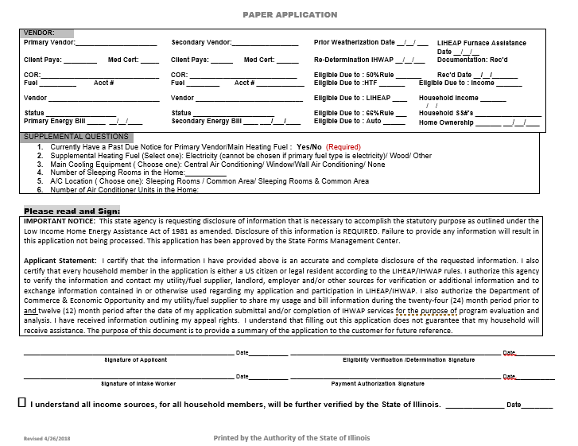

HHS/State Funding Allowances

Despite the SIR Concerns
Category | Type | Pre-Qualifiers | Approved Measure
Insulation | Attic  Wall  Foundation Walls  Bandjoist  M/H Underbellies | No SIR Concerns  No SIR Concerns  No SIR Concerns  No SIR Concerns  No SIR Concerns | Insulate the Attic(s) to IHWAP Standards  Insulate all Walls to IHWAP Standards  Insulate the Foundation to IHWAP Standards  Insulate the Bandjoist to IHWAP Standards  Insulate the Underbelly to IHWAP Standards
Heating | 80% EFE Units  90% EFE Units  Clean & Tune | None, automatic qualifier  Must be 15 yrs or older  Must be 15 years or newer OR  when budgets are exceeded | Replace with a 95% EFE Unit  Properly sized by a Manual J calculation  Replace with a 95% EFE Unit  Properly sized by a Manual J calculation  Allowable as an Incidental Repair Measure
Cooling | Central A/C  Window A/C Units | Must be 10 yrs or older  OR 10.0 SEER or less  Must be 8 yrs or older  OR 8.0 SEER or less | Replacement must be Energy Star Rated  Must be properly sized  Replacement must be Energy Star Rated  Must be properly sized
Water Heaters | Natural Gas or Propane  Power Vent Kits  Electric | Must be 10 yrs or older  Must be 10 yrs or newer  OR  When budgets are exceeded  Must be 10 years or older | Replacement must be Energy Star Rated;  Preferably Power Vented Units  Allowable as a Health & Safety Measure  Replacement must be Energy Star Rated;  Preferably Heat Pump units
Baseload | Refrigerators  Freezers | Must be pre-2010  Must be pre-2010 | Replacement(s) must be Energy Star Rated  Replacement(s) must be Energy Star Rated  Max combination of 4 units can be installed
Air-Sealing | Windows  Doors  Missing Basement  Doors-Bilco existing | Must have State approval  Must have State approval  Must have State approval | See directives in IHWAP PY-2023 Ops Manual  See directives in IHWAP PY-2023 Ops Manual  See directives in IHWAP PY-2023 Ops Manual

Reminder: A max of 2 pots of money can be spent per approved unit using any combination of the 3 funding sources; $8,000 M/L & $1,750 H/S limits on each source. DOE has a $5,932 M/L average that can’t be exceeded for the program year. All applicable IHWAP rules apply for waiver request.

Weatherization Plus Measures and Funding Allowances

Roof
- Minor repair of roof for leak (patch work, replace ridge cap or ridge vent)
- Replacement of roof because of several/major leaks
- Replacement of roof due to condition of roof (severe degradation of shingles, poor condition of sheathing)
- Replace section of old roof as part of adding solar retrofit
- Elastomeric roof coating (mobile home)
- EPDM rubber roofing (mobile home or site built home with flat roof)
Note 1: All roof work must be completed by a licensed roofer and must have at least a 5- year workmanship warranty and have a 30-year shingle warranty
Note 2: If roof replacement is needed and if there are two layers of shingles on home, the layers must be torn off prior to installation of new shingles
Other Structural Repair
- Foundation Repair (address sinking foundation, foundation cracks, buckled walls, address sagging floors, settling foundation, waterproofing)
- Foundation water drainage (sump pit, sump pump, etc.)
- Replacing unstable flooring
- Wall repair
- Ceiling repair
- Improve porch and step stability
- Repair/Replace window to assure one in each bedroom can open
Mold & Moisture
- Mold remediation (also address source of moisture)
- Repair deteriorated caulk on bathtub/shower/sink
Electrical
- Replace knob & tube wiring when it prohibits effective insulation coverage, or it is deemed unsafe
- Upgrade electric service/panels
- Install GFCI outlet (for those within 6 feet of water source and other locations as required by code)
Plumbing & Sanitation
- Repair/replace plumbing where there are leaks
- Repair/Replace non-operable or leaking toilets (replace w/ 1.6 gal/flush toilets)
- Repair/Replace non-operable or leaking sinks
- Repair/replace/auger sewer lines
- Repair dry floor drains if sewer gas detected
- Repair/replace water lines
- Septic services (does not include new septic tank installation)
Bulk Water
- Gutter repair/replacement/addition
- Replace non-repairable windows and doors where bulk water is entering
- Exterior grading to alleviate flooding in basements/crawlspaces
- Repair/Replace exterior cladding to eliminate water from entering the walls
- Replace fascia and/or soffit (rotted out, termite damage)
Healthy Home
- Pest removal
  - Client education and plastic containers for food could be a component of this
- Replacing old/dirty carpet with hard surface
- Install kitchen range hood to vent to exterior (especially for gas ovens)
- Install pleated filter in forced-air heating system
- HRV/ERV ventilation systems (for tight homes, healthy homes?)
Solar
- Rooftop or ground mount solar PV (3 kw maximum)
Other
- Repair/Add Mobile home skirting
- Install railings on stairways
- Repair stairs and other trip hazards
- Install grab bars in bathrooms (for seniors)
- Items not included on this can be proposed to OCA
Funding Limits:
- Only State funds or DOE Readiness Funds can be used for Weatherization Plus measures (DOE Readiness funds cannot be used for solar retrofit).
- The maximum funding that can be used for Weatherization Plus measures is $30,000 for a single-family owner-occupied home and $15,000 for a mobile owner-occupied home. Weatherization Plus measures are not available for rental and multi-family projects.
OCA Approval Requirement:
- OCA approval is required for each project with a cumulative Weatherization Plus budget over $5,000. Projects with less than $5,000 of Weatherization Plus measures do not require OCA approval but the Agency most document the reason for selecting the measures and provide photos that illustrate the need for the measure in the client file.

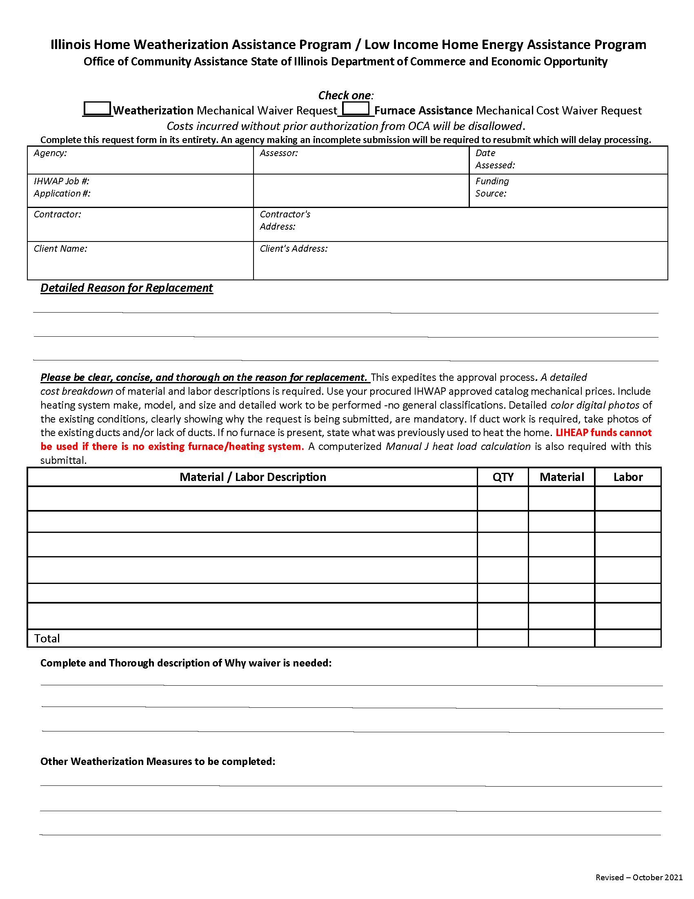

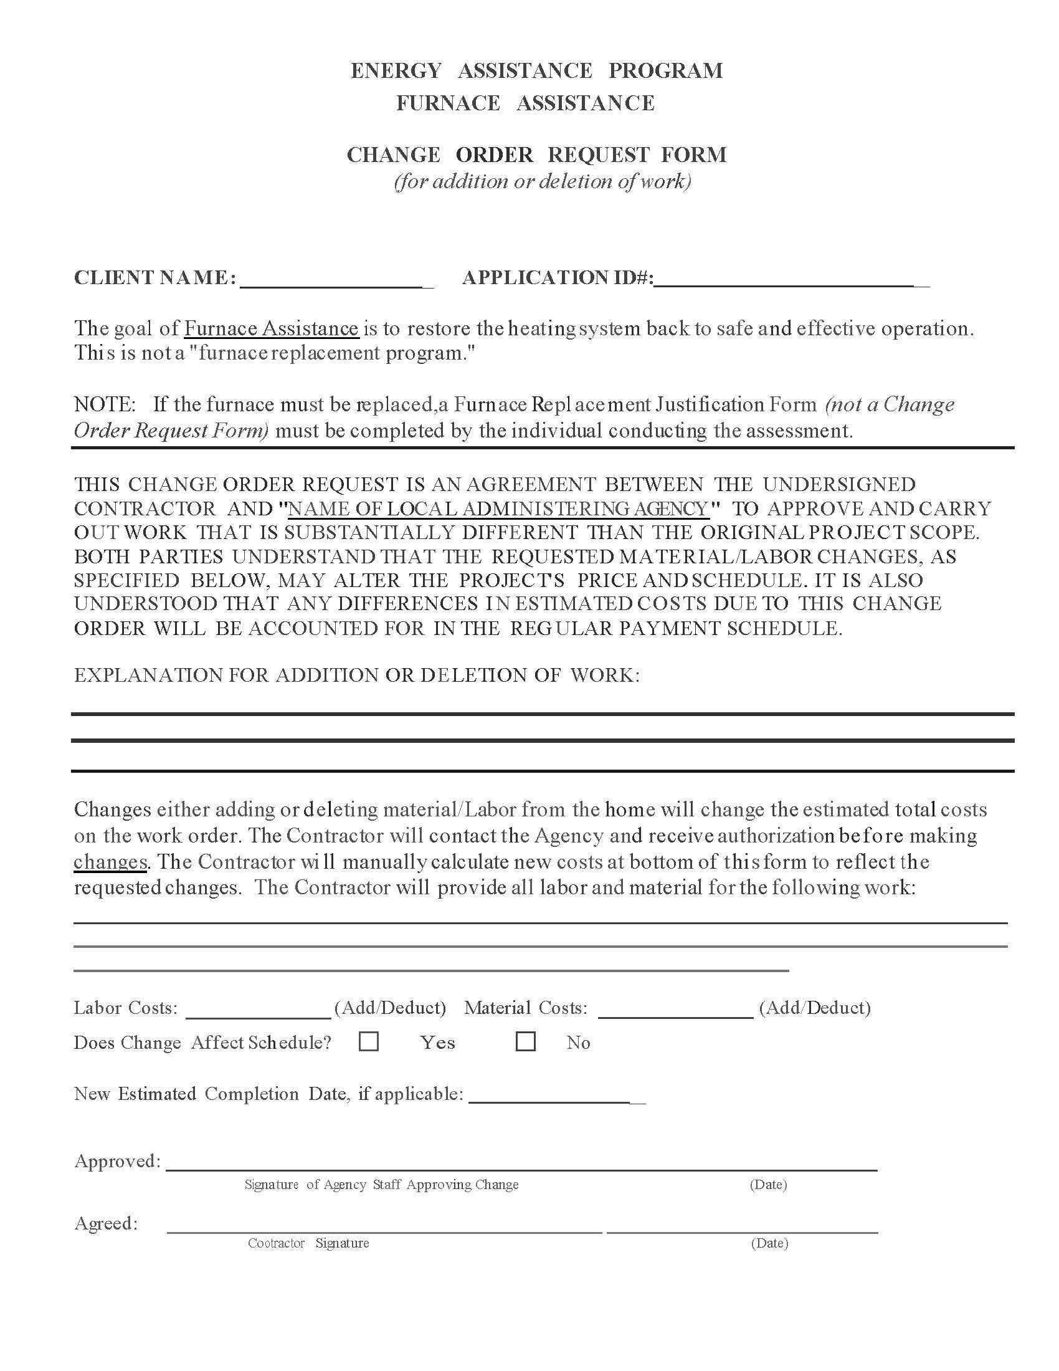
Illinois Home Weatherization Assistance Program
Historic Preservation Review

Weatherization File Number:
Building Address:
Age of Home
- The age of the home does not warrant a Historic Preservation Review
- All Weatherization measures are included in the list of exemptions (Volume 1 – IHWAP Program Operations Manual).
- Illinois Historic Preservation Agency, Section 106 Review completed and attached.

Certification Signature:
(LAA Reviewer) (Date)

(Title)

Note: All information must be filled out completely and placed in the appropriate client case file. See Volume I – IHWAP Program Operations Manual, Section II --Program Eligibility and Benefits for a list of weatherization measures and work EXEMPT from full Section 106 review by the Illinois Historic Preservation Agency.

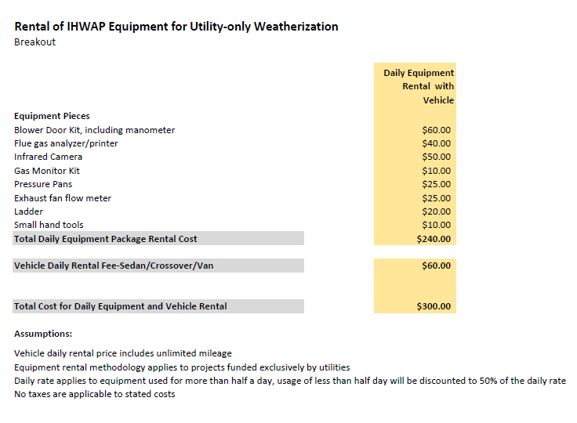

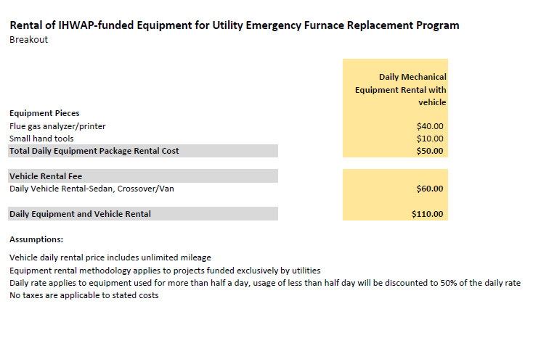

SECTION III –OUTREACH AND CLIENT EDUCATION

Outreach
Outreach is intended to let the general public know of the weatherization services offered by the agency. Each LAA is required to put together an Outreach Plan. This plan will outline the steps that the LAA will take to ensure that they have enough approved income eligible applications to complete their production each year.
Agencies must develop outreach procedures that ensure the elderly (60 and over), persons with disabilities, families with young children (5 years of age or under), and LIHEAP households are aware of IHWAP benefits. It is imperative that each agency develop a positive working relationship with those groups in the community that are in regular contact with these targeted populations.
Outreach is often considered an unnecessary activity by agencies that have a list of weatherization clients that will take them through the end of the program year. However, outreach responsibilities include more than seeking clients. It includes:
- Ensuring the elderly, persons with disabilities, households with children, and LIHEAP households are prioritized for services.
- Coordinating with and referring to other energy-related services.
- Providing energy-related consumer education throughout the agency's service area.
Outreach is the agency's first contact with a potential client. This contact may be as direct as a "walk-in" client who has questions about weatherization services or as indirect as a person reading an agency's program flyer on the grocery store bulletin board.

Coordination and Referral
IHWAP is only one of many residential energy assistance programs. Agencies should see that each potential applicant is aware of the array of services available in their service area. In addition to making referrals to energy assistance programs, the agency should attempt to determine other needs of the household and make appropriate referrals. For example, does the household know about and utilize other benefits/programs such as: "Circuit Breaker" tax relief; food stamps; Supplemental Security Income; senior services such as homemaker and chore service; nutrition programs; child abuse hotline; Head Start; local discount programs; etc. A client, who has to wait for IHWAP services, could apply for the Low-Income Home Energy Assistance Program to help reduce energy costs.
As a low-income service provider, the agency will regularly receive referrals from various agencies and hotlines. The following toll-free hotlines will probably make referrals.

Hotline Number | Agency |  | Client
877/411-9276 | The OCA Energy Assistance Hotline |  | Households needing LIHEAP and IHWAP assistance
800/252-8966 | Senior Help Line Department of Aging |  | Seniors with diverse needs
877/581-3690 | DIAL-Department of Human Services |  | Persons with disabilities may receive Rehabilitation Services
800/772-1213 | Social Security Benefits
800/252-2873 | DCFS-Child Abuse Hotline |  | Family needs
866/814-1113 | Illinois Office of the Executive Inspector General |  | Hotline to report LIHEAP or IHWAP fraud or abuse
The agency should develop a system for handling these referrals.
To ensure adequate coordination and referral at the local level, the agencies' grant agreement specifies that a directory of services be compiled and/or updated. At a minimum, this directory should include the following:
- Program title
- Program components
- Eligibility criteria
- Limitations on availability
- Contact agency/person and phone number
The agency should develop a system for handling these referrals.

Client Health and Safety Education
Client Education on Health and Safety will be provided at both the time of application and at the time of assessment/energy audit.

At Assessment, the assessor will discuss with the client health and safety hazards identified and will give general education on home health and safety hazards including LEAD hazards (if home was built before 1978), mold and moisture risks, and such information that the assessor deems appropriate or is required when the assessor identifies particular hazards.
The Assessor will give every IHWAP client household the EPA publications Lead Booklet (Renovate Right), A Brief Guide to Mold, Moisture, and Your Home, and A Citizen’s Guide to Radon at the time of the initial assessment / energy audit. Unless the assessor can determine conclusively that a continuous ventilation fan will not be required in the weatherization process, the assessor must also give the client the brochure “Ventilation for You & Your Home” as well.
Applicant Health and Safety Intake Questionnaire – This questionnaire is required by federal regulation to be completed at the time of application for Weatherization Services. This form can be found in the Forms and Exhibits at the end of this section.
At the time of the Assessment/Energy Audit the Client must sign the Client Education Materials Notification stating they have received the booklets/ brochures and client education on specific health and safety hazards identified in the assessment as well as the required publications and general home health and safety education.
If LAAs do not have sufficient health and safety publications on hand they should make copies from the digital version available on the OCA extranet site in the Health and Safety Materials folder (figure 1), or from these websites:
A Brief Guide to Mold, Moisture, and Your Home - http://www.epa.gov/iedmold1/pdfs/moldguide.pdf
Lead Safe Certified Guide to Renovate Right - http://www.epa.gov/lead/pubs/renovaterightbrochure.pdf
Seven Tips to Keeping a Healthy Home - http://portal.hud.gov/hudportal/documents/huddoc?id=DOC_11882.pdf
Safe Pest Control –http://portal.hud.gov/hudportal/documents/huddoc?id=DOC_25454.pdf
A Citizen's Guide to Radon - http://www.epa.gov/radon/pdfs/citizensguide.pdf

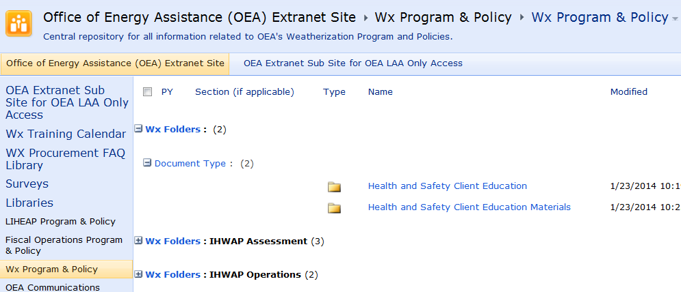

Figure 1. Location of IHWAP Health and Safety Materials
OCA encourages Agencies to give clients other appropriate building energy efficiency and home health and safety information and education as it sees fit, including:
- Any appropriate client education materials hazard or health and safety risk identified in the assessment. See Hazardous Conditions Notification The directory of services below:
  - The IHWAP client brochure
  - The LIHEAP client brochure
  - The IHWAP/LIHEAP Energy Savings Tips brochures

Hazardous Conditions Notification
In addition to receiving standard client education, whenever an Energy Auditor/Assessor believes there are conditions that constitute an immediate or potential risk to an individual or property, the client /household must receive a Hazardous Conditions Notice Form and appropriate client education. The Hazardous Conditions Notification Form should list the hazardous conditions identified and the assessor should give a copy to the client and/or landlord. In concurrence with WPN 17-7, listed below are some of the conditions that could be included on the Hazardous Conditions Notification Form when identified or suspected:
Asbestos - in siding, walls, ceilings, pipes, heating systems, etc.
Removal of siding is allowed to perform energy conservation measures. Removal of siding is done to perform energy conservation measures. All precautions must be taken not to damage siding. Asbestos siding should never be cut or drilled. Recommended, where possible, to insulate through home interior.
Abatement and replacement of asbestos containing building components is not allowed with any IHWAP funding. Removal of siding is done to perform energy conservation measures. All precautions must be taken not to damage siding. Asbestos siding should never be cut or drilled. Recommended, where possible, to insulate through home interior.
When suspected asbestos siding is present client / owner is informed and informed on how to take precautions.
Asbestos – in vermiculite
Attic Insulation that looks like vermiculite should not be removed or disturbed.
Blower door testing is still permitted and should be done in pressurization mode. Since vermiculite cannot be disturbed, air-sealing cannot be performed in an attic with vermiculite and ventilation may not be installed through an attic.
If there is vermiculite in the attic and it is not possible to comply with ASHRAE ventilation requirements through supply ventilation, balanced ventilation, or exhaust ventilation that goes through the side wall, the home should be deferred.
The removal of vermiculite attic insulation is not allowed with any IHWAP funding.
If a local agency chooses to test for asbestos to determine whether insulation or air sealing can be conducted, it must follow the by Asbestos Hazard Emergency Response Act of 1986 sample collection method, and testing must be conducted by a certified tester.
When suspected vermiculite is present in the attic, the client/owner is informed on how to take precautions.

Biologicals and Unsanitary Conditions - odors, bacteria, viruses, raw sewage, rotting wood, etc.
Remediation of conditions that may lead to or promote biological concerns and unsanitary conditions is allowed. Limited water damage repairs that can be addressed by weatherization workers and correction of moisture and mold creating conditions are allowed when necessary in order to weatherize the home and to ensure the long-term stability and durability of the measures.
Addressing bacteria and viruses is not an allowable cost. Where severe Mold and Moisture problems are so severe they cannot be resolved under existing health and safety measures and with minor repairs the building is deferred.
Mold testing is not an IHWAP allowable cost.
Deferral may be necessary in cases where a known agent is present in the home that may create a serious risk to occupants or weatherization workers.
Where these problems are identified clients receive information on the issues and where appropriate information on how to maintain a sanitary home or moisture awareness information. Where a home is deferred for these issues the LAA will inform the client of what steps to take to correct the deferral conditions.
All clients will receive the EPA Lead Booklet (Renovate Right), and the Moisture/Mold Booklet, are required to be given to every IHWAP Client at the time of the Assessment/Energy Audit. The Client must sign a form stating they have received the booklets at the time of Assessment. They can either sign the form in the back of the book or the form in Exhibit VIII.12. If LAAs do not have sufficient copies on hand, they will copy the camera-ready copies of these booklets from the EPA’s internet site and print them locally.
Building Structure and Roofing
Building rehabilitation is beyond the Scope of DOE’s WAP. Homes with conditions that require more than incidental repair should be deferred. Full roof replacement is no longer allowed with any IHWAP funding source.
Visual inspection for roofing and structural issues is part of the assessment protocol. Evaluation of roofing and structural issues includes ensuring that access necessary for weatherization work is safe for entry and performance of assessment, work, and inspection. Limited structural and roof repair are allowable.
Where the house has been condemned or electrical, heating, plumbing, or other equipment has been "red tagged" by local or state building officials or utilities the home is deferred.
Clients are to be notified of structurally compromised areas and, where the building is deferred for roofing or structural issues, of the necessary steps to correct.
Roofing repair to ensure the long-term stability and durability of weatherization measures may be allowed under the health and safety budget.
Code Compliance
Correction of preexisting code compliance issues is allowable only where weatherization measures are being conducted.
Correction of pre-existing code compliance issues is not allowable except where weatherization measures are being conducted. When correction of pre-existing code compliance issues is being paid for with IHWAP funds, the LAA must cite the specific code requirements with reference to the weatherization measure that triggered the code compliance issue in the client file.
Weatherization work will comply with applicable codes in the jurisdiction where the work is being done. Visual inspection at assessment and local code enforcement inspections are used to establish code compliance issues.
Condemned properties and those with “red tagged” health and safety conditions are deferred.
Clients will be informed of code compliance issues where they are uncovered in the assessment.
Combustion Gases
Proper venting of combustion appliances is an IHWAP requirement. Correction of venting is allowed when testing indicates a problem.
Replacement, repair, or modification of combustion venting that is not related to solving health and safety problems indicated by testing is beyond the scope of IHWAP weatherization funding.
Combustion safety testing will occur wherever combustion appliances are present. The assessor shall inspect venting of combustion appliances and confirm adequate clearances. Naturally drafting appliances are tested for spillage under worst case conditions before and after air sealing. Cooking burners may be inspected for operability and flame quality.
Electrical Other than Knob and Tube Wiring
Electrical repairs are allowed where health and safety of occupants is at risk. Upgrades and repairs will also be allowed when necessary to perform specific weatherization measures.

Beyond IHWAP Scope: Replacement of the entire electrical systems is allowable with State funding only, on a case-by-case basis, with review/approval from your assigned State Tech. Request must include proper justification.
Standards for Remedy: The Assessor will inspect for electrical safety issues at assessment.
Standards for Deferral: To the extent electrical conditions prevent proper weatherization and may not be addressed with WAP funds, the home is deferred and other resources, if available, on a case-by-case basis.
Client Education: Clients may be provided the Electrical Safety workbook which includes information on over-current protection, overloading circuits, and basic electrical safety/risks.
Electrical Knob and Tube Wiring
Electrical repairs, including upgrades of knob and tube wiring systems, are allowed where health and safety of occupants is at risk. Upgrades and repairs will also be allowed when necessary to perform specific weatherization measures.

Beyond IHWAP Scope: Replacement of the entire electrical systems is allowable with State funding only, on a case-by-case basis, with review/approval from your assigned State Tech. Request must include proper justification.
Standards for Remedy: The Assessor will inspect for electrical safety issues at assessment.
Standards for Deferral: Where the extent electrical conditions prevent proper weatherization and may not be addressed with WAP funds the building will be deferred.
Client Education: Clients are provided the Electrical Safety Workbook which includes information on over-current protection, overloading circuits, and basic electrical safety/risks.
Fire Hazards
IHWAP allows correction of fire hazards when necessary to perform weatherization work.

Beyond IHWAP Scope: IHWAP funds cannot be used to remedy certain conditions that constitute fire hazards, such as excessive accumulation of debris that make it impossible to safely perform weatherization work beyond the limits of the Health and Safety Budget.
Standards for Remedy: Assessment and audit will include a check for fire hazards.
Standards for Deferral: Certain conditions that constitute fire hazards, such as excessive accumulation of debris that make it impossible to safely perform weatherization work and cannot be remedied within the health and safety budget is grounds for deferral.
Client Education: Clients are informed of observed fire hazards.
Formaldehyde, Volatile Organic Compounds (VOCs) and other Air Pollutants
Removal of pollutants is allowed and is required if they pose a risk to workers.

Standards for Remedy: Sensory inspection is part of the inspection process. Removal of pollutants is allowed and is required if they pose a risk to workers.
Standards for Deferral: If pollutants pose such a risk and they cannot be removed, or the client will not allow removal, the property is deferred.
Client Education: Clients are advised where there is an observed risk and may be provided with written materials on safety and proper disposal of household pollutants.
Gas Ranges/Ovens/Stoves
Standards for Remedy: Replacing or repairing gas ranges/ovens/stoves where the client’s health is at risk is an allowable Health/Safety measure. At assessment the assessor will measure the C/O levels and determine if it is in a safe and allowable range. If there is an unsafe condition repairs should be attempted. If repairs are not a viable option, then replacement is allowable on a case-by-case basis with DCEO/OCA approval. DOE funds may not be utilized for the replacement of a gas range, oven, or cook stove. HHS funding and State funding are the only grants that should be utilized for replacement.
Client Education: Clients are informed of the hazardous condition resulting from high C/O emissions.
Injury Preventions for occupants and workers
Minor repairs and installation are allowed only when necessary to effectively weatherize a home.

Beyond IHWAP Scope: Repairs for injury prevention other than when necessary to effectively weatherize a home are not allowed to be funded with IHWAP funds from any source.
Standards for Remedy: Assessor observation at assessment is the primary means of identification of injury risks to workers such as repairing stairs or replacing handrails.
Client Education: Clients are informed of observed hazards and associated risks.
Lead Based Paint Hazards
Where lead safe work practices are required their costs may be funded as a health and safety measure.
Lead based paint hazard abatement is not allowed with IHWAP Weatherization funding.
Testing for lead based paint hazards is allowed. If testing is not performed, all homes built prior to 1978 are treated as if they have lead-based paint and all work follows the requirements of the United
States Environmental Protection Agency’s “Renovation, Repair, and Painting” (RRP) program employing lead-safe methods while working on painted surfaces that are being repaired or retrofitted for energy efficiency.
Summary of Lead-based Paint Safe Work Practices –An RRP Certified Renovator performs job site set up and cleaning verification.

All weatherization workers and LAA coordinators, assessors and final inspectors have Lead Safe Weatherization Training and EPA Lead Safe Renovator training.
DCEO provides the revised Lead Safe Weatherization (LSW) Practices Training to all WAP Sub grantee staff as part of both its required TCP training required of all agency coordinators, assessors and final inspectors and its Contractor Certification Training required of all weatherization contractors.
All Sub-Grantees and building shell contractors are required to have the EPA Certified Lead Renovator training. The Sub-Grantees and building shell contractors will obtain this training on their own.
Mold and Moisture
Limited water damage repairs that can be addressed by weatherization workers and correction of moisture and mold creating conditions are all allowed when necessary in order to weatherize the home and to ensure the long-term stability and durability of the measures. Gutter and downspout installation to promote proper site drainage is an allowable health and safety measure. Sump pump repair, replacement, installation, or covers necessary to keep seepage water out of a dwelling are also allowable health and safety measures.

IHWAP funding from any source cannot be used to address severe Mold and Moisture issues nor can it be used for mold testing. Severe mold is defined as an aggregate area of 10 ft² or more (see section 1113 in the IHWAP Field Standards Manual).
The sub grantee’s assessor shall visually inspect at the time of the audit.
Where severe Mold and Moisture issue cannot be addressed, deferral is required.
The client shall be provided a copy of the EPA publication "A Brief Guide to Mold, Moisture, and Your Home" is distributed to all WAP clients
Occupant Pre-existing or Potential Health conditions
Temporary relocation of at-risk occupants is allowed on a case by case basis.

Beyond IHWAP Scope: If cost of relocation is beyond the scope of the health and safety budget, no IHWAP funds from any grant source may be used.
Standards for Remedy: Initial client interview will include questions on known or suspected health concerns. Clients are screened again during audit.
Standards for Deferral: If cost of relocation is beyond the scope of the health and safety budget, the home must be deferred.
Occupational Safety and Health Administration (OSHA) and Crew Safety
Weatherization workers will follow OSHA standards and Material Safety Data Sheets (MSDS) pursuant to the revised Hazard Communications Standard 29 Code of Federal Regulations 1910.1200 and will take precautions to ensure the health and safety of themselves and other workers.

Wherever workers or residents may be exposed to hazardous materials sub grantees and their sub-contractors will develop and maintain a written hazard communication program conforming to the revised Hazard Communications Standard 29 Code of Federal Regulations 1910.1200 which at least describes sub grantees and/or their subcontractors’ program for:
1. Labeling of hazardous chemicals and other forms of warning, safety data sheets, and employee information and training, and
2. Maintaining a list of the hazardous chemicals known to be present on the jobsite using a product identifier that is referenced on the appropriate safety data sheet (the list may be compiled for the workplace as a whole or for individual work areas); and,
3. Methods used to inform employees of other employers and, when appropriate residents, of hazardous chemicals in use on the jobsite.

Training also includes the requirement and use of Material Safety Data Sheets (MSDS), first aid techniques, and related safety equipment like ladders and respirator protection and proper worker safety techniques.
Pests
Pest removal is allowed only where infestation would prevent weatherization.
Standards for Remedy: At assessment the assessor will determine the presence and degree of infestation and risk to workers.
Standards for Deferral: Infestation of pests may be cause for Deferral where the infestation cannot be reasonably removed or poses health and safety concern for workers.
Client Education: Clients are informed of observed conditions constituting pest related health risks.
Radon
Testing may be allowed in locations with high radon potential. However, due to the inconsistencies of radon tests, these tests are not advised.
Beyond IHWAP Scope: Other than covering exposed dirt with vapor barriers, the costs of radon mitigation cannot be funded with DOE WAP funds.
Standards for Remedy: Whenever site conditions permit, exposed dirt must be covered with a vapor barrier except for mobile homes. In homes where radon may be present, precautions should be taken to reduce the likeliness of making radon issues worse.
Refrigerant
The costs of refrigerant handling and safe disposal are included in the costs of the relevant retrofit weatherization measure.
Standards for Remedy: Refrigerant is reclaimed per the Clean Air Act 1990, section 608, as amended by 40 CFR82, 5/14/93.
Training: Workers handling refrigerants are required to have EPA approved section 608 type I or universal certification.
Client Education: Clients are advised to not disturb refrigerants.
Disposal Procedures & Procedure and Protocol: Refrigeration appliances that are replaced are disposed of according to the environmental standards in the Clean Air Act (1990), Section 608,
as amended by the Final Rule, 40 CFR 82, May 14, 1993. The party recovering the refrigerant must possess an EPA-approved Section 608 Type II license or an approved universal certification.
Smoke, Carbon Monoxide Alarm and Fire Extinguishers
Installation of smoke/CO alarm is allowed where alarms are not present or are inoperable.
Standards for Remedy: In all houses weatherized at least one operational smoke alarm is installed. Smoke alarms are installed by the contractor and not left with the client. Smoke / CO Alarms are installed per manufacturer’s instructions. Smoke/CO combo units are allowed. CO alarms are installed on each separate living level of the home where household members frequently spend time.
When smoke alarms / CO alarms are installed, the installer will test them for proper performance assure that they contain new batteries or, in the case of hard-wired smoke alarms or CO alarms, are wired to a circuit that is energized at all times and not wired to a ground- fault circuit interrupter (GFCI).
CO alarms will meet or exceed UL2034-98 and/or IAS696 standards, need an internal non-replaceable battery, will have a manual test and reset button, and will have a ten-year warranty. The expiration date, as warranted by the manufacturer, is written on the front of the alarm in permanent ink.
Client Education: LAA personnel review smoke alarm testing procedures with clients following alarm installation and advise them regarding battery replacement as appropriate.
Solid Fuel Heating (Wood Stoves, etc.)
Maintenance, repair, and replacement of primary indoor heating units is allowed where occupant health and safety are a concern. Maintenance and repair of secondary heating units is allowed.
Standards for Remedy: Agency inspectors inspect chimney and flue of all wood stoves and conduct combustion appliance zone depressurization testing.
Client Education: Where assessment detects evidence of this health and safety hazard, sub grantee staff at assessment or at final inspection will counsel the client on wood stove safety.
Space Heaters / Stand Alone Electric
Removal is allowed. If new heating system is installed and is now providing heat to this area of the home, space heaters should be removed.
Beyond IHWAP Scope: Repair, replacement, or installation of a stand-alone electric space heater is not allowed with IHWAP funding from any source.
Standards for Remedy: Removal is recommended to clients who use them.
Space Heaters Unvented Combustion
Removal of unvented combustion space heaters is required and is an allowable expense to IHWAP grants.
Standards for Remedy: IHWAP Weatherization contractors are required to remove unvented space heater even if used as a secondary heat source and the unit conforms to ANSI Z21.11.2. The unit may remain until a replacement heating system is in place.
Client Education: Clients are informed of the dangers of unvented space heaters.
Space Heaters, Vented Combustion
For purposes of health and safety vented combustion space heaters are treated as furnaces, venting is tested consistent with furnaces and combustion safety protocol for draft, CO, and supply line leaks under the same protocol as furnaces.
Spray Polyurethane Foam (SPF)
Health and safety precautions related to the installation of SPF, including worker personal protective equipment (PPE) are included in the costs of the associated measure.
Standards for Remedy: Installers shall follow EPA recommendations when working within a conditioned space or when SPF fumes become evident within the conditioned space. When working outside the building envelope, isolate the area where foam is applied, precautions are taken so that fumes will not transfer to inside conditioned space, and exhaust fumes outside the home. During installation installers will check for penetrations in the building envelope and make sensory inspection inside the home for fumes during foam application.
Client Education: Before installation notification are given to clients of plans to use two-part foam and the precautions that may be necessary.
Ventilation
When mechanical ventilation systems are required to meet the ASHRAE 62.2 (2016) requirements, costs are allowable health and safety expenses.
Standards for Remedy: Compliance with ASHRAE 62.2 (2016) ventilation compliance to the fullest extent possible is met in all homes weatherized.
Client Education: Clients are provided with information on function, use and maintenance of ventilation system and components when ventilation fans are installed. Clients are provided a disclaimer that ASHRAE 62.2 does not account for high polluting sources or guarantee indoor air quality.
Window and Door Replacement, Window Guards
Replacement, repair, or installation is not allowed health and safety cost.

Enhanced Safety Protocols for Field Workers, Crews, and Contractors
IHWAP is implementing enhanced safety protocols to limit the risk of exposure for clients, field staff, crews and contractor staff conducting IHWAP work inside the home. All IHWAP staff and contractors must comply with the following list of enhanced safety protocols during home visits and any other related site visits.
- Prior to scheduling work, clients will be made aware of enhanced safety protocols, and receive a Household Health Questionnaire through a phone interview (one should be conducted by assessor, contractors, and final inspectors).
  - The client interview portion of the assessment shall also be conducted over the phone prior to the assessment of the home. Results of the Household Health Questionnaire should be placed in the client file.
- If a field staff member has COVID-19 they should not report to duty. Staff should follow CDC or local health department guidelines for quarantine.
- If a field staff member is known to have been in contact with a person with COVID-19 they shall follow CDC or local health department guidelines for quarantine.
- Hands should be washed frequently with soap and water for at least 20 seconds. If soap and water are not available, hand sanitizer (>60% alcohol content) shall be used frequently. Hands should also be washed immediately upon return to office or shop.
- Avoid touching mouth, nose, or eyes with unwashed hands.
- Local Agencies shall provide EPA approved disinfectant wipes and hand sanitizer to crews and field staff. Contractors shall be responsible for providing these materials for their employees.
- All field staff, crew, and contractor staff shall follow CDC or local health department guidelines (whichever is more strict) on the use of masks while doing work in a client’s home. Staff shall wear masks upon request from a client.
- If workers arrive at a site and determine a client is exhibiting signs of respiratory illness, the home may be placed on the Health Deferral List. Households will be re-evaluated in 30-day increments.
COVID-19 Documents
All documentation related for the COVID-19 Enhanced Safety Protocols (including the Employee Health Report and the Household Health Deferral List)can be at https://ceo.partner.illinois.gov/OEA/OEA_LAA/default.aspx.

FORMS AND EXHIBITS for SECTION III - OUTREACH AND EDUCATION

Client Education Materials Notification Page 62
IHWAP Applicant Health & Safety Intake Questionnaire…………. Page 63
IHWAP Household Health Questionnaire ………………..……………… Page 64
IHWAP Enhanced Health and Safety Protocols PPE Training……. Page 66

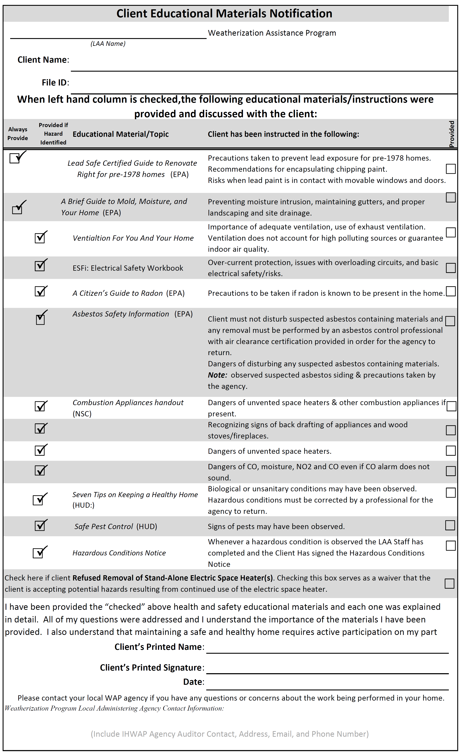

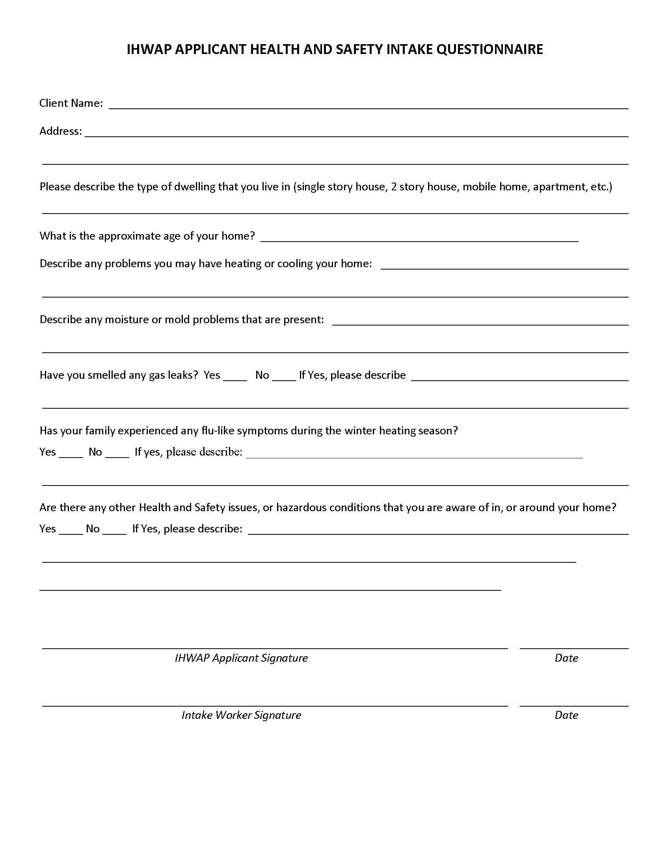

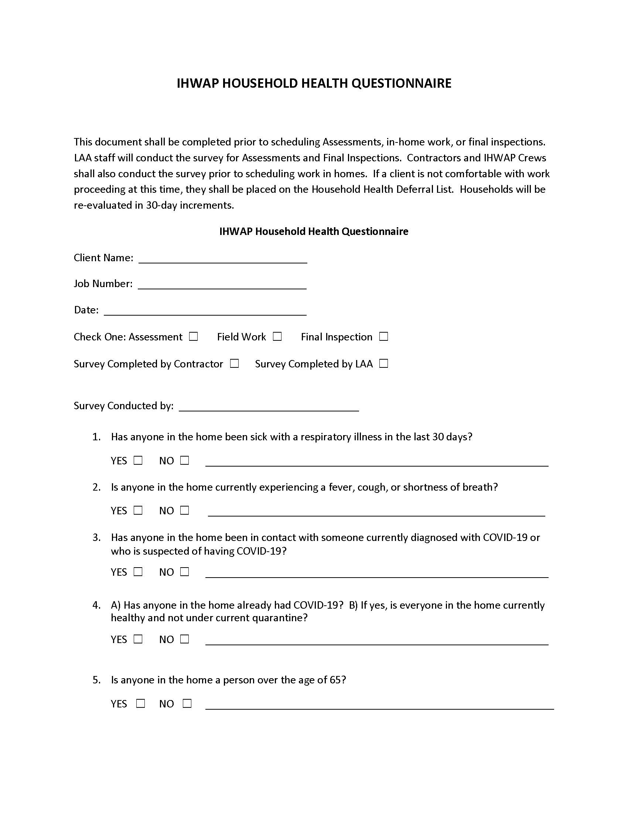
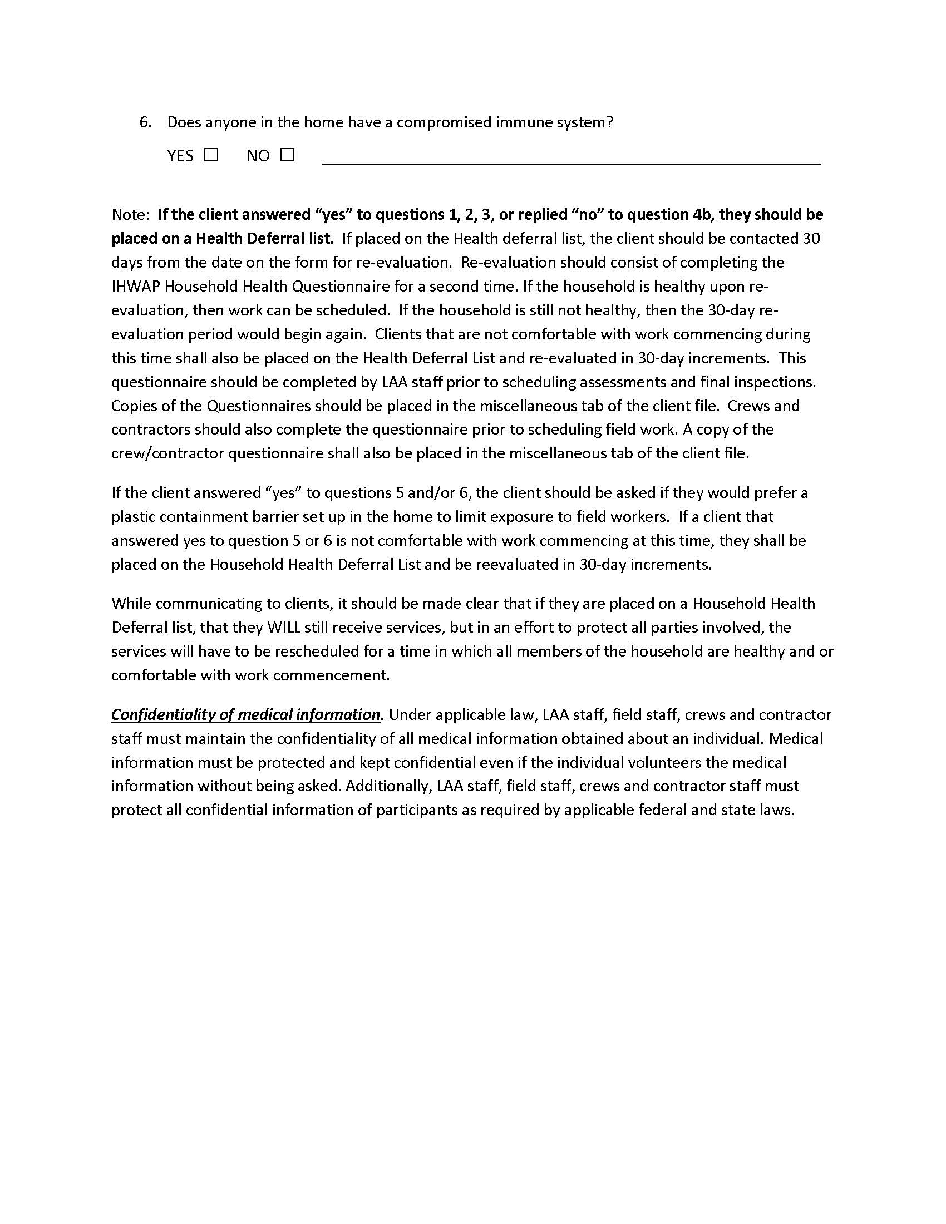
IHWAP Enhanced Health and Safety Protocols Personal Protective Equipment Training
It is an OSHA requirement to train employees on the proper use of personal protective equipment. In an effort to comply with OSHA regulations.
The video links below are available for viewing for all IHWAP Field Staff, Crew Members, and Contractor staff that will be working in homes.
Handwashing training video:
https://www.youtube.com/channel/UCWaZkT4GpdC15bc5VPfaddA
Donning and Doffing Tyvek suit training video:
https://www.youtube.com/watch?v=zLbvQcpfZyQ
Donning and Doffing a mask:
https://www.youtube.com/watch?v=OABvzu9e-hw
Donning and Doffing disposable gloves:
https://www.youtube.com/watch?v=xueBYfElFEg
The Do’s and Don’ts of Wearing Masks and Gloves:
https://m.youtube.com/watch?v=eVJbenwzR1s

Cleaning frequently touched surfaces:
https://www.youtube.com/watch?v=bmR2nglFncQ

SECTION IV – INTAKE
Every agency must establish an intake system that will collect the application data needed to determine an applicant household is eligible for weatherization assistance. The importance of the intake process cannot be overemphasized. The IHWAP/LIHEAP Program Application is the official application form.
If any agency other than the grant recipient provides intake services or an intake site, the agency must ensure they will perform intake responsibilities according to the instructions in this manual. If these services are free of charge, a non-financial agreement must be signed by the LAA and its intake provider. If the LAA pays for these services, a subcontract must be established and noted in the LAA's annual grant applications; or, if added later, reported to the OCA in writing.
Intake responsibilities cover the following areas:
- General Intake
- The IHWAP/LIHEAP Application form
- Required documentation

IHWAP Priority
A priority ranking system will be used for all homes in the IHWAP, including homes that are being re-weatherized under the 15-year rolling Program Year date. IHWAP applications are taken throughout the year but income eligible households containing elderly members (60 and over), persons with a disability, or young children (5 years of age or below) will be given priority for weatherization services.
- IHWAP no longer uses income or high energy burden/usage when determining priority. Upon completion of the new weatherization database, IHWAP will once again consider high energy burden/usage in priority calculations. Guidance on prioritization will accompany the rollout of the new database.

IHWAP no longer allows the grouping of priority lists by application periods but rather inserting high priority applicants in the priority rankings as they are approved. This will ensure that the highest priority applicants are provided weatherization services first.
- First come, first served on application date if tie,
- Prioritization is by county.

Prioritization by county should be based on the percentage allocation by county utilized in determining LAA budgets. The number of jobs completed in a year in each county should be similar to the index of need for each county. For example, if a two-county agency had an allocation (based on index of need) of $300,000 for County 1 and $200,000 for County 2, then approximately 60% of the jobs each year should be in County 1 and 40% in County 2.
Lower priority-ranked, income-eligible households will be served later in the program year, or when funding is available. It is important that the Intake staff convey this information to the client during the intake process.

Prioritizing the Waiting List
Another option for prioritization, and the approach OCA will require when the new WeatherWorks system is complete, is for LAAs to prioritize their waiting list, then take applications based on the prioritized waiting list. This approach would eliminate having approved applications that are 1 or more years old and having to re-determine eligibility.
For example, if an LAA plans to weatherize 100 homes in the next program year, has 25 approved applications ready for assessment and 125 people on a waiting list (which will continue to grow), the LAA can continually prioritize their waiting list and select the top 75 of the prioritized waiting list at the time they are ready to take additional applications (if some of these applicants are not eligible LAA may have to go back to list and select another batch from the waiting list). The prioritize waiting list would be based on the same priority basis as applications and would be updated after new potential applicants are added to the list. After completing the application process for these 75 waiting list people, the applications should be re-prioritized before conducting assessments.
To implement this approach, LAAs would need to develop a waiting list spreadsheet to track and prioritize potential applicants. This spreadsheet would need to include name, address, city, date, and time put on waiting list, basic demographic data (households containing elderly members, persons with a disability, or young children), and a preliminary priority score. A template for the Waiting List Tracker is available at https://ceo.partner.illinois.gov/OEA/OEA_LAA/default.aspx.
Every household is ranked and assigned a priority by the WeatherWorks system. All eligible households in 2- 4 unit buildings should be ranked with the average score used to determine the building’s priority in the following manner:
ELDERLY DISABLED CHILDREN
YES = 2 YES = 2 YES = 1 There is a new maximum of 5 points
NO = 0 NO = 0 NO = 0 that determine the priority ranking.
IHWAP Priority Definitions
Elderly. Any member of the household 60 years of age or older; 2 points no matter how many elderly occupants.
Disability. Household containing a person with a disability per the Americans with Disabilities Act; 2 points no matter how many persons with disabilities.
Children. Any member of the household 5 years of age or below; 1 point no matter how many children.
All higher priority households should be weatherized before going to lesser priority households. Scheduling variances (due to location, etc.) within a program year are permissible provided the priority rankings are followed during the program year.

Vacant units that will be occupied within the next 180 days with an eligible client are not subject to prioritization. For example, if a client lived in one side of a duplex and the other half was vacant, then the priority ranking for the eligible client would determine the ranking for both units.
A clarification on LIHEAP Furnace Assistance clients: LIHEAP Furnace clients are to be placed at the bottom of your IHWAP waiting list. They should not be inserted to the top of the IHWAP waiting list.
EXAMPLE: Funding Available for Seven Houses
Household | Application Date | Elderly | Disability | Children | TOTAL | RANK
A | July- 1 | 0 | 0 | 0 | 0 | 7
B | July- 8 | 2 | 2 | 1 | 5 | 1
C | July-14 | 0 | 0 | 1 | 1 | 5
D | July-17 | 0 | 2 | 1 | 3 | 3
E | August- 1 | 0 | 0 | 1 | 1 | 6
F | August-10 | 2 | 2 | 0 | 4 | 2
G | August-14 | 0 | 2 | 0 | 2 | 4

Pre-Application Through the Helping Illinois Families website
The State launched the Helping Illinois Families initiative in 2020 to help Illinois families access all OCA programs. This initiative included the implementation of an online pre-application form to make it easier for individuals/families to remotely access all OCA programs. All LAAs should access the smartsheet weekly and add pre-applicants for weatherization services to their waiting list and notify the pre-applicants of their status. Please contact your assigned weatherization specialist if you need access to the smartsheet.

General Instructions for Intake of Applications
If the agency is accepting applications, all households must be given the opportunity to apply, whether or not the applicant has all the necessary information with him/her at the time of application. Applicants have 15 calendar days from date of application to supply the necessary documentation. At Intake, a Documentation Request Form is to be given to every client whose documentation is not complete.

All documentation must be date stamped. This is especially important for documentation submitted after the date of application. It is the date documentation is completed that determines the start of the 30-calendar day notification timeline.
If the applicant does not provide the required documentation within 15 calendar days, the application must be denied. Agencies are reminded that information received on applicants is confidential and is obtained only for use by the Weatherization Assistance Program. DO NOT give out information about the applicant or his/her application over the telephone except the status of the application (for example, "the application has been approved"). All information requested during intake applies to the status of the applicant's household on the day of application.
Weatherization applicants that have received LIHEAP benefits within the previous 12 months will not need to complete a new IHWAP application. If the applicant's income has not changed since the LIHEAP application was approved, a copy of the approved LIHEAP application may be used as the client's new IHWAP income and verification.

IHWAP/LIHEAP Application Instructions
OCA utilizes a dual LIHEAP/IHWAP application. PRINT all responses clearly and legibly. Use a ball-point pen, rather than a pencil or felt-tipped pen. DO NOT USE CORRECTION FLUID TO MAKE CORRECTIONS. To correct, draw a horizontal line through the mistake and write corrections to the side of the box.

Agency - Enter the Agency Name.
Intake Site - Enter the location of the intake site. If you wish, you may also use an intake site # or code. The agency may use its own number or letter code.
County – Enter the County that the Household resides in.
Application Date. Enter the date the application is taken. This will be an eight-digit number. The first two digits represent the month (e.g., January will be 01, February will be 02, etc.). The second two digits will represent the day of the month (01/31). The final four digits represent the current calendar year. Example: February 18, 2012, will be recorded as 02/18/2012.
Service Requested – Enter LIHEAP or IHWAP. If the applicant wants to apply for both programs, enter LIHEAP/IHWAP.
Application Number - When this application has been entered into the LIHEAP.net system, the Application ID # should be entered here.
Job Number - When this application has been entered into the WeatherWorks system, and approved, the Job Number should be entered here.
Household Member Grid – This area should contain all of the information for all household members. If there are more than 4 members in the household, you must use an additional application or supplemental sheet to record the additional household information.
HOH – Place a check mark on the line that represents the Head of Household (HOH).
Social Security Number. Enter the household member’s Social Security Number.
Hard copy proof of SSN may include a copy of the Social Security card, a copy of a valid driver’s license that shows the Social Security Number, or any other form of government-issued identification that shows both name and number. The Department of Commerce and Economic Opportunity (DCEO) is committed to protecting the privacy of its vendors, grantees and beneficiaries of programs and services. At times, DCEO will request social security numbers (SSNs) or other personal identifying information. Federal and state laws, rules and regulations require the collection of this information for certain purposes relating to employment and/or payments for goods and services, including, but not limited to, grants. DCEO also collects confidential information for oversight and monitoring purposes.
Furnishing personal identity information, such as a social security number, is voluntary; however, failure to provide required personal identity information may prevent an individual or organization from using the services/benefits provided by DCEO as a result of state or federal laws, rules, and regulations.
Last Name/First Name/Middle Initial - Enter the legal name of the household member
Date of Birth - Enter the birth date of the household member. This must be entered in the following format: MM/DD/YYYY.
Ethnicity – Enter the ethnic group
Sex. To indicate the sex of the head of household, check M if a male; F if a female.
Disabled. If the applicant fits the description of a person with a disability, mark YES, if not, mark NO.
Ethnic Group. Indicate the ethnic group of the household member.
1 Asian, Asian-American, Indochinese, Vietnamese
2 African-American
3 Hispanic
4 Native American
5 White
6 Other than the above ethnic groups
Emancipated – Place a check mark on this line if the household member is emancipated.
Disabled - Place a check mark on this line if the household member is disabled.
Household Income - This section pertains to all gross income received by the household members at the time of application. LIHEAP.Net will use a 30-day income eligibility period. Weatherization uses a 12-month eligibility period, or an approved LIHEAP application. The gross income amount should be listed in whole dollar amounts only—always drop the cents figure. For Weatherization purposes, if the household can be documented as receiving LIHEAP benefits within the past twelve months, enter the income amount by taking the 30-day LIHEAP income and multiplying by 12. Attach a copy of the approval notification letter or a copy of the LIHEAP.net screen. It is important to note that any new Weatherization application will require the income to be determined by DOE’s definitions in Section II. For IHWAP, Documentation must be based on at least one month’s income prior to the date of the application. For example, the previous year’s tax return may not be acceptable, unless it was filed near the time that the IHWAP application was completed. If an applicant does not have proof of income for the full 1 month, the best and quickest way to handle this is to have the applicant go to the source of the income(s) and have the source complete an Income Statement. If the applicant does not have proof of income, or is claiming no (zero) income, then the Income Affidavit must be completed. This form is required to be notarized.
Wages/Salaries/Self-Employment. Enter the previous 30-day (IHWAP-12 month) gross total of all money, wages, and salaries (before any deductions—excluding food or rent in lieu of wages. Wages earned by childcare and other odd jobs should also be entered on this line.
Applicants who are self-employed must complete the Self-Employed Income Worksheet (this worksheet is available at https://ceo.partner.illinois.gov/OEA/OEA_LAA/OCA%20Forms%20Library1/Forms/AllItems.aspx).
Wages/cash draws paid to the applicant and/or household members are considered income. The sum on the Self-Employed Income Worksheet will be entered on the application. In addition, if Line C of the form shows a profit and Line D is marked Yes, add the profit amount to the income for that household member on the application. If Line C shows a loss, no action is required.
Social Security Administration (SSA). When using the award letter as documentation, subtract the monthly Medicare amount from the gross monthly amount to get the 30-day income. When using a copy of the check, a bank statement or a statement from the business that cashed the check, use the actual amount to calculate the 30-day amount, or multiply by 12 for IHWAP. Do not add Medicare amounts to this figure.
Be careful not to confuse SSA benefits with those of Supplemental Security Income (SSI). Some monthly amounts may change.
Unemployment. Enter the previous 30-day/12-month total of payments for unemployment.
Supplemental Security Income (SSI). Enter the total of payments from SSI, excluding Medicare payments.
Temporary Assistance for Needy Families (TANF). Enter the total of payments from TANF.
Aid to Aged, Blind, and Disabled (AABD). Enter the total of payments from AABD.
General Assistance. Enter the total of cash or vouchers for cash from Transitional Assistance.
Other. Enter the total of all other sources of income not listed above.
Total Household Income. Add items and enter total.
Dwelling Type. To indicate the type of a household’s dwelling circle one of the following:
Single Family means a structure containing no more than one household unit.
Two to Four Units if there are 2, 3 or 4 household units in the dwelling or building in which the applicant's household resides (e.g., a two-story house with one apartment on each floor would be two units).
Five to Ten Units if there are 5 to 10 household units in the dwelling or building in which the applicant's household resides. A TREAT generated model is required for buildings with five or more units.
Eleven or More Units if there are 11 or more household units in the dwelling or building in which the applicant's household resides. A TREAT generated model is required for buildings with five or more units.
Mobile Home if the applicant resides in a mobile home.
Group Home if 3 or more people not related by blood or marriage where cooking and eating facilities are shared or nonexistent, and which has previously been established and identified as a group home.
Single Room Occupancy (SRO) means a converted hotel or building whose occupants rent a room and do not share eating facilities and are living as independents (i.e., not part of a common group), and which has previously been identified as an SRO. A TREAT generated model is required for buildings with five or more units.
Shelter means units that house individuals principally on a temporary basis who may or may not be related to one another and who are not living in nursing homes, prisons, or similar institutional care facilities. A TREAT generated model is required for buildings with five or more units.
Ownership – Circle the appropriate choice:
Owns – Yes or No
Rent - If the household pays rent.
Subsidized Housing if the household lives in subsidized housing.
Rent $ - If the household rents, enter the amount of the monthly rent payment. If the household owns, draw a line through the space. Negative rent (Housing Authority) should be entered as 0.
Food Stamps – If anyone in the household receives Food Stamp/LINK/SNAP assistance, then circle Yes.
Service/Site Address - Enter the household’s Service/Site address, including City and Zip Code. Try to be as detailed as possible, making note of any numbers/letters of the Apartment, Box, Building, Floor, Trailer Lot and/or other identifier. This address will be verified when the application is entered into the system.
Phone # 1 - Enter the head of household’s telephone number or a number where he/she can be reached. Then circle the appropriate type of Phone #1 (Home, cell, work, etc.).
Phone # 2 - If the telephone number is other than that of the head of household, or an additional number has been provided, enter it here. Circle the appropriate type of Phone #1 (Home, cell, work, etc.).
Mailing Address - Enter the head of household’s mailing address if different than Service/Site Address listed above. If the Mailing Address is the same as the Service/Site Address, mark the Same as Service Address Box (on LIHEAP.Net). Referral – Check any of the listed programs that the household has been referred to.
VENDOR INFORMATION:
Client Pays - Separate boxes are available to capture the Client Pays data on the application for Primary and/or Secondary vendors. Mark either or both boxes if the applicant pays the bill(s) directly to the vendor(s). Do not mark the box if the applicant pays the bill but the account is in another’s name (e.g., the landlord’s).
Medical Certification - Mark this box if the applicant household qualifies as a Medical Household.
Customer of Record (COR) - Print the name of the primary and secondary Customer of Record.
Fuel – Primary - Enter the fuel type of the primary vendor on the line. Fuel types are:
Natural Gas
Propane
Fuel Oil
Electric
Wood
Coal
Other
Fuel – Secondary - Enter the fuel type of the applicant’s Secondary vendor. To be heat-related, the electricity must be an essential part of the Primary heating system such as an electric thermostat, or a heating system fan or pump.
Special Instructions on Applicants Who Cut Their Own Wood as a Primary Fuel - Applicants who cut their own wood are not eligible for LIHEAP assistance. If, however, a reputable vendor is available and signs a vendor agreement, a DVP must be made to the wood vendor on the household’s behalf.
Vendor - Print the name of the Primary and Secondary vendor. The Primary vendor is the heat source for the unit. The Secondary vendor is the electric source. The name is copied from a current bill the applicant presents.
Listed below are some accepted abbreviations for certain vendors:
Ameren CILCO AmCILCO AmIP
Ameren CIPS AmCIPS Ameren IP
Commonwealth Edison ComEd North Shore Gas
NICOR Gas North Shore Northern Illinois Gas
Peoples Gas
Note: The secondary heat-related vendor will be an electric vendor.
Account Number - Enter the applicant household’s Primary and Secondary vendor account numbers. If the vendor does not use an account number, enter the applicant’s last name plus last 4 digits of social security number.
Status – Enter the status of the account. Is it disconnected from the vendor?

Eligibility
Eligible – Yes or No
Eligible Due to: Income – If the household is eligible due to income, check this line.
Eligible Due to: 66% Rule – Weatherization only – If 66% of the IHWAP households residing in this Site are eligible and the building is a 3 or 5, greater than 5 units building, check this line.
Eligible Due to: 50% Rule – Weatherization only – If 50% of the IHWAP households residing in this Site are eligible and the site is a Two- or Four-Unit building, check this line.
Eligible Due to: Auto - Weatherization only – If any household member receives SSI Title IV and XVI.
Eligible Due to: LIHEAP – Weatherization only – If the household is eligible for LIHEAP, check this line.
Prior Weatherization Assistance – If the household was previously weatherized, then enter the date here.
LIHEAP ES Furnace Date – If the household received prior ES Furnace assistance, then enter the date here.
Re-Determination IHWAP – If more than 12 months have passed since the last IHWAP application was approved, then enter the re-determination here.
Documentation - Enter the status of the needed documentation and the date here.
The Following Four Areas are for Verification/Determination Staff Only.
Household Income – For verification purposes, carefully review the information for correctness and documentation, then enter your initials and date here.
Household SSNs – For verification purposes, carefully review the information for correctness and documentation, then enter your initials and date here.
Primary Energy Bill - For verification purposes, carefully review the information for correctness and documentation, then enter your initials and date here.
Home Ownership - For verification purposes, carefully review the information for correctness and documentation, then enter your initials and date here.
Applicant Signature - If the applicant cannot read the Important Notice and the Applicant Statement on the application, the Intake Worker is responsible for reading and explaining the material. The application must then be signed and dated by the applicant.
If another person provides the information, that person (must be 18 years or older) shall sign the applicant’s name, then their own name and indicate their relationship to the applicant (e.g., John Jones by Mary Smith, daughter).
If the person giving the information is other than an immediate household member, the applicant must give written permission for the application to be signed by the person. The applicant/signer must then enter the date.
If applicants are unable to sign their name to the application and have no representative to sign for them, applicants may sign with an “X” if they so desire. The intake worker must then initial the applicant’s “X”. Signature of the Intake Worker - The intake worker must sign his/her name on this line and enter date of signature. DO NOT sign an agency or organization name or use the intake worker’s initials.
Eligibility Verification/Determination Signature - The Verification/Determination worker must sign his/her name on this line and enter date of signature. DO NOT sign an agency or organization name or use the worker’s initials.
Payment Authorization Signature - The Payment Authorization worker must sign his/her name on this line and enter date of signature. DO NOT sign an agency or organization name or use the worker’s initials.
Your Rights Handout – If the Your Rights information was not able to be printed on the back page of the application. The client must be provided with the separate one-page handout at the time of the application.
The intake worker gives the last page or copy of the application to the applicant and places the first page (original) in the client file.
If any documentation is not provided (as required in the documentation section), the intake worker must give the applicant a Documentation Request Form, indicating in writing the documentation that the applicant must provide and the time in which it must be provided (no less than fifteen (15) calendar days). A copy of the "Documentation Request Form" provided to the applicant must be placed in the applicant's file.

Required Documentation
Both income documentation and home ownership documentation are required to determine a client's eligibility for home weatherization.

Income Documentation
At the time of application, gross income documentation must be provided for each person in the household who has received income during the last 12 months. If a household is on a fixed income (income that does not change), it is acceptable to verify one payment as income and multiply the amount times twelve to obtain an annual amount. Examples of fixed income include:
- SSA and SSI
- VA Benefits
- IDHS payments (TANF, AABD, RRA)
- Pensions
- Acceptable types of documentation are:
- Check(s) or copy of check(s) for the above-described examples of fixed income
- Check stubs that indicate payee, source, time period, and amount
- An affidavit of a person who cashes the checks (such as currency exchanges, banks, and grocery stores)
- A medical eligibility card for TANF or RRA recipients (a copy of both sides of the card must be made)
- Statement or affidavit from the source of the income, such as an employer, Social Security Administration, IDHS (state office), Veteran's Administration, Department of Labor, Township, etc. (Income Statement).
- W-2 statements less than 30 days old.

Documentation must be based on at least one month’s income prior to the date of the application. For example, the previous year’s tax return may not be acceptable, unless it was filed near the time that the IHWAP application was completed. If an applicant does not have proof of income for the full month, the best and quickest way to handle this is to have the applicant go to the source of the income(s) and have the source complete an Income Statement.
Forms should be provided for each source of income and may be returned directly to the agency by the income source. In such cases, agencies may consider providing self-addressed, stamped envelopes for this purpose.
If an intake worker examines the documentation, such as a check, and determines that it cannot be kept on file, either a copy should be made of the documentation, or an affidavit filled out by the intake worker if it is not possible to make a copy.
Undocumented (Zero) Income. The intake worker must document how the individual manages without income (i.e., living on savings, gifts, etc.). This is done by having the applicant fill out an Income Affidavit stating the amount and the source (to include name, address, etc.
Dept. of Human Services. Cash payments from TANF, AABD supplemental payments, Transitional Assistance, and Refugee/Repatriate Assistance (RRA) are considered income. Food Stamps, medical assistance (see below), and cash payments made to providers on behalf of clients are not income.
Recipients of DHS Assistance receive a medical eligibility card. This card can be used to determine the type of assistance and number of recipients.
IF THIS CARD IS CODED WITH ASSISTANCE 04 OR 06, THE RECIPIENT IS RECEIVING TANF. MAKE A COPY OF THE CARD (BOTH SIDES). THIS IS SUFFICIENT DOCUMENTATION FOR TANF INCOME.
The IDHS case ID number is divided in the following manner:
Category PA Local Office Basic Number
00 000 000000
The type of assistance received is indicated on the medical eligibility card by the codes:
Cash Assistance Medical Assistance Only
00 RRA 90
01 AABD 91
02 AABD 92
03 AABD 93
04 TANF 94
06 TANF 96
07 GA - Chicago Only 97

LIHEAP. Eligibility for LIHEAP means automatic eligibility for IHWAP; however, the applicant must have been notified of LIHEAP benefits within the last twelve months. Otherwise, a new IHWAP application must be taken. Acceptable documentation is a copy of any of the following:
- LIHEAP application with an authorization signature dated within the last twelve months
- Copy of the notification letter dated within the last twelve months
- Written statement or affidavit from the LIHEAP agency
- Copy of the LIHEAP.net screens

Rental Income. Rental income is counted if: 1) the applicant rents property outside his/her own household or, 2) if the applicant shares his/her home (i.e., one household unit with a boarder(s) and/or renter(s) who is NOT related). For item #2, do not count the renter(s) as household member(s) or include his/her income in the household's income. In the situation of an income eligible, owner-occupied landlord, the applicant may deduct from their income those expenses associated with operating the property (i.e., heating costs paid by landlord, maintenance, etc.).
If the Applicant Requests Assistance in Obtaining Documentation
While the major responsibility for obtaining documentation rests with the applicant, the agency may assist on some occasions (for example, when an employer will not provide the information requested, or when a social security office delays the verification process). While it is best to have written documentation, the agency may verify the information by telephone in cases where the written information is difficult to obtain. If this is done, the file must contain a statement which includes:
- Person contacted and their relation to applicant (e.g., employer)
- Date of call
- Address and telephone number of persons contacted
- Information obtained in the telephone contact
- Signature of person(s) at the agency who made contact

Ownership Documentation
If an applicant owns his/her home, documentation must be provided by the applicant to verify home ownership. If the applicant rents, the landlord must supply proof of building ownership. This documentation may include a copy of the deed, property tax bill, mortgage payment book, or an authorization statement from the executor of a blind trust, etc.

In addition to the above described documentation, the following document must be completed by the applicant who owns, and placed in the file:
Building Owner Certification Work Authorization.
If the applicant rents, the landlord must complete both forms before the unit is determined eligible:
- Building Owner Certification Work Authorization
- Rental Agreement
These forms must be placed in the applicant's file as documentation, and a copy given or mailed to the applicant and/or landlord.
- Note: After the applicant and intake worker have signed the IHWAP application form, the application is ready for data entry. All weatherization applications, regardless of status, are to be entered on the WeatherWorks system. (Section XII, Program Reporting).

Rental Properties
LAAs must accept applications for weatherization from clients that live in rental property. Refusing to consider rental properties for weatherization is not an option. All LAAs should create prevailing wage catalogs for each contractor.

LAAs with crews or contractors completing work on rental properties must pay the State Prevailing Wage (reference the Illinois State Prevailing Wage Act) for each job description (i.e.: carpenter, plumber, electrician, pipefitter, frost insulator, laborer, etc.). An Illinois Department of Labor, Certified Payroll Form must be completed and present in the client file for all workers associated with labor activities conducted on an IHWAP Rental Property. The Illinois Department of Labor has created an online portal for completing certified payroll forms. The portal is available at: https://webapps.illinois.gov/DOL/PayrollCertification/(if do not have a Illinois Public ID account must first create one at https://www2.illinois.gov/sites/accounts/Pages/default.aspx.
Print out the prevailing wage form from the portal to include in the client file. Other important links on prevailing wage include:
Prevailing Wage Act Information - https://www2.illinois.gov/idol/Laws-Rules/CONMED/Pages/prevailing-wage-act.aspx
Current Prevailing Wage Rates - https://www2.illinois.gov/idol/Laws-Rules/CONMED/Pages/Rates.aspx
Local agencies are required to monitor contractor compliance. OCA will sample rental property client files to ensure prevailing wage compliance.
There is still the caveat that prevailing wage is not required for a rental property where an income eligible landlord lives on-site. For more information, please contact the Illinois Department of Labor.

Determining Prevailing Wage
As part of procurement, Agencies must determine the prevailing wage that will be used for labor prices on rental properties. Agencies should use the following approach to appropriately calculate prevailing wage (this should be completed at beginning of each program year):

- Obtain prevailing wages from the Illinois Department of Labor (https://www2.illinois.gov/idol/Laws-Rules/CONMED/Pages/current-prevailing-rates.aspx) for each trade title and each county in your service area.
  - HVAC worker – use boilermaker or sheet metal worker (whichever is higher)
  - Architectural worker - carpenter or Heat/Frost insulator (whichever is higher)
  - Plumber
  - Electrician
The prevailing wage for a trade title is the base rate, H/W, Pension, Vacation, Training, and Other Insurance.
- After obtaining the prevailing wage for each county, take the highest county prevailing rate per trade category and use that rate for your region.
- Subtract the regular labor rate (without markup) from the regional prevailing wage rate and multiply with the time on task.
- Add the amount from step 3 to the total regular labor cost with mark up.

Using a multiplier on the labor cost with markup is not an appropriate method for determining prevailing wage because it also multiplies the overhead and profit.

LAA Staff Applications for Assistance
Any applications for Weatherization Assistance that are made by Local Administering Agency (LAA) employees (full or part-time), or immediate family members of LAA employees, must first be reviewed, approved, or denied and signed off on by the LAA Executive Director.
- An email detailing this action must be submitted via mail, or email, to the LAA’s Weatherization Specialist.

FORMS AND EXHIBITS for SECTION IV - INTAKE

Agency-Contractor Agreement Page 82
Homeowner-Agency Contract Page 85
Owner-Occupied-Agency-Contractor Contract Page 88
Sample IHWAP Rental Agreement ………………………..………………...Page 91

AGENCY - CONTRACTOR AGREEMENT
THIS AGREEMENT, made the [DATE], by and between [AGENCY], herein referred to as the AGENCY, acting herein through its Executive Director, and ___________________, (a company) of _______________, County of ___________, and State of Illinois, herein referred to as the CONTRACTOR.
The term of this contract shall be for a period of [PERIOD OF CONTRACT] beginning [DATE] and ending [DATE]. The AGENCY will give thirty days advance notice in writing of the intention to terminate the AGREEMENT. The AGENCY, under the provisions of this Agreement, may terminate this AGREEMENT in accordance with the general conditions of this contract if any provision of this contract is violated.
WITNESSETH: That for and in consideration of the payments and agreements hereinafter
mentioned, to be made and performed by __________________, the CONTRACTOR hereby agrees with the AGENCY to commence and complete the basic and/or furnace weatherization work described as follows. The job names and numbers assigned to the CONTRACTOR will have weatherization material items installed (as designated by the Work Order of each individual dwelling) according to the terms and conditions stated in the attached Scope(s) of Service, General Labor Specifications, Notice to Proceed, Contractors Individual Work Packet Agreement. The CONTRACTOR hereby agrees to perform all work at his/her own proper cost and expense and to furnish all machinery, equipment, tools, supervision, labor insurance, and other accessories and services necessary to complete said jobs.
This AGREEMENT shall include the following documents marked as Exhibits and made a part hereof and the CONTRACTOR agrees to comply with such Exhibits, in addition to any and all other related IHWAP documents, as determined by the Agency, in accordance with IHWAP rules, regulations and policies:
Exhibit A, Owner-Occupied Weatherization Contract, dated __________
Exhibit B, Supplemental Conditions, dated __________
The CONTRACTOR shall, in a satisfactory and proper manner as determined by the AGENCY, perform the following: supply materials listed on the bid sheets at the cost accepted for the agreement for the duration of the agreement; provide that the quality and acceptable standards of safety and effectiveness of all materials; and meet appropriate standards for weatherization materials.
The CONTRACTOR agrees to assume financial liability for all materials used according to the terms and conditions outlined in this Contract and to fully complete each group of Weatherization jobs within thirty (30) calendar days from the day the CONTRACTOR signs for the work orders from the AGENCY. The CONTRACTOR hereby agrees to be responsible for storing any materials to be used at the job site. In the event of theft, fire or flood, which may damage said materials; the CONTRACTOR agrees to replace all materials at his/her own expense and to complete the work as specified.
The AGENCY WEATHERIZATION PROGRAM agrees to pay the CONTRACTOR, in a timely manner in current funds, for the performance of the Contract, subject to additions and deductions, as agreed upon by the AGENCY and the CONTRACTOR.
The CONTRACTOR shall maintain such records and accounts, including property, personnel, financial records, as are deemed necessary by the AGENCY to assure proper accounting for all funds. These records will be made available for audit purposes to the AGENCY and will be retained for three (3) years after the expiration of the Contract unless permission to destroy them is granted by the AGENCY.
SIGNATURE PAGE

IN WITNESS WHEREOF, the parties to those present have executed this Contract in two (2) counter parts, each of which shall be deemed an original, in the year and day first mentioned and mutually agreed that the length and duration of this contract will remain in effect from (date) to (date).

__________________________________  Agency name | __________________________________  Contractor name
__________________________________  Street address | __________________________________  Street address
__________________________________  Phone number | __________________________________  Phone number
__________________________________  Agency FEIN | __________________________________  Contractor FEIN or SSN
BY:_______________________________  Signature of agency representative | BY: _______________________________  Signature of contractor representative
__________________________________  Executive director | __________________________________  Title

HOME OWNER-AGENCY CONTRACT

This Owner-Occupied Weatherization Contract, hereinafter referred to as AGREEMENT, made the [DAY] day of [MONTH], [YEAR], by and between [HOMEOWNER], hereinafter referred to as the OWNER, and [AGENCY/NONPROFIT], hereinafter referred to as AGENCY.
WHEREAS, the OWNER is the owner and occupier of a single-family residential structure located at [ADDRESS], hereinafter referred to as the PROPERTY; and
WHEREAS, the OWNER wishes to weatherize the PROPERTY, hereinafter referred to as the PROJECT with funds provided by [AGENCY] through the AGENCY’S [WEATHERIZATION PROGRAM]; and
WHEREAS, the OWNER wishes to engage the AGENCY to undertake the PROJECT and the AGENCY wishes to perform the PROJECT for the OWNER; and
WHEREAS, the OWNER and the AGENCY recognize that the receipt and use of the funds obligates them to comply with all Federal, State and local laws, ordinances, rules, regulations, circulars, and executive orders applicable to the PROJECT.
NOW, THEREFORE, the parties do mutually agree as follows:
- That for and in consideration of the payments and agreements hereinafter mentioned, to be made and performed by the AGENCY, the AGENCY hereby agrees with the OWNER to commence and complete the PROJECT described as follows: the AGENCY will install weatherization material (as designated by the Work Order for the OWNER’s dwelling).
- The AGENCY hereby agrees to perform all work at his/her own proper cost and expense and to furnish all machinery, equipment, tools, supervision, labor insurance, and other accessories and services necessary to complete the PROJECT.
- The AGENCY shall, in a satisfactory and proper manner as determined by the OWNER and the AGENCY, supply materials listed on the bid sheets at the cost agreed to by the AGENCY for the duration of the AGREEMENT and provide that all weatherization materials meet appropriate standards of safety and effectiveness.
- The AGENCY agrees to assume financial liability for all materials used according to the terms and conditions outlined in this AGREEMENT and to fully complete the PROJECT within thirty (30) calendar days from the date hereof.
- The AGENCY hereby agrees to be responsible for storing any materials to be used at the job site. In the event of theft, fire or flood, which may damage said materials; the AGENCY agrees to replace all materials at his/her own expense and to complete the work as specified.

- The AGENCY agrees to accept payment for services rendered to the OWNER for performance of the AGREEMENT, subject to additions and deductions as agreed upon by the OWNER and the AGENCY.
- The AGENCY agrees that they will indemnify and hold the OWNER harmless from any and all claims from all parties including the AGENCY themselves, their employees, and their subcontractors.
- This AGREEMENT may be executed in any number of counterparts, all of which shall be taken to be one and the same instrument, for the same effect as if all parties hereto had signed the same signature page.

SIGNATURE PAGE

IN WITNESS WHEREOF, the parties hereto have caused this Contract to be executed and attested by their authorized representatives.

OWNER: ____________________________
Representative: __________________________
DATE: ____________________________

AGENCY: ____________________________
Representative: ___________________________
DATE: ____________________________

OWNER-OCCUPIED WEATHERIZATION CONTRACT

This Owner-Occupied Weatherization Contract, hereinafter referred to as AGREEMENT, made the [DAY] day of [MONTH], [YEAR], by and between [HOME OWNER], hereinafter referred to as the OWNER, [CONTRACTOR], (a company) of _______________, County of ___________, and State of Illinois, herein referred to as the CONTRACTOR, and [AGENCY/NONPROFIT], hereinafter referred to as AGENCY.
WHEREAS, the OWNER is the owner and occupier of a single-family residential structure located at [ADDRESS], hereinafter referred to as the PROPERTY; and
WHEREAS, the OWNER wishes to weatherize the PROPERTY, hereinafter referred to as the PROJECT with funds provided by [AGENCY] through the AGENCY’S [WEATHERIZATION PROGRAM]; and
WHEREAS, the OWNER wishes to engage the CONTRACTOR to undertake the PROJECT and the CONTRACTOR wishes to perform the PROJECT for the OWNER; and
WHEREAS, the AGENCY will act as OWNER’s agent to direct the PROJECT and provide the CONTRACTOR with the agreed upon funds under this AGREEMENT; and
WHEREAS, the OWNER and the CONTRACTOR recognize that the receipt and use of the funds obligates them to comply with all Federal, State and local laws, ordinances, rules, regulations, circulars, and executive orders applicable to the PROJECT.
NOW, THEREFORE, the parties do mutually agree as follows:
That for and in consideration of the payments and agreements hereinafter mentioned, to be made and performed by the AGENCY, the CONTRACTOR hereby agrees with the OWNER to commence and complete the PROJECT described as follows: the CONTRACTOR will install weatherization material (as designated by the Work Order for the OWNER’s dwelling) according to the terms and conditions set forth in the Agency-Contractor Agreement and attachments.

The CONTRACTOR hereby agrees to perform all work at his/her own proper cost and expense and to furnish all machinery, equipment, tools, supervision, labor insurance, and other accessories and services necessary to complete the PROJECT.

The CONTRACTOR shall, in a satisfactory and proper manner as determined by the OWNER and the AGENCY, supply materials listed on the bid sheets at the cost agreed to by the CONTRACTOR and the AGENCY for the duration of the AGREEMENT and provide that all weatherization materials meet appropriate standards of safety and effectiveness.

The CONTRACTOR agrees to assume financial liability for all materials used according to the terms and conditions outlined in this AGREEMENT and to fully complete the PROJECT within thirty (30) calendar days from the date hereof.

The CONTRACTOR hereby agrees to be responsible for storing any materials to be used at the job site. In the event of theft, fire or flood, which may damage said materials; the CONTRACTOR agrees to replace all materials at his/her own expense and to complete the work as specified.

The AGENCY agrees to pay the CONTRACTOR on behalf of the OWNER, in a timely manner in current funds, for the performance of the AGREEMENT, subject to additions and deductions, as agreed upon by the OWNER, AGENCY and the CONTRACTOR.

The CONTRACTOR agrees that he or she will indemnify and hold the OWNER harmless from any and all claims from all parties including the CONTRACTOR himself, his employees, and his/her subcontractors.

This AGREEMENT may be executed in any number of counterparts, all of which shall be taken to be one and the same instrument, for the same effect as if all parties hereto had signed the same signature page.

SIGNATURE PAGE

IN WITNESS WHEREOF, the parties hereto have caused this Contract to be executed and attested by their authorized representatives.

OWNER: ______________________
Representative: ______________________
Date: ______________________

AGENCY: ______________________
Representative: ______________________
Date: ______________________

CONTRACTOR: ______________________
Representative: ______________________
Date: ______________________
FEIN/SS# ______________________

Illinois Home Weatherization Assistance Program
Rental Agreement
I,________________________________, certify that I am the owner/authorized-agent for the property located at __________________________________________________________________________________.
(Owner/landlord initials here) ______ I understand that the energy efficiency and health and safety work performed on my property is being offered to benefit the tenants of my building and is offered free of charge.
(Owner/landlord initials here) ______ I certify that I have given my permission to (local agency name here), the weatherization agency or its designated agent, to allow work on the dwelling and/or mechanical systems at the property listed above.
Owner shall mean either the party holding the legal title to the building located at the above address that contains a total of ______ dwelling units or the person authorized, in writing, to enter into a contract for the party holding the legal title to the said building.
This agreement entered into by and between the Owner/Authorized Agent, Tenant and the Weatherization Agency shall be subject to the following conditions:
- (local agency name here) agrees to provide weatherization services to the residence of the Owner/Authorized Agent that is occupied by the current tenant(s) with the owner paying 0% of any weatherization work as noted above.
- The owner and his or her heirs or assigned agrees not to raise the rent (based on the weatherization improvements) on the described property for a period of 12 months from the date of the completion of the weatherization final inspection. At present, the rent is $_______ per ________. (HUD/Section 8 annual rental restructuring increases are exempt and may still be applied as a rental increase.)
- The owner and his or her heirs or assigned agrees that the tenant will not be evicted without legal cause (non-payment of rent, etc.) for a period of 12 months from the date of the weatherization final inspection.
- The owner hereby affirms that the premises are not presently being offered for sale. If the owner sells the building within 12 months from the date of the weatherization final inspection, the new owner must comply with the terms of this agreement.
- The agency and owner agree that the tenants are the persons to benefit from the weatherization program and may enforce this Agreement. The agency shall provide a copy of this agreement to each tenant. The owner agrees to provide a copy of this Agreement to all future tenants while this Agreement is in effect.
- The owner understands that weatherization work performed will be guaranteed for a period of 12 months.

If this agreement is not adhered to by the Owner, the cost of the weatherization improvements shall be reimbursed by the owner to said agency providing the weatherization services.
I certify that I agree to the aforementioned provisions of this agreement.
Signed________________________________________________________ __________________
(Owner/Authorized Agent) (Date)

SECTION V - DETERMINATION

Determination of Client Eligibility
Determination is the step in the client application processing that ensures the household is eligible for weatherization services. It is a cross-check of the information and documentation provided at intake. The determination step is for the agency's protection - by having two people review the application reduces the likelihood of ineligible clients and related monitoring findings. Determination may not be performed by the same person who did intake unless a waiver is approved by DCEO/OCA.
Determination responsibilities include the following:
- Reviewing the application form to see that it is complete
- Assuring all documentation is present
- Determining if documentation is valid
- Completing application verification
- Re-determining eligibility (when necessary)

Assuring Documentation is Present
The applicant has a maximum of 15 calendar days from the date of application to supply the necessary documentation, or the agency will deny the application. For this reason, it is recommended that pending files be organized by date.
When documentation has not been received, the agency may attempt to contact the applicant either by telephone or letter (please document that effort). Any contact should indicate that the application will be denied unless the documentation is submitted and may include an offer to assist in obtaining the documentation.
Once the documentation is complete, the LAA has 30 calendar days from the date all documentation was received to determine and notify the client of their eligibility status. Intake instructions require all documentation to be date-stamped on the date of receipt. This date is day one (1) of the thirty (30) day determination and notification period.

Reviewing and Validating the Application Form
This is a confirmation of the intake work. It is the responsibility of the person performing the determination step to assure intake has been done correctly. For this reason, the determination worker must be as familiar with intake instructions as intake workers are.

Verifying Household Income Information
The determination/confirmation process should verify the number of persons, types of income, and who receives which income documented in the file corresponds to the application information.
Using the family size indicated in "Number of Household", determine/confirm that the verified annual income is at or below amount listed on the Income Eligibility Guideline chart.
Recipients of SSI Title IV and XVI, and applicants notified of LIHEAP eligibility within the last twelve months are automatically eligible for IHWAP.

Determination of Building Eligibility
In addition to determining a client's income eligibility, it is also necessary to assure the building is eligible to be weatherized. Prior to authorizing the work, verify that documentation obtained, and procedures followed to support building weatherization. Requirements will vary by building type:
Single Family Owner-Occupied. Dwellings shall be assisted if they are occupied by an income-eligible owner. The owner must supply proof of property ownership.
Single Family Renter-Occupied. For dwellings occupied by income-eligible renters, a rental agreement signed by the landlord is required. The weatherization process cannot move forward until the Rental Agreement is signed.
2-4 Unit Rentals. If one unit of a Two Unit building is, or two units of a Three- or Four-Unit building are, occupied by income-eligible renters, and the building has a common foundation, then the entire building may be weatherized. If this is the case, then the landlord must sign a rental dwelling unit agreement.
NO ARCHITECTURAL WORK IS TO BE DONE ON ANY UNIT WHERE THE HEATING SYSTEM HAS BEEN DETERMINED TO BE UNSAFE.
Condominiums: Condominium units in multifamily buildings cannot be weatherized as single-family homes. To weatherize a condominium multifamily building all 100% of the buildings’ condominium owners must qualify as income eligible households. The 60%, 66% and 50% eligible household threshold applicable to multifamily rental buildings does not apply to condominium multifamily weatherization projects.
- An exception will be made to allow weatherization of unit in a condominium multifamily building as single-family unit when a townhouse or duplex unit has no common spaces or shared HVAC systems with other units, and it can be energy modeled to justify weatherization measures that solely benefit that townhouse or duplex unit.

Re-determination of Eligibility
If actual weatherization work (materials installed) has not begun on the unit within 1 year from the date eligibility determination, household income eligibility must be re-determined. Unless a substantial amount of information on the application has changed, a new application will not need to be completed. In this case, sign and enter the date of the re-determination of income on the original application and attach a new wage calculation tape.
If the client is over-income or otherwise determined ineligible after re-determination, the application is denied. However, if work has begun within the required timeframe on the mechanical system, it is not necessary to re-determine client eligibility. If more than 1 year has elapsed since eligibility determination and weatherization measures are installed without a re-determination of the income, the costs of those measures are disallowed.
If 2 years have elapsed since the application was approved and weatherization has still not begun, a new application must be completed.

SECTION VI: WORK AUTHORIZATION
The Work Authorization process links eligible clients to the weatherization services and includes the following activities:
- Overseeing client notification
- Prioritizing assessment for IHWAP Clients
- Receiving authorization for work on multi-unit buildings, SROs, Shelters, and Group Homes
- Reversing approvals and denials
- Selecting heating contractors
- Tracking of assessment timelines and scheduling re-determination and reassessment when needed.

Client Notification
The agency has 30 calendar days from the date the application documentation is complete to determine eligibility and notify the applicant in writing the status of the application. A copy of the notification letter, as well as the approval or denial letter must be placed in the client file. The denial letter must include appeals information and the appeals brochure. (Sample letters appear at the end of this section - Forms and Exhibits for Section VI -- Work Authorization).
Process for Eligible Applicants:
  - Eligible applicant will receive a letter of notification
  - Eligible application will be prioritized
  - High priority applicant will receive Approval letter
  - Applicant’s home will be assessed
  - Applicant's home will be weatherized
  - Applicant's home will be inspected
Process for Ineligible Applicants:
- Ineligible applicant will receive a letter of denial
- Ineligible applicant will receive information on process for hearing and appeals

Prioritizing Households
Upon approval of a high-priority ranked household application, including homes that qualify for re-weatherization, the file is to be marked in a manner that identifies the household as a priority household. The only exception to this rule applies when weatherizing a multi-family building. In such cases, the need to weatherize the entire building takes precedence. Weatherization work for all high priority households should be immediately scheduled for assessment and installation of weatherization measures.
Agencies should remember that all timeframes remain in operation. This system will result in higher-priority households receiving weatherization services first. It is possible that low-priority ranked households may not be scheduled for assessments during any given period. These households may be included in the next subsequent priority ranking.

Extenuating Circumstances
As described in Section I of this manual, Section 440.18 of the DOE Rules and Regulations describes the allowable weatherization expenditures. Three specific circumstances will reverse the determination to provide or deny weatherization services:
            - The approved household lives on a site scheduled for clearance or demolition within 12 months of the date of weatherization
            - A household is denied as having received prior weatherization, but the unit has been damaged by fire, flood, or other act of God, and the repair of the damage to the weatherization materials is not paid for by insurance. In other words, the denied house due to prior weatherization is approved for reasons outlined above.
            - The unit approved for weatherization becomes vacant before weatherization work is completed. A vacant building is not to be weatherized. If a client is a homeowner, work shall be discontinued, and the unit shall be counted as a complete. If not owner occupied, and the landlord signs an agreement to rent to another low-income eligible client within 180 calendar days, work shall be continued, and the unit shall be counted as a completion

IHWAP Timelines
Work Authorization includes the responsibility of the agency to follow the required timelines as described below:
Eligibility Determination.
The agency has 30 calendar days from the date an applicant's documentation is completed to determine and notify the client of their application status. If documentation is incomplete at time of application, the applicant has a maximum of 15 calendar days to provide the necessary information. If the required documentation is not provided, the application will be denied.
Assessment.
Prior to beginning any weatherization work, trained agency personnel will conduct an assessment for architectural shell and mechanical systems weatherization.
- Re-Assessment.
If weatherization work has not begun within 1 year of the original assessment date, an on-site re-assessment is necessary. The assessment must be recalculated, and a new Work Order printed. Caution must also be taken when assessments have been completed, work has not started and spans over program years where program rules have changed. New rules apply when work has begun. Failure to comply with new program rules will result in disallowed weatherization costs.
Work Began.
Under the above guidelines, actual weatherization work must begin within 1 year of the date eligibility determination was made. No work (mechanical or architectural) is to be started until the Weatherization Audit System(s) has determined, which cost effective measures will be done on the entire unit. The final costs for mechanical work must be determined before architectural work begins, to avoid exceeding per unit costs maximums.
- Work Began means: architectural and/or mechanical contractors or LAA crews have started the weatherization work process. Where an assessment is completed but the work has not yet been started the agency is responsible for conforming the work to any changes in programmatic rules that have been changed in the period between the assessment and work start date. In those cases where program rules have changed, those new rules apply. Failure to comply with new program rules will result in disallowed weatherization costs.
Work Completed.
All weatherization work must be completed on each unit within 90 calendar days of the date work was begun on that unit, excluding multi-family projects consisting of 5 units or more.
- Due to the limitations of the WeatherWorks System, and following Best Accounting Practices, ALL weatherization projects that are started in one production year must be completed and closed out in that same production year. ALL completed weatherization jobs must be Cost Reported in a single production year. Failure to complete all the work on a home in the same program year that it was started may result in disallowed costs to the LAA. If an LAA anticipates that this situation may arise, OCA must be notified as soon as possible to assist in the resolution of the issue.
Final Inspection.
The final inspection must be done within 15 calendar days after work on the unit has been completed, unless an extension waiver has been granted, and all the required paperwork is turned in by the contractor. In the event the Final Inspector determines the unit is a call-back due to workmanship and/or missed measure(s) the 15-day time frame is nullified and will re-start upon completion of the workmanship or call-back measure(s) being remedied and final inspection approval has been obtained.
Call-Backs and Change Orders.
All call-back measures and/or change orders resulting from the final inspection must be
satisfied within 15 calendar days of the final inspection or the reason for the delays must
be documented in the client file until the measures are completed.
- Call-Back measures and/or change orders resulting from a State Monitoring Visit must be satisfied within 30 calendar days of the receipt of the Monitoring Letter or a partial response is required, and the partial response process begins. The goal is to have all outstanding issues resolved within 60 calendar days from the initial notification.
DOE funded Jobs.
All jobs with DOE funding must have all weatherization work completed by June 15th and have final inspection (and any callbacks) done by June 30th.

Data Entry.
Agencies are required to complete data entry on the WeatherWorks System and have jobs in “closed” status on each unit within 15 calendar days of the final inspection date. The completed unit is to have final costs entered into the Costs Reporting Screens of the WeatherWorks Energy Audit within 15 calendar days of final inspection.
The Data Entry includes completing the “Change Assignments” and “Contractor Dates” sections in the “Historical Dates” tab in order to confirm that the established deadlines are being met. Failure to complete these dates in WeatherWorks will result in a Finding during Quality Assurance Monitoring.
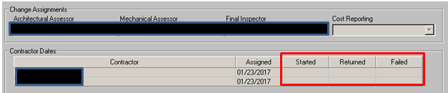

FORMS AND EXHIBITS for SECTION VI - WORK AUTHORIZATION

Approval Letter Page 99
Denial Letter (General) Page 100
Notice to Owner of Completion of Work Page 101

ILLINOIS HOME WEATHERIZATION ASSISTANCE PROGRAM
Weatherization APPROVAL LETTER
Date

Applicant's Name
Applicant's Address

Dear (Applicant):
Your application for the Illinois Home Weatherization Assistance Program (IHWAP) has been approved for assistance to improve your home's energy efficiency. A staff member will contact you to set a time to inspect your home to determine if it can be weatherized.
The steps taken in weatherizing a home are as follows:
- One of our staff members will assess your home and conduct a computerized energy audit that will determine the work to be done.
- The work to be done will then be placed on a schedule. You will be called and advised of the date when work will begin on your home.
- When the weatherization work is complete, a staff member will come to inspect the quality of work. You will then be asked to sign the final inspection form that indicates that an inspection was done.
The purpose of this program is to reduce a home's heat loss. Heat loss can be reduced by:
- Stopping infiltration
- Adding insulation
- Make sure the furnace is working properly
The work generated by the energy audit will be completed. The labor and materials to perform the weatherization work is provided to the applicant at no charge.
If you have any questions about the weatherization program, please contact

Worker Phone

We appreciate this opportunity to serve you.

Sincerely,
(Agency Representative)
cc: Applicant's File

ILLINOIS HOME WEATHERIZATION ASSISTANCE PROGRAM

DENIAL OF ASSISTANCE LETTER
Date

Applicant's Name
Applicant's Address
Dear (Applicant):
Your application for the Illinois Home Weatherization Assistance Program (IHWAP) has been considered and a determination was made that your household is ineligible because:
- Your household's total income was over the allowable limit for your household size.
- Your residence has already received Weatherization Assistance on _________________.
Date
- Your household did not submit all required documents and/or information by
_______________, the required date for submission.
Date
- ____There are insufficient funds available in this program year.
- Your home is not structurally sound, and the energy conservation measures that could be installed would not be effective.
- __ Other

You have a right to appeal this decision by requesting an informal conference at our agency within 30 days of this letter by contacting:
Remember, you have a right to reapply for assistance.
Sincerely,

(Agency Representative)
cc: Applicant's File

(LAA Letterhead)

NOTICE TO OWNER

This is to notify you that on __________, (Date) or soon thereafter, ______________intends to make payment of $___ (Amount) to ________ (Name of Contractor) for ______ (Work scope) done at _______________ (Building Address). _________________ (LAA) has inspected the work and has determined it to be completed in a satisfactory manner. Should you have any cause why payment should not be made to the contractor as set forth above, please notify __________________ (LAA) prior to the date indicated for payment.

SECTION VII – PROGRAM REQUIREMENTS
The Local Administering Agency (LAA), as a Sub-grantee for Illinois Weatherization Program Grants, will comply with the Illinois Home Weatherization Assistance Program (IHWAP) requirements as outlined in this manual and the other IHWAP Manuals, Procedure Letters, Technical Assistance Memoranda, electronic communication, and all other directives, as promulgated by the Office of Community Assistance (OCA), Illinois Department of Commerce and Economic Opportunity.

Training
- The LAA will maintain a complete set of program manuals, procedure letters, technical assistance memoranda, and other directives as established by OCA. The LAA will make a sufficient number of copies available to ensure accessibility to all staff and where relevant, such as the IHWAP Field Standards, available to subcontractors and their personnel.
- The LAA will be represented at all workshops, round tables, and/or meetings called by DCEO/OCA for local administering agencies.
- The LAA will ensure that the Weatherization Coordinator, Assessors, and Final Inspectors complete the requirements for IHWAP’s Training Certification Program (TCP) including attendance at training sessions, successful completion of written examination, and successful field certification.

Program Requirements: Training and Certification Program (TCP)
Weatherization Coordinators, Assessors, and Final Inspectors must be TCP certified within one year of their employment unless written approval is granted by DCEO/OCA for an extension. This certification ensures that weatherization staff understand the policies and technical requirements necessary to complete the home weatherization process successfully. Staff that do not meet the requirements of certification cannot sign-off on assessments or final inspections.
Note: IHWAP requires all potential TCP students to take and pass the Building Performance Institute’s (BPI) Building Science Principles Certification prior to enrolling in TCP (unless student already possesses a BPI Energy Auditor, Quality Control Inspection, or Building Analyst certification). Building Science Principles is an excellent introduction to a career in weatherization. If a new employee is not able to obtain this certification, it is an indicator that weatherization may not be a proper fit for the new employee. A copy of the student’s certification shall be provided to ICRT at the time of enrollment for TCP courses. For details on the certification please visit: http://www.bpi.org/building-science-principles.
The Training and Certification Program (TCP) is a Weatherization Assessment Course consisting of ten one-week sessions as follows:
- Weatherization Basics;
- Heat Transfer;
- Building Fundamentals;
- Introduction to Building Diagnostics;
- Infra-Red Thermography and the Architectural Assessment;
- Introduction to Heating Systems;
- Advanced Heating Systems;
- Heat Pumps, Air Flow, and Air Conditioning;
- Health & Safety, Indoor Air Pollutants and Lead-safe Weatherization; and,
- Complete Assessment Exam (hands-on field examination) and Proficiency Exam.

Continuing Education Classes
Periodically during the program year Continuing Education classes will be offered to Weatherization Coordinators, Assessors, and Final Inspectors. To maintain certification status, staff will be required to participate in the Continuing Education classes.
Refresher Classes
The state will provide a series of refresher classes every four years to ensure that Weatherization Coordinators, Assessors, and Final Inspectors are up to date on the technical aspects of the program. To maintain certification in the TCP, the local agency staff will be required to successfully pass the test(s) for the Refresher classes.

Training and Certification for Quality Control Inspectors
As part of an effort to establish high quality work standards for the national weatherization assistance program, the U.S. Department of Energy (DOE) has established a national certification for Energy Auditor, Final Inspector, Installers, and Installer Crew Leaders. Final Inspector Certification, known as Quality Control Inspector (QCI) Certification, was the first to be implemented.
The QCI certification requires the Final Inspector and State Monitor to demonstrate knowledge of inspection of work in progress, inspection for safety practices, work quality, client relations, and client satisfaction. The Quality Control Inspector must also demonstrate a level of competency in running and properly interpreting all the required diagnostic testing. A pre-qualification for the QCI is to have the Energy Auditor (EA) certification; the QCI is now a micro-certification of the EA certification.
QC Inspectors will also be expected to perform our traditional tasks of file review, post‐work inspections of both work completed and assessment, and close‐out.
In conjunction with the Indoor Climate Research and Training Center (ICRT) at the University of Illinois in Champaign, DCEO/OCA has developed a plan to ensure that IHWAP’s LAAs have the means to pursue this certification process for its weatherization staff. To prepare IHWAP candidates for the exam, ICRT has received accreditation for a QC Inspector Training Program.
Each LAA should review the prequalification requirements outlined below and identify who among their staff need to take the examination. DOE has set the minimum experience requirement for taking the QCI as 40 points accumulated in the following manner:
  - WAP assessor experience – 10 points for every 1,000 hours, maximum 20 points.
  - Other industry experience
    - 5 points for 2,000 hours as a crew leader
    - 10 points for 2,000 hours as an assessor – minimum 15 audits (proof required)
  - Building experience (framing, roofing, insulating, etc.) – 10 points for 1,000 or more hours
  - Training from industry‐specific, RESNET, NATE, etc.) – 10 points each
ALL DOE-funded weatherized units will receive a final inspection by a QCI-Certified Final Inspector. This inspection will ensure that the weatherization work was completed properly, that all measures called for in assessment and work order(s) have been installed and completed in a workman like manner and are in accordance with the priorities determined by the audit procedures, standard work specifications, and Illinois Home Weatherization Assistance Program Field Standards Manual. This same process and requirements apply where monitoring is conducted by a QCI-Certified State Tech.
LAAs may request a temporary waiver to allow experienced field staff who have not yet completed TCP or achieved their QCI certification to conduct assessments and final inspections on HHS and State funded homes. The waiver must indicate the type and length of related field experience of the employee, and when they anticipate the employee will complete TCP and/or take the test for EA/QCI certification. A weatherization specialist will accompany the staff person for an assessment or final inspection to ensure they can conduct this field work in accordance with IHWAP policy.
QCI-Certified Final Inspectors will be periodically monitored to ensure high quality work standards are being completed and that the individual is competent in running and properly interpreting all the required diagnostic testing. Consultation will be given when the need is noted, as well as training and technical assistance. If the individual continues to struggle and is not showing signs of improvement restrictions may be placed on them including a probationary period and up to re-vocation of final inspection sign-off authority. In some instances, if egregious disregard for program policy or client health and safety is displayed by a QCI, OCA reserves the right to revoke a QCI’s signature authority upon first offense.
Where program size, budget, and/or temporary staff shortages at the sub-grantee level make independent final inspection impossible a waiver may be granted to allow the assessor to final inspect the same job as long as all efforts have been exhausted. This waiver request and approval must be renewed annually. Independent Final Inspectors are individuals who have no prior involvement in the work inspected as the energy auditor/assessor or as a member of the crew.
For LAAs who have a planned production of 60 units or fewer, the waiver request must be submitted via email to your assigned Tech for review and potential approval. For agencies with a planned production of at least 61 units, the waiver request must be reviewed and approved by IHWAP management.
When such a waiver is granted DCEO will require that the sub-grantee conduct an internal review of ALL the assessor/final inspectors work and DCEO will increase its’ field monitoring to at least 15% of the sub-grantee’s weatherization and will conduct targeted desk monitoring of the assessor/final inspector’s work to ensure that the assessor/final inspector is able to competently perform both tasks.
DCEO/OCA will also ensure that each client file contains a form which certifies that the unit has received a QCI credentialed final inspection. IHWAP’s final inspection form has been revised to include adherence to SWS standards. The client file must also contain a second completed final inspection form if it was monitored by a State Tech.

Training for Contractors and Crews
All weatherization crews and contractors must complete the applicable training (Architectural/Crew leader Certification Training, HVAC Certification Training, Mobile Home Training) from the Indoor Climate Research and Training Center. All crew leaders and business owners (those directly involved in installation of measures) for each company are required to complete this training. When Agencies are procuring new contractors, new contractors do not have to complete the training prior to doing work for an Agency but must complete the training at the next possible scheduled training.
Local Administering Agencies may use DOE & HHS T&TA funds for contractors who attend training at the request of the local agency or as required by IHWAP. Reasonable stipends to cover labor time and travel cost may be included as part of the training expense. The stipend will be limited to no more than $300 per day for labor cost. DOE T&TA funds are limited to $3,000 per private contractor for labor cost (enough to support 2 people per private contractor to attend a week-long training); there is no limit on the stipend amount per contractor for HHS T&TA funds.
In addition to labor cost, contractors are also eligible to receive a stipend for travel, per diem, and lodging. Travel cost for the training are to be based on current federal travel, per diem and lodging rates for the applicable location (go to these links for more information: https://www.gsa.gov/travel/plan-book/per-diem-rates/per-diem-rates-lookup and https://www.irs.gov/tax-professionals/standard-mileage-rates.
Only contractors with an executed contract to provide weatherization services are eligible for training stipends.

Reimbursing Weatherization Staff for Technical/Trade School or Community College Tuition
LAAs may use HHS T&TA funds to reimburse new or existing local agency weatherization employees for tuition costs incurred at technical/trade schools or community colleges in a field related to weatherization, energy efficiency, building science, and/or building trades. DOE T&TA funds cannot be used for this purpose.
A new employee who has completed trade school or junior college within three years of the date of hire at a local agency (must have degree or certification of completion) may receive up to $5,000 reimbursement for education cost at the one- year anniversary of their employment at the local agency, and an additional $5,000 for each additional year of work for up to 3 years total. Therefore, the employee may receive up to $15,000 over three years of employment to cover the education/training cost they incurred prior to employment. The amount of reimbursement cannot exceed the total actual tuition costs incurred.
Current employees would also be eligible for tuition reimbursement for classes/training received from trade school or junior college that is related to trades, building science, and/or energy efficiency. The same $5,000 limit per year/$15,000 over 3 years would also apply to current employees.
The employee must provide documentation of training and schooling (degree, certification, etc.) and provide documentation of the cost of tuition. This documentation should be kept in the employee’s personnel file. Tuition reimbursements will be reviewed by OCA during programmatic/fiscal monitoring.

LAA Staffing Requirements
- Each LAA will employ a Weatherization Coordinator. The Weatherization Coordinator is responsible for all IHWAP programmatic components at the local level.
- The LAA will secure an adequate number of personnel (full and part-time, paid and volunteer) to serve as outreach workers, intake workers, verifiers, clerical support, and accounting/bookkeeping staff.
- The LAA will have written job descriptions on file for all weatherization program positions, including those described in paragraph 2 above, regardless of the position’s funding source, full or part-time status, or paid or volunteer status.
- The LAA will keep on file a current agency organizational chart detailing how its weatherization staff will fit within the overall agency structure. The LAA will also keep on file a separate organizational chart for weatherization staff that includes job title and job functions.
- Nepotism/Conflict of Interest - no employee, officer, board member, or agency of the provider shall participate in selection, or in the award or administration of a contract supported by IHWAP grant funds if a conflict of interest, real or apparent, is involved. Such a conflict would arise when the employee; officer; board member; agent; any member of the immediate family; his/her partner; or an organization which employs, or is about to employ, any of the above that has a financial or other interest in the firm selected for award.
- Each local agency must have an internal document that contains a Code of Standards of Conduct regarding procurement procedures. This Code of Standards should describe specifically how the LAA segregates responsibilities during the procurement, assessment, final inspection, and during the overall Weatherization process. The local agency shall describe their policy regarding Nepotism (the act of favoring a related family member for employment, or any Weatherization services/work) in detail.
Outreach
- The LAA will conduct outreach activities designed to assure that priority households, those households which participate in the Low-Income Home Energy Assistance Program, or which contain elderly or disabled individuals or both, are made aware of weatherization assistance offered with IHWAP grant funds.
- The LAA will keep a record of outreach contacts (letters, phone calls, meetings, and workshops).
- The LAA will disseminate general weatherization program information brochures which will include the LAA name, address, and telephone throughout the service area. These materials may be developed by the local agency.
- The LAA will contact the local officers of other specified agencies to coordinate outreach/ publicity efforts and to implement referral mechanisms.
- The LAA will contact other groups, clubs, churches, schools, and local units of government to coordinate outreach/publicity efforts.
- The LAA will develop news releases about the program. News releases must contain a program description, eligibility criteria, and application procedures, as well as the information to be provided by the applicant. All news releases or media interviews, contacts, and/or events must be pre-approved by DCEO prior to release to the media. A record of news releases and to whom they are sent must be kept.
- The LAA will arrange sites for intake, which are preferably transportation accessible, accessible to disabled persons and visible at the community level, e.g., senior centers, nutrition sites, etc.
- The LAA will contact local resources to arrange for interpreters as needed, e.g., second language, signers. These could include county DHS offices and community colleges and/or universities.
- The LAA will, where appropriate, conduct door-to-door canvassing to identify potential applicants.
Intake
- The LAA will ensure that applicants are assisted on a priority-ranked basis.
- The LAA will provide home visits to those potential applicants who, due to disability or lack of transportation, could not otherwise make application. Under exceptional circumstances, applications may be taken by other means, however these procedures must be approved by DCEO/OCA.
- The LAA will develop a systematic approach to the intake, priority ranking, and processing of applications, e.g., internally, how the applications are processed within the agency consistent with the input of client applications into the Department client information computer system. An outline of the intake and processing systems to be used by the LAA will be kept on file by the LAA.
Application Process
- No household may be denied the right to apply for Weatherization assistance.
- The LAA is required to utilize the dual-application form provided by the State.
- The LAA will assure that all applicants are provided assistance, when needed, in completing the application form and/or in obtaining required documentation as outlined in this IHWAP Program Operations Manual. The LAA will work with employers, County DHS offices, Social Security offices, banks, etc., to secure the required information.
- The LAA will ensure that the IHWAP Applicant Health and Safety Intake Questionnaire is completed with the client at the time of the IHWAP application.
- The LAA will take and verify an application, make a determination of eligibility, and notify the applicant within 30 calendar days of the date of application. Sample notification formats will be provided by the State.
- The LAA will assure that all applicants are informed of eligibility requirements and hearing rights. Pamphlets outlining this information will be provided by the State.
- The LAA will assure that all applicants are afforded the hearing rights as prescribed in this IHWAP Program Manual, including the right to an informal conference before the LAA and a hearing. The hearing procedures are outlined in Section XIV – Hearings and Appeals.
- The LAA will prepare an outline providing the locations in the proposed service area needing bi-lingual assistance, as well as the network to be used by the LAA to provide the assistance.
- The LAA will provide, as needed, communication assistance to households with individuals who are hearing, vision, or speech impaired or who have low literacy levels. The resources to be used by the LAA to assist the visually, speech or hearing impaired will be kept on file by the LAA.
- The LAA will verify income eligibility for 100 percent of the applications, as defined in Section V of this Manual.
- The LAA will designate a staff person(s) to authorize the eligibility of all applications.
- The LAA will establish and maintain a filing and tracking system (See Section 10 - Filing System) for all applications. The method for filing and tracking the applications will be kept on file by the LAA.

Agencies Considering Crews for Implementing Weatherization Services
Any Agency that wants to develop a crew for implementing weatherization in their service territory must receive approval from OCA prior to moving forward. Agencies should seek approval at least 6 months in advance of the program year they want to initiate crews. The Agency must submit a business plan that includes the following information:
- Reason for shifting from Outside Contractors to Crews
- Goals and Objectives for Crews
- Staffing plan with information on crew positions and expected burdened wage;
- Crew Staff recruiting plan
- Training plan for Staff
- Management plan for Crew Staff (including construction management experience of management)
- Office/warehouse space plan and estimated budget
- Identify equipment needs and estimate budget
- Procurement Process for Weatherization Material
- Timeline for Shift to Crew
- Production Plan for Agency – Assessments, Weatherization Services, and Final Inspection

OCA will review business plans and provide feedback or approval within 30 days.

LAA Coordination
- The LAA will survey and identify energy conservation programs in its service area and compile a resource directory (the Department will provide information about national and statewide programs).
- As appropriate, the LAA will make referrals on behalf of IHWAP applicants to other benefit and social service programs as administered by the federal government and this state, particularly low income energy-related programs under Subtitle VI (relating to Community Services Block Grant Program) under the Supplemental Security Income Program, under Part A of Title IV of the Social Security Act, under Title XX of the Social Security Act, under the Low Income Energy Assistance Act of 1981 and the Illinois Energy Assistance Act of 1989, as amended, or any other provision of law which carries out programs which were administered under the Economic Opportunity Act of 1964. If needed, the Department will provide assistance in identifying appropriate state agency benefit/service providers.
- The LAA will secure written agreements with all agencies/organizations which assume any of the following activities:
- provide facilities for intake sites;
- provide outreach and/or intake services; and
- provide intake workers and/or clerical support staff.
The agencies/organizations which will be conducting any of the above noted activities will be kept on file by the LAA.

Compliance Monitoring and Reporting
Grant Agreements
The sub-grantee’s signature of acceptance on the Grant Agreement(s) serve as its certification under oath that the sub-grantee has read, understands, and agrees to all provisions of the agreement(s). The sub-grantee further acknowledges that the award of grant funds is contingent upon this agreement.
Any sub-contractor(s) contracted by the sub-grantee shall also be subject to, and conform with, all applicable terms and conditions of the Grant Agreement.

Grant Agreement Enforcement
LAA failure or refusal to comply with IHWAP standards, policies, and/or procedures as found in the IHWAP Field Standards Manual, IHWAP Program Operations Manual, IHWAP Assessment Manual, and/or IHWAP Procurement Manual are grounds for the Illinois Department of Commerce and Economic Opportunity, Office of Community Assistance, to suspend, terminate, or otherwise apply special condition(s) to the sub-grantee agreements to provide weatherization services.

Monitoring by OCA, General Monitoring Procedure
To determine compliance with Illinois Home Weatherization Assistance Program Policies, Guidelines, Rules and Regulations, DCEO/OCA will conduct monitoring visits to the LAAs’ offices, active jobsites, and weatherized homes and will conduct other grant compliance activities such as review of WeatherWorks data specific to an agency's weatherized homes. These monitoring activities will include, but not be limited to: Quality Control Monitoring, File Reviews, Assessment Monitoring, Procurement Monitoring, Lead Safe Weatherization Monitoring, EPA Lead Renovator Compliance Monitoring, Fiscal Monitoring, Historic Preservation Monitoring, and/or any other monitoring deemed necessary by Federal and/or State rules, policies, or regulations.
- Quality Assurance Monitoring will evaluate the overall effectiveness of retrofits selected, safety practices, workmanship, overall appearance, and compliance of installed measures with the IHWAP Field Standards Manual. This Monitoring will also evaluate the overall quality of the initial assessment.
After gathering facts from the Quality Assurance Monitoring Visit and related Client File Review, the OCA monitor will make a Determination. The OCA monitor will rate the weatherized home as either “Acceptable” (PASS) or “Unacceptable” (FAIL).
- File Review Monitoring will evaluate the overall organization, completeness, and accuracy of the IHWAP Client files. These reviews will include document review and verification. OCA will require the LAA to correct specific problems observed in its client files. Where consistent file deficiencies are observed OCA will require the LAA to submit a corrective action plan for review.
- Desk Monitoring: WeatherWorks Job File Monitoring will review accuracy, completeness, and compliance of the LAAs use of WeatherWorks energy monitoring and job management functions. OCA will ask the LAA to correct specific problems observed in its WeatherWorks job files and may initiate quality control monitoring of specific files when warranted. Where consistent job file deficiencies are observed OCA will require the LAA to submit a corrective action plan for review.
- Assessment Monitoring will evaluate the LAA’s completed assessments for overall quality and adherence to all IHWAP Policies and Procedures. Assessment Monitoring will also review the LAA’s WeatherWorks data entry and retrofit selection. The evaluation of the assessment will be rated as either “Acceptable” (PASS) or “Unacceptable” (FAIL).
- Procurement Monitoring will evaluate the Local Administering Agency’s implementation of the IHWAP Procurement Policy during the annual programmatic monitoring. Procurement Monitoring will include, but not be limited to a review of: market analysis, procurement approach, Advertising Plan, Contractor file, Request for Proposal, material/labor bid survey, and subcontracts and WeatherWorks Catalog. OCA will also review the schedule of the LAA’s procurement process to ensure an annual market analysis and biennial procurement is being conducted.
If DCEO determines that the LAA’s procurement procedures are not in compliance with the procurement requirements of an “open and fair” process the LAA may be required to re-procure or revise specific portions of the procurement.
- Lead Safe Weatherization Monitoring will be conducted to ensure compliance with DOE mandated Lead Safe Weatherization Practices and training requirements.
- EPA Lead Renovator (RRP) Compliance Monitoring will ensure LAA and subcontractor compliance with EPA Lead Renovator training and work practices requirements.
- Confined Spaces Policy Monitoring will be conducted to ensure compliance with OSHA mandated Confined Space Requirements of CFR 1926.1201 AA Subpart, as defined in DCEO/OCA’s Confined Space Safety Plan.
- Fiscal Monitoring will be conducted by OCA Fiscal staff in accordance with the LAA’s Grant Agreement, Joint Committee on Administrative Rules Administrative Code, and all other applicable Federal and/or State rules and regulations.
- Historic Preservation Monitoring will be conducted to ensure the LAA is complying with the historic preservation requirements outlined in this manual.
- Programmatic Monitoring will be conducted to ensure that the LAA’s application, outreach and education, eligibility, priority system, subcontracting, worker training and safety, health and safety, final inspection, records maintenance, and any other relevant aspect of its program complies with the rules, regulations, and statutes that govern the use of IHWAP funds for weatherization of homes.

The Quality Assurance Monitoring Process
OCA conducts a comprehensive quality assurance monitoring at each agency during each Program Year that consists of:
- Selecting homes to be monitored by geographical area, date completed, grant source(s) utilized, and/or housing type.
- A comprehensive review of the job files for the homes selected for monitoring.
- A field visit will review the work installed, compare work installed to the work order and invoice, review the quality of the original assessment, and review the LAA’s final inspection.
- Where OCA monitoring identifies a deficiency in the work or in the weatherization process the OCA monitor will gather facts and documentation describing the deficiency.
- Whenever possible the OCA monitor will bring the evidence of the deficiency to the attention of LAA personnel during the inspection and/or at an exit interview with the LAA before departing the agency.
- After completing a monitoring visit the OCA monitor will, where there is evidence of a deficiency in work quality or in the weatherization process associated with the home weatherized, make a determination of “Acceptable” (PASS) or “Unacceptable” (FAIL).
- Within 30 calendar days of the conclusion of a monitoring visit, the OCA Monitor will send the LAA Monitoring Letter which will review the Quality Assurance Monitoring Visit, its purpose, and conclusions. Where the home was deemed “Unacceptable” the IHWAP rule, standard, and/or policy upon which the determination was based will be referenced.
- The Monitoring Letter will require the agency to remedy work quality deficiencies identified during the visit. If deficiencies are identified, the agency may be asked to correct their procedures to ensure the deficiency is not repeated. Additionally, the Monitoring Letter may disallow costs associated with any measure and/or repair that does not comply with the IHWAP Field Standards Manual and/or the IHWAP Program Operations Manual.
- LAA’s Response to the Monitoring Letter containing determination(s) within 30 calendar days of the letter stating any dispute with the determination(s), the LAA’s actions taken to remedy the deficiencies, and where requested in the Monitoring Letter, the action taken or planned to ensure that homes weatherized by the agency will not have similar work quality deficiencies in the future.
- Partial Responses. If the LAA’s Response to the Monitoring Letter is a partial response, where not all of the corrective actions have been satisfied, the State will issue a follow-up letter within 15 calendar days of the receipt of the LAA’s Response Letter releasing the measures that have been satisfied. The State will also require an additional response from the LAA within 15 calendar days of the State’s
  - Partial Release. This process may be repeated a second round, for a maximum of 60 calendar days, to resolve all outstanding issues. If all measures have not been completely satisfied by the aforementioned deadlines, the non-compliance process will begin.
- OCA will issue a Release Letter to the LAA’s Response Letter within 15 calendar days releasing the LAA from the determinations of the monitoring letter if all deficiencies cited have been corrected.
  - If all of the deficiencies have not been satisfied a Follow-Up Letter will be sent by OCA requiring a 15-calendar day response.
- Monitoring visits may focus on problem areas identified in previous monitoring visits to prevent patterns from becoming trends.

Monitoring Determinations
Monitoring Activities are rated as either Acceptable or Unacceptable based on the infraction or deficiency in the quality of work, the assessment, the final inspection, and/or any other aspect of the LAA’s execution of the IHWAP weatherization grants. OCA monitors base their determinations on the following:
- Findings:
  - Work completed with IHWAP funds that compromises the health and safety of clients, LAA staff, and contractor/crew staff, or the structural integrity of the building.
  - A health and safety problem is created by, exacerbated by, or not corrected by the delivery of IHWAP-funded services.
  - The omission of a required procedure that addresses health and safety concerns that are within the scope of weatherization.
  - The omission of a required measure or technique with major energy savings potential as determined by the Savings-to-Investment Ratio in the WeatherWorks System or Weatherization measures that were paid for with IHWAP Funds but are not applied to the dwelling.
  - Expenditure of IHWAP funds for items that exceed the stated cost limits, without prior written OCA authorization as specified in IHWAP Program Operations Manual. Additional funds that exceed the cost limit specified will be considered as disallowed costs and must be removed from WeatherWorks and refunded to DCEO. All fiscal files, records, and documentation must be revised accordingly.
  - Poor quality workmanship that significantly affects the performance of the installed weatherization measures.
  - Expenditure of IHWAP funds on a measure or measures that are not approved under IHWAP or required for mitigation of health and safety concerns.
  - Expenditure of IHWAP funds on Retrofit measure that do not yield an acceptable Savings-to-Investment Ratio as determined by the WeatherWorks System.
  - Any action or lack of action that would threaten the integrity of the IHWAP and/or its ability to receive future grant funding.
- Observations:
  - Observations, previously referred to as Minor Findings, may include, but are not limited to: sloppy work, missing attic insulation measuring sticks, incorrect documentation, etc. Observations may, or may not, cause the field inspection to fail depending on the severity of the infraction.
    - Observations will require a Response from the LAA, detailing the corrective action taken to alleviate the deficiency identified, if specifically noted in the Monitoring Visit Letter.
    - When similar Observations are found on two or more consecutive monitoring visits, those Observations may be elevated to a Finding.
    - Observations could result in the requirement of additional training for the LAA personnel and/or contractor personnel.
- Recommendation:
  - For field conditions observed that do not constitute substantial noncompliance with the IHWAP Field Standards Manual and/or IHWAP Program Operations Manual, OCA may determine a Recommendation.
- Best Practice:
  - For weatherization work installed or weatherization process completed that is exemplary in nature OCA may make a Best Practice determination.
A monitoring visit report from OCA that contains Findings:
- Requires an immediate response from the LAA receiving the Finding as defined in the Monitoring Visit Report generated by OCA.
- Requires that corrective action must be taken.
- Could result in disallowed costs that the LAA would have to refund to DCEO.
- Could result in an increased monitoring frequency by OCA.
- Could result in the requirement of additional training for the LAA and/or
- LAA/contractor personnel as specified by OCA.
- Could result in the recommendation of High-Risk status or Grant Default Status for the LAA receiving the Finding. Subsequently, Special Conditions will be placed on the LAA's grant agreement(s).
- Continued Findings may result in the termination of the LAA's IHWAP grant agreement with OCA.
- Substantial Number or Repeated Finding: High Risk Status or Grant Default Status.
- The occurrence of a substantial number of, or repeated, Findings may result in a decision by the DCEO administration that a LAA be placed on High Risk status or Grant Default Status.
- If a LAA is placed on High Risk status or Grant Default Status, special conditions will be placed on the grant which will affect the LAA's ability to draw IHWAP funds. Those special conditions will include but not be limited to additional reporting requirements as specified by OCA, a detailed corrective action plan to remedy monitoring deficiencies, and limited or total restrictions on the availability of cash requests from the appropriate IHWAP grants, or all DCEO funding.
  - If a LAA is placed on High Risk status or Grant Default Status, the LAA will be placed on probationary status for up to two years following the date of the probation period initiation.
  - Failure by the LAA to comply with the special conditions placed on the grant agreement and/or continued non-compliance or Findings will be grounds for termination of the grant agreement between the LAA and DCEO.
  - After failing to comply with Weatherization grant conditions, or the correction of grant deficiencies, the LAA will be referred to DCEO Legal Counsel for review and disposition.
Notwithstanding any of the above, DCEO may suspend or terminate a contract without prior written notice upon a Finding of substantial non-compliance or substantial breach of grant agreement.

Quality Control-Quality Assurance
The LAA will ensure that IHWAP services are provided in a quality manner. Specific procedures on how the LAA manages, monitors, reviews, and evaluates assessments, workmanship, and final inspections must be developed and on file for OCA review.

Production
- The LAA will weatherize an appropriate number of homes to utilize all funds made available on the WeatherWorks Budget for each IHWAP Grant. The LAA will ensure that funds are spent in the county to which they were allocated.
- The LAA will submit a production plan and will revise this plan on the Tracker Screen in the WeatherWorks system as required by DCEO. Tracker must be updated between the first and fifth day of each month for planned and actual production and assessments.
- Due to the limitations of the WeatherWorks System, and following best accounting practices, ALL weatherization projects that are started in one production year must be completed and closed out in that same production year. ALL completed weatherization jobs must be Cost Reported in a single production year. Failure to complete all the work on a home in the same program year that it was started may result in disallowed costs to the LAA. If an LAA anticipates that this situation may arise, OCA must be notified as soon as possible to assist in the resolution of the issue.

Production-Related Costs
- Program Support will be reimbursed at a rate of 35% of the material and labor applied for each individual unit completed (45% reimbursement for program support for crew-based agencies and agencies that have crew-based agencies complete the weatherization of homes via a memorandum of understanding/shared services agreement. In this scenario, the crew-based agency would be providing services “at cost” with no mark-up associated with the work.) and must be expended during the current grant period on expenditures allowed under the Weatherization grant.
- The LAA agrees not to exceed the maximum per unit costs for the IHWAP established in writing by DCEO, unless a written waiver has been obtained.
- Administrative funds will be earned at a final rate of the amount of the grant that was properly expended. For example: If an IHWAP agency was only able to complete 80% of a grant’s production, they would only be able to receive a total reimbursement of 80% of the administrative funds for that grant.

Procurement Process
OCA requires LAAs to conduct a full procurement for weatherization material and labor every two years with a start date for new contracts no later than October 1st of the procurement year. Agreements with contractors should be limited to 1 year, with a provision to extend for an additional year.
Procurement for weatherization material and labor should be done through a competitive proposal process such as competitive negotiated bid, Request for Proposal, and Invitation for Bid. If procuring only weatherization material, such as is the case for a crew-based agency or in the case of appliances where no labor is involved, a sealed bid procurement may be implemented.
Furthermore, based on the requirement in WPN 19-4, LAAs are to conduct a market analysis every year. The market analysis for the non-procurement year does not have to be a full market analysis; the analysis can be a sample of 10% of the entire list of measures with a focus on the most commonly implemented measures and the most expensive measures.
Agencies utilizing contractors cannot allow contractors to use the local agency’s tax-exempt status to purchase material/equipment.
In the past SAMs/DUN registration was required for all contractors. DOE has changed the SAMs/DUN requirement to a Unique Entity Identifier (UEI) number, but this is no longer required for contractors.
More details on how to conduct procurement can be found in the Procurement Manual.

Assessing the Overall Health of Local Administrative Agencies’ Weatherization Program

OCA will conduct an annual agency assessment, called the IHWAP scorecard, to measure the overall health of all 34 local administrative agencies’ weatherization programs in Illinois based on various factors. This agency assessment will be used to determine if OCA should explore soliciting an alternative local weatherization provider in any region of the state. The IHWAP scorecard will score each agency based on production (units weatherized) and funding expenditures, weatherization program and overall agency staffing capabilities, and results of programmatic, quality assurance, and fiscal monitoring. OCA will consider soliciting an alternative provider of weatherization services for any region where the local agency weatherization program scores below a minimally acceptable score in this agency assessment.

Furthermore, some local agencies may decide on their own that they are not equipped to continue administering the weatherization program. The weatherization program requires staff with the building science knowledge and technical skills that many other community programs don’t require and maintaining staffing with these skills may be difficult for some agencies. When agencies decide they no longer are able to administer the program, they should request in writing for OCA to solicit a new weatherization program provider.

Performance
The LAA will provide complete IHWAP services to all eligible households throughout the service area which will be a critical factor in evaluating the overall performance of the LAA under this grant.

General IHWAP Requirements
- Under no circumstances is the LAA to complete the Architectural portion without first ensuring that no fuel leaks are present, and the heating system and water heater are operating safely and are properly venting.
- No Weatherization material is to be left at the job site for the client to install and/or dispose of. If a weatherization material cannot be installed, notation is to be made on the Work Order as to why installation was not possible.
  - Any item replaced must be removed from the premises. This would include refrigerators, freezers, incandescent lightbulbs, space heaters, heating units, window air-conditioning units, etc. All refrigerators, freezers, and air conditioning units that are replaced must be removed from clients’ homes upon delivery of the replacement units and properly disposed of in accordance with the Clean Air Act (USC Title 42 7671 g).
- Weatherization waste byproducts/debris are required to be removed daily.
- The LAA will ensure that the WeatherWorks Catalog is complete with the current competitive prices for all material and labor. Each WeatherWorks System catalog:
  - Shall not reference installation of storm doors. IHWAP grant funds cannot be used to install storm doors;
  - Shall Reference replacement windows and doors as Retrofit Measures or as an air-sealing measure when documented, justified, and approved. Storm windows can only be considered as a retrofit.
- Replacing windows &/or doors under air-sealing. When a window &/or door is damaged beyond repair or when they are an ineffective air-barrier they can be replaced when the air leakage is quantified.
- Replacing storm windows (or glass in storm windows) cannot be considered as an air-sealing measure. Storm windows can only be considered as a retrofit and must have an SIR over 1.
- All duct work installed or repaired (except duct insulation that supports a Retrofit) is considered an Incidental Repair Measure and/or a mechanical cost and shall only be costed as either part of the retrofit measure or as an incidental cost when it is in support of a retrofit measure such as furnace replacement.
- Switching primary fuel sources can only be done after approval in writing is provided by the assigned OCA Weatherization Specialist. Fuel Switching is allowed on a case-by-case basis when the savings over the life of the measure are greater than what they would be without the fuel switching. It must be demonstrated by generating two SIRs – one for each fuel source measure. If approved, documentation must be maintained in the client file.
- If an Agency wants to install measures that are more efficient than the standards (ex. R-60 attic insulation instead of R-49, 17 SEER central air conditioner instead of 16 SEER, tankless water heater instead of power-vented energy star storage water heater), they must calculate and document the SIR for the two options and can only call for the measure with higher efficiency than the standard if it has a higher SIR than the other measure.
- Installation of new jalousie or mobile home awning type windows is prohibited.
- When primary sashes (on a site-built home) are not assessed for replacement or when the window did not receive an SIR of 1.0 or greater for replacement, the check rails of the window at the point of the sash lock shall meet and be flush. This may require that the lower sash be planed on the bottom to allow the checkrails to be flush with one another at the sash lock. It is prohibited to shim and “space” sash locks.
- If rolled metal is used for the heat barrier on attics insulated with cellulose, the barrier must be fastened securely to the attic joist in such a manner as to not allow the barrier to collapse and touch the heat source. All heat barriers must be anchored in such a manner as to provide a three-inch air space between the barrier and the heat producing source. Batt insulation may not be used as a heat barrier.
- Duct repair refers to situations where major duct work installation is required to balance the heat delivery of the furnace. This usually occurs when a replacement furnace is installed, and the existing duct work is oversized, or major pieces of the duct system are missing. Duct repair includes supply and return air registers. Duct replacement with the installation of a new furnace is considered as part of the overall Retrofit measure costs.
- When an existing lightbulb can simply be replaced with an LED lightbulb, replacing the lighting fixture is prohibited. Installers should also avoid using diode LED fixtures where replacement of burned-out LED lightbulbs requires replacing the entire fixture.
- Electrical refers to the installation of electrical wiring needed to allow the installation of insulation. The installation of electrical wiring includes all junction boxes and conduit needed to complete the work.
- Plumbing refers to the installation or correction of plumbing problems that may cause any weatherization measure not to be installed. Plumbing also includes the repairing of the plumbing pipe if the water or sewage is backing up and creating a moisture problem for installed weatherization material. All plumbing work must be completed by a licensed plumber.
- Roof refers to the replacement or repair of roofing so that insulation may be installed. Limitations do apply; weatherization does not include replacing the entire roof.
- Structural refers to repairs to the structure of a home that must be made to preserve the integrity of the building shell and can be an incidental repair when necessary to allow installation of a retrofit measure or protect and preserve a retrofit measure after installation. Examples of structural repair are replacing the flooring under a water heater in a mobile home and patching open sections of side wall on a site-built home for air-sealing purposes.
- Water heater work refers to health and safety measures necessary to ensure that no fuel leaks are present, and the water heater is properly venting. All water heaters must also have a pressure relief valve and discharge pipe.
- New furnaces installed in the Illinois Home Weatherization Assistance Program and in the LIHEAP Emergency Services Component must have the flue gases checked for Carbon Monoxide and Oxygen after installation and the tape of the post-test included in the client file and taped to the gas appliance.
These two (2) measurements will indicate whether the new furnace is operating to manufactured specifications. The heating system efficiency and Oxygen percentages will vary depending on the individual manufacturer and system design specifications. On new heating system installations, the PMI manual is to be attached to the HVAC system, and available for inspection. Furnace filter racks are to be installed in accordance with the system’s PMI manual.
95 Plus Furnace Installations – 95 plus heating systems will be installed only as 2-pipe systems with separate exterior combustion air intake and flue gas exhaust. The Oxygen (O2) and Carbon Monoxide (CO) measurement will be taken at the flue on the outside of the house. Normally the furnace will be side vented through the foundation of the home. If the furnace is vented through the roof and it is difficult to access or hazardous, the flue test may be omitted. When the flue has been drilled, the hole is to be sealed with high temp RTV sealant, nylon plug, or butyl-backed adhesive tape. Standard adhesive aluminum tape is not to be used.
In cases where the Oxygen and/or Carbon Monoxide measurements do not fall within the parameters established by the manufacturer, the mechanical contractor is to correctly adjust the furnace to proper specifications.
80 Plus Furnace Installations - The Carbon Monoxide (CO) measurement will be taken at the furnace, unless the manufacturer specifies that drilling the flue will invalidate the warranty. No draft test is needed on these power vented systems. Mobile home heating systems with sealed double wall flues are not to be drilled. Double wall, type B-vent flues may be drilled and sealed with high temp RTV sealant.
In cases where the oxygen and carbon monoxide measurements do not fall within the parameters established by the manufacturer, the mechanical contractor is to adjust the furnace to proper specifications.
80% furnaces may only be installed with a DCEO waiver. A Mechanical Waiver Request, with the appropriate documentation, and digital photos are required.

Disregard for IHWAP Policy and/or Client Health and Safety
If any local administrative agency staff (including but not limited to intake staff, assessor, final inspector, weatherization coordinator, fiscal staff, or Executive Director) displays egregious disregard for program policy or client health and safety, DCEO reserves the right to revoke the signature authority of staff and prohibit participation in IHWAP or other OCA programs upon the first offense. Furthermore, IHWAP will prohibit the local administrative agency salaries from the staff being paid from OCA grants of staff.

DCEO also reserves the right to prohibit IHWAP trainers or any weatherization contractors who display egregious disregard for program policy or client health and safety from participating in the IHWAP or other OCA programs. LAAs should include language in the contracts with contractors to make sure contractors are aware that they could be prohibited from participating in the program if DCEO finds they have egregiously disregarded IHWAP policy.

If IHWAP exercises this right, the local administrative staff, IHWAP trainers, and weatherization contractors will be notified by letter and will be informed of the appeals process.

Use of IHWAP Funds for Out of State Travel
Per Section 200.474 of 2-CFR-200, Out-of-State travel costs are defined as expenses for transportation, lodging, subsistence, and related items incurred by employees who are in travel status for official business of the non-Federal entity.
Effective July 1, 2017, all new grants administered by OCA will be required to have ALL Out-of-State travel, regardless of estimated cost, approved by OCA. The request should be submitted at least six (6) weeks prior to the travel date in order to receive approval in a timely manner.
Grantees will be required to complete and submit the “Out-of-State Travel Request Form” to their Weatherization Specialist for review and approval purposes. The LAA must complete the form in its entirety, including “prepared by” and “approved by” signatures. “Approved by” signatures must be either the Authorized Signature Authority or Designee for the grant in which the travel is being paid from. The Department will notify the LAA within 10 business days with their decision.

FORMS AND EXHIBITS for SECTION VII - PROGRAM REQUIREMENTS

Tuition Reimbursement Approval Form………………………………….Page 120
Out-of-State Travel Form Page 121

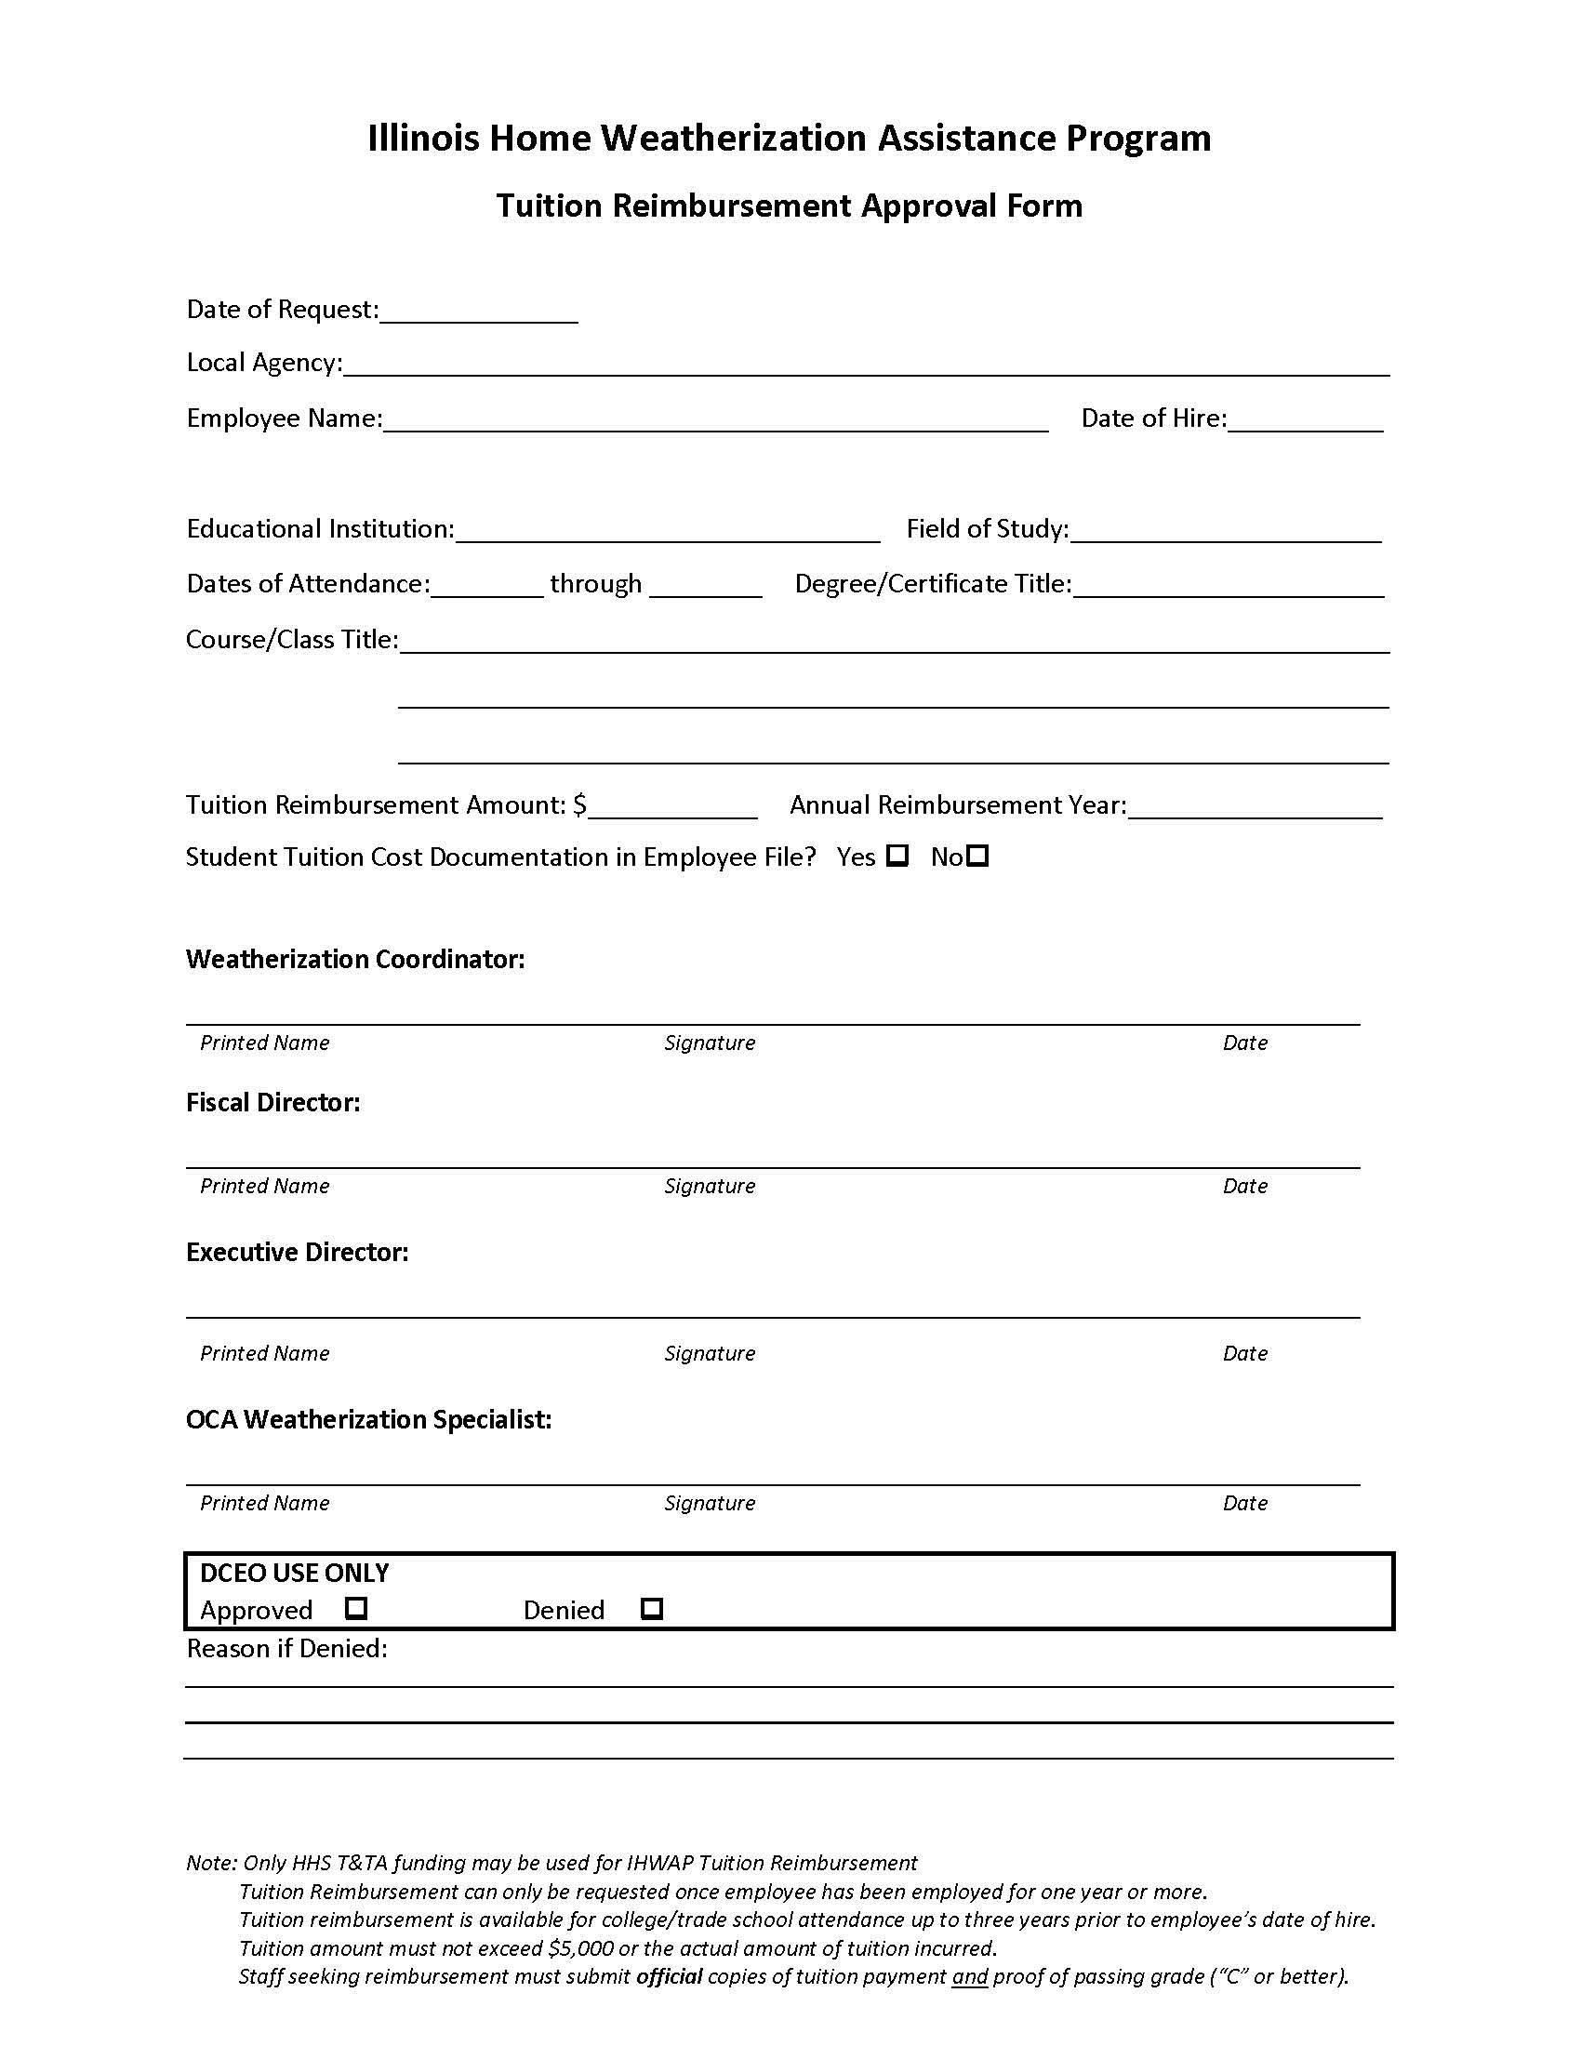

OFFICE OF COMMUNITY ASSISTANCE
Out of State Travel Request Form

DESCRIPTION
C/LAA
Amount Requested
Contact (Name/Title)
Telephone/Email
All grant programs benefiting from travel
Justification for Travel (Why is this travel necessary)
Conference/Event Description (include conference/event title, dates, location, and a brief description)
Expected Outcome (What information or experience will be gained? Who will information be shared with upon return?)
Attendees which the request is for? (include names and titles)

BUDGET
Budget Category | CSBG | LIHEAP | Weatherization | Other | Total
Travel
Event Fee/ Conference Rate
Lodging
Per Diem
Other:
Total

C/LAA Prepared by: _______________________________________Date________________

C/LAA Approved by: _______________________________________Date________________

_____________________________________________________________________________

DCEO Use Only: Approved Denied

DCEO Signature: __________________________________ Date: _____________

Reason if Denied:

____________________________________________________________________________________________________________________________________________________________________________________________________________________________________________________________________________________________________________________________________________________________________________________________________________________________________________________________________________________________________________

SECTION VIII - ASSESSMENT

Assessment Overview
The assessment is one of the most important steps in the weatherization process. The assessment is the first point at which the agency enters the client's home and determines the structural condition of the home. The assessor's job is to conduct a thorough client interview and review of the home to determine the weatherization measures that will save the most energy while ensuring health and safety. If weatherization work has not begun within 1 year of the original assessment date, a reassessment is required. The assessment must be recalculated, and a new Work Order printed.
The process for conducting the assessment of the home is contained in Volume IV- Illinois Home Weatherization Assistance Program, Assessment/Energy Audit Manual. The Health and Safety procedures are contained in this section. The assessment for both architectural weatherization and HVAC system weatherization is required to be done at the same time, with the exception of a LIHEAP Furnace Assistance Assessment. The completion of the Standardized IHWAP Assessment Input Document is mandatory.
The EPA Lead Booklet (Renovate Right) and Moisture/Mold Booklet are required to be given to every IHWAP Client at the time of the Assessment. At the time of Assessment, the Client must sign the Client Education Materials Checklist stating they have received these two brochures and any other Client education brochures and education necessary because of the presence of specific hazardous conditions.
Additionally, where specific hazardous condition or conditions are identified, the assessor must complete and sign the Hazardous Conditions Notice Form, deliver it to the client and collect the client’s signature on a copy to be kept in the IHWAP client / job file.

Required Color Photographs
Digital color photos documenting existing conditions for any retrofit or other measures that involve replacement of equipment, fixtures or building materials are required to be placed in the client file. Photos should document any problematic areas that the contractor needs to address. The assessor should refer to Volume IV - Illinois Home Weatherization Assistance Program, Assessment/Energy Audit Manual, for photo requirements. Copies of photos of problem areas should also be attached to the work order for crew/contractor reference. Photos present in the client file must be clearly labeled as assessment photos, final inspection, or post weatherization photos, for auditing purposes.
When a change order is requested by and /or granted to the contractor, color digital photographs are required to support the request. The photographs must clearly document the need for change and must be affixed to the change order with legible copies in the IHWAP Client file.

Refrigerator/Freezer Replacement
The Illinois Home Weatherization Assistance Program will remove inefficient refrigerators and/or freezers and install replacement high efficiency units (Energy Star rated) that are cost effective. These newer units use much less electricity to operate and can pay for themselves, in energy savings, in a few years. Only HHS and State funds can be used to replace freezers.
- Refrigerator/Freezer Replacement Purpose
The purpose of replacement refrigerators and/or freezers in the weatherization program is to reduce the electrical consumption in low-income households and save the client money on their energy costs. It is not necessary to assess a refrigerator and/or freezer for replacement if they were manufactured after 2010. Only refrigerators and freezers located within the thermal boundary of the home are eligible for replacement (garage or porch refrigerators/freezers shall not be specified for replacement).
- Refrigerator/Freezer Replacement Discussions with Client
During the initial client interview and before the assessment of the dwelling the potential for replacing the refrigerator and/or freezer should be discussed with the client. It is most important that the client not be promised a new refrigerator and/or freezer.
  - The assessor must make it clear to the client that a refrigerator and/or freezer will only be replaced if they meet IHWAP criteria and the existing unit(s) is/are removed from the dwelling.
  - The assessor should also explain to the client that a color choice is not an option and that IHWAP will not pay for installation of ice makers or other add-ons.
Refrigerator Replacement Assessment Procedure
The assessor identifies the make and model of the refrigerator and/or freezer. The model number of the refrigerator and/or freezer can be found in several places depending on the make and year; it is often in the inside of the door, bottom of the panel of the refrigerator, or in the freezer compartment. In some cases, the number may be in the back of the unit.
- The existing size of the refrigerator/freezer must be noted to ensure that the replacement can fit the physical space (depth, width, height, and clearance).
Refrigerator Back-up documentation
The assessment of the refrigerator and/or freezer must be placed on an IHWAP approved assessment document that includes a notation for the manufacturer’s name, model number, serial number, single door, right or left hinge, height, width, depth, and whether it is a freezer to be replaced. In addition, the location and any other special conditions that might be needed should be noted.
- The documentation must also include a form the client signs that states they understand the refrigerator and/or freezer that is being replaced will be removed and disposed of, according to U.S. Environmental Protection Agency Regulations, by the installer.
- A copy of the certificate or receipt indicating the appliance has been accepted by the recycling facility must be provided to the local weatherization agency and be placed in the client file for each refrigerator/freezer replacement.
- Under no circumstance is the refrigerator and/or freezer that is being replaced to remain in the house and not disposed of.
Program Refrigerator/Freezer Replacement Rules
- Only Energy Star rated refrigerators (larger than 7 cu ft), or freezers are allowed for replacement.
- The weatherization program will not pay for any installation of icemakers or water feeds.
- The program will not pay for a particular color refrigerator as an extra charge;
- Refrigerator or freezer repair is not allowed; this component is not a repair activity.
- Refrigerators or freezers that are replaced are to be disposed of according to U. S. Environmental Protection Agency requirements.
- Refrigerator/Freezer Data must be entered into WeatherWorks even if we’re not replacing it:

Deferral/Walk-Away Policy
The decision to defer work in a dwelling or, in extreme cases, provide no weatherization services, is difficult but necessary in some cases. This does not mean that assistance will never be available, but that work must be deferred or postponed until the problems can be resolved. LAAs are expected to pursue all reasonable options on behalf of the client.
Deferral conditions may include, but are not limited to, the following:
- The client has known health conditions that prohibit the installation of insulation and/or other weatherization materials.
- The building structure or its mechanical systems, including electrical and plumbing, are in such a state of disrepair that conditions cannot be resolved in a cost-effective manner.
- The house has sewage or other sanitary problems that would further endanger the client and weatherization installers if weatherization measures were installed.
- The house has been condemned or electrical, heating, plumbing, or other equipment has been "red tagged" by local or state building officials or utilities.
- Moisture or site drainage problems are so severe they cannot be resolved under existing allowable health and safety measures or with minor repairs.
- Dangerous conditions exist due to high carbon monoxide levels from combustion appliances and cannot be resolved under existing health and safety allowable limits.
- The client is uncooperative, abusive, or threatening to the crew, subcontractors, auditors, inspectors, or others who must work on or visit the house.
- The extent and condition of lead-based paint in the house would potentially create further health and safety hazards for the client or workers and could not be corrected with weatherization.
- Illegal activities are being conducted in the dwelling.
- Client has an unvented space heater and refuses removal of the unit prior to weatherization services being conducted.
- Client refuses installation of any weatherization measures that have been prioritized through the WeatherWorks database, including the installation of an ASHRAE 62.2 Fan.
- Severe Mold and Moisture problems are so severe they cannot be resolved under existing health and safety measures and with minor repairs. Severe Mold is defined as an aggregate of 10 square feet.
- Areas cluttered or obstructed to such an extent that workers do not have access to home areas where assessment, weatherization work, or final inspection need to be performed.
- Pest Infestation may be cause for deferral if the pests cannot be removed and pose a health and safety risk to the workers.
- Homes that contain products containing air pollutants, flammable liquids, and other volatile organic compounds that may pose a threat to workers may be deferred. Clients should be educated on the dangers of these products, and informed that the products must be removed before work can commence.
- Any other health or safety condition present or created by, exacerbated by, and cannot be corrected by the delivery of IHWAP funded services.
In some cases, IHWAP funds may be utilized to correct the situation (red-tagged heating system, high CO readings, minor roof repair to stop bulk water intrusion, etc.).
If you have questions, or concerns, contact your Weatherization Specialist.
When a LAA determines that invoking the Deferral Policy is necessary, the following steps must be followed:
- The client must be notified in writing via certified mail stating the reason(s) for invoking the Deferral Policy.
- The LAA is required to notify the client that work may proceed if the reason(s) for deferral are properly remedied, and the client contacts the LAA when remedy is complete. The LAA must visit the site to verify the reasons for deferral have been remedied.
Tracking Deferrals
Each agency should maintain a spreadsheet that tracks all projects that have been deferred including applicant name and address, date of deferral, information on the reason for deferral, potential steps that can be taken by homeowner to address the deferral issues, and date that deferral issues were resolved. A template for the deferral tracking excel spreadsheet is available at https://ceo.partner.illinois.gov/OEA/OEA_LAA/default.aspx. This spreadsheet should be provided to OCA upon request.

Health and Safety Plan
Illinois has developed a Health and Safety Plan using WAP funds to identify and abate specific health and safety hazards that may exist in dwellings weatherized by Local Administering Agencies.
Health and Safety Expenditure Limits: Recognizing that potential Health and Safety Costs could absorb and exceed IHWAP resources for any one home weatherization project, DCEO has established a Health and Safety Budget with an average of $1,202.00 per weatherized unit (DOE funding only) and may not exceed $1,750 in any one unit without written approval from your assigned State Tech.
Costs which may be paid under Health and Safety include:
- Installation of Smoke Detectors and Carbon Monoxide detectors; and fire extinguishers when solid fuel sources are utilized;
- Installation/Repair of exhaust fans in kitchens and bathrooms in accordance with ASHRAE 62.2 protocols;
- Correcting/Repairing unsafe or ineffective dryer venting;
- Correcting/Repairing leaking fuel supply lines;
- Correcting/Repairing improper or ineffective HVAC venting (such as installing a chimney liner);
- Heating System repair and/or replacement must have OCA approval;
- Repairing/Replacing Air Conditioning units in homes where at-risk, medically certified/necessitated occupants’ dwell;
- Water Heater repair and/or replacement must have OCA approval;
- Remediation of conditions that may lead to or promote biological concerns and unsanitary conditions;
- Electrical repairs/upgrades necessary for weatherization measures and where the health and safety of the occupant is at risk;
- Minor correction of moisture and mold creating conditions when necessary to ensure the long-term stability and durability of the weatherization measures and the clients’ long-term health and safety;
- Gutter or downspout work when necessary to promote positive site drainage and to stop or prevent moisture/mold mildew conditions;
- Sump Pump repair, replacement, installation, and/or covers necessary to keep seepage water out of the dwelling to stop or prevent moisture/mold mildew conditions;
- Sealing of foundation cracks, the installation vapor barriers, sump pump covers to lower the risk of radon to occupants;
- Repair stairs (including attic stairs) and/or replacing hand railings for workers (and occupants) health/safety;
- Pest Removal, as outlined in WPN 17-7;
- RRP lead safe work-related activities;
- Oven/Stove repair and replacement (Note: DOE funding cannot be used for oven replacement, only repairs);
- Lead testing of painted surfaces in homes built prior to 1978. Note: if an agency does not wish to perform lead testing, they may assume the home built prior to 1978 contains lead. RRP practices should be followed if assuming the presence of lead.
- Asbestos Testing in accordance with the Asbestos Hazard Emergency Response Act of 1986 sample collection method. The sample must be taken by a certified individual and the test must be completed by a certified testing facility. If testing is performed, documentation must be present in the client file.
- Other Health and Safety related costs as deemed appropriate, must have OCA approval.
LAA Health & Safety Plans and Confined Space Safety Plan: All LAAs must have a written Health & Safety Plan and a Confined Space Safety Plan in accordance with OSHA Regulations. OCA confirms that these plans exist during the Programmatic Monitoring each year.

Health and Safety Guidance (Specific Hazards)
- CO Detectors
CO detectors shall be installed according to the manufacturer's recommendations, and the IHWAP Field Standards Manual.
- Combustion Appliances
The type of work allowed under the IHWAP Health and Safety Plan shall include Inspection and Testing of Combustion Appliances, checking combustible fuel lines for leaks for all combustion appliances. This includes the heating appliance, water heater, gas stoves and dryers. Leak testing shall be conducted on all accessible gas lines.
  - Performing a flue gas analysis test on the heating appliance, gas stove, and water heater to determine the parts per million of carbon monoxide and ensure adequate draft in both the heating appliance and water heater vent pipes.
  - If a high level of carbon monoxide is found to be present (See IHWAP Field Standards Manual for current CO limits) in the water heater or furnace vent, then the client should be notified that the home cannot be weatherized until the water heater, or gas appliance is repaired or replaced. At that time, the tests will be re-conducted, and weatherization will proceed, if CO levels are acceptable. Health and Safety funds may be used to correct high CO issues with appliances.
- Ventilation
Exhaust fans/HRV/ERV may be installed to ensure compliance with ASHRAE 62.2 as well as spot ventilation in bathrooms and kitchens, when needed. In tight buildings with limited natural infiltration, a balanced ventilation system can meet the ventilation requirements of a home without creating depressurization or pressurization problems. Section 505-507 of the Illinois Home Weatherization Standards Field Manual provides the instructions for installing new exhaust fans and venting existing ones. Fans intended for spot ventilation should be installed on a single-pole switch. Fans installed to meet ASHRAE 62.2 compliance should be installed with either a timed switch (intermittent) or wired direct using the breaker for the maintenance shutoff (continuous flow).
- Fire Extinguishers
The installation of Fire Extinguishers is an allowable IHWAP expenditure only when the home is heated with a solid fuel source (such as wood). Fire extinguishers shall be installed near the solid fuel source appliance.
- Flexible Gas Line Connectors
Gas lines supplying gas appliances that do not leak are to be left in place without modification. Install a flexible gas line connector when an existing connector is leaking gas. A properly sized flexible gas line connector may be utilized on IHWAP installed water heaters or furnaces.
- Gas Line Replacement
Gas lines of gas appliances that do not leak are to be left in place without modification. Replace gas lines only in cases where the gas line is leaking. When replacing gas lines use black pipe or track pipe of the correct diameter to allow adequate amount of gas to appliances.
  - Any gas line that is leaking, is considered an Immediate Hazard and must be remedied. This includes black pipe, copper, galvanized, etc.
  - Any functional, but improper type of gas piping, such as copper used in natural gas lines, galvanized, etc. is considered a Potential Hazard. This condition should be noted on the Hazardous Condition Form and a copy of this form should be given to the client. Total copper gas line replacement is not an allowable IHWAP expenditure.
- Gutters and Downspouts
Repairs and Improvements are recommended to promote positive site drainage, preventing water from leaking into the crawl space or basement.
- Moisture Control
Excess moisture will be controlled by implementing the following measures:
  - A visqueen ground cover is required in all accessible crawlspaces (See field Standards for exceptions)
  - Exhaust fans in kitchens and bathrooms shall be replaced when necessary.
- Sediment Traps
Gas lines supplying gas appliances that do not leak are to be left in place without modification. When installing new gas appliances, a sediment trap may be installed as part of the retrofit, costs should be reflected in the retrofit measure, not as a health and safety expenditure.
- Smoke Detectors
If not existing, at least one smoke detector will be installed on each level of the home. The costs of installing these units will be charged to Health and Safety costs.
- Mercury in Existing Thermostats and CFLs
When replacing existing thermostats and CFL bulbs, identify and dispose of any mercury containing thermostats and CFLs in accordance with Environmental Protection Agency guidance.

Immediate and Potentially Hazardous Conditions
During the assessment, the IHWAP assessor may discover a variety of hazardous health and/or safety conditions. These hazardous conditions are classified as either "immediate" or "potential" depending on their severity. They are defined as follows:
Immediate Hazard Conditions
A condition that reasonably represents an immediate risk of harm to person or property.
  - Examples of Immediate Hazards could include: Dryers exhausting into chimney; gas leaks, insufficient combustion air in the Combustion Appliance Zone (CAZ); CO reading above the maximum allowable levels, Unvented combustion space heater in the interior living space.
Potentially Hazardous Conditions
This would be a condition that reasonably represents a potential risk of harm to person or property.
  - Examples of Potential Hazards could include: Improper pipe for gas line (copper for natural gas, or galvanized water pipe); Improper or missing Water Heater discharge pipe; or an uncertified water heater in a mobile home.
  - All conditions an assessor believes constitute an immediate or potential risk to an individual or property, shall be documented on the Hazardous Conditions Notice listed in the FORMS AND EXHIBITS section at the time of assessment and a copy given to the client and/or landlord. The original copy of the Hazardous Conditions Notice must be included as part of the client file.
IF AN IMMEDIATE HAZARD IS DISCOVERED, NO WORK, ARCHITECTURAL OR MECHANICAL, IS TO BE DONE ON THE UNIT UNTIL THE IMMEDIATE HAZARD HAS BEEN CORRECTED! IF THE HAZARD CAN BE CORRECTED, AS AN ALLOWABLE IHWAP EXPENDITURE, THE HAZARD REMEDIATION WILL TAKE PRIORITY!

Radon Consent
- In order to align IHWAP with WPN 17-7 Health and Safety Guidance, IHWAP has added a radon consent form to the audit book. The client must be informed that as a result of weatherization activity, there is a slight risk of increasing radon levels of the home. The client will also be informed that we will be installing measures that can alleviate radon levels in the home such as covering and sealing exposed dirt crawlspaces, sealing foundation cracks, covering open sump pits, and installing crawl space venting on unconditioned crawlspaces.

Weatherization Plus
Weatherization Plus measures go beyond the traditional weatherization measures; these are home improvements to address deferral issues, protect weatherization retrofits, incorporate simple healthy home measures, and/or install solar PV system to further reduce electricity costs.
Documenting the need for Weatherization Plus Measures in the Assessment
Weatherization Plus measures (other than solar energy systems) must be documented in the energy assessment as deferral or healthy home items. If the measure is to address a deferral issue, the assessor must identify which deferral issue is being addressed, and if it is a healthy home measure, then the assessor must identify which “keep-it” principle is being addressed (deferral issues and keep-it principles are listed at the bottom of the Weatherization Plus assessment page). Documentation must include a description of the deferral issue or healthy home issue that needs to be addressed in the comments section of the assessment document and must include photos that illustrate the issue.
Information on size, pitch, layers, type, and condition of roof will, when necessary, be documented in the assessment document (last page of assessment). Roofing detail information will only be required when roof replacement and/or solar is being considered as a Weatherization Plus measure.
Solar photovoltaic (PV) systems information will also be part of the assessment process. The solar information will be a very basic assessment of the potential for solar for the home (both roof-mounted and ground-mounted solar are allowed). The basic solar assessment will evaluate the age/condition of roof shingles, if there is room on the roof for a 3 kW solar PV system (or space for a ground mount on property), and the level of shading on roof or area for ground mount. Assessors can also use Project Sunroof (https://sunroof.withgoogle.com/) to evaluate solar potential of a home (Project Sunroof is only available for larger metropolitan areas). The solar installer will be required to conduct a more comprehensive solar assessment, estimate the annual electricity the system will produce (ensure the system does not produce more than homeowner uses), and provide a proposal with a detailed scope of work and total cost to install the system.
When the total cost of all Weatherization Plus measures exceed $5,000, OCA approval is required. Local agencies shall submit OCA waiver form (see form in Forms and Exhibits). This form will detail the costs of each weatherization plus measure being proposed and should include a copy of the Weatherization Plus measure page from the assessment document, and photos that document the need for each measure.
Procurement of Unique Services
IHWAP understands some of the new services offered will require contractors with a different skillset than the contractors that are currently enrolled in the program. It is not our expectation that each LAA will sign a typical weatherization contract with contractors providing unique services (mold remediation, foundation repair, etc.).
Options for procuring Weatherization Plus:
Wx Plus Work Order less than $1,000 – Purchase of services (Material & Labor) from a contractor for under $1,000 of Wx Plus measures may be awarded without multiple price quotes if price is considered reasonable. To the extent practicable, the work orders should be distributed equitably among qualified contractors. This approach would be particularly appropriate when you are selecting a measure that may not be able to be addressed by a current contractor (measures such as exterior grading to alleviate bulk water issues, pest removal, or foundation repairs). Another option for measures that your current contractors could install (e.g., current architectural contractor(s) could also install new caulking of tub or sink or replace facia/soffit) is to create a new task in an existing catalog. These costs should be based on current labor rates with current contractor and market analysis of material not currently in catalog.
Procure by Project – these would be considered small purchases (under the $250,000 simplified acquisition threshold). Small purchase procedures are those relatively simple and informal procurement methods for securing services, supplies, or other property that does not cost more than the simplified acquisition threshold. If small purchase procedures are used, price or rate quotations must be obtained from a minimum number of qualified sources (more than one price quote). (see p. 25 of OCA Procurement Manual).
Procure Annual Contract for Services – can procure various contractors for unique services as is currently conducted for current contractors (for example, a roofing contractor). This procurement could be conducted as a competitive negotiated proposal or a request for proposal (see p. 34 of OCA Procurement Manual for competitive negotiated proposal and p. 10 for RFP information).

FORMS AND EXHIBITS for SECTION VIII - ASSESSMENTS

Notice of Hazardous Conditions Form ……………………….…………….Page 133
Moisture/Mold Checklist …………………………………………….…………..Page 134
Certified Lead Renovator Checklist …………………………………………. Page 135
Lead Hazard Pre-Renovation Letter Sample Language …………… Page 136
Radon Consent Form……………………………………………………………….Page 137
Air Conditioning/Cooling Medical Condition Verification Form..Page 138
Weatherization Plus Waiver Request…………………………………..…..Page 139

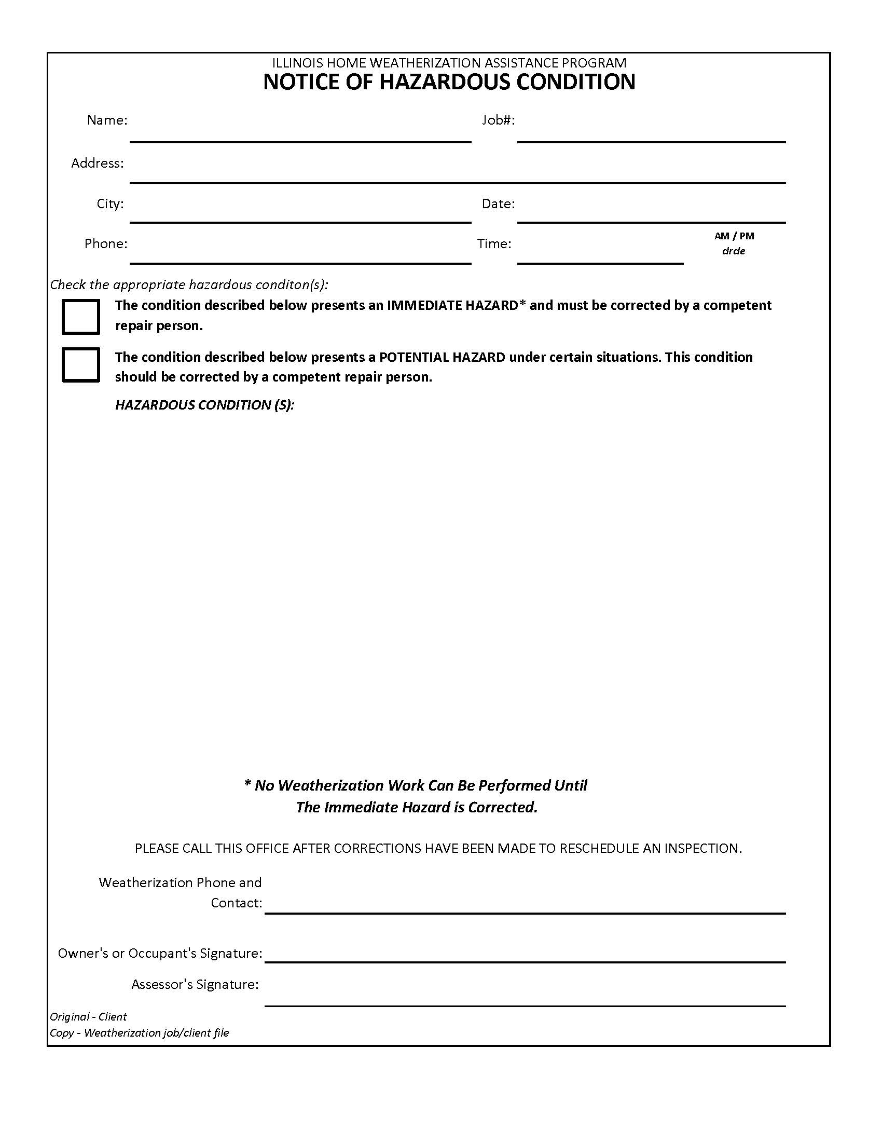
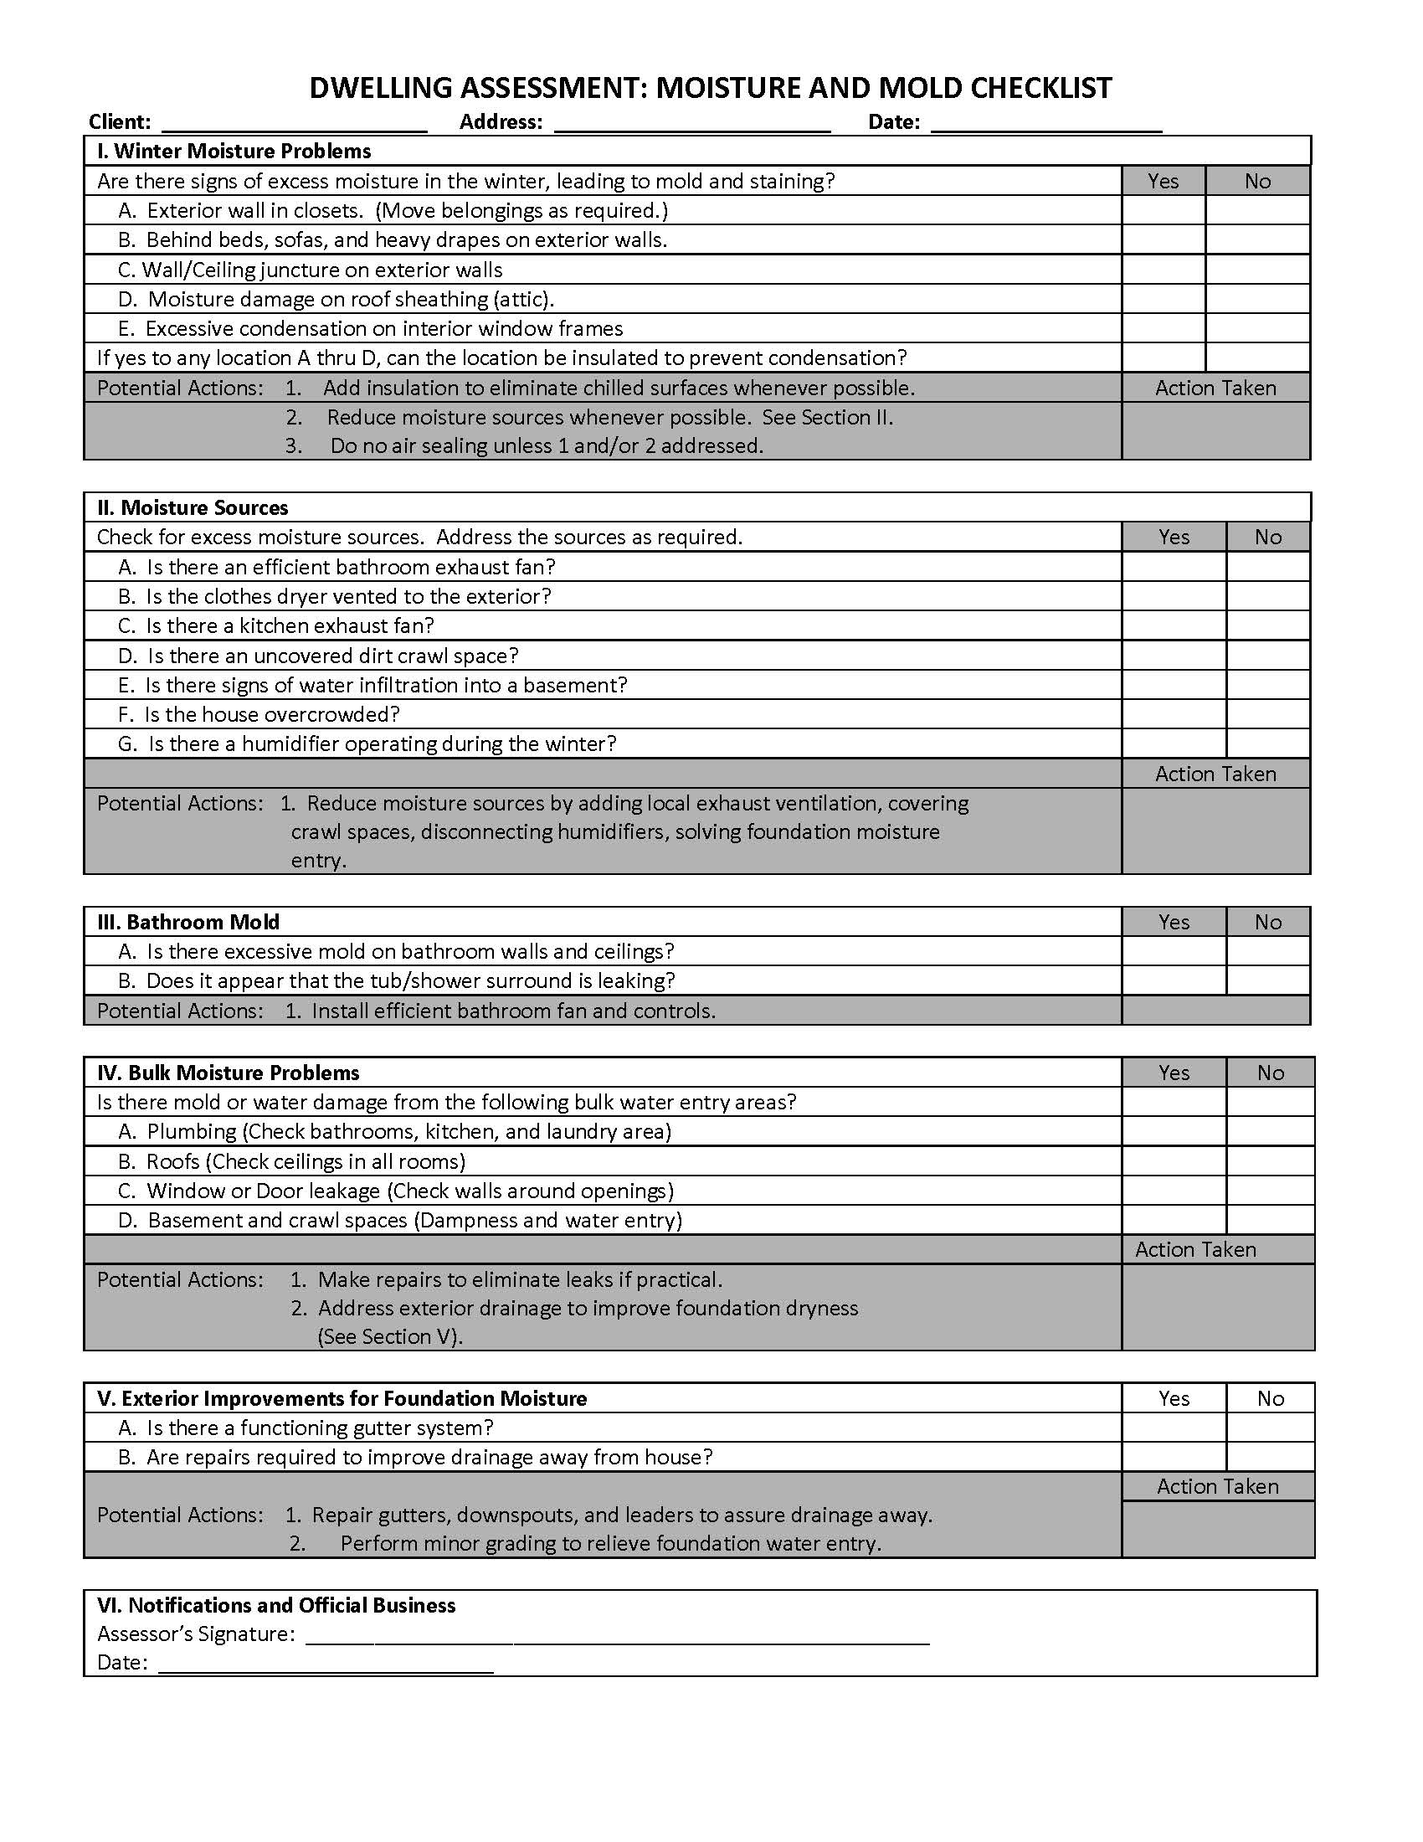
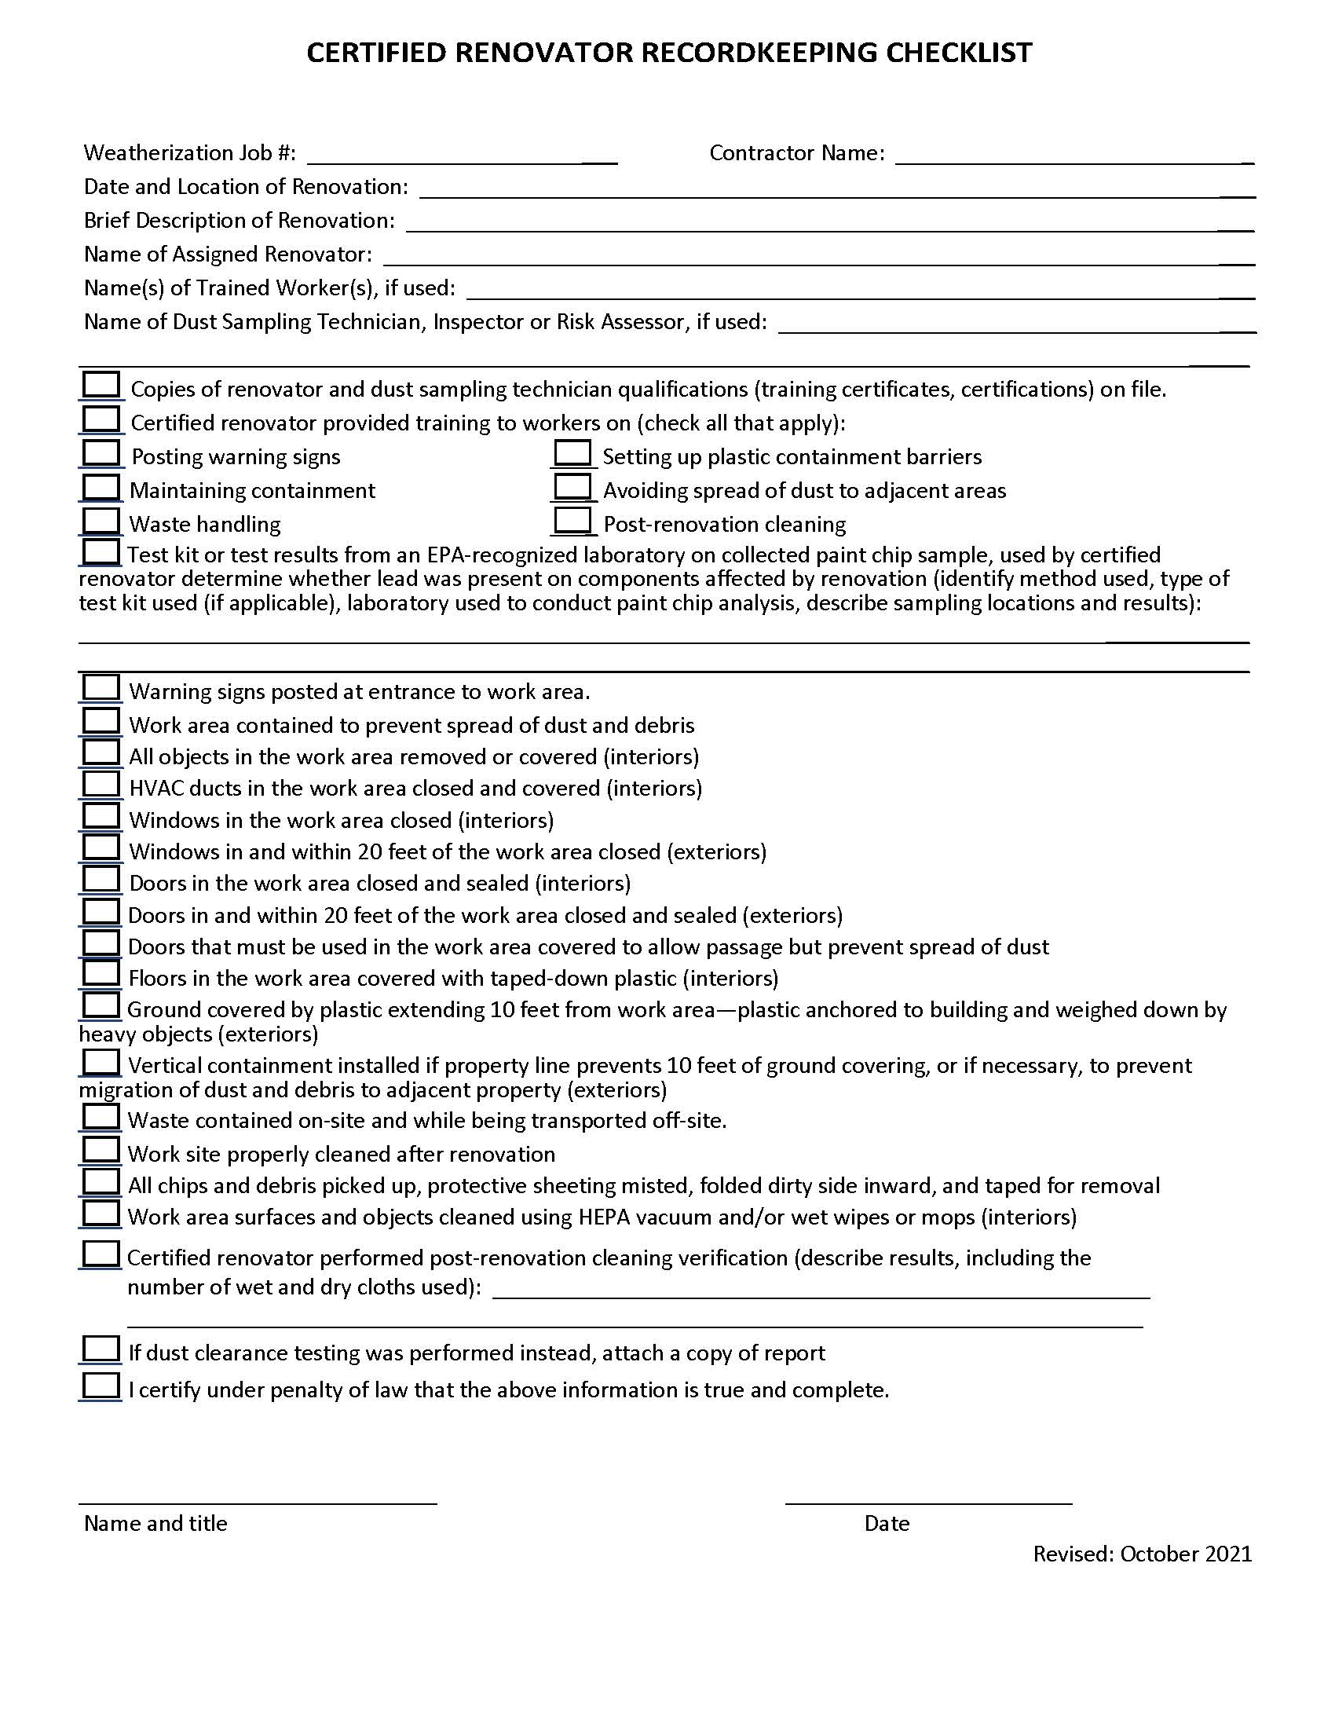
Lead Hazard Pre-Renovation Letter Sample Language
This sample form may be used by renovation firms to document compliance with the Federal pre-renovation education and renovation, repair, and painting regulations.
Occupant Confirmation
Pamphlet Receipt
- I have received a copy of the lead hazard information pamphlet informing me of the potential risk of the lead hazard exposure from renovation activity to be performed in my dwelling unit. I received this pamphlet before the work began.

Printed Name of Owner-occupant

__________________________________________________________________________________________
Signature of Owner-Occupant Signature Date

Renovator’s Self Certification option (for tenant-occupied dwellings only)
Instructions to renovator: If the lead hazard information pamphlet was delivered but a tenant signature was not obtainable, you may check the appropriate box below.
- Declined – I certify that I have made a good faith effort to deliver the lead hazard information pamphlet to the rental dwelling unit listed below at the date and time indicated and that the occupant declined to sign the confirmation of receipt. I further certify that I have left a copy of the pamphlet at the unit with the occupant.
- Unavailable for signature – I certify that I have made a good faith effort to deliver the lead hazard information pamphlet to the rental dwelling unit listed below and that the occupant was unavailable to sign the confirmation of receipt. I further certify that I have left a copy of the pamphlet at the unit by sliding it under the door or by (fill in how pamphlet was left).

Printed Name of Person Certifying Delivery Attempted Delivery Date

Signature of Person Certifying Lead Pamphlet Delivery

Unit Address

Note Regarding Mailing Option – As an alternative to deliver in person, you may mail the lead hazard information pamphlet to the owner and/or tenant. Pamphlet must be mailed at least seven days before renovation. Mailing must be documented by a certificate of mailing from the post office.

IHWAP Radon Informed Consent Form

Weatherization achieves energy and cost savings and improved comfort, health and safety of homes through a variety of home retrofit measures, including some which improve the airtightness of the building. According to the Department of Energy (DOE) sponsored study, “Weatherization and Indoor Air Quality: Measured Impacts in Single-family Homes under the Weatherization Assistance Program,” there is a small risk of increased radon levels in homes when the building air tightness levels are improved. These increases are smaller in manufactured housing everywhere, and all homes in low-radon potential counties, and higher in site-built homes in high-radon-potential counties. There is some evidence that the installation of continuous mechanical ventilation reduces radon levels in homes, and counteracts any radon increases that are due to improved building air tightness levels.
Precautionary Measures: The precautionary measures indicated below will be installed as part of weatherization, when applicable:
- Exposed dirt floors covered and sealed
- Floor/foundation penetrations sealed
- Open sump pit capped
- Crawl space venting inspected and/or improved (unconditioned crawlspaces)
- Other: ________________________________________________

I am aware that weatherization may result in increased levels of radon, and that mechanical ventilation may counteract those increases. I have received the Environmental Protection Agency’s (EPA’s) “A Citizen’s Guide to Radon,” and radon-related risks were discussed. I have chosen to go forward with weatherization and accept all risks of injury or damages.
I have carefully read this informed consent form and have signed it of my own free will.
Client Name: ______________________________________________________________
Client Signature: ___________________________________________ Date: ________________

Illinois Home Weatherization Assistance Program
Air Conditioning/Cooling Medical Condition Verification Form
Please fill out this statement and return to the address listed below:
I certify that ________________________________________________ suffers from an existing serious medical condition which necessitates the need for air conditioning.
Illness or medical condition:

Signature ______________________________________________________________
Name of Title/Degree ____________________________________________________
Practice or Organization Name _____________________________________________
Registration Number _____________________________________________________
Phone Number __________________________________________________________
I hereby authorize this agency to verify that information provided by me and to contact my physician or other public health official for the purpose of securing medical certification as described above.
Name of Applicant Signature of Applicant Date

Social Security Number of Applicant _____________________________________
Completion of this form does not guarantee the repair or installation of central or window unit air-conditioning as a Weatherization activity.
Return form to:
__________________________________
__________________________________
__________________________________
__________________________________

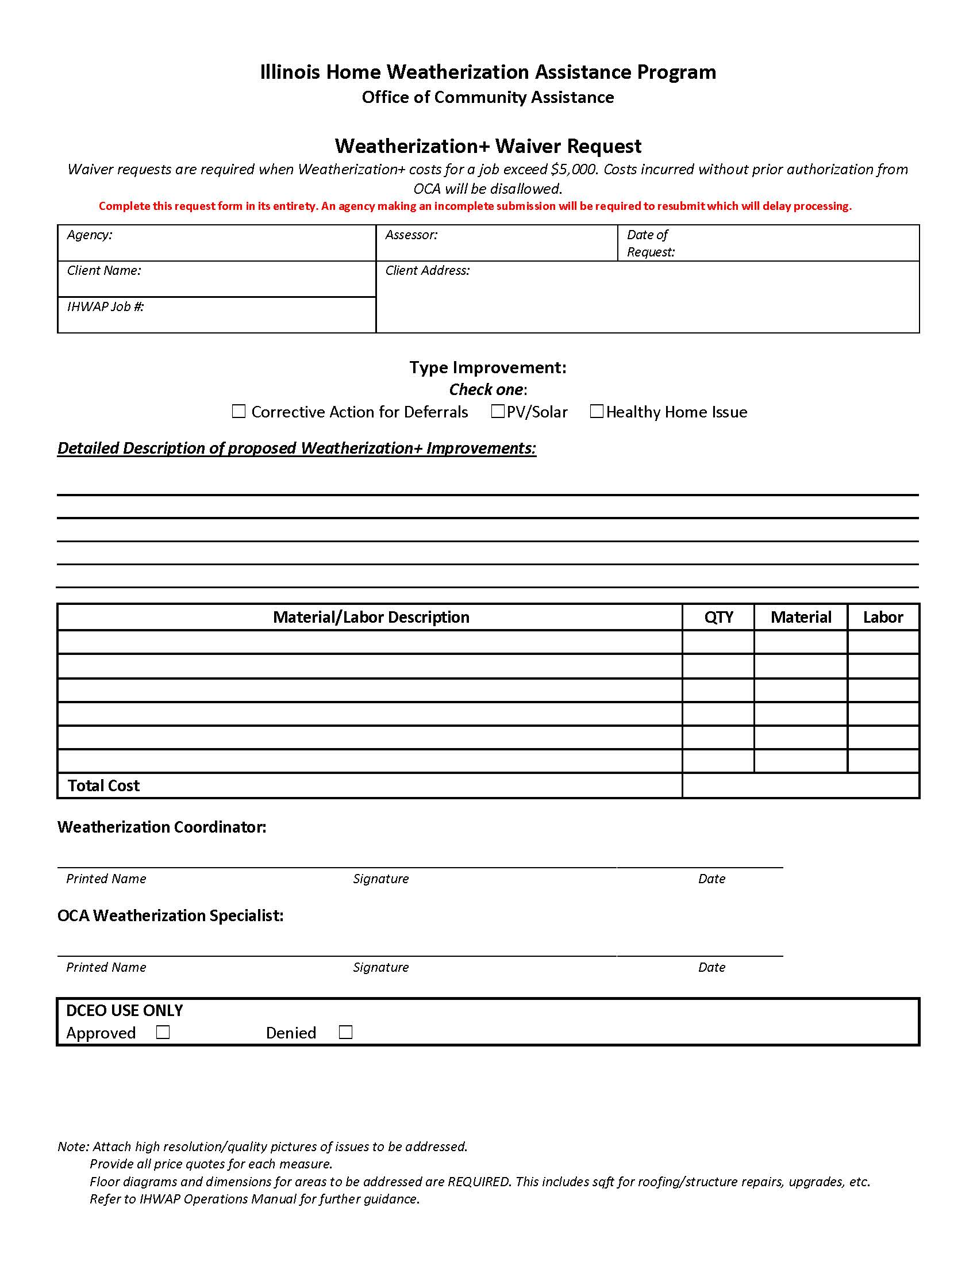

SECTION IX – Final and In-Progress Inspections

QCI-Certification Requirement for DOE Funds
Every DOE weatherized unit, regardless of how much DOE money was spent, will receive a final inspection by a QCI-certified final inspector. This inspection will ensure that the weatherization work was completed properly, that all measures called for in assessment and work orders have been installed and completed in a workman like manner and are in accordance with the priorities determined by the audit procedures, standard work specifications, Illinois Home Weatherization Assistance Program Field Standards Manual, and in alignment with the IHWAP Operations Manual.
QCI Mentorship Approach
Alternatively, OCA supports the QCI mentorship option made available in WPN 22-4. New field staff working towards QCI certification (Mentee) under the mentorship of a certified QCI may perform final inspections and other QCI job tasks, as long as work is reviewed by the certified QCI. LAAs must request a waiver to utilize the mentorship approach. The waiver must address each of the following items:
- The mentee is a Subgrantee/Grantee employee or contractor pursuing QCI certification.
- A timeline and the number of dwelling units for the mentees to complete training and obtain QCI certification.
- At least one designated mentor, agreed upon by OCA and the LAA, who can review field inspections, provide on-the-job training and coaching. The use of video or virtual technology is encouraged.
- All work performed by the mentee is reviewed and attested by a certified QCI which includes the printed names, signatures, certification number (for the mentor) and dated by both the mentor and mentee.
Note: OCA will perform monitoring at several units that were inspected by a mentee to ensure compliance with IHWAP standards and policy.
Evaluating the Assessment
The final inspection process includes the following:
- review of the audit and work scope to determine that the work that was specified was completed, and that any changes to the work scope were approved in advance and properly documented;
- photographs of completed work;
- verification of field measurements and the accuracy of the maps/diagrams;
- verification of the quality and quantity of materials installed;
- verification that installation standards and work quality is acceptable;
- a blower door test to verify final air flow, in units where the test can be safely conducted;
- verification that health and safety tests were conducted and that appropriate mitigation measures were performed;
- a steady-state efficiency test, when necessary;
- client signatures verifying completion of work;
- written notification to owners and occupants of any unsafe conditions; and,

- any additional documentation necessary to explain the outcome of the weatherization project

The final inspection is to be conducted as thoroughly as the assessment, including verifying the measurements of the dwelling by re-measuring it. Final inspectors should look for problems that the crew or contractor may have to correct and check for materials that significantly vary from those assessed. As part of the final inspection process the client satisfaction questionnaire should be completed and signed off by the client. Ask the client for their input, whether suggestions or complaints.
Considering the potential for vandalism, weather-related damage and safety problems, it is required that the final inspection be done on each unit within 15 calendar days, unless a waiver has been granted by OCA, after both the architectural and mechanical system work is completed. The final inspection cannot proceed until the Work Order and support documentation for work completed has been returned to the Local Administrative Agency (LAA) by the weatherization contractor, a final inspection cannot be completed without an invoice and other required contractor paperwork.
To ensure an objective final inspection is completed on every home, the person performing the final inspection cannot be the same person who completed the assessment; unless the agency has received a written waiver from the DCEO/OCA allowing this action. A waiver for this will require the agency to identify a plan to ensure that the quality and integrity of assessment and final inspection are maintained. The waiver must be renewed annually. Under no circumstances, may the final inspection be done by any person who performed the work.
- An objective final inspection, ensuring the weatherization work completed conforms to IHWAP policy and rules, is a procedure unique to the weatherization program that guarantees the IHWAP weatherization work will deliver energy savings with reduced indoor environmental risk to the residential households the program serves.
- Work that was not installed to standards or energy and health and safety measures that were missed at assessment or installation must be corrected before an IHWAP weatherization job is complete.
- The final inspection must be objective and thorough.
The following Final Inspection Forms must be completed and included in the Client File:
- Final Inspection Detail Report This checklist form ensures that the Final Inspector has reviewed each section of the weatherized home and must complete in full for each home weatherized. This form should guarantee that the agency has reviewed its weatherization work as completed as an outsider reviewer would. Photo documentation is required to support the final inspection process, as during the assessment process.
- Results from the Final Inspection are to be uploaded into SharePoint by accessing the OEA Extranet and going into the Weatherization Quality Control Reviews Tab:
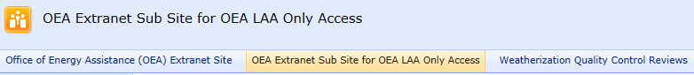

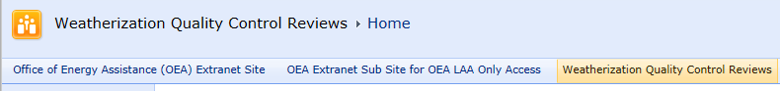
- Photo Documentation Failures and deficiencies require clear color digital photographs highlighting the failure or deficiency as noted. The photographs are sent with callback and/or rework notice(s) to contractors or crews.
  - A copy of the callback/rework notice with digital photographs must be maintained in the client file even after rework has been completed and re-inspected.
- Final Inspection Summary is a review of the work with the client and a summary checklist that ensures that all phases of the Final Inspection and that all post weatherization diagnostic readings are complete. This form requires review and signature and final inspector completion and signature.
The Final Inspector’s job is to ensure that:
- The Assessor has correctly assessed each building section in accordance with the IHWAP Assessment procedures (see, Illinois Home Weatherization Assistance Program, Assessment/Energy Audit Manual, Volume IV).
- The work completed has been accomplished to a "workmanlike standard" in accordance with the quality control standards and specifications set forth in Volume III Illinois Home Weatherization Assistance Program, Field Standards Manual.
- The Work Order, any Change Orders, the contractors’ invoices, and the work installed correspond and that nothing has been omitted or missed. This process also ensures that materials applied, labor, and actual costs for the unit are accounted for and checked off by the crew/contractor on the Architectural and Mechanical Work Orders.
  - For HVAC work, the final inspector will review the Mechanical Contractor Checklist for completeness.
- A post-work efficiency test with the flue gas analyzer (if applicable to the fuel source) is conducted on the heating and domestic hot water distribution systems and is entered on the Final Inspection Summary Report.
- The Final Inspector is to attach the final Flue Gas Analyzer readings to the Final Inspection Summary Report, and a copy is to be attached to the heating system and the water heater.
- If the fuel source is natural gas, the meter must be clocked, and measured input entered on the Final Inspection Summary Report as well.
- The final inspector will also make a final diagnostic reading with the blower door and compare it to the pre-weatherization and interim readings.
  - In instances where the air sealing target is not met the final inspector must make a determination whether additional air sealing opportunities exist and if cost effective measure can be made to reduce the infiltration.
    - If yes, the callback /change order process must occur before final inspection can be completed.
    - The procedures for conducting these tests are listed in Volume III Illinois Home Weatherization Assistance Program, Field Standards Manual.

Evaluating and Confirming the Initial Assessment
The Final Inspector must review the assessment document and the home weatherized to verify the assessment was done properly. Any section of the assessment document not completed indicates the Assessor failed to conduct a full assessment. Notes on any assessment deficiencies found should be entered both in WeatherWorks audit database in the section applicable to the building.
- In cases where the Assessor did not complete a full assessment of the unit the final inspector is to return the assessment document to the Assessor for completion of the assessment or complete the assessment themselves.
  - Every LAA is required to have a process where assessment deficiencies are tracked and communicated to the assessment staff for continual improvement and elimination of incomplete assessments.
- If a Change Order is required, and project budget permits, additional assessment information is entered into the WeatherWorks Energy Audit and the assessment information is recalculated for SIR. A supplemental Work Order (Change Order) is then generated to address the missing weatherization measure(s).
  - The supplemental Work Order is attached to the original Work Order and becomes part of the Client File. The weatherization crew/contractor is provided the Change Order to complete any additional measure(s) that the WeatherWorks Energy Audit calculated to be installed.
- In instances where no program funds remain to complete the needed measures the Local Administrative Agency will pay for the measure with agency funds.
Required Documentation Review Prior To Final Inspection
The Final Inspector must insure the weatherization crew/contractor has submitted all of the required documentation regarding the work completed before the final inspection.
- The Final Inspector must complete a comprehensive file review of the Client File. If documents are missing, the final inspector notifies the contractor or weatherization crew.
- Final inspection of a weatherization job cannot begin until the missing documentation is submitted and reviewed. The required documentation and definitions by Mechanical Contractor and Architectural Crew/Contractor are listed below:

Mechanical Documents
- Mechanical Work Order - Weatherization measures to be completed by the Mechanical Contractor are printed in list form on a “Work Order”. The Work Order provides cost estimates for each weatherization measure and summarizes total costs by category. There is an “Estimated Grand Total” at the bottom of the work order that provides an estimated total cost for the job. When estimated costs have not changed “Estimated Grand Total” becomes “Actual Grand Total”. The “Actual Grand Total” must be the exact same as the grand total of the mechanical contractor invoice.
  - Where changes to the work order effect material and labor costs the work order must be manually reconciled to insure the “Actual Grand Total” is correct. Verification of the approved change order(s) must be completed. When a weatherization measure is completed a checkbox is “checked” by the contractor next to the measure to indicate completion. The final Inspector also checks a box next to the measure to indicate final review.
  - All of the “completion” and “final inspection” checkboxes must be checked to show completion and final inspection before costs of the home are reported.
  - The Final Inspector is required to initial and date the work order below the “Actual Grand Total” of the approved final inspection as a certification of the charges.
- Mechanical Change Order document(s) – There are certain circumstances where the mechanical contractor cannot install a weatherization measure listed on the Work Order, or a measure needs to be added.
  - When changes to the Work Order are needed the mechanical contractor must first obtain permission to make the change by contacting the Local Administrative Agency (LAA). Making changes to the Work Order is known as the “Change Order Process”. A “Change Order” is only required when there is a substantial change from the Work Order. Minor changes can be simply noted on the Work Order. The contractor will write an explanation of the change in the “Building Section” of the measure. The explanation will identify the measure modified, who the crew/contractor contacted to authorize the change, date of change, and the amount of labor and material dollars added or deleted. The crew/contractor will also initial the explanation (see example in Forms and Exhibits section).
  - Adding substantial cost to a retrofit or adding a retrofit measure will require a recalculation of the SIRs prior to approving a change order request. This is necessary to ensure the current Work Order SIR and measure SIR are in program compliance.
  - A thorough assessment should not result in a substantial number of change orders. If final inspector(s) note an inordinate amount of change orders, the assessment process shall be evaluated.
  - The process includes the completion of a “Change Order Document” that must be submitted to the LAA upon completion of the weatherization work. The LAA will place the change order document into the client file. The document will list the measure(s) subtracted or added to the Work Order with the labor and material costs for each measure stated separately. The bottom of the change order must provide a “Grand Total” providing the sum balance of all changes.
  - Weatherization measures listed on change orders must be reconciled with the work order. The Work Order must reflect the information on the Change Order(s).
    - For example: If the Change Order subtracts a weatherization measure from the Work Order a notation must be made on the Work Order at the location of the measure as to who at the LAA authorized said change and the date of the measures’ deletion. With the measure deleted from the Work Order the total costs for the category in which the measure appeared would be overwritten with a new total cost. If a weatherization measure is added, the measure is to be written in at the location on the Work Order where it would appear. The written measure would include the description, labor and materials costs, and name and date of the LAA staff authorizing it. The category for the added weatherization measure would include the new total.
- Mechanical Invoice - The mechanical contractor is to submit an invoice summarizing, by labor and material, the cost of each measure applied to the home. The costs summaries of the invoice are to match the detail and costs summary of each measure on the Work Order.
    - For example: The replacement furnace on the Work Order states the summary cost for furnace labor is $500.00 and summary costs for material is $950.00. The invoice would say “Installed 80,000 BTU 90% EFI (Make/Model/Serial Number) Furnace” with the labor column showing $500.00 and the material column showing $950.00. The invoice is to also show a “Grand Total” at the bottom which is to match the “Grand Total” of the mechanical Work Order.
- Assurance and Guarantee of Work - Labor and materials applied to client homes are guaranteed for one year starting on the approved final inspection date. The guarantee is valid for one year where there is no misuse by the client of weatherization services (breakage, etc.).
  - The Assurance & Guarantee of Work document does not supersede any manufacturer warrantee for a weatherization measure guaranteed beyond the twelve-month period. The Assurance and Guarantee of Work document is a required document that must be completed by the Mechanical Contractor, with the original document given to the owner of the property and a copy, or duplicate, placed in the client file.
- Release of Lien - a master copy must be placed in each procurement award file. We no longer require that the contractor/vendor complete the release on a per job basis. This form will no longer be required in the client file.
- Mechanical Contractor Checklist - The mechanical contractor will document the condition of the heating system with the Mechanical Contractor Checklist by taking various readings and measurements outlined on the checklist. Corrective repairs or replacement of the heating system may be determined by the results of the readings and measurements.
  - The Mechanical Contractor Checklist must be entirely completed and signed by the Mechanical Contractor completing the work for every heating system installed.

Architectural Documents
- Architectural Work Order - Weatherization measures to be completed by the Architectural Contractor/Crew are printed in list form on a “Work Order”.
  - The Work Order provides cost estimates for each weatherization measure and summarizes total costs by category. There is an “Estimated Grand Total” at the bottom of the work order that provides an estimated total cost for the job.
  - When estimated costs have not changed “Estimated Grand Total” becomes “Actual Grand Total”. The “Actual Grand Total” must be the exact same as the grand total of the Architectural Contractor invoice.
  - Where changes to the work order effect material and labor costs the work order must be manually reconciled to insure the “Actual Grand Total” is correct.
  - Verification of the approved change order(s) must be completed. When a weatherization measure is completed a checkbox is “checked” by the contractor next to the measure to indicate completion.
  - The final Inspector also checks a box next to the measure to indicate final review. The Final Inspector is required to initial and date the work order below the “Actual Grand Total” of the approved final inspection as a certification of the charges.
  - The “Intermediate Blower Door Number” must be written on the first page of the Work Order or documented on the Contractor’s Intermediate Blower Door Form.

- Architectural Change Order document(s) - There are certain circumstances where the Architectural Contractor cannot install a weatherization measure listed on the work order, or a measure needs to be added. When changes to the work order are needed the Architectural Contractor must first obtain permission to make the change by contacting the Local Administrative Agency (LAA). Making changes to the work order is known as the “Change Order Process”.
  - A “Change Order” is only required when there is a substantial change from the Work Order. Minor changes can be simply noted on the Work Order. The contractor will write an explanation of the change in the “Building Section” of the measure. The explanation will identify the measure modified, who the crew/contractor contacted to authorize the change, date of change, and the amount of labor and material dollars added or deleted. The crew/contractor will also initial the explanation (see example in Forms and Exhibits section).
  - Adding substantial cost to a retrofit or adding a retrofit measure will require a recalculation of the SIRs prior to approving a change order request. This is necessary to ensure the current Work Order SIR and measure SIR are in program compliance.
  - A thorough assessment should not result in a substantial number of change orders. If final inspector(s) note an inordinate amount of change orders, the assessment process shall be evaluated.
  - The process includes the completion of a “Change Order Document” that must be submitted to the LAA upon completion of the weatherization work. The LAA will place the change order document into the client file. The document will list the measure(s) subtracted or added to the work order with the labor and material costs for each measure stated separately. The bottom of the change order must provide a “Grand Total” providing the sum balance of all changes. Weatherization measures listed on Change Orders must be reconciled with the Work Order. The Work Order must reflect the information on the change order(s).
    - For example: If the change order subtracts a weatherization measure from the work order a notation must be made on the work order at the location of the measure as to who at the LAA authorized said change and the date of the measures’ deletion. With the measure deleted from the work order, the total costs for the category in which the measure appeared would be overwritten with a new total cost.
If a weatherization measure is added, the measure is to be written in at the location on the work order where it would appear. The written measure would include the description, labor and materials costs, and the name and date of the LAA staff authorizing it. The category for the added weatherization measure would include the new total.

- Architectural Invoice - The architectural contractor/crew is to submit an invoice summarizing by category (windows, doors, etc.) the cost of labor and materials applied to the home.
  - The costs summaries of the invoice are to match the costs summaries of each category on the work order.
    - For example: The windows category on the work order states the summary cost for window labor is $100.00 and summary costs for window material is $250.00. The invoice would say “window work” with the labor column showing $100.00 and the material column showing $250.00.
If there are detailed questions about the type of window work completed for the summary costs refer to the Work Order. The invoice is to also show a “grand total” at the bottom which matches the “grand total” of the architectural work order.
- Assurance and Guarantee of Work - Labor and materials applied to client homes are guaranteed for one year starting on the date of the signed final inspection.
  - The Contractor’s Assurance & Guarantee of Work does not supersede any manufacturer warrantee that extends beyond the twelve-month period.
  - The document used to provide the guarantee is the Assurance and Guarantee of Work.
  - The Architectural Contractor must complete an Assurance and Guarantee of Work document, give the original document to the owner of the property, and give a copy or duplicate to the LAA for placement in the client file.

- Release of Lien - a master copy must be placed in each procurement award file.
  - We no longer require that the contractor/vendor complete the release on a per job basis.
    - This form is no longer required in the client file.
- Intermediate Blower Door measurement - Architectural Contractors complete work on homes that seal interior air bypass openings to the outside. Air Sealing Measures eliminate or reduce air movement through the thermal/pressure barrier of the home.
  - The Architectural Contractor’s work order will identify the openings to be sealed. After sealing the openings identified in the work order the Architectural Contractor will make at least one blower door measurement with a manometer to determine the success of the air sealing work that was completed.
  - The “Intermediate Blower Door Number” must be written on the first page of the Work Order or documented on the Contractor’s Intermediate Blower Door Form.
- The Intermediate Blower Door measurement must also be entered into the “Blower Door” tab of the WeatherWorks Energy Audit before the home can be closed and reported. If the Intermediate Blower Door measurement could not be completed a notation on the first page of the Work Order explaining why will be provided by the Contractor.
Note: If the air sealing target determined in the Assessment is not met, the contractor must use the blower door for guided air sealing measures in an attempt to meet or exceed the target. (See Illinois Home Weatherization Assistance program – Field Standards Manual, Section 200 –Architectural Standards, Subsection 2121 – Testing).
- Additional documents as required by the Local Administrative Agency (LAA), State and/or Federal Regulations.
  - Before arriving on-site, the Final Inspector must review the work order before the final inspection begins to insure it is completed correctly and to become familiarized with the weatherized home.
  - If the work order indicates weatherization measures were not completed, and there is no supporting documentation explaining why the work was not completed, return the work order to the contractor for completion of the weatherization measures.

Verification of Work Order Completion. The final inspector must review the Work Order before the final inspection begins to insure it has been completed correctly. Below is a list of items to look for:
- Have all of the completion check boxes been checked?
- Has the labor and material for each weatherization section been tallied?
- Has the total labor for the job been written at the bottom of the Work Order?
- Has the total material for the job been written at the bottom of the Work Order?
- Has a grand total for labor and material been written at the bottom of the Work Order?
- If a change was made to the Work Order, were a date, time, and name of the LAA staff authorizing the change written on the Work Order?

The Final Inspector verifies the work called for on the assessment input document and then checks the work that has actually been done. If procedures were not followed, check to see if:
- The audit was entered correctly
- The field measurements are accurate
- Ayn unforeseen problem(s) was/were documented when the work was attempted
- The assessment was wrong
- The work was incomplete
- There were no significant reductions in the blower door readings
  - If any of the last three items apply, a call-back and/or change order is required.

Verification of Completed work. Determine whether completed work meets the standards and specifications indicated in the Illinois Home Weatherization Standards Field Manual. In most cases, the job of the final inspector will be to determine that the assessment and data entry were correct, and the weatherization measures on the Work Order and invoice have been installed correctly.
- Where the work is clearly unacceptable a call-back must be ordered. In circumstances where there is a question of whether a completed measure meets quality control standards, document the measure in question and discuss it with the contractor/crew completing the work. Locate the measure in the quality control standards and review call back or questioned measures with the contractor/crew.

Accounting for the Work. Materials applied and actual costs must all be accurately accounted for. The final inspection is the last opportunity to make changes to the weatherization work. Therefore, it is his/her responsibility to ensure these items are correctly and safely installed.
- The correct numbers and costs are to be entered on the Work Order and placed in the file. The Contractor’s invoice must be detailed and broken out by measure in the same order and format as the Work Order. These figures are the basis for reporting to the Department.

Work Order Check-off. The final inspection should include verifying and comparing the work order, change orders, the contactor’s invoice and the work installed. After comparing the documents to the work inspected and verifying that the work installed complies with IHWAP standards and procedures, the final inspector should check off each item on the Work Order.
- The goal of this process is to be the final check for high quality weatherization work. OCA can review only a percentage of an LAA’s weatherization work. It is the final inspector who has the last chance in the IHWAP process to detect and correct problems with the completed job.

Completing the Final Inspection Detail Report and the Final Inspection Summary Report. The final inspector completes the Final Inspection Forms only after any and all call-back work has been successfully completed. These forms should be completed in the presence of the client/owner. Every effort must be made to fully inspect the unit and to obtain the client/owner's signature on the Final Inspection Summary Report.
- A copy of this form is to be left with the client and the original placed in the Client File.
- The Final Inspector is to attach the final Flue Gas Analyzer readings to the Final Inspection Summary Report and a copy is to be attached to the heating system. The Final Inspector is to ensure that the Final Blower Door reading is entered on the Final Inspection Summary Report and on the cover page of the Final Work Order.
  - In the event that repeated trips to the home do not result in a final sign-off, the agency must document the efforts made and attempt to get the client/owner's signature via certified mail. Retain a copy of the letter sent to the client/owner requesting a final inspection date and/or signature on the Final Inspection Summary Report. If the agency does not receive a response from the client/owner, the home may be reported as final inspected, using the date of actual inspection, or the date the response to the letter was due back in the agency.

In-Progress Inspections
In-Progress Inspections have always been considered a best practice and are now being incorporated in the IHWAP on a percentage of weatherized units. In an effort to comply with WPN 17-7 Health and Safety Guidance, Local Agencies will now be required to complete in-progress inspections on 20% of their IHWAP production. Local Agencies must document the inspection in the client file and track the inspections in a spreadsheet that may be reviewed by OCA Monitoring Staff. An In-Progress Inspection may be performed by any TCP Certified employee. In-progress inspections will provide the contractors with real-time feedback and give local agencies an opportunity to provide hands on training while the work is being conducted.
An In-Progress Inspection includes a review of the following when applicable:
- OSHA Construction Regulations, local agencies are not the “OSHA Police”, but should pay attention to worker safety. If you see a crew member in clear violation of OSHA Construction Regulations, provide constructive guidance to the workers and document the training.
- EPA/Lead Renovator, local agencies are also not the “Lead Police” but have a responsibility to the clients and crew members. If you see a clear violation of lead safe work practices, provide constructive guidance to the workers, and document the training.
- IHWAP Field Standards, local agencies are the “IHWAP Field Standards Police”, when you see a completed task or task in-progress that does not comply with IHWAP Field Standards, provide constructive guidance to the workers, and document the training.

FORMS AND EXHIBITS for SECTION IX - FINAL INSPECTION

Final Inspection Detail Report ………………………………………………. Page 152
Final Inspection Summary .. Page 154
Client Satisfaction Questionnaire………………………………………….. Page 155
In-Progress Inspection Report……………………………………………….. Page 159
Weatherization Callback / Rework Notice …………………………….. Page 161
Contractor Assurance & Guarantee of Work Page 162
Contractor Release of Lien ……………………………………………………. Page 163
Change Order Request Page 164
Example of Change Order Documentation Page 165

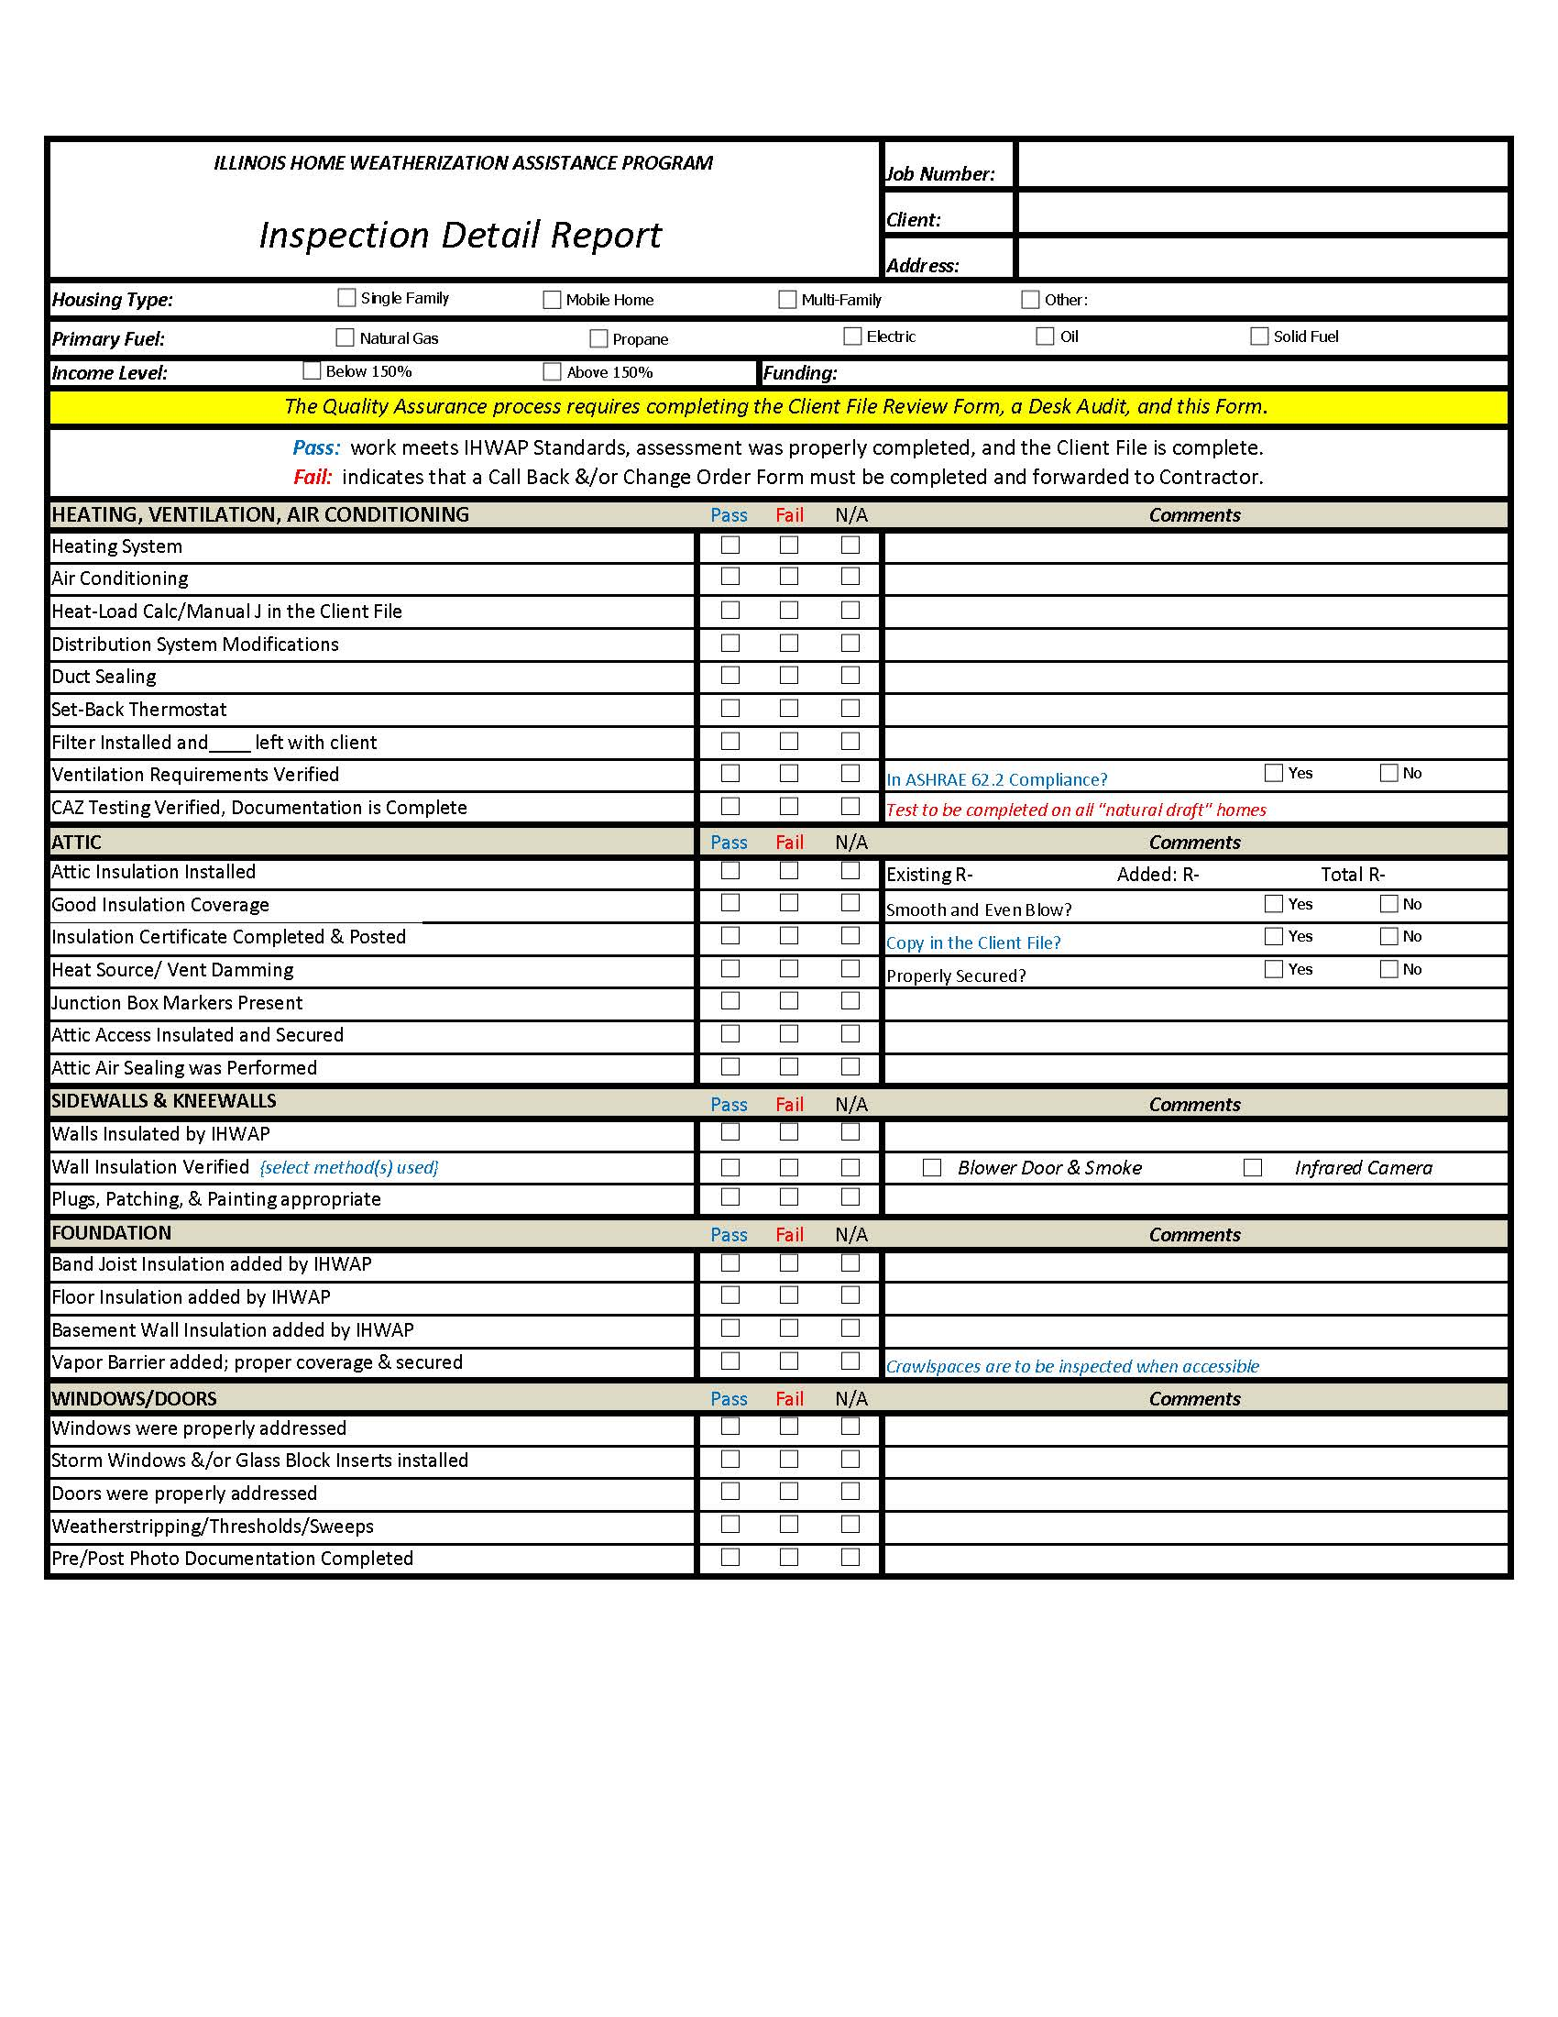

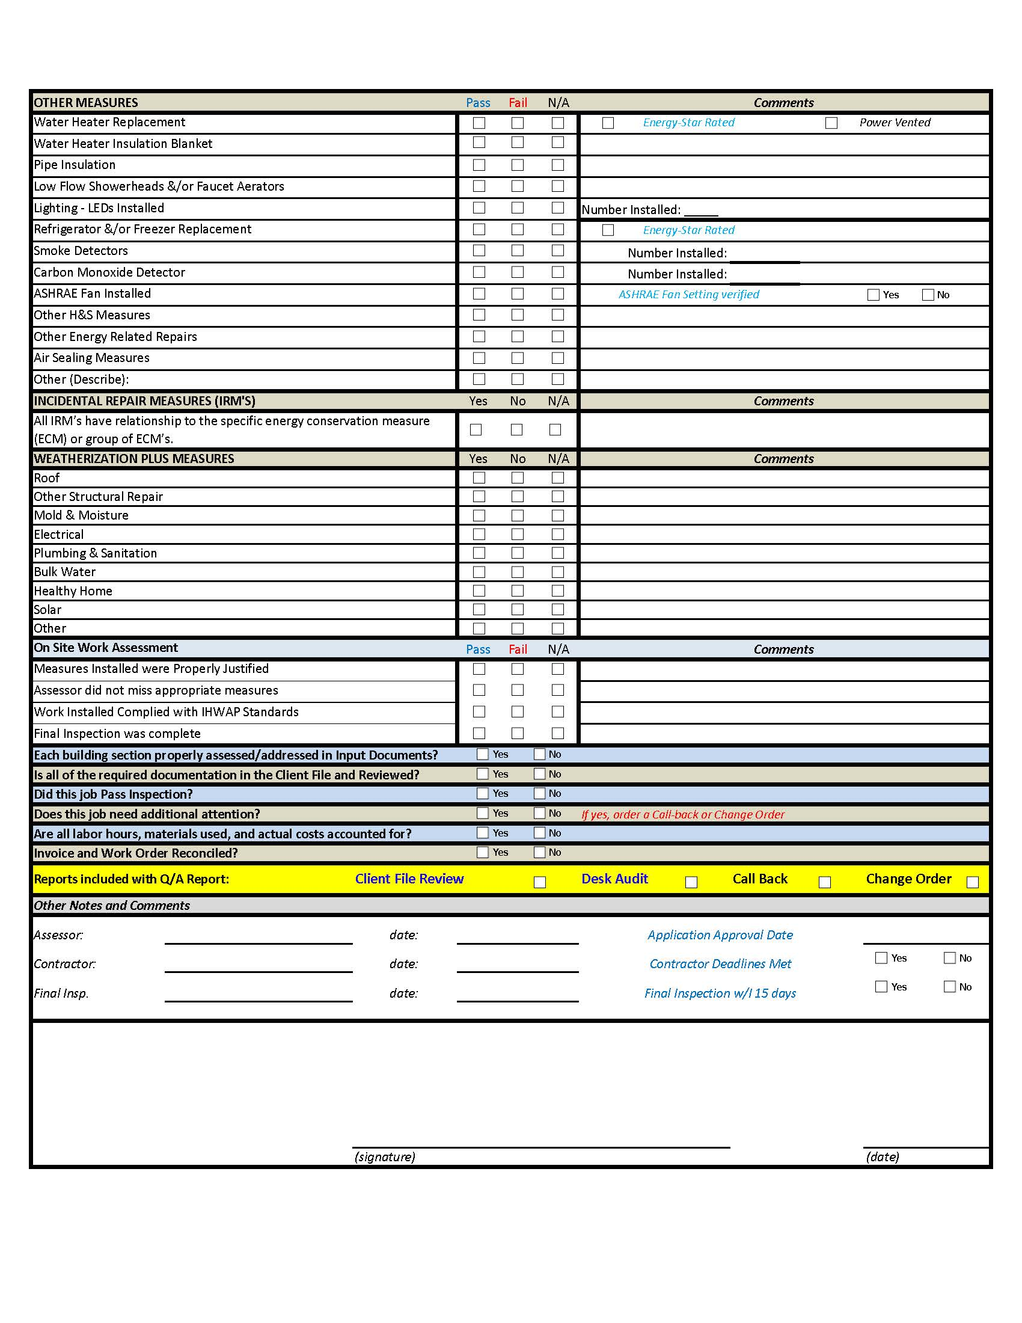

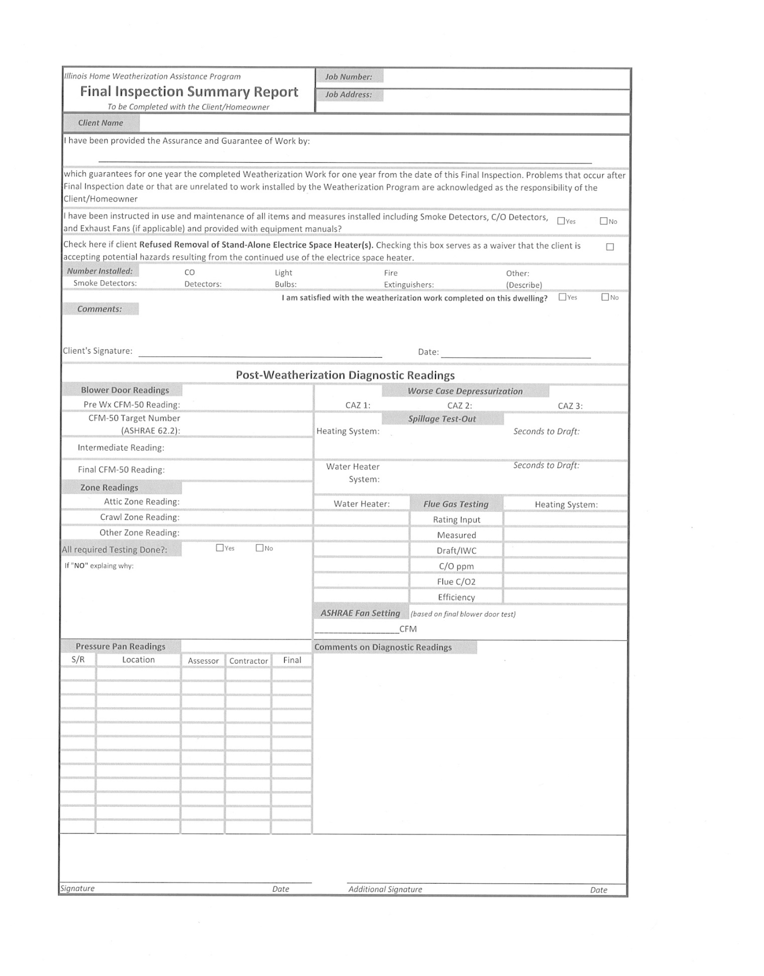
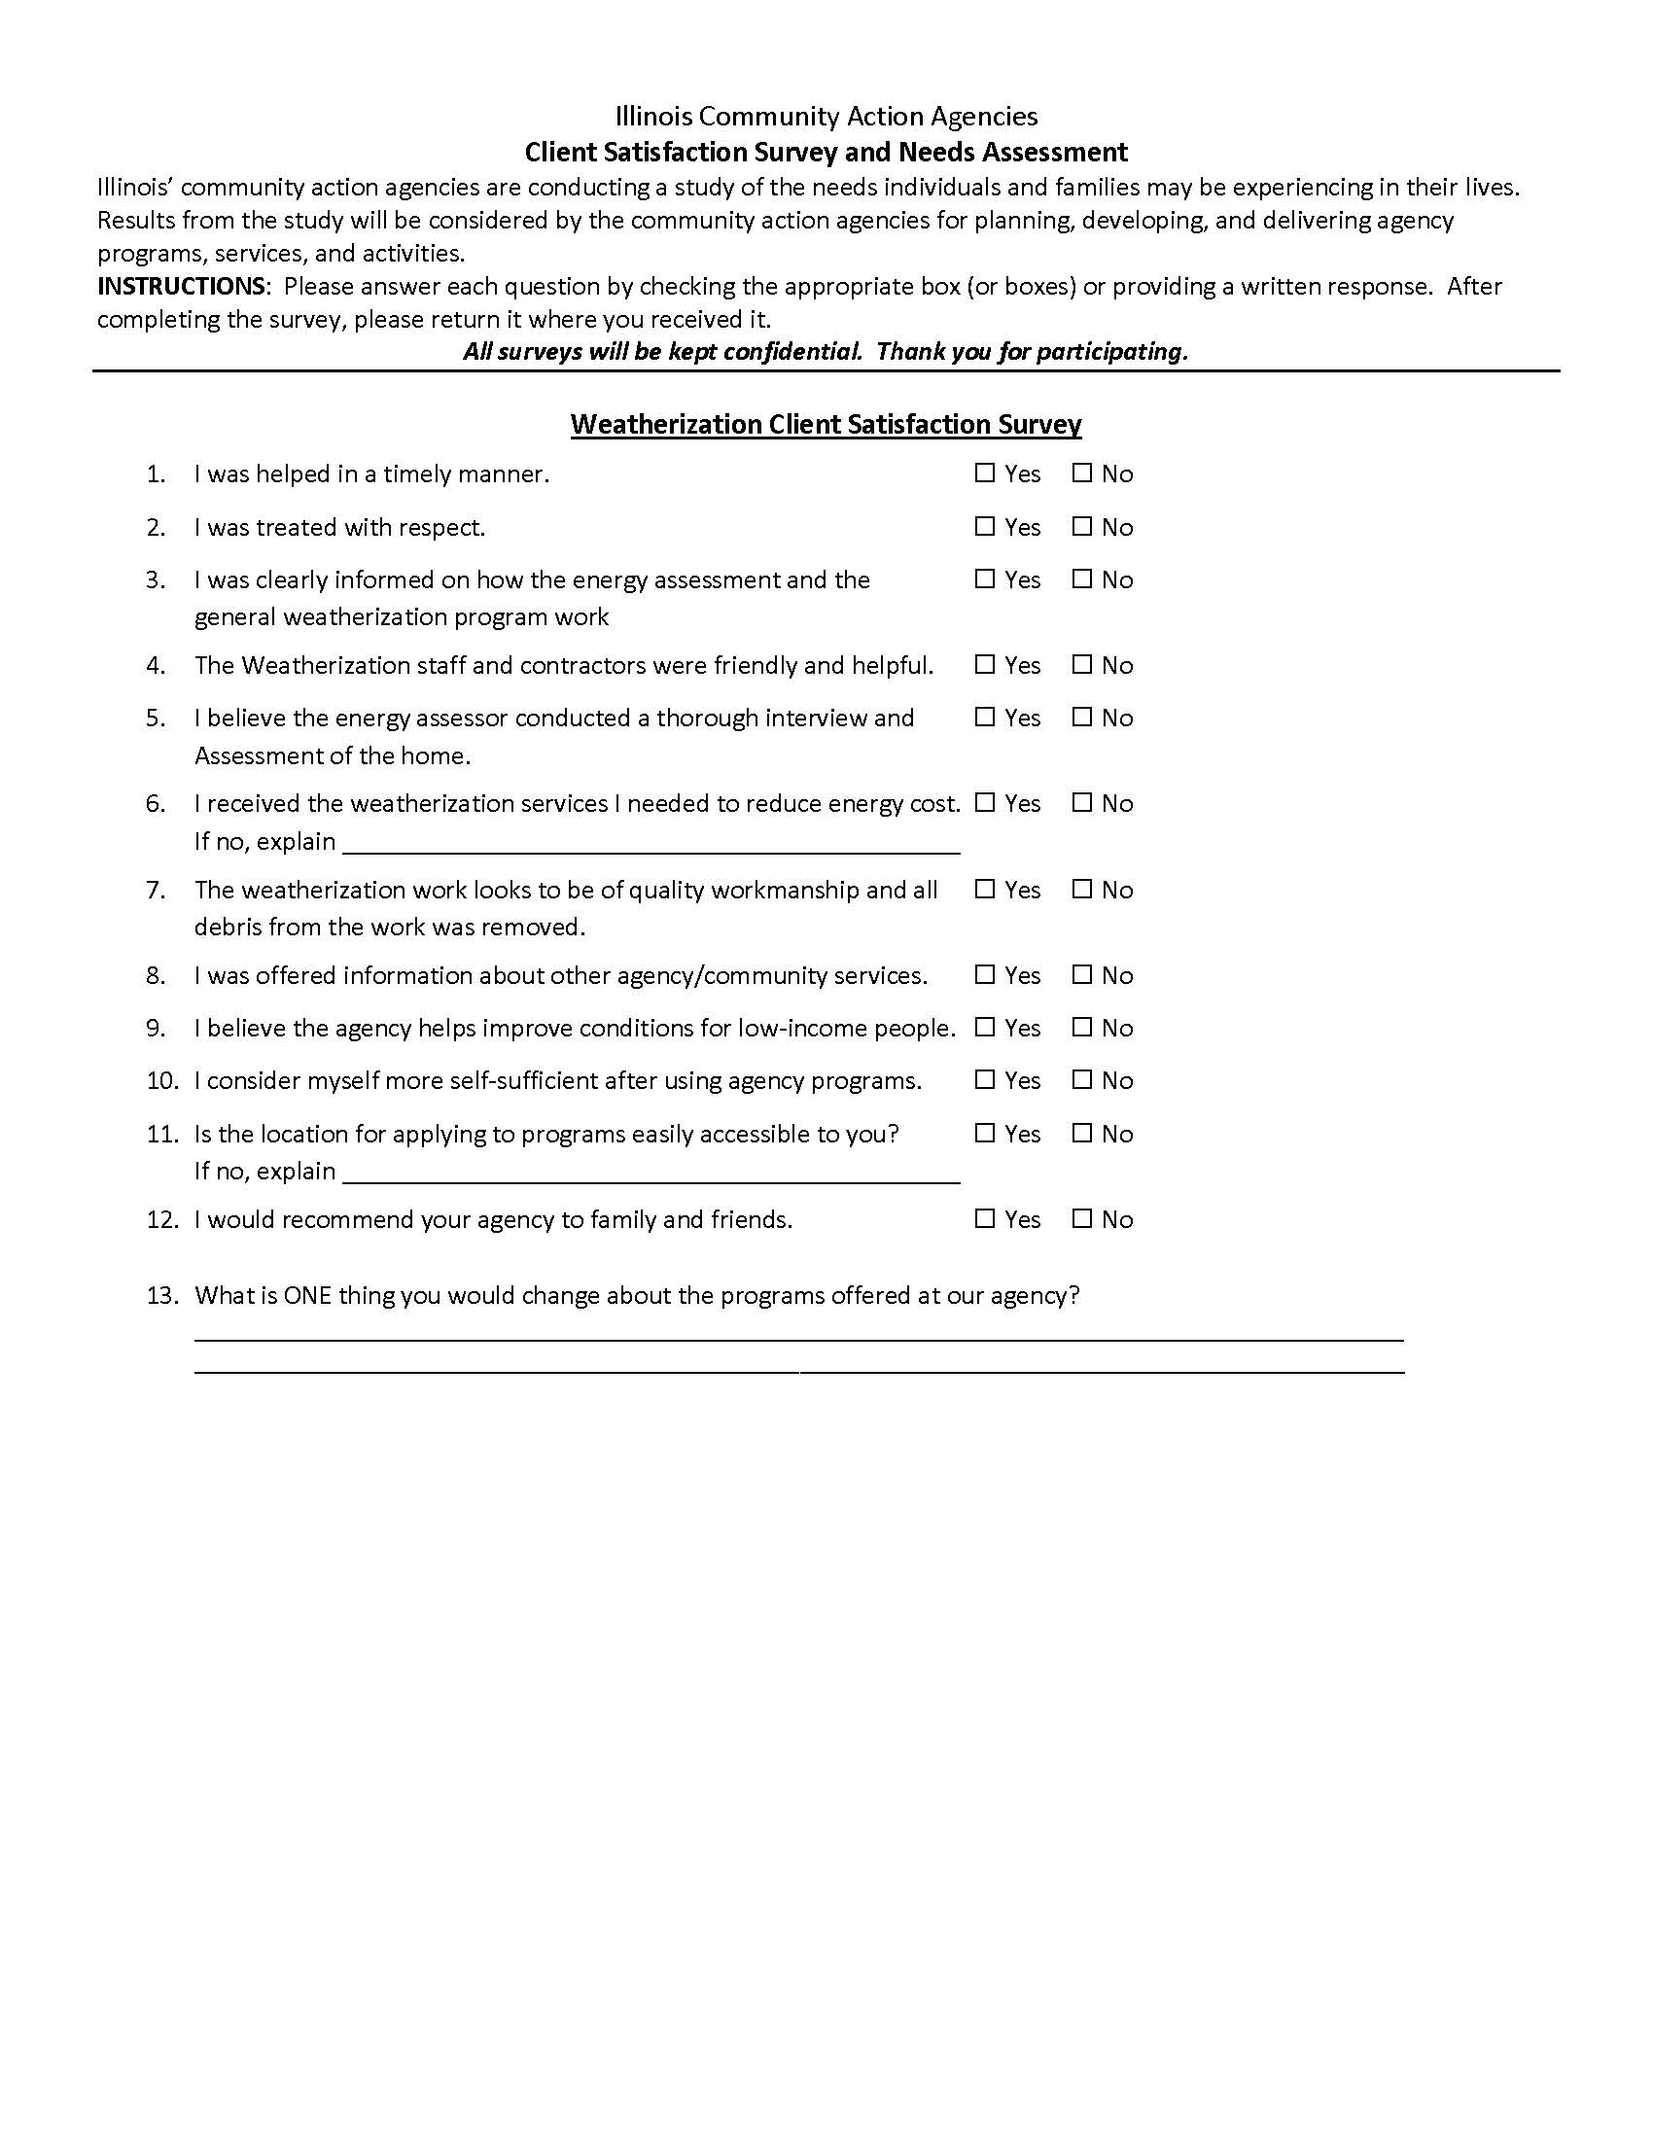

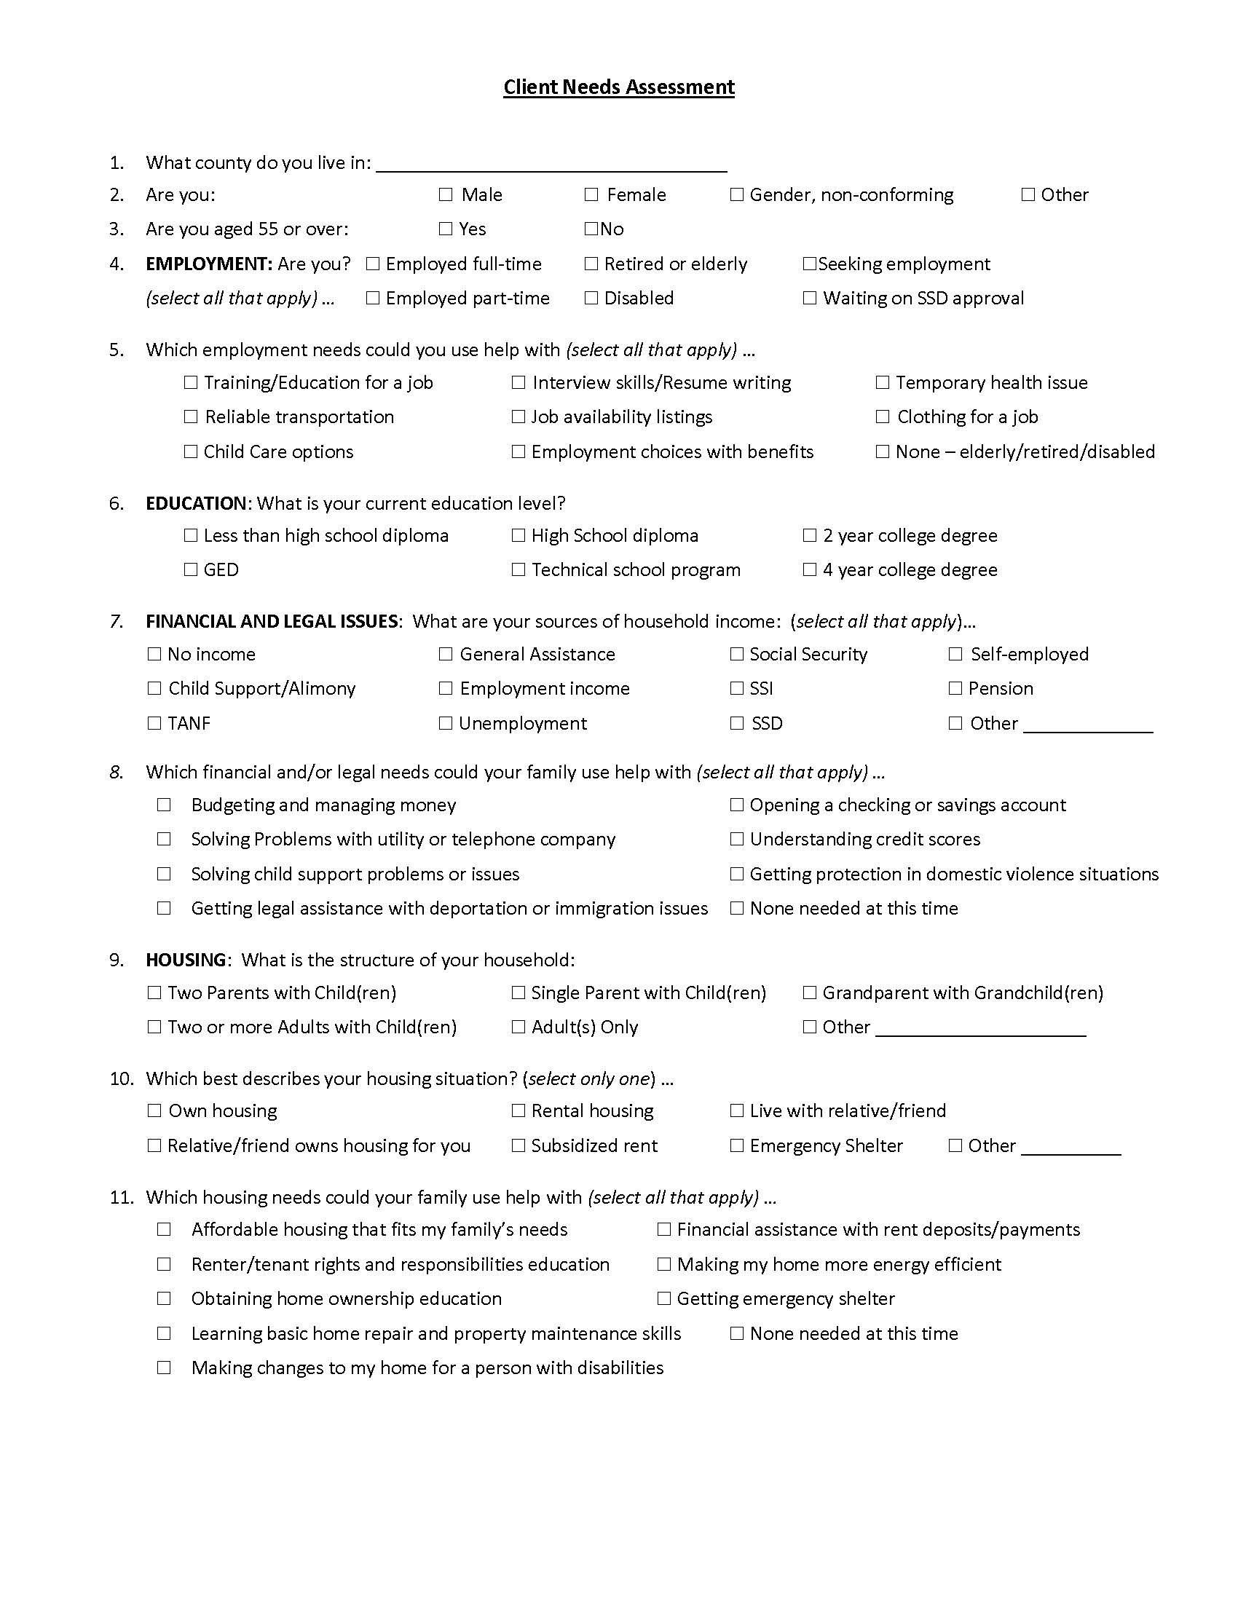
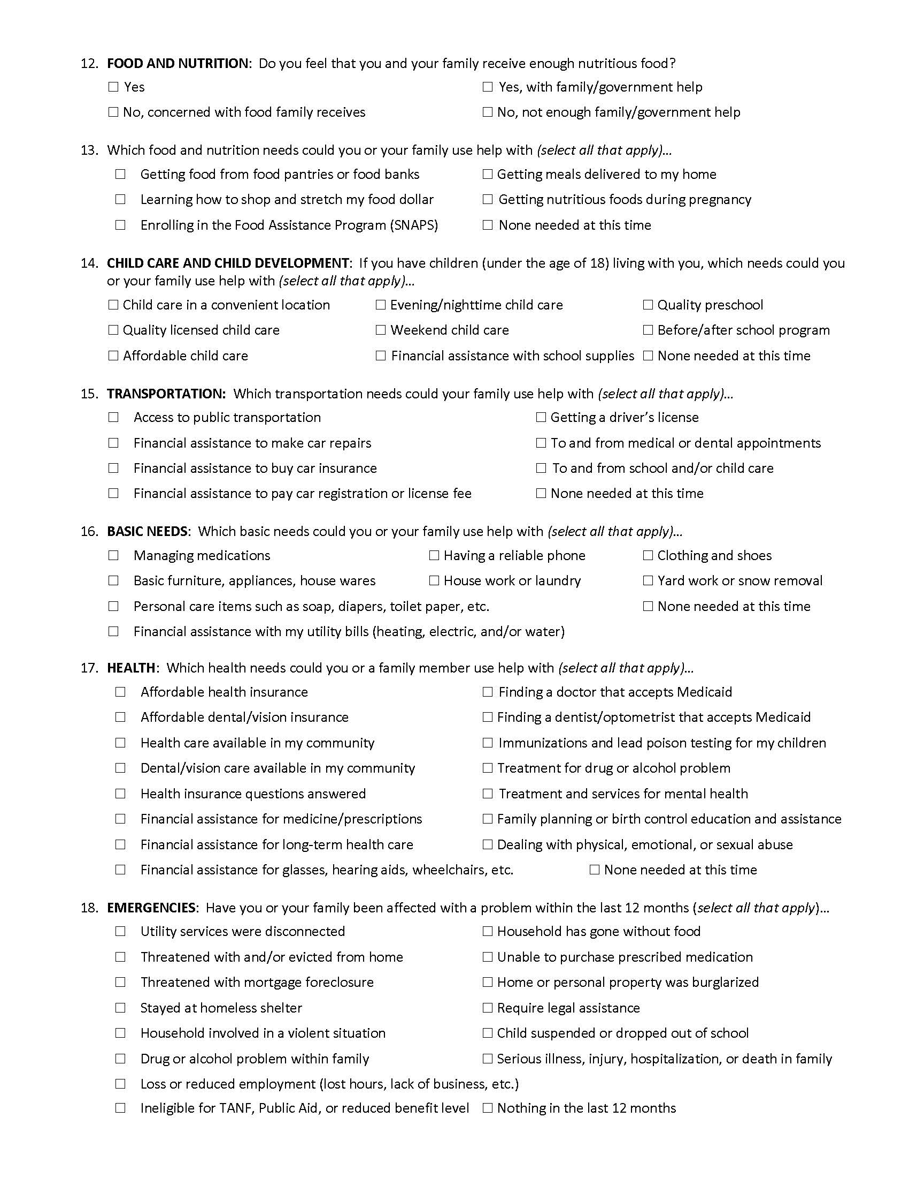

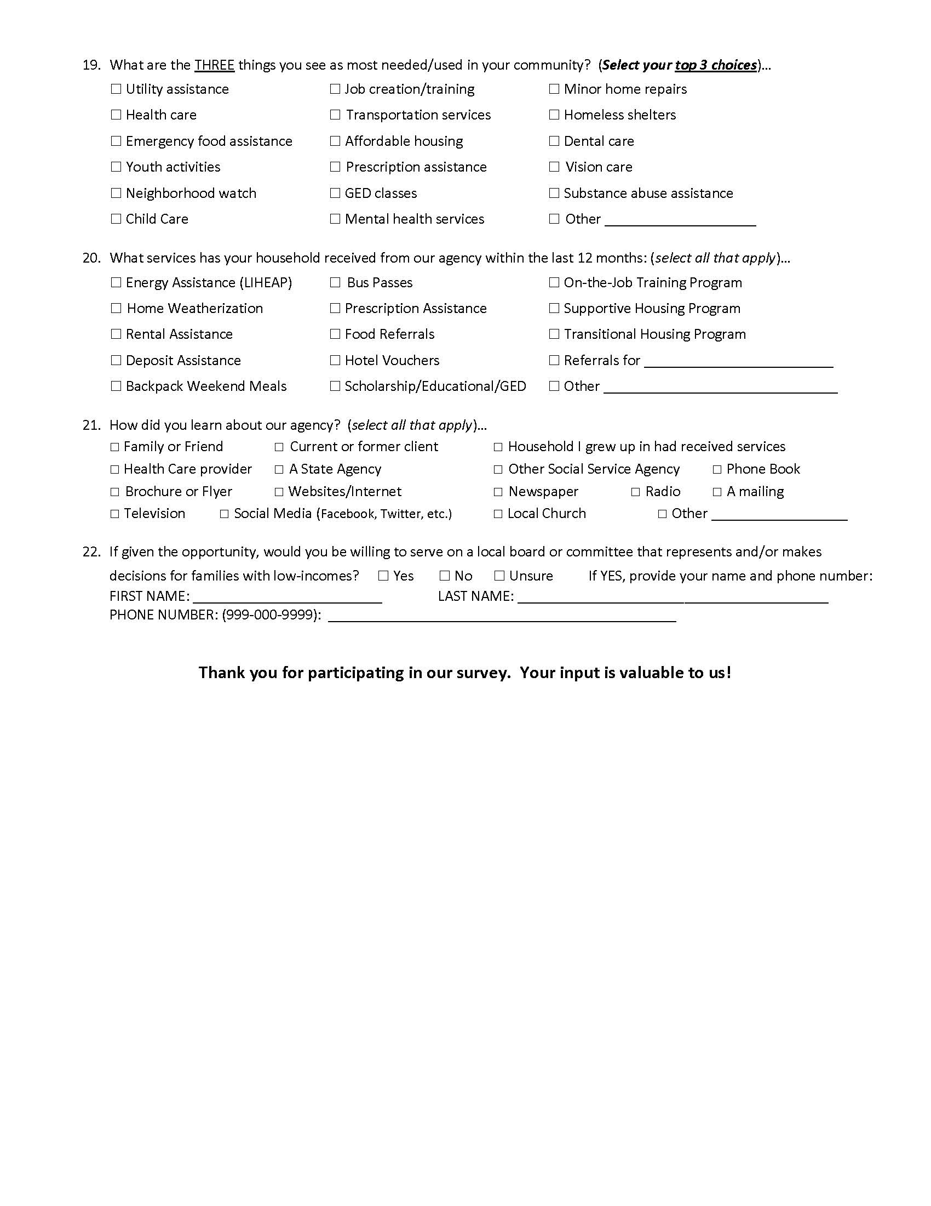
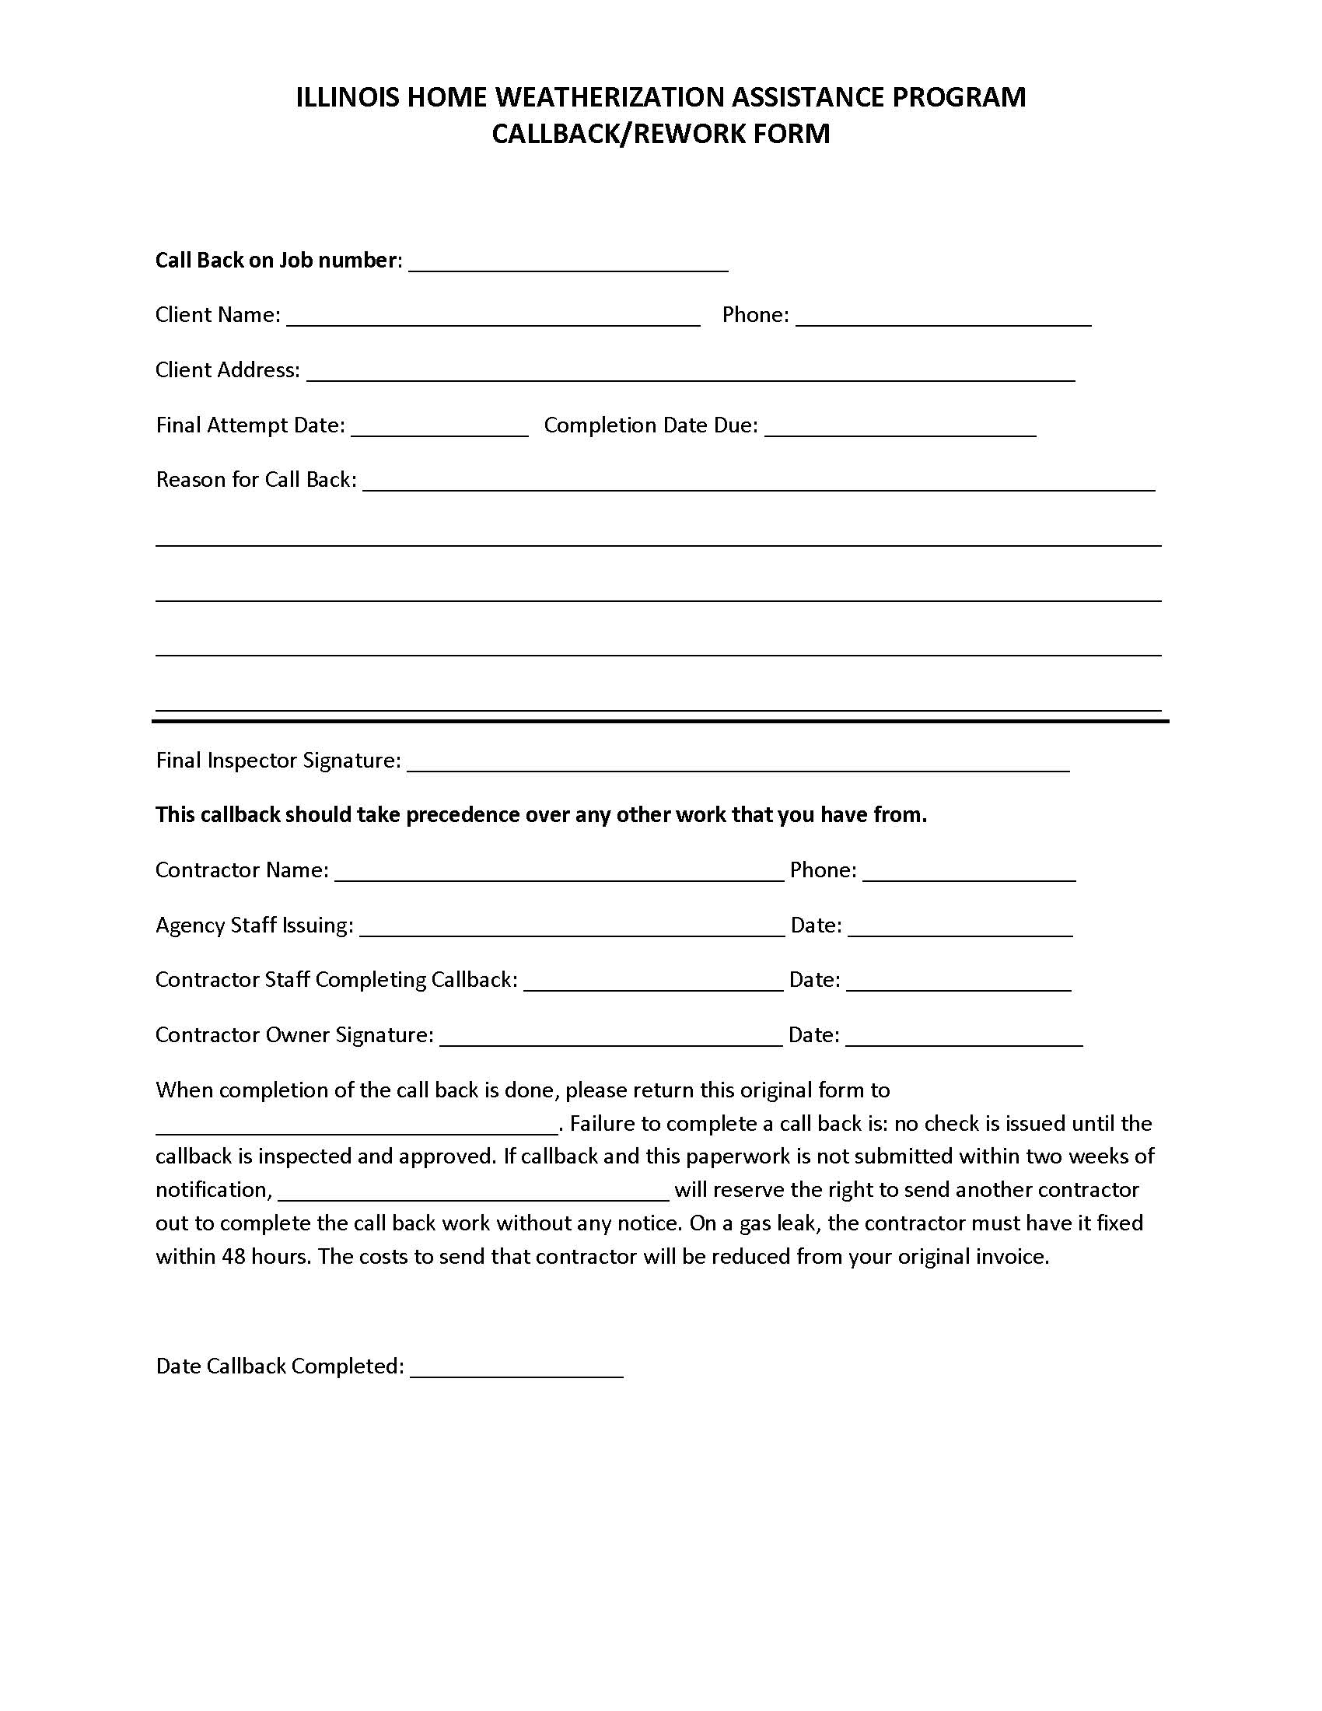

CONTRACTOR ASSURANCE AND GUARANTEE OF WORK
(Give original to the client; retain a copy for the file)

I, _____________________________________________________________________________of
Name
guarantee the workmanship for installation of:
Firm Name

at_________________________________________________________________ for one year
Client Address
beginning _____________________________ and ending
Date Date
in accordance with manufacturer’s instruction and the American National Standards Institute (ANSI) procedure.

Signature Date
______________________
Position/Title
MASTER CONTRACTOR RELEASE OF LIEN

WHEREAS, we the undersigned, have installed materials and furnished labor and/or equipment and that all materials were installed, and labor was furnished according to a
written agreement dated _________________ between __________________________ (herein referred to as the LAA) and _________________________________ (hereafter referred to as the contractor);
WHEREAS, we the undersigned have agreed to release any and all claims and liens which we have, or might have, against the owner weatherized properties, the occupiers of weatherized properties, and the LAA by reason of the labor, materials, and equipment furnished by us in connection with said Weatherization Projects.
NOW THOSE PRESENT WITNESSETH that we, the undersigned, in consideration for the sum listed on the Work Orders and any attached associated Change Orders, the receipt whereof we do hereby acknowledge, do hereby release, remiss, and forever quit any or all manner of liens, claims, and demands whatsoever which we now have, or might have in the future against the owners and occupiers of weatherized properties and the LAA.

_______________________ _____________________ __________
(Company Name) (Company Representative) (Date)

Program Year(s): _________________________ {if the Procurement Award is for multiple years}

Verified By: ___________________________ {Agency Staff/Procurement Lead}

Date: _____/_____/________

CHANGE ORDER REQUEST

Job Name: __________________________________________
Job Address: ________________________________________
Job #: ________________________
This is an agreement between the undersigned contractor and ______________________ to approve and carry out work that is substantially different than the original project scope. Both parties understand that the requested changes, as specified below, may alter the project’s price and schedule. It is also understood that any differences in estimated costs due to this change order will be accounted for in the regular payment schedule.
Changes either adding or deleting material/Labor from the home will change the estimated total costs on the work order. Contractor will contact agency and receive authorization before making changes to work order. Contractor will manually calculate new costs at bottom of work order to reflex changes. Contractor will also write changes, added or subtracted, at location on work order where changes take place and enter new costs, greater or less than, those costs printed on work order.
Explanation Need for addition or deletion of work:
_____________________________________________________________________________
_____________________________________________________________________________
Contractor will provide all labor and material for the following work:
_____________________________________________________________________________
_____________________________________________________________________________
_____________________________________________________________________________
_____________________________________________________________________________
_____________________________________________________________________________

Labor Costs: $_____________ (Add/Deduct) Material Costs: $______________ (Add/ Deduct)
Does Change Affect Schedule? Yes / No
New Estimated Completion Date: _____________
Approved: __________________________________ ________________
(Agency Contact Person) (Date)
Approved: __________________________________ ________________
(Contractor Name) (Date)

Example of Change Order Documentation
A “Change Order” is only required when there is a substantial change from the Work Order.
Minor changes can be simply noted on the Work Order. The contractor will write an explanation of the change in the “Building Section” of the measure. The explanation will identify the measure added or deleted, who the crew/contractor contacted to authorize the change, date of change, and the amount of labor and material dollars added or deleted. The crew/contractor will also initial the explanation. Any changes in cost will be accurately reconciled on the invoice and cost reporting in WeatherWorks. See the following example:

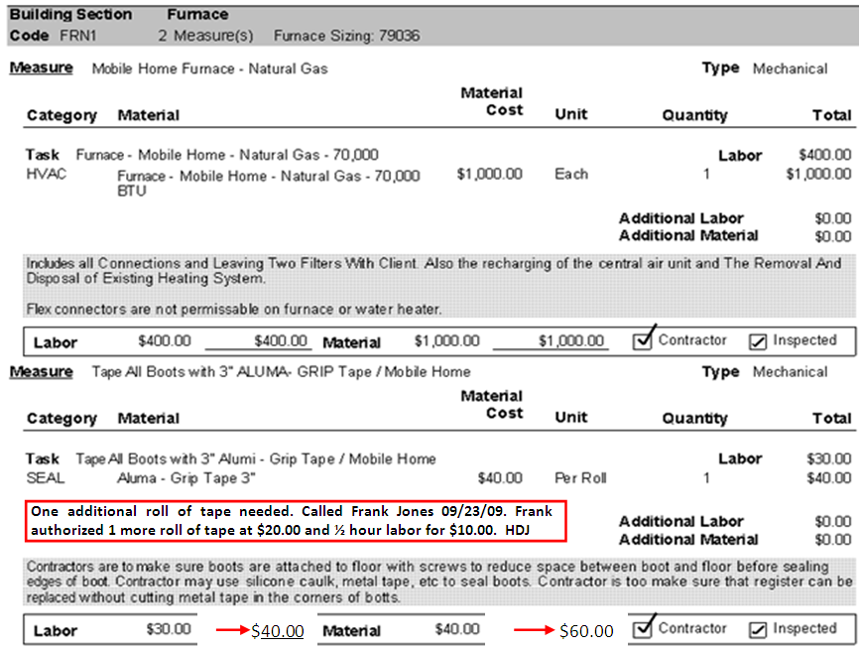

The costs of the measure will be added or subtracted from the estimated labor and material costs on the Work Order. The revised costs will be written into the actual material and labor costs lines. In this example the $20.00 for the addition roll of tape was added to the $40.00 roll of tape already existing on the Work Order for a total of $60.00. The $10.00 of additional labor was added to the existing $30.00 labor for a total of $40.00.

SECTION X FILING SYSTEMS
This section of the manual provides guidance for establishing and maintaining effective filing systems. Records are to be classified, arranged, and stored so they can be found quickly when they are needed. Any files containing PII must be stored in a secure location.
- IHWAP requires that the LAAs shall maintain two file systems
  - Weatherization Subject Files (see below)
  - Weatherization Client Files (also known as Job Files).
- The LAA shall also utilize file systems as necessary to operate an effective weatherization program as well as maintain a Release and Retention of Records Policy.

IHWAP Subject Files
The LAA is required to establish Subject Files in order to maintain the basic program records. These files should be kept so they are easily found and reviewable by OCA monitors. Subject headings under which records are to be retained include:
      - Grant Agreement
- Ineligible Applicants List
- Insurance
- Procurement Code of Conduct
- Personnel
- Correspondences
- Regulations
- Procurement
- Homes Previously Weatherized
- Grant Agreement. The grant agreement is one of the most important files in the system. It contains the following documents:
- A copy of the signed Illinois Weatherization Assistance Program Grant Agreement
- A copy of the current WeatherWorks Budget Summary page, Budget Detail sheets and current Production Plan
- A copy of any Budget Modification sheets (in chronological order)
- Usually, the originals of the above documents are filed directly in the Executive Director's office. The Weatherization Coordinator is to secure a copy. The contract file contains the documents that give the agency its authority to operate the weatherization program.
- Ineligible Applicants. The agency must maintain files containing applications and other pertinent information on ineligible applicants.
- Insurance. It is required that each agency maintain a file on insurance coverage. The file will contain at least the following information:
- Type of required insurance requirements
- Agent or company providing coverage and telephone number
- Policy number and date of expiration
- A copy of the policy

- Procurement Code of Conduct
Each local agency must have an internal document that contains a Code of Standards of Conduct regarding procurement procedures. This Code of Standards should describe specifically how the LAA maintains segregation of responsibilities during the procurement and overall Weatherization process. The local agency shall describe their policy regarding Nepotism (the act of favoring a related family member for employment, or any Weatherization services/work) in detail. For more information, please refer to the IHWAP Procurement Manual.
- Nepotism/Conflict of Interest
As prescribed by 10 CFR 600.236 II.2 (b)(3)(iv) or OMB Circular A-110, Attachment O, 3.a. (whichever applies), no employee, officer, board member, or agency of the provider shall participate in selection, or in the award or administration of a contract supported by IHWAP grant funds if a conflict of interest, real or apparent, would be involved. Such a conflict would arise when the employee; officer; board member; or agent; any member of his immediate family; his or her partner; or an organization which employs, or is about to employ, any of the above has a financial or other interest in the firm selected for award. For more information, please refer to the IHWAP Procurement Manual.
- Personnel. Each person employed as a part of the Illinois Home Weatherization Assistance Program shall have a file which contains those necessary items for proper personnel management. This file may be under the direct control of any person identified by the Director of the agency and shall meet the minimum requirements found in the grant agreement with THE DEPARTMENT.
- Correspondence. The agency must maintain a file that deals with general correspondence for the Weatherization Program. Examples of file subjects follow:
- The Department miscellaneous correspondence
- News media correspondence
- Citizen (non-client) correspondence
- Public and/or elected officials’ correspondence
- Regulations. The department program regulations define activities that are permitted under the Weatherization Program. The following documents must be contained in the file:
- All the Department manuals, Procedure Letters, Technical Assistance letters
and other directive or guidance documents relating to the Weatherization
Program.
- Federal Management Circular 74-4; cost principles applicable to grants and
contracts with State and local governments.
- Office of Management and Budget (OMB) Circular A-l02 Uniform
Administrative Requirements for Grant-in-Aid to State and Local Governments;
or OMB Circular A-110.
- State Energy Efficiency Programs Improvement Act of 1990: 10 CFR Part 440
Weatherization Assistance for Low-Income Persons.
- Procurement. An important aspect of the Weatherization Program is the relationship between the agency and equipment and materials suppliers, as well as weatherization contractors. Several files are required to maintain records and correspondence of this activity.
  - Please reference Volume II - Procurement Procedures for more details on filing requirements. This manual has been recently updated with major changes.
- Homes Previously Weatherized. A file must be established listing the addresses of all units previously weatherized under this program.
  - Both the unit and the client must be eligible for weatherization. A card file or spreadsheet/database is suggested, since it is only the address that is needed.
Release and Retention of Records Policy
There are three areas the agency must be aware of relative to the release and retention of records.
- These areas are Freedom of Information, the Right to Privacy, and Records Retention.
- Freedom of Information makes it easier for individuals, legal representatives, advocacy groups, investigators, and other interested parties to gain access to information in government program files.
  - First, the applicants have a right to see what the agency has on file about them.
  - Second, anyone who files a written request can obtain certain program information that does not violate the client's right to privacy. (The department legal counsel has, in the past, interpreted this to include addresses of units weatherized.)
- The provisions for a Client's Right to Privacy are also important. In accordance with the Client Privacy Act of 1974 (5 USC 552a), the agency may not release the client's name, phone number, income information, etc. Nor may it release lists of client names and addresses to other entities (including service agencies), even with the best of intentions.
  - The WeatherWorks information is also confidential. Do not use this information for anything other than the authorized purpose. If you receive a request for information from outside groups or individuals, contact the Department prior to supplying any information.
- Finally, Records Retention is of concern. Local agencies are to keep program files for four years or until that program year's audit is finally resolved to the satisfaction of DCEO.
  - The Department may require an LAA to retain records longer than four years by specific request.
  - Agencies wishing to store records in reduced size using microfilm must apply in writing to the Secretary of State and receive written approval before records can be converted.

Weatherization Client Files
The Local Administering Agency’s weatherization program will maintain a separate hard copy Weatherization Client File for each weatherization application opened. The order and contents of the Client File, also referred to in this manual and elsewhere as the Job File, will follow the Standardized IHWAP Client File System described in this chapter.

The Client File System serves three purposes:
1) Standardization for easy review and completion,
2) Continuity, and
3) File audit efficiency.
The files should be arranged by the county of the client’s residence in alphabetical order (by client last name) or in numerical order (by job number).
OCA will monitor an LAA’s Weatherization Client Files for conformance with this prescribed format, as well as for the presence of these documents and their conformance to the IHWAP standards and rules. Subgrantees are mandated to completely fill out all information on each required form.
A minimum of a six-tab section/classification style folder is required. To ensure consistency across the IHWAP network, and to fulfill our review and auditing requirements, DCEO has mandated a Client File System that prescribes what documentation will be found within or under each tab.
- Agencies that utilize a General Contractor or Crews may use a five-tab system with DCEO/OCA approval.
Each tab should start with a copy of the appropriate tab checklist (see below) to be used by LAA weatherization staff to track the completion of the file.
The tabs should be labeled in same order as the checklists appear below --which are arranged by the order of operation of the weatherization process.
- The first tab of the file contains the Application - only, as a standalone document.
- The second tab contains health Documentation.
- The third tab contains Assessment Documentation.
- The forth tab contains Mechanical Documentation.
- The fifth tab contains Architectural Documentation.
- For agencies that utilize a General Contractor, or Crews, who are approved to use a five-tab system they may combine tabs 4 and 5.
  - Available upon request from your assigned State Tech.
- The sixth tab is the last tab of the file and should contain the WeatherWorks Fiscal Detail Report on top, Homeowner initiated contracts, certified payroll, in-progress inspection form and any other agency specific or other miscellaneous paperwork may be contained in this section.
- Once again, LAAs are mandated to completely fill out all of the information on each required form.

Content requirements under each Tab:
Tab 1: Application
- Application signed and dated by client and intake worker

Tab 2: Intake Documentation (when applicable)
- Approval/Denial letter
- WeatherWorks Intake Report
- Pre-screen Questionnaire
- Applicant Health and Safety Intake Questionnaire
- Social Security Cards for the household
- Current heating bill
- Utility Bill Release Form
- Income calculation tape
  - Check stubs
  - Income statements
  - Zero income affidavit (signed, dated, and notarized)
- LIHEAP eligibility forms (when applicable)
  - Income calculation tapes
  - Benefit summary screen
  - Household screen
  - Verification of WX eligibility, signed and dated
- Proof of ownership (One of the following is needed)
  - Property Tax Bill
  - Mortgage documentation
  - Deed (filed at the Courthouse)
- Mobile home proof of ownership (One of the following is needed)
  - Title for Mobile Home (Copy of front and back of title)
  - Mortgage documentation
- Weatherization Multi-family building plan (if applicable)
- Building Owner Certification and Work Authorization Form
  - Client is the Owner
  - Client is a renter
    - Rental Agreement

Tab 3: Assessment Documentation
- Completed Desk Audit Form
- SIR Report from WeatherWorks
- Historic Preservation Review
- ASHRAE 62.2 Spreadsheet
- Client Education Materials Notification
- Radon Informed Consent Form
- Lead or Asbestos Testing results
- Hazardous Conditions Notice (if applicable)
- Air Conditioning/Cooling Medical Condition Verification Form (if applicable)
- WeatherWorks Assessment Input Documents
  - Energy Audit Input Checklist
  - Client Signature Form
  - Client Interview/General Information
  - Health and Safety
  - Mold and Moisture Checklist
  - Weatherization Plus Measures
  - Pressure Diagnostics
  - ASHRAE 62.2 Work Sheet
  - Worst Case Depressurization Sheet (if applicable)
  - Spillage Test-Out Sheet
  - Attic(s) Section
  - Walls Section
  - Foundation(s) Section
  - Windows Section
  - Doors Section
  - Heating and Cooling Systems Section (flue gas tapes attached when applicable)
  - Hot Water Heaters Section (flue gas tapes attached when applicable)
  - Baseload Section
  - House Diagrams per Floor (Foundation, 1st Floor, 2nd Floor, Attic)
  - Roof Section
  - Solar Section
  - All required photos
- Household Health Questionnaire

Tab 4: Mechanical Documentation
- Mechanical Actual Cost Report(s)
- Vendor/Contractor Invoice(s)
- Final Inspection Detail Report (only 1 required if Mech and Arch were completed at the same time)
- Final Inspection Summary Report (only 1 required if Mech and Arch were completed at the same time)
  - Client signature and date
  - Final Inspector signature and date
  - Post Weatherization Readings
  - Final Flue Gas Tape attached
- Worst Case Depressurization Form (Final Inspector Copy)
- Spillage Test-Out Form (Final Inspector Copy)
- Contractor Call-Back Notice w/color photographs of Deficiencies (if applicable)
- Client Survey and Needs Assessment
- Work Order(s) – if labor and material were procured separately then a copy of the
labor only and material only Work Orders should be in the file
- Change Order(s) (if applicable)
- Hazardous Condition Notice (if applicable)
- Furnace Waiver (if applicable)
- Mechanical Contractor Checklist
- Worst Case Depressurization Form (Contractor Copy)
- Spillage Test-Out Form (Contractor Copy)
- Contractor Assurance Sheet
- Computerized Heat Load Calculation (if applicable)
- Notice to Proceed, a.k.a. Notice to Owner
- Household Health Questionnaire

Tab 5: Architectural Documentation
- Architectural Actual Cost Report(s)
- Vendor/Contractor Invoice(s)
- Final Inspection Detail Report (only 1 required if Mech and Arch were completed at the same time)
- Final Inspection Summary Report (only 1 required if Mech and Arch were completed at the same time)
  - Client signature and date
  - Final Inspector signature and date
  - Post Weatherization Readings
- Worst Case Depressurization Form (Final Inspector Copy)
- Spillage Test-Out Form (Final Inspector Copy)
- Contractor Call-Back Notice w/color photographs of Deficiencies (if applicable)
- Client Survey and Needs Assessment
- Work Order(s) – if labor and material were procured separately then a copy of the
labor only and material only Work Orders should be in the file
- Change Order(s) (if applicable)
- Hazardous Condition Notice (if applicable)
- Intermediate Blower Door Form (if applicable)
- Spillage Test-Out form (if applicable)
- Insulation Certificate (if applicable)
- Certified Renovator Recordkeeping Checklist (if applicable)
- Contractor Assurance Form
- Notice to Proceed , a.k.a. Notice to Owner
- Household Health Questionnaire

Tab 6: Fiscal Detail Report/Misc. Documents
The last tab of the file should contain the WeatherWorks Fiscal Detail Report on top, Homeowner initiated contracts, certified payroll, in-progress inspection form and any other agency specific or other miscellaneous paperwork may be contained in this section. All Weatherization Plus documents should be included in this tab. This includes the actual cost report, contractor(s) invoices, the final inspection detail report, and all photo documentation.

Other Tabs:
Other documentation should not be maintained in tabs 1 through 5. The LAA may determine to include additional tabs with documentation as it sees fit if Tab 6 proves to be insufficient for miscellaneous or other documents.

FORMS AND EXHIBITS for SECTION X - FILING SYSTEMS

6-Tab Client File Checklist Page 174
5-Tab Client File Checklist Page 179

6-Tab Client File Checklist

TAB 1 Intake Documentation Checklist
Application
- Client Signature and Date
- Intake Worker Signature and Date
- Documentation Date ( 15 days from Application Date)
- Eligibility Signature & Date ( 15-30 days from Documentation Date)

TAB 2 Intake Documentation
- Approval Letter
- WeatherWorks Intake Report
- Pre-Screen Questionnaire
- Applicant Health and Safety Intake Questionnaire
- Social Security Card(s)
- Current Heating Bill
- Utility Bill Release Form
- Income Calculation Tape for 12-month
  - Check Stubs
  - Income Statements
  - Zero Income Affidavit signed and notarized
  - Other Income Documentation___________________________________________________
- If Client is LIHEAP eligible the following 4 items must be included:
  - Income Calculation Tape
  - Benefit Summary Screen
  - Household Screen
  - Verification of WX Eligibility, signed and dated
Proof of Ownership
- For Single Family homes we need one of the following:
  - Property Tax Bill
  - Mortgage Payment Book
  - Deed (filed at the courthouse)
  - Other___________________________________________________________
- For Mobile Homes we must have one of the following:
  - Title for Mobile Home (front and back)
  - Mortgage Documentation
- For Multi-Family Building
  - Weatherization Multi-Family Building Plan
- Building Owner Certification and Work Authorization Form
  - Client is the owner
  - Client is a renter
    - Rental Agreement (Signed and Dated by the Landlord)
- Applicant Checklist
- Applicant File Checklist
- Client Contact Information
- Other File Documentation

TAB 3 Assessment Documentation Checklist
- Completed Desk Audit Form
- SIR Report from WeatherWorks
- Weatherization Plus OCA Approval Form and Documentation (when applicable with OCA signatures)
- Historic Preservation Review Form
- ASHRAE 62.2 Spreadsheet
- Client Education Materials Notification
- Radon Informed Consent Form
- Asbestos/Lead Testing Documentation (If applicable) Note: LAAs have a choice whether they would like to perform Lead and/or Asbestos testing
- Hazardous Conditions Notice (if applicable)
- Air Conditioning/Cooling Medical Condition Verification Form (if applicable)
Weather Works Assessment Input Documents
- Energy Audit Input Document Check List (completed, signed, and dated)
- Client Signature Form (signed, dated, and initialed)
- Client Interview/General Information
- Health & Safety Measures
- Mold and Moisture Checklist
- Weatherization Plus Measures
- Pressure Diagnostics Checklist
- ASHRAE 62.2 Work Sheet
- Worse Case Depressurization (bottom of page completed)
- Attic Information
- Walls
- Foundations
- Windows
- Doors
- Heating and Cooling Systems (Flue gas tapes required in file)
- Water Heaters (Flue gas tapes required in file)
- Baseload
- House Diagrams (one per floor)
- Roof
- Solar
- Pictures
- Household Health Questionnaire

TAB 4 Mechanical Documentation Checklist
- Mechanical Actual Cost Report(s)
- Vendor/Contractor Invoice(s)
(QCI) Final Inspection Forms
- Inspection Detail Report (only 1 required if Mech and Arch were completed at the same time)
- Final Inspection Summary Report (only 1 required if Mech and Arch were completed at the same time)
- Client Signature and Date
- Final Inspector Signature and Date
- Post-Weatherization Readings
  - Final Flue Gas Tape Attached
  - Final Flue Gas Readings N/A
- Worst Case Depressurization Form
- Spillage Test-Out Form
- Contractor Call Back Notice
- Client Survey and Needs Assessment
Work Orders
- Material-Only Work Order (if labor and material were procured separately)
- Labor Work-Only Order (if labor and material were procured separately)
- Combined Labor and Material Work Order (if applicable)
- Furnace Waiver
  - Furnace Waiver N/A
- Contractor Checklist
    - Worst Case Depressurization Form
    - Spillage Test-Out Form
- Contractor Assurance Sheet
- Heat Load Calculation
  - Heat Load Calculation N/A
- Notice to Proceed
- Household Health Questionnaire

TAB 5 Architectural Documentation Checklist
- Architectural Actual Cost Report(s)
- Contractor/Vendor Invoice(s)
(QCI) Final Inspection Forms
- Inspection Detail Report (only 1 required if Mech and Arch were completed at the same time)
- Final Inspection Summary Report (only 1 required if Mech and Arch were completed at the same time)
- Client Signature and Date
- Final Inspector Signature and Date
- Post Weatherization Readings (Flue Gas Tape attached, when applicable)
- Worst Case Depressurization Sheet
- Spillage Test-Out Sheet
- Contractor Call back Notice (if applicable)
- Client Survey and Needs Assessment
Work Order
- Material-Only Work Order (if labor and material were procured separately)
- Labor-Only Work Order (if labor and material were procured separately)
- Combined Labor and Material Work Order (if applicable)
- Change Order(s) (if applicable)
- Health and Safety Acknowledgement Form
- Intermediate Blower Door Sheet
  - Assessment Blower Door Reading
  - Blower Door Intermediate Reading
- Spillage Test-Out Form (if applicable)
- Insulation Certificate (if applicable)
- Certified Renovator Recordkeeping Checklist (if applicable)
- Contractor Assurance Form
- Notice to Proceed
- Household Health Questionnaire

TAB 6 Fiscal Detail Report / Misc. Documents
- WeatherWorks Fiscal Detail Report.
- Homeowner Initiated Contracts.
  - IDOL Certified Payroll form for rental properties
- In-Progress Inspection Document (if applicable)
- Other miscellaneous agency specific documents.
- The LAA may determine to include additional tabs with documentation as it sees fit if Tab 6 proves to be insufficient.
- Weatherization Plus documents
- This includes the household health questionnaire(s), actual cost report, contractor(s) invoices, the final inspection detail report, and all photo documentation.

5-Tab Client File Checklist

TAB 1 Intake Documentation Checklist
Application
- Client Signature and Date
- Intake Worker Signature and Date
- Documentation Date (15 days from Application Date)
- Eligibility Signature & Date (15-30 days from Documentation Date)

TAB 2 Intake Documentation
- Approval Letter
- WeatherWorks Intake Report
- Pre-Screen Questionnaire
- Applicant Health and Safety Intake Questionnaire
- Social Security Card(s)
- Current Heating Bill
- Utility Bill Release Form
- Income Calculation Tape for 12-month
  - Check Stubs
  - Income Statements
  - Zero Income Affidavit signed and notarized
  - Other Income
Documentation ______________________________________________
- If Client is LIHEAP eligible the following 4 items must be included:
  - Income Calculation Tape
  - Benefit Summary Screen
  - Household Screen
  - Verification of WX Eligibility, signed and dated
Proof of Ownership
- For Single Family homes we need one of the following:
  - Property Tax Bill
  - Mortgage Payment Book
  - Deed (filed at the courthouse)
  - Other___________________________________________________________
- For Mobile Homes we must have one of the following:
  - Title for Mobile Home (front and back)
  - Mortgage Documentation
- For Multi-Family Building
  - Weatherization Multi-Family Building Plan
- Building Owner Certification and Work Authorization Form
  - Client is the owner
  - Client is a renter
    - Rental Agreement (Signed and Dated by the Landlord)
- Applicant Checklist
- Applicant File Checklist
- Client Contact Information
- Other File Documentation

TAB 3 Assessment Documentation Checklist
- Completed Desk Audit Form
- SIR Report from WeatherWorks
- Weatherization Plus OCA Approval Form and Documentation (when applicable, with OCA signatures)
- Historic Preservation Review Form
- ASHRAE 62.2 Spreadsheet
- Client Education Materials Notification
- Radon Informed Consent Form
- Asbestos/Lead Testing Documentation (If applicable) Note: LAAs have a choice whether they would like to perform Lead and/or Asbestos testing
- Hazardous Conditions Notice (if applicable)
- Air Conditioning/Cooling Medical Condition Verification Form (if applicable)
Weather Works Assessment Input Documents
- Energy Audit Input Document Check List (completed, signed, and dated)
- Client Signature Form (signed, dated, and initialed)
- Client Interview/General Information
- Health & Safety Measures
- Mold and Moisture Checklist
- Pressure Diagnostics Checklist
- ASHRAE 62.2 Work Sheet
- Worse Case Depressurization (bottom of page completed)
- Attic Information
- Walls
- Foundations
- Windows
- Doors
- Heating and Cooling Systems (Flue gas tapes required in file)
- Water Heaters (Flue gas tapes required in file)
- Baseload
- House Diagrams (one per floor)
- Roof
- Solar
- Pictures
- Household Health Questionnaire

TAB 4 General Contractor Documentation Checklist
- Actual Cost Report(s)
- Vendor/Contractor Invoice(s)
(QCI) Final Inspection Forms
- Inspection Detail Report (only 1 required if Mech and Arch were completed at the same time)
- Final Inspection Summary Report (only 1 required if Mech and Arch were completed at the same time)
- Client Signature and Date
- Final Inspector Signature and Date
- Post-Weatherization Readings
  - Final Flue Gas Tape Attached
  - Final Flue Gas Readings N/A
- Worst Case Depressurization Form
- Spillage Test-Out Form
- Contractor Call Back Notice
- Client Survey and Needs Assessment
Work Orders
- Material-Only Work Order (if labor and material procured separately)
- Labor Work-Only Order (if labor and material procured separately)
- Combined Labor and Material Work Order (if applicable)
- Change Order
- Furnace Waiver
- Contractor Checklist
    - Worst Case Depressurization Form N/A
    - Spillage Test-Out Form
- Contractor Assurance Sheet
- Heat Load Calculation
  - Heat Load Calculation N/A
- Health and Safety Acknowledgement Form
- Intermediate Blower Door Sheet
  - Assessment Blower Door Reading
  - Blower Door Intermediate Reading
    - Unable to perform blower door test
- Insulation Certificate (if applicable)
- Certified Renovator Recordkeeping Checklist (if applicable)
- Notice to Proceed Form
- Household Health Questionnaire

TAB 5 Fiscal Detail Report / Misc. Documents
- WeatherWorks Fiscal Detail Report.
- Homeowner Initiated Contracts.
  - IDOL Certified Payroll form for rental properties
- In-Progress Inspection Document (if applicable)
- Other miscellaneous agency specific documents.
- The LAA may determine to include additional tabs with documentation as it sees fit if Tab 6 proves to be insufficient.
- Weatherization Plus documents
- This includes the household health questionnaire(s), actual cost report, contractor(s) invoices, the final inspection detail report, and all photo documentation.

Section XI - Multi-Family Project Procedures

2-4 Unit Multi-Family Projects
Agencies can use the single-family energy audit document (except the Wx Plus page) for assessing 2-4 unit multi-family projects. These projects can also be modeled in WeatherWorks and do not require an engineer’s report.
2-4 unit buildings must meet the following eligibility requirements:
# of Units | Eligibility Requirements
2 | 1 (50%)
3 | 2 (67%)
4 | 2 (50%)
If a building meets these eligibility requirements, the entire building can be weatherized (including non-qualified units and common areas).
All units need to be assessed and final inspected. In terms of blower door diagnostic, whole building, guarded, or compartmentalized blower door test are optional. However, these tests are considered best practice. Assessors and final inspectors should also use the multi-family ASHRAE spreadsheet to calculate required ventilation.

Shelters, Single Room Occupancy, and Group Homes
Publicly or privately owned not-for-profit shelters operated to provide emergency housing for low-income households are excluded from the “66% or greater” rule and individual unit eligibility determination. SRO buildings, group homes and shelters are considered multifamily dwellings; and therefore, the landlord must sign a rental agreement.
For the purpose of determining how many dwelling units exist in a shelter, SRO buildings, and group homes, a grantee may count each 800 square feet of the shelter as a dwelling unit, or it may count each floor of the shelter as a dwelling unit.
The size and the mechanical makeup of the building will determine whether a TREAT model or WeatherWorks model shall be used. Agencies should contact their assigned Weatherization Specialist to determine which modeling approach shall be utilized.

5+ Unit Multi-Family Projects
All Illinois Home Weatherization Assistance Program (IHWAP) multi-family weatherization projects for buildings with five or more living units must use an energy audit software tool approved by the United States Department of Energy (DOE) for energy modeling. IHWAP uses TREAT multi-family energy audit software to meet this requirement. While weatherization job management will continue to be managed on IHWAP’s WeatherWorks, the energy audit and modeling will be conducted with the TREAT system.
The procedures in this manual serve as the requirements and guidelines for:
- Collecting data for income verification and utility usage, and other pre-assessment information;
- Collecting assessment data to create the TREAT generated energy model;
- Use of the TREAT software to generate an IHWAP approvable energy model; and
- Submission of a multi-family project package for review and approval by the Illinois Department of Commerce and Economic Opportunity’s Office of Community Assistance
Local Administrating Agencies (LAAs) using any of the IHWAP weatherization grants for multi-family projects of five or more units must receive approval of the Illinois Department of Commerce and Economic Opportunity’s Office of Community Assistance (OCA) at several stages of the multi-family project. The approval process will be granted by OCA during the following project milestones:
- Project Eligibility Approval. Before beginning an assessment of a multi-family project, the LAA must submit the following to OCA (IHWAP Program Manager and Assistant Program Manager, and the LAA’s Weatherization Specialist):
  - demographic data on each occupied unit (income, # in households, priority categories – seniors, disabled, children under 5 years old),
  - number and percentage of units eligible,
  - budget allowed per funding source based on number of eligible units,
  - sampling plan for utility data,
  - utility usage data collected and extrapolated for units and common areas of buildings,
  - copy of rental agreement with building owner/management,
  - building assessment (unit and common area) sampling plan,
  - and any other pre-assessment information on building and owner/management.
Once OCA has reviewed and verified correctness of data and other information, OCA will email the LAA approval to move forward with assessment.
- Approval of Assessment, Energy Model, and Scope of Work. Before moving forward with project scope of work, the LAA must submit the following to OCA:
  - a project description (use form provided in manual),
  - fully completed IHWAP-approved Multi-Family Assessment Document (includes standard assessment document, and may also include heating, cooling, and appliance spreadsheet that has the manufacturer, serial number, and age of the existing equipment, spreadsheet of type and quantity of existing lighting in building
  - documentation and photos of typical and unusual conditions
  - blueprints for larger multi-family buildings(11+ units), if available;
  - engineering reports (when applicable);
  - Multifamily Buydown Waiver form (when applicable); and
  - TREAT model files and SIR Report (with and without H&S measures), and proposed project budget (breakdown by measure and funding source).
Once OCA has confirmed the LAA has completed an accurate and complete multi-family assessment, energy model, and scope of work that meets IHWAP requirements and guidelines, OCA will email the LAA approval to commence with the project.
- Project Completion. Upon completion of project local agencies shall submit final inspection documents, finalize costs in WeatherWorks and provide TREAT-calculated SIRs to OCA to enter into WeatherWorks (only OCA is allowed to edit SIRs). OCA will review budgets to verify they meet the budget limits for the project based on number of eligible units.

Outreach and Application Process for Multi-Family Buildings
Local agencies should maximize their efforts to inform building owners, neighborhood organizations, potential clients, and local units of government about the weatherization program. Distributing weatherization brochures and local agency printed information shall be done to encourage applicants who live in multi-family buildings. Outreach to potential clients shall be done on an equitable basis to all targeted communities in the local agency service area. A record of visits shall be kept that indicates the audience and date of visits to promote weatherization in multi-family buildings.
Local agencies shall make every effort to respond to inquiries about the program by talking to building owners/managers and explaining the program benefits and requirements. Local agencies shall prepare written materials that describe how the program operates and client eligibility requirements. Brochures shall be made available to the building owner/manager and tenants, who shall also be given written information on how and where to apply for the program, and the type of income documentation that is required. Local agencies shall also contact community organizations to encourage participation by all the tenants in the building when an inquiry has been initiated.
HUD Listings
HUD no longer updates the lists of qualifying properties that meet income eligibility for the weatherization program. Owners of HUD-assisted and public housing multifamily properties are encouraged to use the certification procedure adopted by HUD and DOE to qualify individual properties on an as-needed basis. A list of properties approved by HUD can be obtained from DOE upon request.
HUD or Other Buildings That Have Client Income and Demographic Data
If centralized client data is obtainable for the building owner/landlord, then a single application may be utilized for the entire building. Even when owners or landlords submit data directly, LAAs will still need to collect and input income and demographic data on individual household units in the building. This information will need to be entered on the WeatherWorks Unit Screens in the Site Manager section.
In the case of the HUD buildings, most of the needed data is contained on the HUD 50059 forms that the building owner/landlord will have. The building owner/landlord can give you copies of this information or allow you to enter it into a spreadsheet for later reference. Any other needed information can be collected from the building owner/landlord without the need for a separate application process for each client.
The LAA will still need to enter and verify the income eligibility information for each unit to determine budget levels for the building, even when individual tenant applications are not completed. All HUD units are not on the two HUD lists. You may find HUD buildings that will qualify for Weatherization in your area that were not on the 2 lists. When applicable, Agency documentation confirming that a building is on the HUD or USDA Lists is required.
Other Regular or Non-Federally Assisted Multi-Family Buildings
Multi-family buildings where the owner/landlord does not have documentation of the current building occupant’s current income and demographic information, will need to have an IHWAP application taken for each individual unit in the building. Access to intake sites is important when weatherizing multi-family buildings.
IHWAP cannot weatherize individual units in a multifamily building. An entire building must qualify for a weatherization project to proceed.

Pre-Application Activities
Pre-Application contact with the Client should be conducted to gain as much information prior to actually visiting the complex to obtain information such as age of building, number of floors, number of units, number of tenants, space types, occupancy demographics, laundry facilities, are site maps/building plans available, type of utilities, types of HVAC and hot water distribution systems, Historical Preservation issues/concerns, etc. The key pre-application steps include:
  - Establish who are the main contacts (owner/landlord/maintenance manager) that the assessment team will be working with on this project and get all of their office and work cell phone numbers, as well as their e/mail address. This is also a good time to figure out who pays for the utilities (landlord or tenant) and how to go about getting the required utility bills.
Owner’s Meeting to explain the audit process and what type of measures that IHWAP provides, if they qualify (ECMs, IRMs, H/S, Air-Sealing, etc.), is optional but may be beneficial depending upon the size and complexity of the project. It is also a great opportunity to explain the SIR requirements.
  - Based on the information gathered a Professional/Mechanical Engineer’s Report may be required.
  - interviews should be conducted with the person(s) most knowledgeable of day-to-day and historical operation of the building, such as the maintenance supervisor, on-site building operator, and/or property manager. It is highly recommended that a knowledgeable on-site staff person be available throughout the site visit to answer specific questions as individual building components are encountered.

Multi-Family Project Process

Phase 1: Determining Multi-family Project Eligibility

Unit Income Eligibility Requirements
To weatherize a multi-family rental building consisting of five units or more, at least 66% of the building’s apartments must be occupied by income-eligible tenants. The eligibility chart below must be followed:
# of Units | Eligibility Requirements
5 | 4 (80%)
6 | 4 (67%)
7 | 5 (71%)
8 | 6 (75%)
9 | 6 (67%)
10+ | multiply by .67, round up.

A vacant unit may not be counted as eligible for purposes of determining allowable expenditures for the building.
The funding allowance rules, policies, and procedures under HHS and State funding also apply to multi-family projects. The allowable expenditures for work on multi-family buildings are derived by multiplying the maximum material and labor budget limits per unit times the number of income-eligible units. The maximum expenditure for the Site (building) is then spread equitably between all units and common areas. However, vacant units cannot receive funding.
Landlord Agreements are required by IHWAP. A copy must be given to each tenant. The tenants are responsible for monitoring the terms of the agreement and may file a complaint if they feel it has been violated.
Row Houses, where there is a complete separation between units (thermal and pressure boundaries) and have their own HVAC systems, can be considered and treated as a single-family dwelling.
Multi-family buildings (buildings of five or more units) are not subject to priority ranking. The Department will, however, include the priority potential of the buildings in its multifamily review process.
Given these eligibility requirements, the Local Agency must develop and provide OCA a demographic spreadsheet the following information for each unit: name of head of household, household income, total number of household members, total number of disabled household members, total # of household members 60 years old or older, total number of children 5 years old and younger, eligibility status (Approved or Denied), and eligible funding sources. The spreadsheet should total the number of eligible units for DOE, HHS, and State funds, and provide the percentage of all units that are eligible. Furthermore, the spreadsheet should include the total potential project budget for 2 pots of funding.
Local Agencies should not stop collecting income data as soon as they obtain information on enough units to meet the 66% requirement. The more income eligible units there are, the higher the potential project budget, given that each additional eligible unit adds $16,000 to the potential M/L budget, and $3,500 to the H&S budget (2 funding source limits per unit).
Utility Bill Requirements and Sampling
IHWAP requires 12 continuous months of utility (electric and natural gas) usage and cost information. Utility bills must be obtained and recorded on a spreadsheet before the physical assessment begins. If the utility bills are incomplete and/or do not meet IHWAP sampling requirements the project will be delayed until the proper billing information has been obtained.
If only a sampling of unit or tenant space utility data is made available to the person conducting the audit, a utility bill sampling plan can be used only if it is:
            - Judged to be representative of unit or tenant space at the building, and
            - Sufficient to estimate energy use for all tenants at the building.
            - Extrapolated to account for the usage of the whole building in order to analyze the building in its entirety.
            - The plan should define the total number of dwelling units, the number of units being requested for sampling, and common areas.
            - The utility sampling guidelines below must be followed unless a waiver is granted by DCEO/OCA:
              - 5 to 25 Apartment Units 70% of all utility bills must be sampled
              - 26 to 100 Apartment Units 50% of all utility bills must be sampled
              - 100+ Apartment Units 30% of all utility bills must be sampled
              - The utility sampling should account for different unit sizes (1-3 BR), interior units, and corner units to the extent possible.
              - Sampling sums must be extrapolated up to account for the whole building usage
in order to analyze the whole building.
              - ALL common areas, offices, etc. that are separately metered must also be included in the sampling group but are not part of the extrapolation process.
              - None of the data captured for utility bills shall be older than 18 months prior to application date.
Before any analysis of the utility data begins, the utility bills or invoices should be reviewed for billing errors, including but not limited to billing for incorrect buildings or facilities. Billing irregularities are not uncommon and identifying them will ensure the correct data are used in the subsequent analysis. Review of the data also often provides additional benefits that improve the auditing process and data analysis.
If the project is an IHWAP/Utility funded project, the LAA should be able to work with the local utilities to obtain the utility bill information from the utility directly.
As part of the submission of the project to OCA for approval of Project eligibility, the LAA must submit the Utility Bill sampling plan, a utility usage spreadsheet showing the electric usage (kWh) and cost and natural gas usage (therms) and cost for each unit (unless building is master-metered) and for all metered common areas for a 12 month period, and the extrapolated total building energy usage and cost.

Assessment Sampling Plan and Requirements
Sampling may depend on the size of the building(s), potential issues with tenant dwelling access, or cost implications. Assessment sampling is involved in two general activities:
            - Sampling of apartments/buildings for inspection, testing, and analysis.
            - Sampling of equipment such as furnaces, refrigerators, hot water heaters, or lighting to understand installed characteristics and operation.
A sampling plan (or protocol) must be established for every project. A written Sampling Plan Request is required by the submitting agency. The plan should define the total number of dwelling units, the number of units being requested for sampling, common areas, the different types of diagnostic testing and the different types of inspections to be conducted. Sampling includes a representative cross section of units within the building, e.g., if units vary in size, the sample should reasonably represent all sizes to the extent possible. Units in the audit sample must undergo a uniform scope of inspections and testing.
Extrapolations:
Sample sums must be extrapolated up to account for the whole building in order to analyze the whole building; i.e., if 10 units are sampled in a 13-unit building, the simple extrapolation is to multiply summed values (such as for energy use) by 13/10 to obtain a value for the whole building.
Unit Sampling/Assessing:
WPN 16-5 states that a minimum of 10% of apartment units must be assessed or at least 5 units, whichever is greater. IHWAP is requiring a minimum of 15% to be assessed with a minimum of at least 5 units or whichever is greater.
The following sampling/assessing protocols that must be followed:
- A minimum of 15% of multi-family units must be assessed, with no fewer than 3 units of each floor plan, with a minimum of 5 total units.
The intent is to make the sample as representative as possible for the effects of the building envelope.
Common Space Sampling/Assessing
Hallways:
- In buildings having 1–4 stories, all hallways must be inspected.
- For buildings of 5–20 stories, hallways on at least half the floors (rounding up for odd values, or 3 floors for a 5-story building) should be inspected.
- In buildings taller than 20 stories, hallway inspection can be based on elevator layouts, if elevator banks have floor series (e.g., one bank serves floors 1–24 and one bank serves 24–48). At least 10 floors should be inspected.

Stairwells:
- In low-rise buildings, every interior stairwell must be inspected, with special attention paid to the top and bottom of each.
- In buildings taller than three stories, the top and bottom of every interior stairwell should be inspected, and any exterior façades of interior stairwells should be examined before deciding which stairwells to inspect further.

Other Unique Spaces:
- Meeting rooms, day rooms, fitness facilities, and office space need to be visited to obtain data to ensure that the spaces are represented for energy modeling and energy measure evaluation.

The sampling plan should be submitted as part of the Project Eligibility approval to ensure that the sampling plan is approved by OCA prior to the assessment.
IHWAP Rental Agreement
Before beginning an assessment, the LAA should have the owner/authorized agent review and sign the IHWAP rental agreement (see agreement in Forms and Exhibit section at end of this chapter). The agreement ensures that the building owner agrees to give permission to implement the weatherization work, confirms that the building is not currently for sale, tenants are to receive the benefits from weatherization, and most importantly, the owner agrees to not raise the rent for at least 12 months from date of project completion. The agreement also makes clear that the weatherization work is guaranteed for one year.
This agreement should be submitted as part of the Project Eligibility approval. Without this agreement, it would not make sense to commit resources towards conducting an assessment.
Professional/Mechanical Engineer’s Report
Based on the information gathered during the pre-assessment activities a Professional/Mechanical Engineer’s Report may be required. If a report is required this should be determined in Phase 1 and completed concurrently with the overall building assessment.
A State-licensed Professional/Mechanical Engineer’s Report is required if the multi-family project has any of the following:
- A commercial centralized boiler system;
- A central water/steam boiler system;
- Multiple central boiler systems;
- The building has 20 or more units and has a centralized HVAC system.
The Professional/Mechanical Engineer will conduct an analysis on the heating/cooling systems. This analysis includes a complete evaluation of the existing centralized heating/cooling systems and the domestic hot water delivery system, as well as retrofit recommendations. The report should clearly identify the age and efficiency of existing heating/cooling systems and domestic hot water system; this is important information to verify whether any of these systems qualify for replacement under the HHS/State funding allowances if they don’t have an SIR > 1. A Professional/Mechanical Engineer should be present at the time of assessment to discuss and answer any concerns/questions that the assessor might have.
A written waiver from DCEO/OCA is required if a Professional/Mechanical Engineer is not utilized for any project that meets the criteria above.
Phase 1 Submission Requirements for OCA Review
At this stage when unit eligibility has been determined, utility usage data has been collected, the IHWAP Rental Agreement has been signed, potential project budget limits have been determined, assessment sampling plan and other pre-assessment activities have been completed, and a determination has been made on whether a Professional/Mechanical Engineering Report is needed, the LAA should submit all of this information to OCA for approval prior to beginning Phase 2.

Phase 2: Assessment and Energy Modeling of Multi-family Buildings

IHWAP Multi-Family Energy Assessment
The overall assessment and data entry process for multi-family buildings is more complex and interactive than for the single-family assessment process and certain criteria must be met. Multi-Family buildings may have one or more centralized heating systems and complex arrangements for domestic hot water delivery. Some multi-family buildings may have individual heating systems within each unit. Certain buildings may contain a combination heating and cooling system in each unit.
Multi-Family buildings may also have common areas such as a foyer, mailroom, lobby, hallways, stairwells, laundry rooms, and/or other common areas that may be unique when compared to a single-family home or mobile home. The building diagnostic process for air-sealing work can also be more challenging, depending upon the size and shape of the structure. Taller multi-family buildings, over 3 stories, may have a more pronounced stack effect due to their height.
In approaching the assessment for energy modeling the assessor should identify the space types in the building and analyze the common areas for energy conservation and air-sealing measures.
The nature, floor area, and conditioned status of spaces in the building must be understood and documented. In many energy calculations different space types are handled separately and their schedules and internal loads are usually different. Typical space types for multifamily buildings include dwelling units, hallways, stairwells, common areas, laundry facilities, garage, and other business tenants. Some space types may have to be aggregated for energy modeling. The assessment document should include notes that indicate which dwelling units, hallways, stairwells, and other common spaces were assessed. The Multi-Family Audit must be conducted by LAA personnel who have successfully completed IHWAP’s Training Certification Program (TCP) and passed the field exam.
The assessor must evaluate all likely measures chosen to ensure the best possible impact on the building and the clients’ energy burden. A thorough evaluation of the assessment package submission is required by the LAA to ensure that it is accurate, consistent, and complete.
The Field Assessment
The Assessment Procedure requires assessments to be completed on every multi-family building to be weatherized. Each assessment must be completed in a thorough and efficient manner. An OCA Approved IHWAP Input Document must be completed and contain all pertinent information applicable for the project. After completing an assessment/energy audit, measure selection must have the best impact on the building’s energy burden. The Assessment Procedure requires that all applicable areas of the building receive a thorough assessment regardless of budget constraints and/or the existing conditions (except when the Deferral/Walk Away Policy is invoked).
Projects that are not submitted in full will be marked “incomplete” and will be returned to the submitting agency for proper completion. In addition to the IHWAP Multi-Family assessment document(which is available on sharepoint at https://ceo.partner.illinois.gov/OEA/OEA_LAA/default.aspx), the full submission should include:
- all required colored digital photos;
- all Diagnostic Reports and print-out tapes (if applicable);
- heating, cooling, and appliance spreadsheets, and the lighting spreadsheet (if necessary when all of this information will not fit in IHWAP assessment document)
Failure to complete &/or submit the required information will result in a delay in the review/approval process and you will be asked to re-submit the project.
Exterior Inspection
The objective of the exterior inspection is to get a “feel” for the building and the overall dimensions. As the assessor/assessment team is walking around the building, envision the location of the thermal boundary (the boundary that separates conditioned space from un-conditioned space) – this can be confirmed later during the interior inspection. The following are the steps required for conducting an exterior inspection:
- An accurate illustration of the building’s footprint, with bypasses marked, must be drawn for each level of the building, including the basement and attic. For buildings with multiple floors with the same lay-out LAA’s are allowed to use a single footprint representing these floors as long as it is documented on the diagram page.
- Pictures of all windows and doors that are being considered for replacement are mandatory.
- Inspect the foundation for above grade measures. Check the walls for cracks, holes or any other air sealing opportunities that may be present. Pictures must be taken of all Air Sealing opportunities on the exterior of the building (i.e. holes in the foundation, electrical penetrations to be addressed, etc.).
- Photographs are required for all pre-existing damages (damaged siding, broken glass, etc.).
- Drill an Inspection Hole on each side wall to determine if walls have existing insulation. Inspection holes may be drilled in an inconspicuous location on the inside of the building, such as a closet on an exterior wall. The inspection holes drilled on the interior of the building shall be noted on the air sealing diagram to be repaired by the contractor/crew. Note: All test holes drilled for inspection must be noted, including specific locations, in the wall comment section of Assessment Document.
- Inspect crawl spaces to identify retrofit, health and safety, incidental repair &/or air sealing measures needed. For example, identify the need for rim joist or crawl space wall insulation, vapor barrier, etc. Pictures are required for verification.
- Record identifying information from all central air conditioners and/or window air conditioning units, if applicable. Information required for central air units is approximate age, serial numbers, manufacturer, and model number. SEER rating, and size (tons/btus). Information required for window air conditioning units is age, serial numbers, manufacturer, and model number, EER Rating, size (BTUs). It may be necessary to inquire with the resident or building owner regarding window air conditioners that are not in place dependent on the current season of the year. Photographs of the central air conditioning and/or of typical window air conditioning units (including the nameplate) must be included in the client file.
Interior Inspection
The objective for the interior inspection is to obtain information specific to the building’s thermal performance and identify potential energy saving opportunities that can be addressed during the weatherization process. Following are the steps required for conducting an interior inspection:
- Make a visual inspection walk-through of the building. During the walk-through the assessor must identify the thermal boundary and verify the occupiable square footage, while identifying obvious air sealing opportunities.
- Measure the doors identified during the exterior inspection that are part of the thermal boundary. All required Air Sealing, Incidental Repair and Retrofit measures must be documented on the Assessment Document and entered in the comments section.
- Measure the windows identified during the exterior inspection of the home that are part of the thermal boundary. All required Air Sealing, Incidental Repair and Retrofit measures must be documented on the Assessment Document and entered on the comments section.
- TREAT requires an accurate count of ALL light bulbs in the building. Document the light bulbs, including existing wattage and quantity of each, on the Assessment Document (or in a lighting spreadsheet) and for suggested retrofit measures.
- Inspect the attic, for existing insulation and determine the existing effective R-value(s).
- Identify obvious attic bypasses on the attic bypass map and document the proper measures to seal the bypasses. Attic bypasses must be identified by hanging surveyors’ tape above the bypass location from the roof deck. If the building has existing operable exhaust fans, inspect and ensure that the exhaust fans are vented to the exterior properly. (Ref: IHWAP Assessment Manual section #40714 for Attics)
- Inspect the basement for existing condition (if applicable), i.e., bulk water problems, existing insulation, etc. Document all potential air sealing, health and safety, incidental repair(s) and/or retrofit measures. Note the obvious bypasses on the footprint. Basement bypasses must be identified by hanging surveyors’ tape below the bypass location from the floor joist or near the leakage area in the rim joist.
- Inspect the crawl space for existing condition (if applicable and accessible from inside), i.e., bulk water problems, existing insulation, etc. Document all potential air sealing, health and safety, incidental repair(s) and/or retrofit measures. Note the obvious bypasses on the footprint. Crawlspace bypasses must be identified by hanging surveyors’ tape below the bypass location from the floor joist or near the leakage area in the rim joist.
- Assessors are required to collect the serial number, manufacture and model number, and approximate age and size of typical refrigerator / freezers. Extrapolate the data collected for similar refrigerators/freezers found elsewhere in the building.
- Visiting dwelling units should be done in strict adherence to the building’s policies. It is highly recommended that a building staff person accompany the auditor during all visits to dwelling units to ensure auditor safety, ensure the safety of others, and protect against any liability issues. Auditors must always keep in mind that they are entering private homes. A site visit should be respectful of the home, the occupants, and the apartment’s contents. Auditors should wear booties when appropriate and ask permission before opening any door. As with the building staff, asking key questions of the residents can be a valuable tool in assessing any issues with the building. Interview topics include:
    - How long the resident has lived in the building
    - Whether the residents have purchased or replaced any lighting, refrigerators, air conditioners, space heaters, or laundry equipment in the apartment
    - Any issues with heating, cooling, and hot water, including temperatures that are too hot or too cold, or noises in the system
    - Any issues with lighting or electrical equipment
    - Operational issues with windows or intrusion of exterior water or drafts
    - Issues with ventilation system, including stale air, odor migration from adjacent apartments, or mold.
Building Diagnostics:
Building diagnostics are crucial to the thermal performance. Identifying and sealing bypasses may have the biggest impact on the building’s energy usage. Building diagnostics also identifies potential risks to the occupants due to the tightness of the building and the potential indoor air quality issues that can stem from the lack of fresh air. The following are the steps required for conducting the Building Diagnostics:
- A blower door test may be required, depending on the size and composition of the multi-family project.
- Observe the home with an infrared camera as well as using smoke pencils or chemical smoke to help identify insulation deficiencies and bypass locations.
- Duct pressure pan readings are mandatory when ductwork extends through unconditioned spaces.
- Zone pressure tests must be conducted in all applicable zones
- Bypass locations and corrective measures must be detailed in the assessor comments section of the Diagnostics section.
ASHRAE 62.2 Assessment: Ventilation
The Illinois Home Weatherization Assistance Program will implement ASHRAE 62.2-2016 in multifamily buildings to the greatest extent possible, utilizing two distinct variances and approaches for two distinct types of large multifamily buildings. The variance covers existing naturally ventilated multifamily buildings during federal PY 2022, and existing centrally ventilated buildings during federally PY2022.
Health and Safety
Health and Safety is a priority in the Weatherization Assistance Program. During the assessment, the assessor may encounter a variety of hazardous health and/or safety conditions. The following steps are required for identifying a home’s Health and Safety needs:
- All appliances must be inspected to ensure compliance with the current IHWAP Field Standards Manual.
- All common areas and apartment units must be inspected to ensure the placement and proper operation of Carbon Monoxide Detectors, Smoke Detectors, and Fire Extinguishers (when applicable) are in compliance with the current IHWAP Field Standards Manual and ASHRAE 62.2 2016.
- Inspect for proper installation of exhaust fans. All exhaust fans must be vented to the exterior of the building. Exhaust fan vents that run through un-conditioned spaces must be insulated (Ref IHWAP Field Standards Manual Sec 513).
Heating Systems and Water Heaters:
A full range of heating system services are offered by the Illinois Weatherization Assistance Program including safety testing, heating system repair, and heating system replacement. Water Heaters are also assessed for proper and safe operation. The following are the steps required to complete heating system and water heater inspection:
All heating systems must have a complete inspection including;
- A thorough visual inspection.
- Collect information from nameplate (manufacturer, model number, serial number, manufacturing date, etc.)
- Flue Gas Analysis. The reading tapes are required on every operable heating system (propane and gas heating systems only) and must be included in the client’s weatherization file with a copy taped to the heating system.
- All heating systems must be reviewed for proper safety equipment to ensure compliance with the current IHWAP Field Standards Manual. If a heating system does not have the proper safety equipment, a Hazardous Condition Form must be completed, and the assessment/work may continue (Ref: IHWAP Operations Manual Section VIII.1). The Hazardous Condition Form must be included in the client’s file.
- Determine the potential weatherization measures necessary for the heating system(s).
All water heaters must have a complete inspection including;
    - A thorough visual inspection.
    - Collect information from nameplate (manufacturer, model number, serial number, manufacturing date, etc.)
    - Flue Gas Analysis. The reading tapes are required on every operable water heater (propane and gas Water Heaters only) and must be included in the client’s weatherization file with a copy attached to the water heater.
    - All water heaters must be reviewed for proper safety equipment to ensure compliance with the current IHWAP Field Standards Manual. If a water heater does not have the proper safety equipment such as T&P Valves, Fuel Shutoff valve, etc. a Hazardous Condition Form must be completed, and the assessment/work may continue (Ref IHWAP Operation Manual Sec VIII.1).
    - Orphaned water heaters must have a flue liner installed to ensure proper venting.
All natural gas/propane heating systems and water heaters must have inspection of gas lines:
- It is mandatory that all gas lines within the dwelling are tested for leaks. Tests results must be documented on the input document. The client is to be notified of any gas leaks found.
- If gas leaks are verified, a Hazardous Condition Form must be provided to the client. Gas leaks must be marked for identification with surveyors’ tape, leak tags, or other appropriate marking process.
- If the leak can be disabled via a shut off valve, disable the gas flow and notify a contractor for immediate repair. If the leak requires the gas service to be disabled, notify the utility company so they can shut off the gas supply. Once the utility company has been notified, contact a contractor to immediately repair the leak.
Deferral/Walk-Away Policy
The decision to defer work or, in extreme cases, provide no weatherization services, is difficult but necessary in some cases. Deferral of work does not mean that assistance will never be available, but that work must be delayed or postponed until the problems can be resolved. LAAs are expected to pursue all reasonable options on behalf of the client.
Deferral conditions may include but are not limited to the following;
- Clients have known health conditions that prohibit the installation of insulation and/or other weatherization materials.
- The building structure or its’ mechanical systems, including electrical and plumbing, are in such a state that failure is imminent, and the conditions cannot be resolved in a cost-effective manner.
- Sewage or other sanitary problems that would further endanger clients and weatherization installers if weatherization measures are installed.
- The building has been condemned or electrical, heating, plumbing or other equipment has been “red tagged” by local or state building officials or utility companies.
- Moisture problems are so severe they cannot be resolved under existing health and safety measures and with minor repairs.
- Dangerous conditions exist due to high carbon monoxide levels in combustion appliances and cannot be resolved under existing health and safety measures.
- Clients are uncooperative, abusive, or threatening to the auditors, contractor/crew, inspectors, or others who must work on or visit the home.
- The extent and condition of lead-based paint in the building would potentially create further health and safety hazards for the client or weatherization workers.
- Illegal activities are being conducted at the site.
- Units have an unvented space heater and building owner/management or client refuses removal of the unit prior to weatherization services being conducted.
- Building owner/management refuse installation of any weatherization measures that have been prioritized through the WeatherWorks database, including the installation of an ASHRAE 62.2 fan.
- Severe mold and moisture problems are so severe they cannot be resolved under existing health and safety measures and with minor repairs.
- Units cluttered or obstructed to such an extent that workers do not have access to home areas where assessment, weatherization work, or final inspection need to be performed.
- Pest infestation may be cause for deferral if the pests cannot be removed and pose a health and safety risk to the workers.
- Units that contain products containing air pollutants, flammable liquids, and other volatile organic compounds that may pose a threat to workers may be deferred. Clients should be educated on the dangers of these products and informed that the products must be removed before work can commence.
- Any other health or safety condition present or created by, exacerbated by, and cannot be corrected by the delivery of IHWAP funded services.
In many instances, not all units have been assessed prior to weatherization work beginning. If a reason for deferral is identified after the work has commenced, the building owner or management shall be notified and the reason for deferral must be remedied prior to work resuming.
If the project poses a situation that causes the deferral of work the client is to be notified by the LAA with a Hazardous Conditions Form and via certified letter stating the reason(s) for invoking the Deferral Policy. The LAA is required to notify the client that work may proceed if the reason(s) for deferral are remedied, and the client contacts the LAA upon completion of such remedies. If the building poses a situation that causes the LAA to Walk-Away the LAA must notify the client via certified letter stating the reason(s) for invoking the Walk-Away Policy. Extremely dangerous conditions must be immediately reported to the proper authorities.
Field Assessment Conclusion
A personal evaluation of an assessment is important to ensure it is thorough and complete which includes obtaining from the client all necessary documentation and signatures. An IHWAP-approved Multi-Family Assessment Document must be completed on site, including all photographs. The assessor must evaluate all likely measures chosen to ensure the best possible impact on the building and client’s energy burden. Inform the client of any hazards that have been identified and tell the client if the weatherization program will be addressing the hazards. If applicable supply the client with a copy of the “Hazardous Condition” form. If the assessor has encountered any existing damage to the dwelling, the owner must be notified of such and documentation, including photographs, must be placed in the client file. It is important that the assessor account for all equipment and ensure that they have cleaned up after themselves. Thank the client for applying for the Weatherization Assistance Program and give them an estimate on when the work will proceed. Guaranteeing of work is Strictly Prohibited.

Project Description
The project description is designed to give the reviewer a basic understanding of the building audited. DCEO/OCA has also created a Project Description Worksheet to assist the agencies with this process. The project description page is in the Forms and Exhibits section of this manual and is available on Sharepoint at:
https://ceo.partner.illinois.gov/OEA/OEA_LAA/OCA%20Forms%20Library1/Forms/AllItems.aspx.
The completion and submittal of this worksheet is a mandatory requirement.

Energy Audit Modeling
LAAs proposing multifamily projects that are 5 units or larger must submit a complete TREAT multifamily energy model for the project, with SIR analysis for each proposed ECM, for OCA review and approval. The assessor will use TREAT to create recommended measures and improvements, assemble packages, and “true-up” the Project. For IHWAP Multifamily Project modeling on the TREAT software, the software’s standard procedures should be modified by the following guidelines:
- The TREAT Program is a DOE approved program for generating energy audits for multi-family buildings consisting of 5 units or more. However, TREAT was not specifically designed for DOE’s Weatherization Assistance Program (WAP). TREAT default values averages, based on broader data sets, are not always appropriate IHWAP multifamily projects.
  - Each default must be reviewed by the TREAT user to verify that the defaults meet our policies and assumptions during the data entry process.
  - The Form and Exhibit section includes IHWAP-issued measure life expectancies that are to be used for all TREAT Project submittals.
  - Other TREAT default areas of concern are centered around matching the building type and composition with the proper TREAT algorithms:
    - For low-rise buildings, in which DOE defines as 3-stories or less, the “Fixed Infiltration Rate” algorithm is used. Where-as the “Surface Leakage Proportional to Area” algorithm is used for high-rises to account for the stack effect.
      - Also consider occupancy types and habits when determining the “Target Heating Energy Usage”, or BTU/SqFt-HDD. Most of the buildings that IHWAP weatherizes are in the 11 to 15 BTU/SqFt-HDD range.
  - Targeted Pay-Back Periods must also be in line with the recommended improvements that are being installed:
    - The TREAT default is set at 10-years while the improvement package may actually have a longer life-expectancy.
    - Referencing the “Infiltration Help Screen” regarding air-changes per hour is also highly recommended. Most IHWAP’s weatherization projects fall in the .60 (average) to 1.10+ (leaky) range.
  - In some cases, acceptance of the TREAT values should be explained in the Assessment Narrative submitted to OCA in the approval package, so that the OCA reviewer can fully understand the assessment decisions.
  - Each TREAT tab has a “help” icon that will help you navigate through each screen by clicking on the “Help with Current Screen” option.
Developing the TREAT Energy Model
Careful thought and attention must be taken while building the TREAT Model. The simplest of errors and oversights can create hours of frustration. Accurate and complete data entries are a must. Breaking it down step-by-step, screen-by-screen:
- Project Description: pay close attention to the year built; the estimated year of construction may have lead-safe practices implications.
- Fuels/Rates: refer to the utility bills for the current pricing per utility type.
- Weather/Defaults: select the appropriate Daily Weather Site closest to the project location; select the appropriate Long-Term Weather Site under TMY3; enter the Heating and Cooling Seasons for the project’s location; choose the appropriate Energy Model Calculation Modes for the building type; accurately enter the number of stories, the number of apartments, the number of bedrooms, and the number of occupants.
- General Billing Data: enter the conditioned area square footage; determine the target heating energy usage (BTU/SqFt-HDD) and enter; adjust the target payback term with the measures that you have selected to install.
- Metered Spaces: data entry required for one or more individually metered utilities.
- Utility Bills: 12 months of continuous billing are required
- Analysis Period: enter the dates based on the dates of the utility bills utilized; make sure that the target usage (BTU/SqFt-HDD) and pay-back term match the previous entries.
- Spaces: are usually the foundation, living space, and attic for smaller projects with additional spaces for larger buildings (common spaces, stairwells, lobbies, hallways, etc.); common spaces can be combined for modeling purposes when appropriate but must be described in the Narrative Description so that the reviewer has a full understanding of the project.
- Surfaces: each building must have a foundation, walls, ceiling, and a roof; use the surface library to describe the composition of each component.
- Exterior Doors: enter the door information and type on the appropriate wall section.
- Windows: enter the window information and type on the appropriate wall section.
- Infiltration: use the “Help with current screen” tab to guide you through your selection.
- Heating/Cooling: accurately enter the HVAC information.
- Thermostats: must be associated with heating or heating and cooling of conditioned spaces.
- Fans: manually enter the combined exhaust fan information.
- Hot Water: adjust the DHW demand based on the existing appliances and occupancy characteristics.
- Lighting: the actual count of all light bulbs and types at the location.
- Appliances: a true-up feature: add appliances to the model on an as-needed-basis to true-up the model.
- Load Sizing: acceptable TREAT Defaults.
- Visual Inspection: enter any estimates &/or reports that were applied to the project (Engineer’s Report)
- Measurements: any Health/Safety &/or Incidental Repair Measures.
- Improvements: all Energy Conservation Measures recommended for the project.
- Packages: Create a Package of “Interactive – All Measures” and a second Package, “Proposed Measures”, for only those items with an SIR of 1.00 or above.
- Select Reports: click on packages and run the report for the “Proposed Measures”.

Support for TREAT Model Development
LAAs that don’t have any staff trained to develop may contact OCA to seek assistance from another LAA with in-house capabilities on TREAT modeling or to hire a consultant to develop the model.
Submission of TREAT Model
LAAs shall submit the TREAT model for DCEO/OCA review prior to beginning work on a project. The submission should include:
- TREAT file for the project (this should include the package of DOE-funded measures and a package of all the measures that will be part of the project, and must include the overall project SIR without H&S measures);
- documentation to explain the model inputs for each screen of the model, especially an explanation of any differences between the assessment data and the model inputs.
Overall Project SIR of Multi-family Buildings
In addition to calculating an individual Savings to Investment Ratio (SIR) for proposed Retrofit weatherization measures TREAT will calculate an Overall Project SIR for the entire weatherization project. Each weatherization project must have a TREAT calculated Overall Project SIR of 1.0 or greater.
All the proposed weatherization retrofit, air sealing, and incidental costs funded with DOE, HHS, or State funds are included in the Overall Project SIR Calculation. Health and Safety Costs are not included in the Overall Project SIR calculation.
If the project SIR is below 1.0, the LAA has three options for moving forward: (1) the coordinator/assessor may begin removing measures from the project, starting with the measures with the lowest SIRs, (2) negotiate with the contractor to adjust the original project cost enough to achieve an Overall Project SIR of 1.0, or (3) have the building owner contribute enough funds to achieve an SIR of 1.0 (must complete Retrofit Buy-down Waiver form and receive OCA approval).
Phase 2 Submission Requirements for OCA Review
LAAs are required to submit: the completed IHWAP-approved Assessment Document, a Project Description, digital color photos taken at the time of assessment, additional data, if applicable that was entered in a spreadsheet such as existing lighting spreadsheet (by unit and common spaces), heating, cooling and/or appliance spreadsheet (by unit and common spaces), TREAT model files and SIR results, proposed scope of work, Multi-Family Buydown waiver form (if applicable), IHWAP Multi-family Accrual of Benefits form, and an Engineer’s Report (when applicable).
No work may commence until DCEO/OCA has reviewed and approved the project. OCA will review documentation to ensure assessment documentation is complete, TREAT model inputs are consistent with assessment (unless differences are explained), overall Project SIR > 1, each retrofit has appropriate funding source, and the project budget is consistent with braided funding rules for retrofits and Health & Safety measures.

Phase 3: Completion of Multi-Family Projects
Final Inspection of Multi-Family Projects
This inspection will ensure that the weatherization work was completed properly, that all measures called for in assessment and work orders have been installed and completed in a workman like manner and are in accordance with the priorities determined by the audit procedures, standard work specifications, Illinois Home Weatherization Assistance Program Field Standards Manual, and in alignment with the IHWAP Operations Manual. All units must be final inspected for health and safety concerns, regardless if they were weatherized or not. Furthermore, 15% of all weatherized dwelling units and all common areas should be fully inspected to ensure Health & Safety testing and measures, and retrofit installations were completed as called for in the scope of work and to IHWAP standards.
All Multi-Family final inspections shall be conducted by a Building Performance Institute (BPI), Quality Control Inspector (QCI) that has also taken and passed the Illinois Climate Research & Training Center (ICRT) Multi-Family QCI course.
Closing Multi-Family Jobs
Upon completion of a multi-family project, the LAA must enter final cost numbers in WeatherWorks, provide TREAT-calculated SIRS to OCA (only OCA can enter the final SIRs in WeatherWorks). OCA will also review final cost to ensure they are within the braided funding limits given the number of eligible units. The funding allowance rules, policies, and procedures under DOE, HHS, and State also apply to multi-family projects. Project budgets per funding source are limited to $8000 for M/L and $1,750 for H&S per eligible unit.

Procurement of Custom Measures for Multi-Family Projects
LAAs can use the same single-family contractors or conduct a separate procurement for multi-family project contractors. Whichever approach that is used the catalogs for most retrofits and other measures should be the same prices as the prevailing wage catalog for single-family projects.
The only time you would need to do a project-specific procurement is for custom measures such as central heating system, central water heating system, uncommon lighting measures, and other unique multi-family project measures. For these custom measures, OCA suggest that LAAs prequalify contractors that install these types of measures, then based on custom measures identified in engineering report or assessment, send the scope of custom measures to the pre-qualified contractors, and accept proposals.

Renewable Energy in Multi-Family Projects
For Federal PY-2021 renewable energy measures have a cap of $3,929.00 of DOE funds per dwelling unit for multi-family projects. 10-CFR-440.21(c-1) specifies the performance and quality standards criteria. Any renewable energy system proposed as part of the weatherization project and using DOE funds must be submitted to DOE for approval. HHS and State funds can also be considered for renewable energy projects. Weatherization Plus funding can be considered in conjunction with DOE funds for renewable energy projects. Please contact your Weatherization Specialist for additional guidance.
If an LAA is proposing solar energy project, a solar assessment report, specification sheets on solar panels and inverters, and the estimated cost must be provided to OCA. LAAs should contact OCA for assistance in gathering the required information, running the SIR calculation, and developing the documentation to submit for DOE approval of solar projects.

FORMS AND EXHIBITS for SECTION XI - MULTI-FAMILY PROJECT PROCEDURES

Project Description ………Page 201
IHWAP Multifamily Accrual of Benefits…………..……...................Page 202
Measure Life Expectancies – Architectural ECMs…....................Page 204
Measure Life Expectancies – Mechanical ECMs…………….…….....Page 205
Sample IHWAP Rental Agreement……………………………………..……Page 206
Multi-Family Retrofit Buy-Down Waiver….………………………………Page 207
Project Description
General Information: |  |  |  | Additional Comments
Agency |  |  |  | Square Footage:
Property |  |  |  | Occupiable SqFtg:
Address |  |  |  | Occupancy Type: □ Seniors
City/County |  |  |  | □ Disabled
Building Information |  |  |  | □ Handicapped
Fuel Rates |  | Gas $__.__ Elec $__.____ |  | □ Mixed
Approx. Age of Building
# of Units/Apts |  |  |  | # Units Assessed: ( %)
# of Bedrooms |  |  |  | # of Utility Bills Sampled: ( %)
# of Occupants
Building Orientation |  | Wall #1 facing
Roof Construction
Existing Attic Insulation
Wall Composition
Existing Wall Insulation
Window Construction Type |  |  |  | Number of Windows:
Door Composition |  |  |  | Number of Doors:
Type of Heating System
Fuel Type
Type of Distribution System
Type of Cooling System
Location of HVAC
Type of Thermostats
Summer Settings
Winter Settings
Domestic Hot Water
Temperature Setting
Fuel Type
Location of Water Heaters
Type of existing Lighting
Number of each Type
Number of Fridges/Freezers |  | ____ fridges ____ freezers
High/Low Flow Aerators
Existing Mech Ventilation
Existing Smoke Detectors
Existing C/O Detectors
Lead Paint Issues |  |  |  | Weatherization Department
Asbestos Issues |  |  |  | Assessor: date:
Active Knob & Tube |  |  |  | Submitter: date:

IHWAP MULTIFAMILY ACCRUAL OF BENEFITS
Documentation that the accrual of benefits will primarily benefit the resident, reference 10 CFR 440.22(b)(3)

Address: ___Job Number:
Potential Benefit | Tenant Pays All Utilities  (x next to all that apply) | Tenant Pays Some Utilities  (x next to all that apply) | Utilities Included in Rent  (x next to all that apply)
Lower energy consumption when seasonal temperatures are in alignment with historic temperatures

Lower energy consumption in the event of hotter/colder weather than in previous years

Continuation of protection against rent increases beyond that required under WAP regulations (10CFR440.22(b)(3)(ii))

Investment of the energy savings in facilities or services that offer measurable direct benefits to tenants | (If marked X, please provide additional comments below) | (If marked X, please provide additional comments below)
Longer term preservation of the property as affordable housing

Additional improvements, not related to weatherization, to heat and hot water distribution, and ventilation, to improve the comfort of residents

Establishment of a shared savings program | (If marked X, please provide additional comments below) | (If marked X, please provide additional comments below)

IHWAP MULTIFAMILY ACCRUAL OF BENEFITS
Documentation that the accrual of benefits will primarily benefit the resident, reference 10 CFR 440.22(b)(3)

Comments, if applicable:

Measure Life Expectancies – Architectural ECMs
For IHWAP Multifamily modeling the following measure life expectancies must
be substituted for the TREAT default measure life expectancies.

Architectural ECM Life Expectancies
Retrofit Service Life
Air Sealing 10
Install Low Flow Showerhead 15
Install Storm Window 15
Insulate Attic 30
Insulate Band Joist 20
Insulate Basement Wall 20
Insulate Crawl Space Wall 20
Insulate Floor 20
Insulate Mobile Home Floor 20
Insulate Wall 30
Insulate Wall with Dense Pack 30
Low E Storm Window 15
Low E vinyl Argonne (0.33) 20
Low E Window 20
Replace Door 20
Replace Incandescent Bulb with LED 20
Replace Refrigerator 15
Replace Sliding Glass Door 20
Replace Window 20

Measure Life Expectancies – Mechanical ECMs
For IHWAP Multifamily modeling the following measure life expectancies
must be substituted for the TREAT default measure life expectancies.
Mechanical ECM Life Expectancies
Retrofit Service Life
Automatic Setback Thermostat 15
Boiler Pipe Insulation 20
Decouple Domestic Water Heater 20
Duct Insulation 20
Four-point Thermostat 15
Furnace Electric Vent Damper 15
Gas Powered Power Burner 15
Insulate Water Heater Tank 13
Intermittent Ignition Device 15
Oil Flame Retention Burner 15
Outdoor Cut-Off 15
Outdoor Reset Control 15
Outdoor Reset Control w/ ASBT Control 15
Replace Central Air Conditioner 15
Replace Heat Pump 15
Replace Heating System 20
Replace Radiator Vents 5
Replace w/Electric Water Heater 13
Replace w/Gas Water Heater 13
Replace w/Kerosene Water Heater 13
Replace w/Oil Water Heater 13
Replace w/Propane Water Heater 13
Replace Window Air Conditioner 15
Replace/Repair Main Line Traps 10
Replace/Repair Mainline Vent Returns 10
Replace/Repair Radiator Traps 10
Replace/Repair Zone Pumps/Valves/Thermostats 10
Single-point Thermostat 15
Six-point Thermostat 15
Insulate Water Heater Pipe 13
Steam Cycle Control 15
Turbulators 15
Water Heater Electric Vent Damper 15
Install/Repair Hot Water Thermostatic Rad. Valves 10
Install/Repair Steam Thermostatic Radiator Valves 10

Illinois Home Weatherization Assistance Program
Rental Agreement
I,________________________________, certify that I am the owner/authorized-agent for the property located at __________________________________________________________________________________.
(Owner/landlord initials here) ______ I understand that the energy efficiency and health and safety work performed on my property is being offered to benefit the tenants of my building and is offered free of charge.
(Owner/landlord initials here) ______ I certify that I have given my permission to (local agency name here), the weatherization agency or its designated agent, to allow work on the dwelling and/or mechanical systems at the property listed above.
Owner shall mean either the party holding the legal title to the building located at the above address that contains a total of ______ dwelling units or the person authorized, in writing, to enter into a contract for the party holding the legal title to the said building.
This agreement entered into by and between the Owner/Authorized Agent, Tenant and the Weatherization Agency shall be subject to the following conditions:
- (local agency name here) agrees to provide weatherization services to the residence of the Owner/Authorized Agent that is occupied by the current tenant(s) with the owner paying 0% of any weatherization work as noted above.
- The owner and his or her heirs or assigned agrees not to raise the rent (based on the weatherization improvements) on the described property for a period of 12 months from the date of the completion of the weatherization final inspection. At present, the rent is $_______ per ________. (HUD/Section 8 annual rental restructuring increases are exempt and may still be applied as a rental increase.)
- The owner and his or her heirs or assigned agrees that the tenant will not be evicted without legal cause (non-payment of rent, etc.) for a period of 12 months from the date of the weatherization final inspection.
- The owner hereby affirms that the premises are not presently being offered for sale. If the owner sells the building within 12 months from the date of the weatherization final inspection, the new owner must comply with the terms of this agreement.
- The agency and owner agree that the tenants are the persons to benefit from the weatherization program and may enforce this Agreement. The agency shall provide a copy of this agreement to each tenant. The owner agrees to provide a copy of this Agreement to all future tenants while this Agreement is in effect.
- The owner understands that weatherization work performed will be guaranteed for a period of 12 months.

If this agreement is not adhered to by the Owner, the cost of the weatherization improvements shall be reimbursed by the owner to said agency providing the weatherization services.
I certify that I agree to the aforementioned provisions of this agreement.
Signed________________________________________________________ __________________
(Owner/Authorized Agent) (Date)
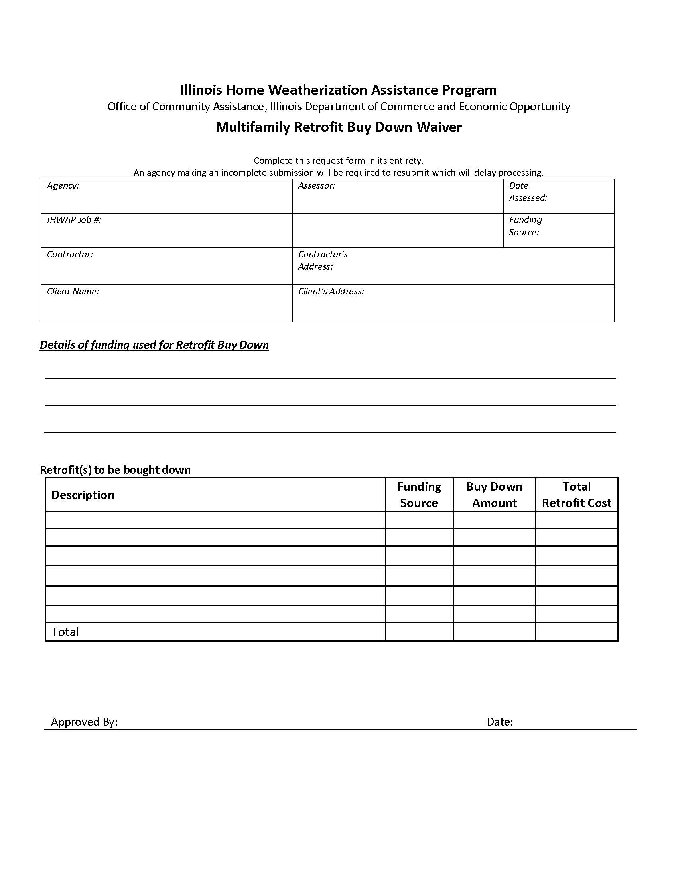

SECTION XII - INVENTORY CONTROL
Inventory control is a requirement for local agencies operating their own warehouse. It consists of several functions, including the general areas of inventory maintenance, inventory tracking, and program-related recordkeeping. This section will provide an overview of each of these areas.

Inventory Control
Storage of the materials an agency purchases involves costs. Storage costs include staff, space, insurance, security, etc. Storage costs are considered "material handling" costs and are limited to ten percent of the actual purchase price for materials to be acquired in any one program year.

Thus, it is in the best interest of the local agency to minimize these costs. Storage of materials is necessary because agencies need an adequate supply of items frequently used, and agencies typically take advantage of bulk purchase savings. Ideally, the agency should maintain a material inventory that assures:
1) an adequate supply of materials;
2) the savings from bulk purchasing should help offset storage costs; and
3) the storage costs (plus purchasing costs) are no more than the allowable material
handling amount.

It is in the best interest of the agency to minimize storage costs by keeping inventory at the lowest level possible. A "safety level" is that level of inventory that assures an adequate supply while holding inventory to the lowest level possible. In other words, a safety level means the agency has just enough of any given item on hand to ensure shortages do not stop production.

Where materials like caulk or insulation are used at a consistent rate, most agencies have established minimum inventory levels. Therefore, staff responsible for inventory maintenance should have already established a method of determining when these minimum levels are reached so that reordering can be automatic.
Other materials, such as soffit vents, and sized storm windows are not used at a consistent rate and/or are subject to non-use due to changes in work standards. When inventory is low on these items, re-ordering must be a decision based solely upon judgment and experience.

Inventory Tracking
If all materials purchased in a given month could be used on units complete with final inspection that same month, the tracking of materials would be relatively simple. Unfortunately, this rarely, if ever, occurs! Normally, several months will go by between the date materials are purchased and the date they can be reported as being placed on a final inspected dwelling unit. Thus, inventory tracking must be done to document the changes in the agency's inventory.

The agency's finance/accounting staff should report the total expenditures for materials purchased by funding source. Through inventory tracking procedures, these reported material expenditures must be divided between 1) the costs of materials on hand (reported as "inventory costs") and 2) the cost of materials applied to a final inspected dwelling unit (reported as "materials applied"). In other words, material costs must be tracked so that the agency knows how much they have on hand, and how much they have used in providing services.
The two most frequently used inventory systems are "periodic" and "perpetual."
- Under the periodic system, the program year's beginning inventory (carry-over) is shown on the books throughout the reporting period until program year close-out. Inventory balances are changed by periodic adjustment entries (e.g., "purchase/1000 tubes of caulk/$1.35 each"; "disbursed/100 bags of insulation/$3.56 each").

At the end of each established period (month, quarter, year): 1) a physical count is taken of materials on hand; 2) the inventory records are adjusted (increased per materials purchased and reduced per materials disbursed); and 3) a new balance is entered that represents the cost of materials on hand at the end of this established period.
- In a perpetual inventory system, the inventory records are balanced at all times. Receipts (cost/items of materials purchased), "in transit" (cost/items of materials released to crews for work in-progress or complete without final), and "final issues" (materials applied to a final inspected dwelling unit) are entered on a day-to-day basis.

Although the perpetual inventory system provides an up-to-date record of inventory balances, a complete physical count must be taken at the end of the program year to verify records. Following this physical count, inventory records are reconciled to reflect the actual cost/items of materials on hand (inventory carry-over). No matter which inventory system an agency uses, agency staff responsible for inventory tracking must keep a record of three things that reduce the inventory in the warehouse:
- Those materials that are "in transit"--released to crews;
- Those materials that are "final issues"--applied to a final inspected dwelling unit; and
- Those materials that are stolen or damaged--not applied.

Inventory Recordkeeping
Agencies are required to submit a year-end program close-out report that includes information on inventory. This report documents those materials on hand which will be carried-over into the next program year. In order to make this report, the staff responsible for inventory recordkeeping must ensure their records collect the information necessary.

First, it must be emphasized that materials are "accountable" by the funding source that purchases them. This "accountability" does not mean owning the actual items purchased by each funding source; rather it is the accountability of "x" dollars’ worth of total material purchases. Thus, the detailed, item-by-item inventory is kept as a combined total, and a separate record of materials costs (purchases and final issues) is kept by funding source.
The local IHWAP agency must also keep a detailed inventory spreadsheet that covers all vehicles and equipment purchased with any IHWAP funds and has an original purchase value of $1,000 or more. The inventory log must show the item, fund source, purchase price, purchase date, description, model #, and serial #/VIN, and condition.

TOTAL INVENTORY, Purchases - April to June
Purchased | 1000 tubes caulk |  | $1.35 each | $1,350 total
Purchased | 500 bags insulation |  | $3.59 each | $1,795 total
(etc.)
 |  |  | Totals $123,991
TOTAL INVENTORY, Final Issue - April to June
Final Issue | 500 tubes caulk |  | $1.35 each | $675 total
Final Issue | 100 bags insulation |  | $3.59 each | $359 total
(etc.)
 |  |  | Total $123,991
INVENTORY by FUNDING SOURCE, Purchases - April to June
TOTAL WX Materials |  | DOE | HHS | (PY12)
$264,000 |  | $125,003 | $138,997 | (Purchases)
INVENTORY by FUNDING SOURCE, Final Issue - April to June
TOTAL WX Materials |  | DOE | HHS | (PY12)
$123,991 |  | $568 | $25,663 | (Final Issue)

Using this method of inventory recordkeeping avoids detailed item-by-item tracking by funding source, while allowing for an adequate record of purchases and final issues by funding source. Actually, in this method, material values are "owned" rather than material items.
If the agency chooses to maintain an inventory record that documents items by funding source, remember that items may be "borrowed" and "repaid." This may become necessary to avoid production problems. Items that are "borrowed" must be repaid in kind (110 tubes of caulk for 110 tubes of caulk) or in value ($1,235 worth of materials for $1,235 worth of materials). All repayments must occur prior to the end of each program year. This will make the close-out report accurate for each funding source.

Equipment
LAAs purchasing equipment and/or vehicles with DCEO funds with a cost of $100 or more must adhere to the following property management standards;
Records for equipment/vehicles shall be maintained accurately and shall include;
- Tag #
- A description of the equipment/vehicle
- Manufacturer’s serial number, model number and identification number for the LAA
- Source of the equipment, including the grant number used to purchase and any applicable approvals from DCEO, DOE, etc.
- Acquisition date (or date received if it was acquired via surplus) and cost.

A physical inventory of the equipment/vehicle must be taken, and the results reconciled with the LAA’s records on an annual basis. Any differences between quantities shall be investigated to determine the cause(s) of the difference
A control system shall be in effect to insure adequate safeguards to prevent loss, damage, or theft of the equipment/vehicle.
Adequate maintenance records shall be implemented to ensure the equipment is kept in good working condition.

FORMS AND EXHIBITS for SECTION XII - INVENTORY CONTROL

Inventory Tracking Form Page 213

INVENTORY TRACKING FORM
Job # ___________________ Address ___________________________Crew______________
To be entered by Inventory Clerk to be entered by Crew Supervisor
Items | Number | Cost  Each | Total  "In Transit" |  | Actual  Applied | Stolen or Damaged* | Remainder on Hand
Caulk
Weather Stripping
Door Sweep
Bag Insulation
Roll Insulation
Vents
Hot Water Wrap
Storm Window
Other
 |  | Total $
Signatures:
Inventory Clerk | Crew Leader _____________________
*Explanation:

SECTION XIII –PROGRAM REPORTING
Program reporting for weatherization is automated in WeatherWorks. Training is on-going for all users. There is a separate user guides on WeatherWorks to explain the system.
In this section, you will find instructions for accessing WeatherWorks.
The WeatherWorks System User I.D. Request Form can be found on the WeatherWorks Desktop (pdf file named Wx Security Form). The WeatherWorks User I.D. Request Form must be completed for all users and returned to the Office of Energy Assistance. The usernames are entered into a database by the Department personnel to ensure security. This form identifies the level of access the user will have in the WeatherWorks system. If one of your staff leaves your agency, please resubmit the form to OCA (submit to ceo.oca@illinois.gov and cc your Weatherization Specialist) and request that the Department delete the employee from the database. This form should also be submitted to OCA when you need to change access for an existing user.
The WeatherWorks User ID and password is only to be utilized for the one person that the user ID was intended for. User IDs and passwords are not to be used by any other staff.
Before logging onto The System, you must do the following:
  - install VPN client;
  - copy WeatherWorks icon to desktop;
  - after double-clicking on icon, log into the system.

Step 1: State of Illinois VPN installation
Initial installation – please note that administrator rights on the computer are required to perform all of the following steps
1. Browse to the following address and confirm download of the file “VPN.zip” by selecting “Save”.
http://www.ildceo.net/downloads/VPN.zip
2. Extract the folder called “Cisco AnyConnect 3.1.05160”; placing this folder on the PC’s desktop or other easily accessible location is recommended.
3. Browse to the folder “Cisco AnyConnect 3.1.05160” and run the file called anyconnect-win-3.1.05160-pre-deploy-k9.msi. Accept the agreement and proceed with installation. Once complete, run the file called anyconnect-gina-win-3.1.05160-pre-deploy-k9.msi – after this has completed a prompt should appear to reboot, confirm the reboot. If no prompt appears, reboot the computer.
4. After reboot, navigate as follows: Start > All Programs > Cisco > Cisco AnyConnect Secure Mobility Client > Cisco AnyConnect Secure Mobility Client
- It is recommended that a shortcut to this location be placed on the desktop.

5. Enter “il-portal.illinos.gov” in the text area on the window that comes up. Click “Connect.”
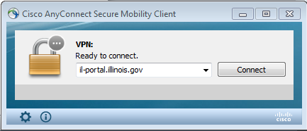
- Select “CEO-ENERGY” from the drop down
- Enter “public\wxuser__” in the username field (each agency’s user name ends with two digits, contact Mick Prince or Wayne Hartel for your agency’s numbers)
- Use the password “We@ther1password”
- Click “OK”
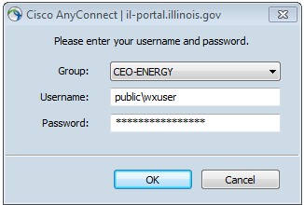
public\user__
6. Click “Accept” in the window that appears.
7. Connection will be confirmed by the presence of the icon in lower right area of the screen by the clock:
NOTE: It is recommended that when not using the Weatherization system, staff disconnect from the State of Illinois VPN to ensure proper functionality of other applications. This is done by right-clicking the icon and selecting “VPN Disconnect”. If the Cisco icon appears in the tray by the clock looking like this, , the user has successfully disconnected from the State of Illinois VPN.

Subsequent VPN connections
Typically, all information entered into the VPN client will stay populated for each subsequent use. The user just needs to navigate to the VPN program item, select the shortcut (if one was created) or double click the icon in the tray to launch the initial connection window and should usually only need to enter the password to connect. Otherwise, refer to steps 5 – 7 to connect.
Step 2: Copy WeatherWorks icon to desktop
Copy WeatherWorks from another computer at your agency or request WeatherWorks icon from Weatherization Specialist and copy to your desktop.
Step 3: Log on to WeatherWorks
This field should default to ENERGY. If ENERGY does not appear in this field, please click the little black arrow to the right of this field to reveal a dropdown box. Select ENERGY from this list and click “OK”.
The first time you log into WeatherWorks, a dialog box will appear that requests your agency code. The code for your agency will be sent to you by the DCEO TechTeam (if not provided, send email to ceo.techteam@illinois.gov to request agency code). Please enter the four-letter code for your agency and click “OK”. You should now be logged onto the WeatherWorks System.
You will also need to install the “UniPrint” software on your computer to enable you to print WeatherWorks reports. It is available at no charge at https://www.uniprint.net/en/uniprint-client/. Download the 5.4 Autodetect and Install option.

SECTION XIV - FISCAL PROCEDURES
The agencies are required to report fiscal information regarding expenditures for the program. The requirements and explanations for fiscal reporting are provided in this section.

Cash Requests
Agencies should submit expenditures on the Certified Cost Screen within the GRS Accounting system prior to submitting a cash request within the system. Prior to approval of a request, Department staff will review the year-to-date certified costs. If there are discrepancies, or lack of required production (cash requests must be within 10% of Finalized amount of production on WeatherWorks tracker), the request will be denied.
To assist LAAs with the start-up of the program year, IHWAP cash for each grant will be initially available up to the 30% level for Labor/Material and Health/Safety line items of the grant, including Administrative and Program Support line items. Administrative and Program Support line-item cash requests will be reviewed based on their reasonable proportion to the Labor and Material expenditures for the relevant grant.
Once the initial cash requests have been approved at 30%, subsequent cash requests will be subject to review on a case-by-case basis based on production, and requests will be approved up to approximately 10% above the Finalized amount of production on the WeatherWorks Tracker. Administrative and Program Support line-item cash requests will be reviewed based on their reasonable proportion to the Labor/Material and Health/Safety expenditures for the relevant grant. Cash requests should not be submitted that exceed this amount. To ensure a smooth transition in the cash flow process, accurate production plans and timely review of the WeatherWorks are a necessity. It is the agency's responsibility to monitor the GRS system for approval/denial status.

Cash Request for Weatherization Plus Measures
In an effort to make timely payment to contractors for weatherization plus measures (other than solar installations), cash request will be considered for projects that have yet to be cost reported and finalized in WeatherWorks. Weatherization Plus cash requests must be entered in GRS and supporting documentation (Weatherization Plus Cash Request tracker -https://ceo.partner.illinois.gov/OEA/OEA_LAA/OCA%20Forms%20Library1/Forms/AllItems.aspx
- and a copy of all invoices) must be submitted to your assigned grant processor (cc Agency’s Weatherization Specialist).
If solar is going to be installed on a home as a weatherization plus measure, the Agency should try to coordinate the scheduling of the solar with the regular weatherization work so the job can be cost-reported and closed when the weatherization and solar measures are completed and final inspected. If the solar installation has to be completed after regular weatherization, then the Agency can close the job in WeatherWorks after weatherization and submit a cash request, then re-open the job and add the solar cost after completion and then re-close the job (solar installation must be completed in same program year as weatherization work).

Budget Modifications
If it becomes necessary for the agency to modify the program budget, two options are available. One is to use the flex authority allowed in the grant agreement, and the second is to submit a formal modification on the WeatherWorks system.
Budget Flexibility (Flex) The agencies often find they have underestimated costs for certain line items or cost categories of their budget. Agencies shall refer to their grant agreement for the allowable flexibility for each funding source.
Formal Budget Modification When it is necessary to make a formal modification to your grant agreement, the request must be initiated through a negotiation with your Weatherization Specialist and Weatherization Specialist Supervisor.
Budget modifications are necessary when the following occurs:
- The total budget is increased or decreased,
- A cost category or line item expenditure will exceed the allowable budget flex,
- The grant period changes, or Scope of Work change or change to other terms or conditions of the grant.
The modification request shall include:
- A letter or email providing rationale or justification for the modification
- Request for Modification/Waiver which includes the Budget Modification table (on WeatherWorks)
- Budget detail sheets - as applicable (on WeatherWorks)

Prior to submission to the Department, the Request for Modification/Waiver form should be signed by the authorized agency representative. A copy, countersigned by the Department Director, will be returned to the submitting agency for their grant file. This document provides for tracking of all modifications to the grant through the sequential numbering of the modifications to the agreement.
The completed and signed Request for Modification/Waiver should be uploaded to the OCA Extranet.
For any budget modifications initiated by the Grantee, a transmittal letter from the authorized person, usually the Executive Director should be submitted to OCA via e-mail. This assures the Department that the agency administrative staff is aware of and agrees with changes being made.

De-obligation of Grant Funds as a Result of Insufficient Production
If the local agencies fail to meet the performance measures, particularly the number of units weatherized, the Department may de-obligate a portion of the IHWAP grant funds. The Department will review the levels of production and budget expenditures at the mid-point of the fiscal year (January 1st) for each local agency. If no production has occurred (no closed jobs in WeatherWorks) or current program year budget expenditures are $0.00 by this point, the Department may de-obligate up to 50% of the local agency’s DOE, HHS, and State grant funds for that year. If production is less than 25% of planned production or expenditures are less than 25% of total budget for the year, the Department may de-obligate up to 40% of the grant funds.

Fiscal Monitoring
Department fiscal staff may review any ongoing and completed IHWAP grants on a periodic basis determined by Department management. Records to be reviewed will include but are not limited to: Procedures Manual, Cash Receipts, Cash Disbursements, Payroll, Inventory, and Job Costing. Each Job file needs to include at a minimum, job number, client name, contractor’s start and finish dates, lien release, final inspection document, final fiscal detail report, and all related invoices.

All job costing needs to agree with information provided in WeatherWorks and the agency’s general ledger. Documentation needs to include agency approvals with dates identifying a clear audit trail. For additional programmatic required documentation refer to Section X of this manual.

Equipment
Equipment Acquisitions All equipment purchases of $5,000 or greater require prior written approval from DCEO OCA. The IHWAP program does not allow for shared ownership of grant funded property and equipment. The Equipment Acquisition Pre-Approval Form must be submitted to your Agency’s assigned weatherization specialist for review and approval prior to purchase. Agencies are required to track any IHWAP equipment with an original purchase price of $5,000 or greater. Equipment tracking must also include detailed information regarding the transfer or disposal of equipment purchased with IHWAP funds. Agencies should include any anticipated equipment purchases in their budget detail as submitted to the Department with the grant application/modification package. However, inclusion of the equipment purchases in the budget does not constitute required pre-approval. If equipment purchase was not outlined in the original budget, a grant modification will be required. Please reach out to your Weatherization Specialist and grant processor to initiate a grant modification.
Once equipment has been purchased, the agency is required to submit an Equipment Acquisition Reporting Form to their Weatherization Specialist and Fiscal Monitor to report final purchase price, date, and other details. This form must be signed by the agency's Executive Director or Fiscal Officer.
Equipment Dispositions According to the federal regulations, items of equipment with a current fair market value of $5,000 or less, may be retained, sold, or otherwise disposed of with no further obligation to the funding agency (2 CFR Part 200.313(e)(1)) 45 CFR Part 75.320(e)(1)]. However, OCA policy is that any funds collected for equipment sold with a value of $500 or more, must be returned to the program (at the local agency) from which it was purchased.
If IHWAP purchased equipment is no longer needed for operation of the weatherization program, the following disposition options are available:
Options In Priority Order
- Trade-in for new IHWAP equipment.
  - Submit an Authorization for Disposition of Property form to your Weatherization Specialist for approval prior to trade-in.
  - Proceeds received from a trade-in shall keep their original federal identity.
- Offer for transfer to other LAA’s in the IHWAP network.
  - Send an email to your Weatherization Specialist with a copy to the DCEO Weatherization Manager notifying them of the availability of excess IHWAP equipment to be offered to the network.
  - Upon agreement of transfer, complete the Authorization for Transfer of Property must be completed and signed by both agencies and an IHWAP Specialist or Manager.
- Public auction
  - Submit an Authorization for Disposition of Property form to your Weatherization Specialist for approval prior to organizing an auction.
  - The LAA must ensure that proper public notice is given and that appropriate channels are used for the auction to avoid actual or implied conflict of interest.
  - All proceeds from auction should be used for purchase of replacement equipment or to offset future other IHWAP expenses.
- Scrap (if deemed necessary)
  - Submit an Authorization for Disposition of Property form to your Weatherization Specialist for approval prior to disposal.
  - IHWAP equipment should only be scrapped when the residual value of the equipment is less than what the estimated value would be for trade-in or auction
  - All items should be offered for transfer to the network prior to considering scrapping as an option.
  - All proceeds from auction should be used for purchase of replacement equipment or to offset future other IHWAP expenses.
Equipment Tracking Department fiscal staff, in periodic reviews, will analyze agency equipment listings and actual equipment purchased for verification of agency tag numbers and/or serial numbers, location, costs, and funding source including grant numbers. Items on this listing should include equipment over $5,000. All purchases, dispositions and transfers will be reviewed during each agency visit All files must contain written authorizations for all purchases, dispositions and transfers of property and equipment. Agencies should maintain records for equipment tracking utilizing the longest time period of the following two options: 1) The life of the equipment or, 2) A minimum of 10 years. This tracking method includes purchases, transfers, and dispositions.

Crew-Based Agency/Contracting Operating Policies
As a result of 2 CFR 200 and to provide the Crew Based Agencies with better internal controls and guidance regarding operation of the program, OCA is requiring the following changes in operations and accounting policies with the fiscal year beginning July 1, 2019:

Definitions
Not for profit describes a type of organization that does not earn profits for its owners. All of the money earned by or donated to a not-for-profit organization is used in pursuing the organization's objectives and keeping it running.
External Contracting Unit (ECU): Crews that provide contracted Weatherization services for other LAAs.
Weatherization Work Done Within LAA’s Assigned Territory
General Requirements
- Perform all Weatherization work at cost. No mark-up on any costs.
- Verification of costs:
  - LABOR, timesheets should be kept in the client file, so they are easily accessible by monitors and auditors for labor cost verification.
  - MATERIAL, Actual procured prices, (no markup should be used). Only materials used for grant WX work can be purchased with grant funds.
  - Overhead costs need to be budgeted in Program Support (P/S). Costs must all be directly charged to P/S and have applicable supporting documentation (timesheets, invoices, etc.) for each charge to P/S. No overhead or ancillary charges on WeatherWorks jobs. Examples; fuel, vehicle repair, small tool purchase, etc.
- T and TA allocation is based on Weatherization work in your assigned LAA territory only.
- Equipment
  - Equipment purchased by IHWAP will support your grant funded WX work only.
- Purchase, Construction, or Improvement of real property cannot be completed with any IHWAP funding.
- Procurement: Real procured costs should be represented in your IHWAP WeatherWorks Catalogs and utilized when posting costs to your financial records. No mark-up or overhead fees are allowed. Additional 10% P/S should cover these costs.
Recording Weatherization Jobs to the General Ledger
Crew Based Agencies should use a cost of goods sold method to record cost per job.
- Recording of weatherization work completed within the LAA’s assigned territory MUST originate in the weatherization fund. LAA’s cannot submit invoices from their ECUs to the Weatherization fund for reimbursement. Transactions for work completed within the LAA’s assigned territory and work completed by an ECU MUST not be intermingled.
- Inventory items purchased should be recorded to the inventory asset account. Inventory items may still be purchased with corporate funds and reimbursed by weatherization funds.
- Major items such as furnaces must be tracked by specific individual unit cost.
- Inventory materials used must be tracked by job.
- Each job MUST be recorded separately and reference the WeatherWorks job number in the general ledger to ensure it is easy to trace for audit purposes.
- A physical inventory should be taken at least once a year to adjust any inventory variances at year end.
Weatherization Work Done for Other LAAs
Available Approaches:
Two options are available for performing Weatherization work at other LAAs:
- Perform work at cost. You would need to sign a Memorandum of Understanding (MOU) with the applicable LAA that Weatherization services will be provided to them at cost. In essence, your crew would be shared with another LAA. A grant modification could be completed to provide an additional 10% program support for the LAA receiving the services to support crew overhead expenses. If this approach is used, grant funded equipment and crews can be used for the work at other agencies.
- Perform work at other LAAs as an External Contracting Unit (ECU). In this approach, your LAA is acting as a third-party contractor. Please note that LAA’s performing work as an ECU will be treated as an outside contractor. Any disputes over pricing or quality of work between the ECU and LAA (customer) must be resolved between the two contracted parties. All activities performed for other LAAs must be kept completely separate from grant funded Weatherization activities performed. ECU activities must abide by relevant requirements outlined in the Fiscal Requirements for WX Work Done at Other LAAs section below. The ECU must reimburse the IHWAP grant for use of equipment used while providing Weatherization services at another LAA. There are two options regarding the equipment used by the ECU. It is the responsibility of the LAA to determine the impact of this approach on the not for profit and tax-exempt status of the LAA with regard to I.R.S. regulations
  - Rent equipment from IHWAP. The ECU must reimburse the IHWAP grant for use of equipment used while providing Weatherization services at another LAA. Rental rates must be in reasonable alignment with regional market rates. The rental rate must be approved by DCEO for reasonableness. All ECU time spent using IHWAP equipment must be logged, and rental charge expenses must be recorded by job. ECUs performing weatherization activities for other agencies should follow the same guidelines for renting equipment as is described in Section II regarding Joint Funded Projects.
  - Purchase equipment from IHWAP. IHWAP cannot provide funding to support crew-based agencies on “for profit” endeavors. OCA will continue to provide grant funding to purchase enough equipment to support grant work within each LAAs Weatherization service territory. All current equipment inventory that is in excess of what is needed for your grant funded projects may be purchased from IHWAP at fair market value. All equipment owned by the LAA will be assumed to have been purchased with WX grant funds unless clear documentation to the contrary can be provided. Fair market value must be attained through reasonable methods. A third-party appraisal may be conducted to assess the value of any excess equipment. Fair market value and proposed sale of any IHWAP equipment must be reviewed and approved by OCA in writing prior to the purchase transaction. OCA grant funds may not be used for the purchase of any IHWAP equipment to be used for Weatherization work to be done by an ECU at another LAA. As a result, shared ownership of equipment between grant funds and any ECU is not allowed effective with the start of Weatherization Program Year 2021.
Fiscal Requirements for WX Work Done at Other LAAs
- Tracking WX Activities at Other LAAs
- A separate fund on the general ledger must be created and maintained for all work done at other LAAs.
- For LAAs performing work at other LAAs at cost through an MOU, this fund must be a “net zero” fund. All revenues received from work done at other LAAs must be offset by the actual costs incurred to perform the work. This includes direct labor and material costs to perform the work at other LAAs as well as allocated overhead costs. In the case of allocated overhead costs, a reasonable and supported allocated amount should be charged.
- For LAAs performing work at other LAAs through an ECU, this fund must be maintained completely separate from all grant fund accounts, and contain all revenue and expenditures related to the ECU activities.

- Cash
- Separate bank accounts must be maintained for all WX work done for other agencies. All cash receipts and disbursements for WX activities at other LAAs must be maintained in this separate bank account regardless of the approach utilized.
- Calculation of Charges to Other Agencies in the MOU-At Cost Method
The Crew Based Agencies are not allowed to charge a flat percentage for program support and administrative cost. All costs billed for must be itemized. These include (but are not limited to):
- Charges for Assessment Fee (actual payroll cost for Assessor including travel time)
- Charges for Inspection Fee (actual payroll cost for Final Inspector including travel time)
- Labor timesheets including travel time should be completed to reflect a clear delineation between work done in your agency service territory and work done for another agency. A copy of these timesheets should be kept in the applicable WeatherWorks job file for monitoring and audit purposes.
- Travel time billed at actual costs for inspection, assessment, and job installation.
- Actual fuel cost for travel (must provide clear documentation)
  - Lodging should be billed at actual cost and should not exceed GSA guidelines
  - Meals should be billed at actual costs or using the GSA per diem guidelines. Costs should not exceed GSA guidelines.
- Overhead Costs: Common overhead costs include space (rent), telephone, utilities, office supplies, vehicle and equipment maintenance. These costs should be billed separately on a periodic basis.
- WeatherWorks data entry- Staff costs for WeatherWorks data entry. This can either be charged on a per home basis or aggregated and allocated on the periodic overhead invoice. This must be based on actual staff time cost.
Actual job costs should be traceable by monitors and auditors. Vendor invoices and other supporting documentation (including timesheets and travel records) should be kept in the job files.
The fund balance for the work done at other LAAs must be zero at the end of each program year and result in no profit for the agency.
- Invoicing Other Agencies in the MOU-At Cost Method
To accurately reflect the actual costs incurred, the following method is recommended when invoicing for WX work performed at other LAAs. Refer to sample invoices in the exhibits of this section.
- Invoicing individual jobs:
Each job must be invoiced separately and include all actual costs incurred to perform the work. These invoices must be issued as each job is completed and include clearly detailed itemization of all actual costs being billed.
- Periodic overhead invoices:
Overhead costs should be billed on a regular periodic basis. The most reasonable period of billing would be monthly. This invoice should include the calculated allocation of overhead costs for the LAA being billed.
A suggested method of allocation would be the proportional amount of homes weatherized (Final) for the LAA being billed compared to all homes weatherized that month by the billing LAA. This approach will allow all overhead costs to be traced to the supporting documentation for these costs.
Example of Allocation of Overhead Costs:
LAA XYZ Weatherizes 10 total homes in June broken down as below:

Agency # of Homes %
XYZ LAA 6 60%
ABC Agency 2 20%
DEF Agency 2 20%

Total: 10 100%
In this example, ABC Agency and DEF Agency would each be charged for 20% of the overhead costs for the month of June.
- Invoicing Other Agencies in the ECU Method
Since operating as an ECU is an activity outside of the weatherization grant activities, the invoicing approach is largely at the discretion of the ECU. However, all activities of the ECU must be maintained completely separate from the WX grant activity at the LAA and no grant funds may be used in the operation of the ECU.
Although OCA does not prescribe how the ECU activities are invoiced, OCA monitors will be reviewing the invoices paid by LAAs receiving WX services from ECUs for reasonableness and accuracy. As indicated earlier in this policy, LAAs will not be allowed to pay P/S and Admin. charges that are billed as a percentage. Only direct costs will be allowed.
Please note, loss of funding could occur if it is discovered crew-based agencies are profiting using grant funds.

FORMS AND EXHIBITS for SECTION XIV - FISCAL PROCEDURES

Equipment Acquisition Pre-Approval Form Page 227
Equipment Listing Form Page 228
Authorization for Transfer of Property Page 229
Authorization for Disposition of Property Page 230
Equipment Acquisition Reporting Form Page 231
IHWAP Budget Definitions ……………………………………………………. Page 232

ILLINOIS HOME WEATHERIZATION ASSISTANCE PROGRAM
EQUIPMENT ACQUISTION PRE-APPROVAL FORM
Agency Name:
Estimated Date of Purchase:
Grant Number of Funds Used: HHS WX____________ State_____________
Equipment Description: __________________________________________________________
______________________________________________________________________________
______________________________________________________________________________
______________________________________________________________________________Estimated Cost: $_____________________
Amount of purchase allocated by grant number:
HHS Wx: $________________________
State Wx: $_______________________
Purpose of Purchase:
____________________________________________________________________________________________________________________________________________________________
______________________________________________________________________________

I attest that this equipment will be procured utilizing the methods referenced in 2CFR200 Part 200.317-200/326 and OCA procurement guidelines.
This form will attest that the purchase of the above equipment Is pre-approved by DCEO OCA.

_____________________________________ _________________________________________
Agency Authorized Signature OCA Weatherization Specialist Signature
(Executive Director or Fiscal Officer)

______________________________ _____________________________
Date Date
NOTE: A separate form should be completed for each piece of equipment.
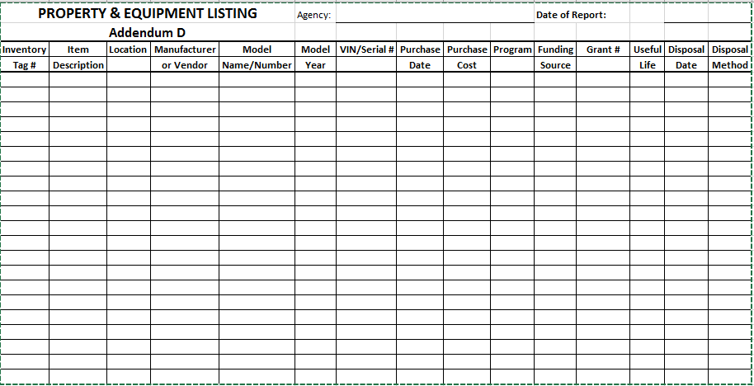
Authorization for Transfer of Property

1. Name of Transferor: 1B. Date Submitted

1A. Name of Transferee: 1C. Source of Funds & Grant #:
APPROVAL
Approval is hereby granted by the DCEO to transfer the items on the attached inventory from ____________________________________ (Transferor) to ____________________________
____________________________________ (Transferee) on this day __________________.
_____________________________________________________________________________.
Name (print) of the Weatherization Manager/ Signature
.....................................................................................................................................................
AGENCY ACTION
I. TRANSFEREE
I have received the items on the attached inventory report.
___________________________________
Agency
___________________________________
Name (print) of Authorized Representative
________________________________________ ___________________________________
Signature of Authorized Representative Date
II. TRANSFEROR
I have transferred the items on the attached inventory report.
____________________________________
Agency
____________________________________
Name (print) of Authorized Representative
________________________________________ ___________________________________
Signature of Authorized Representative Date

Original – The Department
Copy - Transferor Copy – Transferee

Illinois Department of Commerce and Economic Opportunity
Office of Community Assistance
AUTHORIZATION FOR DISPOSITION OF PROPERTY

Agency ______________________________________________________________________
Item description | Inventory Tag | Funding Source | Grant # | Purchase Date | Disposition  Date | Purchase Price
e.g. Blower door | WX 1234 | HHS | 08-221099 | 05/23/08 | 05/23/17 | $1,203.45

Once completed, this form will attest that the disposition of the above equipment meets all required disposition procedures and that the necessary documentation is present at the local agency.

____________________________________ _______________________________________
LAA Authorized Signature DCEO Authorized Signature
(Executive Director or Fiscal Officer) (Weatherization Specialist)
______________________ _____________________
(date) (date)

NOTE: List all grant numbers and funding sources used to purchase the item being disposed.

ILLINOIS HOME WEATHERIZATION ASSISTANCE PROGRAM
EQUIPMENT ACQUISTION REPORTING FORM
Agency Name:
Date of Purchase:
Grant Number of Funds Used: HHS WX_______ State________

Equipment Description: ____________________________________________________
___________________________________

Final Purchase Cost: $
Amount of purchase allocated by grant number:
HHS WX (insert dollar amount) $
State WX (insert dollar amount) $

Serial Number
Purpose of Purchase:

________________________________________________________________________

I attest that this equipment was procured utilizing the methods referenced in 2CFR200 Part 200.317-200.326 and OCA procurement guidelines.

Agency Authorized Signature
(Executive Director or Fiscal Officer)

Date:

NOTE: A separate form should be completed for each piece of equipment.

IHWAP BUDGET DEFINITIONS
Revised 3-10-21

Program Support
Program Support is for non-administrative costs to support installment of weatherization measures. Costs eligible for Program Support are the costs necessary to affect the weatherization of an eligible dwelling unit, including but limited to:
- Wages, fringes, and associated costs (such as allocated space and telephone) for:
  - Weatherization coordinator, assessors, final inspectors, and clerical staff;
- Client outreach, intake and eligibility, and processing applications;
- WeatherWorks data entry and compiling/reviewing weatherization files
- Registration, insurance, maintenance, and fuel for vehicles used to transport weatherization materials, tools, equipment, crews, assessors, and final inspectors to a storage site and to the site of weatherization work;
- Maintenance of tools and equipment used to install materials and/or perform assessments and final inspections;
- Purchase or annual lease of tools, equipment, and vehicles used to install materials or perform assessments/final inspections;
NOTE: All purchase of vehicles must be referred to the Department of Commerce and Economic Opportunity (Department) for prior approval. No vehicles or equipment with a cost per unit of $5,000 or greater may be purchased with DOE funds. No pre-payment of leases or future year costs that exceed the end of the grant period are allowed.
- Storage of weatherization materials, tools, equipment, and weatherization vehicles;
- Space rental for Weatherization related staff with duties directly related with the operation of the Weatherization Program; (As with vehicles and equipment, LAAs may NOT pre-pay leases that exceed the end of the grant period.)
- Utilities and maintenance associated with the operation of a warehouse only; (All other utilities and maintenance costs must be charged to the Administration budget category.)
- Insurance covering materials;
- Wages and fringes for staff that are responsible for materials inventory or purchasing;
- Retrofitting storage facility;
- Computer equipment utilized specifically by the weatherization staff.

NOTES:
- Any costs allowable as program support, but that exceed the available program support allocation, may be budgeted as administrative.
- Crew-based agencies are allocated a supplementary10% in the Program Support budget category for the additional costs incurred in the operation of a weatherization crew.

Client Assistance (Material/Labor and Health/Safety)
Costs eligible as Client Assistance are costs associated with weatherization materials and material handling, including but not limited to:

Material/Labor
- Costs for all weatherization materials, including mechanical measures, are budgeted in this line;
- On-site crew labor and supervisory personnel including on-site subcontractor labor to install weatherization materials; (Material/labor is not to include any costs related to the assessment or final inspection process.)
- Fuel for weatherization crew-based agencies may be charged to material and labor. The Material/Labor budget category MUST not include costs related to the assessment or final inspection processes. Agencies can create a task in WeatherWorks for estimated fuel costs. Actual fuel cost must be entered in cost reporting screen.
- The required fees related to building permits from local governments are allowable under this category.
Health/Safety
- Health/Safety measures are tracked separately from Material/Labor. A calculation should be completed based on prior year’s expenditure to determine the portion of funding that will be placed on this line.
Administration
Costs identified as administrative can only be budgeted and charged to direct administration or indirect budget line items. However, any costs allowable as program support, but that exceed the available program support allocation, may be budgeted as administrative.
Administration contains all costs associated with the administration of the IHWAP, including, but not limited to:
- Wages and fringes for staff salaries such as the Executive Director's, bookkeeper's, and other agency-level administrative staff;
- Salaries and costs related to customer outreach and intake, processing of applications and client eligibility notification, non-audit data entry, and clerical activities;
- Administrative equipment with a cost per unit of $5,000 or greater (except in the DOE grant) -- prior approval from the Department is required;
- Other administrative costs such as equipment under $5,000, supplies, travel, postage, personal computers, rental costs, desks, copying costs, subscriptions, dues, outreach sites, etc.;
- All utilities and maintenance costs (except for those related to the operation of a warehouse);
- The local agency's allocated direct costs [must maintain clear documentation of allowable allocation methodology];
- Allowable costs associated with an approved indirect cost rate;
- Audit costs [Required Single Audit as required by 2 CFR 200.501 (b)] (HHS and State only). [Can be charged to either direct or indirect admin. budget categories)
NOTE: Required Single Audit costs for DOE are not to be budgeted in this Category, see below.
Special Costs Allowed for Specific Grant Funds
Special Costs are limited to specific grant allowable budget categories as detailed below:
- Financial Audit (DOE only) - DOE's proportional share of allowed agency-wide single audit costs.
- Training and Technical Assistance (DOE and HHS only):
  - Registration fees to attend weatherization training events;
  - Salaries and fringes of weatherization personnel while attending and traveling to and from weatherization-related training;
  - Travel expenses to attend training [lodging, per diem, mileage, transportation, etc.];
  - Salaries and fringe for Weatherization trainers; and
  - Costs for facilities used exclusively for weatherization training.

- Liability Insurance (DOE only) - Liability Insurance for the weatherization program for personal injury and property damage resulting from the weatherization services. May include Pollution Occurrence Insurance.

- Vehicle Purchases (HHS Only) - At the discretion and written approval of the Department, LAA’s may opt to purchase vehicles for use within the Weatherization Program.

SECTION XV HEARINGS, APPEALS, and CLIENT COMPLAINTS
Given the size and complexity of the Weatherization Assistance Program, clients will question certain agency actions or their failure to act on a timely basis. Each agency is required to understand and implement the hearings and appeals process established by the Department.
Each agency must provide a copy of the appeals brochure, "Your Rights" to every applicant at the time of application and when he or she is notified that the application has been denied and/or if the agency has received a complaint from the client. All applicants are to be provided with an opportunity for a fair administrative hearing when claims for assistance are denied or are not acted upon with reasonable promptness. This fair administrative process shall include three levels of appeal: the informal conference, the state review, and the formal hearing.

The Informal Conference
This process consists of an initial informal conference held by a staff hearing officer of the LAA at which the applicant applied. This informal conference is designed to ensure that the applicant understands the reason(s) for the action taken by the LAA.
Any applicant receiving or denied energy assistance has a right to request an informal conference within 30 calendar days of receipt of a notice of a decision on the applicant's application.
Any applicant, who has submitted a completed application but has not been notified of the application status within thirty (30) days of the date of a complete application, has a right to request an informal conference within 60 calendar days of the date the application was complete.
Any applicant has the right to complain and request an informal conference if they are not satisfied with the weatherization work that was completed.
Any applicant requesting an informal conference shall be furnished the reason for the decision on the application and be allowed to review the documents leading to the decision prior to the informal conference.
The informal conference must:
  - be held at the application site closest to the applicant's residence or at the applicant's residence if they are confined;
  - be conducted by a LAA staff member who was not involved in the original decision (the IHWAP coordinator may also attend);
  - be held within 15 calendar days of the receipt of request;
  - afford the applicant an opportunity to bring an interpreter and/or representative;
  - Allow the applicant to present oral and written testimony on his/her behalf.
The LAA will give the applicant a written statement at the end of the conference describing the result of the conference and citing the policy reasons for the decision. A copy of this report must be filed in the applicant's file.
In the event of a finding in support of an applicant, the LAA shall, within 15 calendar days of the finding, process the application and notify the applicant in writing of the applicant's eligibility. In the case of an emergency assistance application (for ES Furnace), the LAA shall process the application and notify the applicant within forty-eight (48) hours. In the event of disapproval, the LAA shall provide the applicant with a Request for State Review Form. The request must specify the LAA at which the household applied for assistance, whether the LAA has held an informal conference, and the reasons for requesting a state review.

The State Review
A request for state review must be filed with the Department within 30 calendar days after the informal conference. If the request is timely made, the Department will appoint a state reviewing officer who will review the applicant's file and the informal conference report. A written decision will be made. The request is considered made on the day the request is received by the Department (per the date stamp on the correspondence). The Department will notify the LAA that a request for state review has been filed. The LAA must, within five (5) days of the request for state review, provide both the Department and the applicant with a full copy of the applicant's file.
A state reviewing officer will review the file to determine if the application contains all information required in Section 109.250(d) and all testimony presented at the informal conference. The state reviewing officer shall ascertain if the applicant was provided with a Request for State Review Form in accordance with subsection (a)(7) and determine if the informal conference decision regarding eligibility was correct (see Section 109.250 for eligibility criteria).
This determination will be made, and a letter sent to the applicant and the LAA within 15 calendar days of the request for state review. In the event of finding in support of an applicant, the LAA shall approve and process the application or modify the assistance granted and notify the applicant in writing within 15 calendar days of notification of the finding from the State. In the case of an emergency assistance application (for ES Furnace), the LAA shall process the application within 48 hours of notification of the finding from the State. In the event of a disapproval, the State shall provide the client with a Request for Formal Review Form. The request must specify the LAA at which the household applied for assistance, whether an informal conference has been held, if the state review has been conducted and the household notified of the decision, and the reasons for requesting a formal hearing.

The Formal Hearing
If not satisfied with the results of the state review, the applicant must request a formal hearing by sending a written request to the Department who will notify the LAA that the request has been made by the applicant. This request must be received by the Department within 30 calendar days of the date on which the state review letter was mailed by the Department. The Department will provide the applicant with a notice of the hearing in accordance with Section 10-25 of the Illinois Administrative Procedure Act [5 ILCS 100/10-25]. The hearing will be conducted by a hearing officer, who has not participated in any earlier decision concerning this application, within 30 calendar days from the date the formal hearing request was received by the Department The formal hearing will meet the following standards:
    - The hearing will be held at the application site closest to the applicant's residence or at the applicant's residence if they are confined.
    - The applicant will be afforded an opportunity to review his/her file.
    - The hearing will be tape-recorded.
    - The decision will be based on the record, which will comply with Section 10-35 of the Illinois Administrative Procedure Act, and which will be made pursuant to the procedures set forth in Section 10-45 of the Illinois Administrative Procedure Act. The hearing officer will determine if the household is eligible in accordance with Section 109.250.
    - If requested by the applicant, the applicant will be provided interpretive and auxiliary services (e.g., transportation).
    - The applicant will have the right to:
  - Be accompanied and/or represented by another;
  - Present written and oral statements and other evidence in accordance with Section 10-40 of the Illinois Administrative Procedure Act;
  - Bring an interpreter; and
  - Present and question witnesses.
    - Within 10 calendar days of the formal hearing, the state appeals review board shall send a written determination to the applicant and the LAA in accordance with Section 10-50 of the Illinois Administrative Procedure Act.
    - In the event of a finding in support of an applicant, the LAA shall, within 15 calendar days of notification of the finding, process the application or modify the assistance granted and notify the applicant in writing of the applicant's eligibility. In the case of an emergency application (for ES Furnace), the LAA will process the application and notify the applicant within forty-eight (48) hours.

FORMS AND EXHIBITS for SECTION XV - HEARINGS AND APPEALS
“Your Rights” Brochure Page 239
Flow Chart of Appeals Process Page 240
Informal Conference Cover Sheet Page 241
Informal Conference Report Page 242
Request for State Review Page 243
Formal Hearing Request Page 244
Formal Hearing Request Follow-up Letter Page 245
Formal Hearing Script Page 246
Review Board Denial Letter Page 249
Review Board Approval Letter Page 250
Legal Aid Services by County Page 251

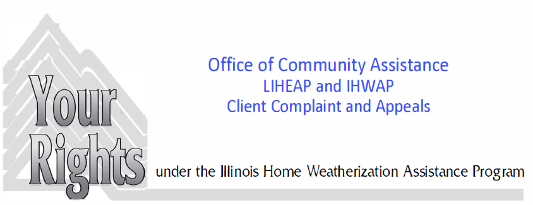
The Illinois Home Weatherization Assistance Program (IHWAP) is designed to help income eligible households conserve fuel and save money by making their homes more energy efficient.
ELIGIBILITY for the Weatherization Program depends on:
- Household Income based on the number of household members; and
- Proof of ownership, or that the landlord complies with IHWAP program requirements
COMPLAINT RIGHTS
- You have the right to complain if you are not satisfied with the work that was completed
APPEAL RIGHTS
- You have the right of appeal if your application was not processed in a timely fashion, after all of the required documentation has been received; Usually within 30 days;
- You disagree with the denial of your application.
CLIENT COMPLAINT/APPEAL PROCESS
INFORMAL CONFERENCE
The first step in the Client Complaint or Appeal Process is an Informal Conference at the local agency.
- You may request an Informal Conference by contacting the agency at ____________________
The Informal Conference will be held by a designated hearing officer representing the Local Administering Agency (LAA). The purpose of the Informal Conference is to ensure that the applicant (client) understands the reasoning for denial of their application or IHWAP policies and standards for the work that was completed.
STATE REVIEW
If you are not satisfied with the results from the Informal Conference you may request a State Review. The LAA will advise you on how to request a State Review.
- The State Office will review your case and advise both you and the LAA of their determination.
- Final decisions on complaints regarding quality of weatherization work are made here (no further appeal of these issues)
STATE APPEAL/HEARING
If you are not satisfied with the results from the State Review of your application complaint you may request a Formal Hearing by a State Appeals Officer. During this hearing you have the right to:
- Be represented by a representative of your choice (bring an interpreter, if needed);
- Present oral and/or written statements or other evidence;
- Cross-Examine witnesses
This testimony will be recorded, and a written decision will be based on the record.
These are YOUR RIGHTS. If you are unclear and/or don’t understand them, please ask to have them explained.
Flow Chart of Client Complaints and Appeals Process
Office of Community Assistance
CLIENT COMPLAINTS and APPEALS PROCESS

 | Applicant Denied  Or Client Complaint | or | Applicant not notified or not satisfied with work
30 Days | Applicant Denied  Or Client Complaint |  | Applicant not notified or not satisfied with work | 60 days
30 Days | Applicant requests  Informal Conference |  |  | 60 days
15 days | Applicant requests  Informal Conference
15 days | Informal Conference
 | Informal Conference | 30 days
 | Applicant dissatisfied | 30 days
 | Applicant request State Review | 30 days
 | Applicant request State Review | 45 days
 | Agency sends informal conference report & case folder to State Agency | 45 days
 | State notifies client & Agency of Determination | 45 days
 | State notifies client & Agency of Determination | 30 days
 | Applicant dissatisfied with decision on application (no further review allowed of work quality) | 30 days
 | Applicant request Formal Hearing | 30 days
 | Applicant request Formal Hearing | 30 days
 | Formal Hearing | 30 days
10 working days | Formal Hearing
10 working days | State notifies Applicant & Agency of Decision

ILLINOIS HOME WEATHERIZATION ASSISTANCE PROGRAM
INFORMAL CONFERENCE COVER SHEET

APPLICANT
Name
Address
City Zip __________ Phone ______________________
LOCAL ADMINISTERING AGENCY
Name
Address
City Zip __________ Phone _____________________
INFORMAL CONFERENCE DATE ____________________________________________________
OUTCOME:
_____________________________________________________________________________
_____________________________________________________________________________
_____________________________________________________________________________
_____________________________________________________________________________
_____________________________________________________________________________
_____________________________________________________________________________
_____________________________________________________________________________
____________________________________ _____________________________
Signature of Informal Conference Convener Signature of Applicant
___________________________________ _____________________________
Date Date
2 copies to Application
1 copy of Agency
ILLINOIS HOME WEATHERIZATION ASSISTANCE PROGRAM
INFORMAL CONFERENCE REPORT
APPLICANT
Name
Address
City Zip Phone
LOCAL ADMINISTERING AGENCY
Name
Address
City Zip Phone
Date of Application Intake Worker
REPORT OF INFORMAL CONFERENCE
Original Determination and Rationale:

Date of Notification Letter
Informal Conference Date
Representing the Applicant:
Outcome of Conference (attach additional sheets if necessary):

ILLINOIS HOME WEATHERIZATION ASSISTANCE PROGRAM
REQUEST FOR STATE REVIEW
Applicant Name
Address
City Zip
Phone

I have applied for assistance under the Illinois Home Weatherization Assistance Program at the following agency:

The agency has held an informal conference and I have been notified of the outcome of the conference. YES NO

I request a review by the state regarding the agency's decision on my IHWAP application because (explain your reasons for requesting a State Review):

Applicant/Representative Signature
Date

Send to: Illinois Department of Commerce and Economic Opportunity
Office of Energy Assistance 500 East Monroe Street
Springfield, IL 62702
ILLINOIS HOME WEATHERIZATION ASSISTANCE PROGRAM
REQUEST FOR FORMAL HEARING
Applicant Name
Address
City Zip
Phone
I have applied for assistance under the Illinois Home Weatherization Assistance Program at the following agency:

The agency has held an informal conference.
YES NO
The Department has conducted a State Review and has notified me of their decision.
YES NO
I am requesting a Formal Hearing to be conducted by the State Hearing Officer.
I am requesting a Formal Hearing because (explain below the reasons why you are dissatisfied with the State Review):

Applicant/Representative Signature

Date

Send to: Illinois Department of Commerce and Economic Opportunity
Office of Energy Assistance 500 East Monroe Street
Springfield, IL 62702
ILLINOIS HOME WEATHERIZATION ASSISTANCE PROGRAM
FORMAL HEARING REQUEST FOLLOW-UP LETTER

Dear (Applicant's Name):
Your request for a Formal Hearing for the Illinois Home Weatherization Assistance Program (IHWAP) has been received by the Department. A review of your file by the State Hearing Officer reveals that

The formal hearing has been tentatively scheduled for (date), (time), and (location).
Please contact our office by (date) at our toll-free number, 800/252-8643 between the hours of 9:00 a.m. and 5:00 p.m., Monday through Friday to confirm this appointment. If this date is not convenient, or if you need assistance in getting to the hearing, please let us know so arrangements can be made.
The hearing will meet these standards:
1. It will be held in a place reasonably convenient to you.
2. You will have a chance to review the case file and any written evidence (a copy of the file will be sent to you before the Hearing).
3. The Hearing Officer will be a state employee.
4. The agency appeals officer, IHWAP determiner, intake worker, and/or any agency witnesses who have personal knowledge of your case will be present, if possible, in order to ensure full explanation and cross-examination of your case.
5. The hearing will be tape recorded.
You have the right to:
1. Bring to the hearing a representative of your choice.
2. Present oral and written statements and other evidence.
3. Have witnesses.
4. Cross-examine (ask questions) other witnesses.
5. Bring an interpreter if needed.
The State Appeals Review Board will review all the evidence presented at the hearing and notify all parties of its decision within ten (10) working days of the hearing.

Sincerely,

Signature of State Official

ILLINOIS HOME WEATHERIZATION ASSISTANCE PROGRAM
FORMAL HEARING SCRIPT

STATE HEARING OFFICER
"This is the formal hearing under the Illinois Home Weatherization Assistance Program requested by .
(Applicant)
This hearing is being held at on
(Time) (Date)
at .
(Location)
"Present are the applicant, _______ , and his/her
representative, , from .
(Agency, if appropriate)
Persons present who are here as witnesses to help explain the applicant's position are:
.
(Name(s), Relationship to applicant or Agency affiliated)
"Also present is the Appeals Officer from
(Agency)
, .
(City) (Name)
"I am , an employee of the Illinois Department
(Name)
of Commerce and Community Affairs. I will serve as State Hearing Officer.
"My role is to collect the information presented at this hearing and deliver it to the Appeals Review Board, which will make the final decision based on this record.
"The purpose of this hearing is to give the applicant an opportunity to tell why he/she disagrees with the decision of the local agency. The Appeals Officer from the Local Administering Agency will present the agency's position through persons who have firsthand knowledge of the applicant's case."
The purpose of this hearing is to determine if the state and federal policy that governs the Illinois Home Weatherization Assistance Program was fairly applied to the applicant's individual case. Challenges to state or federal policy are not pertinent to this administrative hearing and will not be considered by the State's Appeals Review Board. Challenges to the underlying state or federal policy shall be considered for judicial review."

"I want to explain the procedures that we will use in this hearing. First, the applicant will explain his/her position, and any witnesses that the applicant has brought with him/her will also be allowed to explain what they know, from firsthand knowledge, about the applicant's application for weatherization assistance. _________________ from _ will be able to ask the applicant, and any witnesses that the applicant has brought with him/her, questions about what the applicant says happened. If I have any questions about the facts as the applicant sees them, I will ask those questions, too."
"Next, the Appeals Officer, from
will present the agency's position. Just like the applicant's witnesses, the witnesses from the agency will only be people who have firsthand knowledge of the applicant's case. The applicant or the applicant's representative may ask any questions that the applicant feels are necessary of the witnesses from the agency. Again, I may also ask questions of the witnesses from the agency in order to bring out the facts in this case. When the Appeals Officer from the agency presents the agency's position, I will ask him to describe not only the facts of this case, but also the specific policy provisions that the agency relied on in making their decision in the applicant's case."

SWEARING IN OF WITNESSES
"I will now swear in the witnesses. Will all persons who wish to make a statement either on behalf of the applicant or the agency please stand and raise their right hand."
"Do you solemnly swear that you will tell the truth, the whole truth and nothing but the truth?" (The witnesses should reply, "I do.")

REASON FOR HEARING
"The applicant has asked for a formal hearing because he/she

(give reason)
(Directed to applicant's representative or to the applicant if he/she has no representative):
"Mr./Ms., please explain the reasons you disagree with the decision made in your case."
(If written evidence, State Hearing Officer will:
1. Explain the contents of documents
2. Assign each document an exhibit number
3. If necessary, make copies of the documents for all parties at the hearing)
(The State Hearing Officer will ask all questions necessary to clarify statements made by witnesses.)
(At the end of the applicant's statement, ask:) "Do you have any further statements to add at this time?"
(When the applicant has finished his/her statement, ask the Agency Appeals Officer :)
"Do you have any questions you want to ask the applicant?"
(When the Agency Appeals Officer has finished asking questions, ask the applicant :)
"Do you have any other witnesses or evidence you want to present?")
(When each additional witness is finished, ask the Agency Appeals Officer if he/she wishes to ask any questions of each witness.)
(Directed to Agency Appeals Officer:)
"Mr./Ms., please present your agency's position regarding the denial of the application. In making your statement, please describe the facts you know and the policy provision the agency relied on in making its decision."
(If the agency Appeals Officer or the person presenting the agency's position has no further statements, ask the applicant or the applicant's representative:)
Do you have any questions you wish to ask of the witness from the agency?"
(The agency Appeals Officer should then be asked :) "Do you have any other witnesses who wish to make a statement for the agency?"
(The applicant or the applicant's representative should be given an opportunity to ask questions of each witness who makes a statement.)
(In addition, the State Hearing Officer will ask all questions necessary to clarify statements made by agency witnesses.)
CLOSING STATEMENT
"I will now summarize the points that have been developed in this hearing."
(The State Hearing Officer will summarize the points that have been developed in the Hearing by describing why the applicant asked for a formal hearing, explaining the relevant facts as the applicant and the applicant's witnesses saw them, describing why the agency testified that they made the decision that they made, including the policy provision relied upon and the facts as testified to by the witnesses from the agency.)
"Since there are no further statements being offered at this time, I am closing this hearing. Testimony and documents presented at this hearing will be considered by the State's Appeal Review Board and a decision will be reached. All parties will be notified in writing by (date) of the State's decision and the reasons for the decision. Thank you for attending."
ILLINOIS HOME WEATHERIZATION ASSISTANCE PROGRAM
APPEALS REVIEW BOARD DENIAL LETTER
Date

Applicant's Name
Applicant's Address

Dear:

This letter is to inform you of the decision made by the State Appeals Review Board relative to your formal hearing concerning the Illinois Home Weatherization Assistance Program (IHWAP).

The Board has decided, after review of the hearing tapes and documents that your appeal is denied because (give the reasons for Appeals Board decision).

If you are still dissatisfied, you have a right to judicial review of this decision in state or federal court. If you cannot afford an attorney, you should consult the legal aid office nearest you. A list of legal aid offices is enclosed with this letter.

Should you have any questions about this decision, please contact our toll-free energy hotline at (877) 411-9276.

Sincerely,

(Signature of State Official)

Chief, Office of Energy Assistance

cc: (Local Administering Agency)
Applicant File

ILLINOIS HOME WEATHERIZATION ASSISTANCE PROGRAM
APPEALS REVIEW BOARD APPROVAL LETTER

Date

Applicant's Name
Applicant's Address

Dear (Applicant):

This letter is to inform you of the decision made by the State Appeals Review Board relative to your formal hearing concerning the Illinois Home Weatherization Assistance Program (IHWAP).

The Board has decided after review of the hearing tapes and documents that your appeal is approved because (give the reasons appeals board resolution).

Should you have any questions about this decision, please contact our toll-free energy hotline at (877) 411-9276.

Sincerely,

(Signature of State Official)

Chief, Office of Energy Assistance
cc: (Local Administering Agency)
Applicant File

Illinois Legal Aid Services by Region Page 1 of 3

Counties Served
Legal Aid Office
Phone Number

Adams, Bond, Brown, Calhoun, Greene, Hancock, Jersey, Macoupin, Madison, Montgomery, Pike AND Schuyler
Land of Lincoln Legal Assistance Foundation
310 Easton Street, Suite 330
Alton, IL 62002
618/462-0029 or toll-free 800/642-5570

DeKalb, Kane, Kendall

Prairie State Legal Services
1024 W. Main Street
St. Charles, Il 60174

630/232-9415 or toll-free 800/942-4612

Livingston, McLean, E. Woodford

Prairie State Legal Services
316 W. Washington
Bloomington, IL 61701

309/827-5021 or toll-free 800/874-2536

Champaign, Ford, Moultrie, Piatt, Vermilion Douglas, Edgar, Effingham, Jasper, Clark, Coles, Crawford, Cumberland, DeWitt,

Land of Lincoln Legal Assistance Foundation
302 N. First St.
Champaign, IL 61820

217/356-1351 or toll-free 800/747-5523

Monroe Clinton, Fayette, St. Clair Randolph, Washington

Land of Lincoln Legal Assistance Foundation
8787 State St.
East St. Louis, IL 62203
618/398-0958

Fulton, Henderson, Knox, McDonough, Warren

Prairie State Legal Assistance
1614 E. Knox
Galesburg, IL 61401-1232
309/343-2141 or toll-free 800/331-0617

Cook

Cook County Legal Assistance Foundation South Suburban Law Offices15325 S. Page Ave. Harvey, IL 60426
708/271-4950
Will
Will County Legal Assistance
5 W. Jefferson St
Joliet, IL 60431
815/727-5123
Iroquois, Kankakee, Kendall
Prairie State Legal Services
191 S. Chicago
Kankakee, IL 60901
815/935-2750 or toll-free 800/346-2864

Bureau, Grundy, LaSalle, Lee, Putnam

Prairie State Legal Services
1021 Clinton St.
Ottawa, IL 61350

815/434-5903 or toll-free
800/892-7888

Clay Alexander, Gallatin, Hardin, Jackson, Edwards Johnson, Franklin Massac, Perry, Hamilton Pope, Pulaski, Jefferson Saline, Union, Lawrence Williamson, Marion, Richland, Wabash, Wayne, White

Land of Lincoln Legal Assistance Foundation
509 South University Ave.
Carbondale, Il 62901
618/457-7800 or toll-free 800/642-3374

Marshall, Peoria, Tazewell, W. Woodford, Stark
Prairie State Legal Services
331 Fulton, Ste. 600
Peoria, IL 61602

309/674-9831 or toll-free 800/322-2280

Boone, Carroll, Jo Daviess, Ogle, Stephenson, Winnebago
Prairie State Legal Services
303 N. Main Street, Suite 600
Rockford, IL 61101
815/965-2902 or toll-free 800/892-2985
217/356-1351

Henry, Mercer, Rock Island, Whiteside
Prairie State Legal Services
1705 Second Ave.
Suite 314
Rock Island, IL 61201

309/794-1328 or toll-free 800/322-9804

Cass Macon, Shelby, Christian, Logan, Mason, Menard, Morgan, Sangamon, Scott
Land of Lincoln Legal Assistance Foundation
3180 Adolff Lane
Suite 201
Springfield, IL 62703
217/529-8400 or toll-free 800/252-8629

DuPage Prairie State Legal Services 630/690-2130 or toll-free
400 W. Roosevelt 800/690-2130
Wheaton, IL 60187

Lake, McHenry Prairie State Legal Services 847/662-6925 or toll-free
325 W. Washington Suite 100 800/942-3900
Waukegan, IL 60085

