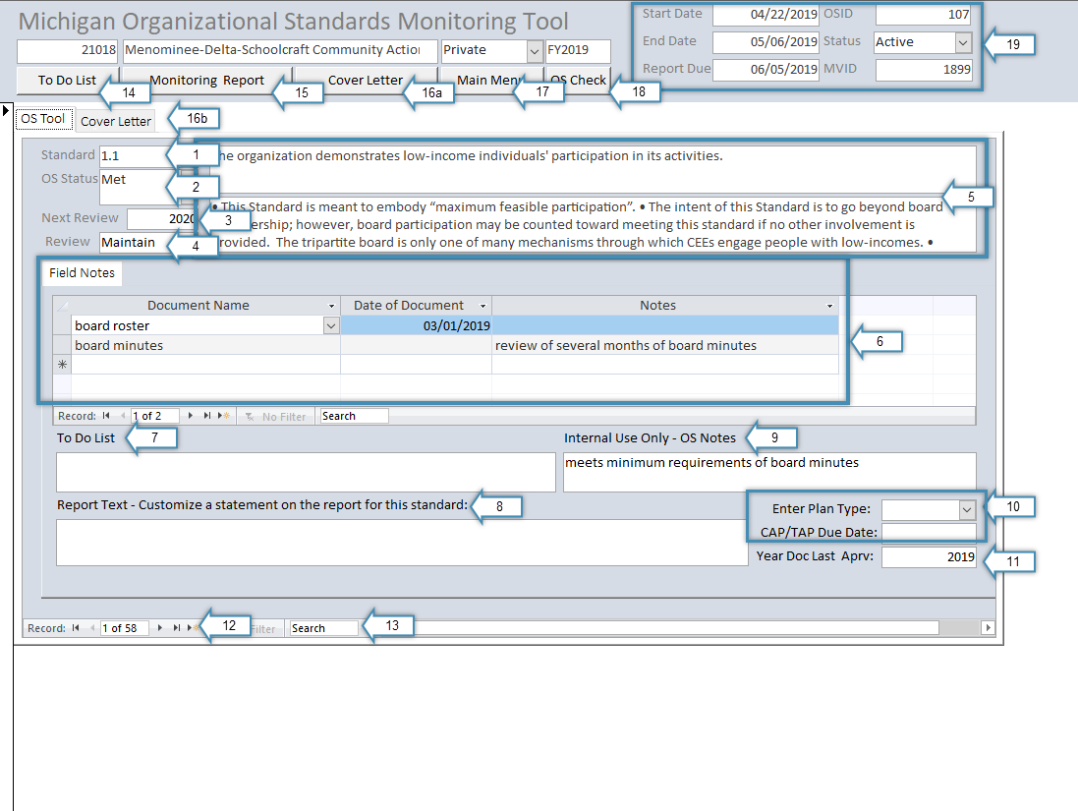

- Displays the number of the organizational standard currently selected.
- The monitor should select the appropriate status of the organizational standard based on the results of the review.
  - Active: This is the default status, and it means no determination about the standard has been made.
  - Met: The monitor should select this status if she determined that the standard has been met.
  - Not Met: The monitor should select this status if she determined that the standard has not been met.
  - N/A: The monitor should only select this for the 8 standards that do not apply to public agencies.
- Displays the next fiscal year in which the standard the current standard will need to be reviewed. The monitor should enter this date based on the results of the review. For example, standard 3.1 states, “The organization conducted a community assessment and issued a report within the past 3 years.” If a Community Needs Assessment was completed and approved in 2018, the monitor should enter 2021 in Next Review based on the three-year requirement of the standard.
- Displays how often the standard is required to be reviewed.
- The top text box displays the language of the standard. The bottom box displays additional information about the standard.
- The Field Notes section consists of three parts.
  - The first column is Document Name. The monitor should enter the name of the document being reviewed. A new row should be used for each separate document.
  - The second column is Date of Document. The monitor should enter the date of the document being reviewed.
  - The third column is Notes. The monitor should enter any notes that are specific to the document being reviewed. For example, some documents have multiple dates, such as a creation date, an approval date by the board, and the date distributed to staff. Utilize notes to explain things like this.
- The monitor can utilize To Do List to keep track of any action items during the review. For example, the monitor can enter additional information that should be provided by the agency to meet the standard. The To Do List Report (number 14) will pull each To Do text box by organizational standard.
- The Report Text field can be utilized by the monitor to add language to the monitoring report over and above what is automatically generated. For example, this can be utilized to provide information about why a standard was marked not met, or to point out particular strengths identified during the review.
- Internal Use Only – OS Notes can be utilized by the monitor to enter any notes that should not be provided to the agency in a report. This field does not pull into any reports.
- If the monitor marks a standard as Not Met, the monitor should select the appropriate type of corrective action from the Enter Plan Type dropdown (CAP, TAP, or QIP) and enter a due date for the corrective action into CAP/TAP Due Date.
- The monitor should enter the calendar year in which the document(s) provided by the agency was approved at the agency level. For example, if the monitor were reviewing standard 3.1, and the board approved and adopted the community needs assessment in October 2018, the monitor would enter 2018 into this field.
- The monitor should utilize the arrows to navigate among organizational standards.
- The monitor can enter search terms into the Search bar to find specific items. For example, if the monitor is reviewing standard 3.1 and wants to jump directly to standard 6.1, the monitor can enter 6.1 into the search box rather than using the arrows to manually navigate through each standard between 3.1 and 6.1.
- Clicking To Do List will initiate the To Do List report. The monitor must enter the desired MVID, and the To Do List for that MVID will be generated.
- Clicking Monitoring Report will initiate the Monitoring Report. The monitor must enter the desired MVID, and the Monitoring Report for that MVID will be generated. The report can be exported to a variety of formats for additional editing, such as Microsoft Word, or for immediate saving or printing, such as Adobe PDF.
- Clicking Cover Letter will initiate the Cover Letter Report.
  - 16a is the button that should be clicked to generate the Cover Letter.
  - 16b is a separate tab in the database that should be completed prior to generating the Cover Letter. The fields on this tab should be completed as appropriate by the monitor.
- Clicking Main Menu will bring up the Main Menu of the Organizational Standards Monitoring Tool.
- Clicking OS Check will initiate the OS Check Report, which displays all 58 organizational standards in a grid indicating the status of each standard. The monitor must enter the desired MVID after clicking OS Check. Note that this report can be exported to other formats, such as Excel. This report can be a very useful tool if provided to agencies in advance of the monitoring review so the agency is aware of which standards will be reviewed during the monitoring review.
- These fields contain general information about the monitoring review. Each field should be updated by the monitor as appropriate during the monitoring review.

