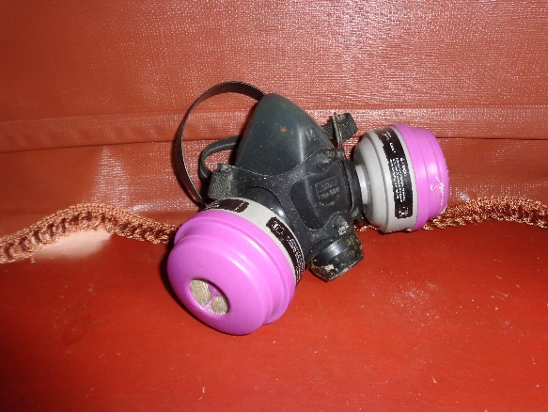 | Half or Full-Face Respirator  Protects- You, NOT others.  Required Use: Installation of 2-part spray foam and Lead Safe Practices. Areas of a home that may have organic vapors present.  Recommended use: P100 cartridge for demolition and installing insulation.  Worn By: Installers and sometimes Auditors/QCI
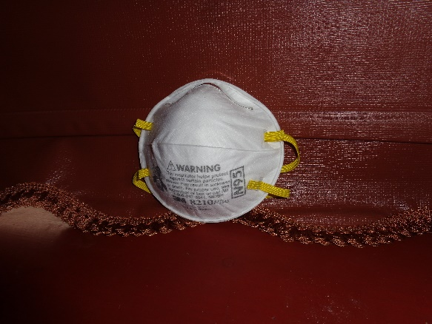 | N95 Face Mask  Protects- You and others around you  Required Use: Minimum protection from airborne contaminants (e.g., insulation materials, mold spores, feces, bacteria, chemicals.  Filters 95% of airborne particles.  Worn During: Coach visit, Auditing/QCI, Installation of Materials, when a dusty environment is present during inspections or working in (e.g., attics, crawlspace, basements, and under mobile homes.
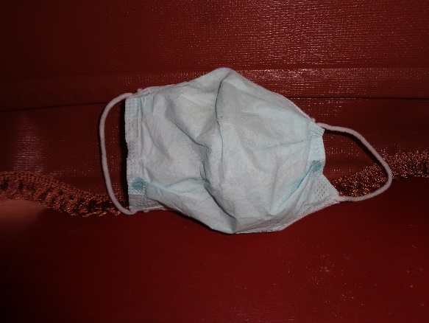 | Cloth Face Mask  Protects- Others, but NOT necessarily you  Required Use: At the office/shop, in work vehicles, public places, at work site.  These masks shall be worn for protecting against the spread of viruses and diseases during working hours.  Worn By: All Staff members  Example: client/co-worker interaction, tasks that do not create dust, but others are present.
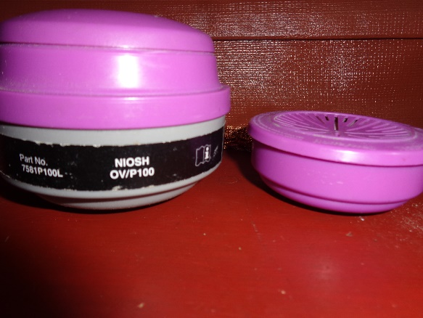 | Respirator Cartridges  Protects-You NOT others  Cartridges shall be NIOSH approved  Type: OV/P100 is a combination cartridge that protects the user from organic vapor and 99.97% of airborne particles. P100 protects the user from 99.97% of airborne particles.  OV/P100 Required when installing 2-part spray foam.  P100 Only Recommended in dusty environments.

