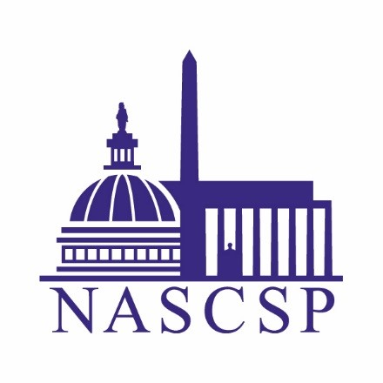
DATA Task Force: Analysis Subcommitte

Kick-off Meeting

March 26, 2018

Agenda

Event: | DATA TF: Analysis Subcommittee
Event address for attendees: | https://nascsp.webex.com/nascsp/onstage/g.php?MTID=ef8d0f836254f741faace3aeb796fb6fb
Audio conference: | US TOLL  +1-415-655-0001  Access code: 668 053 496

March 26, 2018:
- Welcome

- NASCSP Staff Roles

- Subcommittee Member Roles

- Priority Deliverables

- Timeline

- Questions and next steps

