Version 2
Release Date: TBD
CSBG Annual Report Instruction Manual
Module 2: CSBG Eligible Entity Expenditures, Capacity, and Resources
CSBG Annual Report Instruction Manual
Module 2: CSBG Eligible Entity Expenditures, Capacity, and Resources
Contents
Overview 1
History 2
Module 2, Section A: CSBG Expenditures by CSBG Eligible Entity 3
A.1. CSBG Eligible Entity Reporting Period 3
A.2. CSBG Expenditures Domains 3
CSBG Expenditure Domains Definitions 4
A.3. Administrative Costs 5
A.4 Details on Agency Capacity Building Activities Funded by CSBG 6
Module 2, Section B: CSBG Eligible Entity Capacity Building 7
B.1 CSBG Eligible Entity Reporting Period 7
B.2 Hours of Agency Capacity Building (e.g. training, planning, assessment) 7
B.3. Volunteer Hours (e.g. program support, service delivery, and fundraising) 7
B.4. The number of staff who hold certifications that increase agency capacity to achieve family and community outcomes, as measured by one or more of the following 9
B.5. Number of organizations, both public and private, that the CSBG Eligible Entity actively works with to expand resources and opportunities to achieve family and community outcomes. 11
Module 2, Section C: Allocated Resources per CSBG Eligible Entity 13
C.1. CSBG Eligible Entity Reporting Period 13
C.2. Amount of FY 20XX CSBG Allocated to Reporting Entity 13
C.3. Federal Resources Allocated (Other than CSBG) 13
C.4. State Resources Allocated 16
C.5. Local Resources Allocated 17
C.6. Private Sector Resources Allocated 18
C.7. Total Non-CSBG Resources Allocated: (Federal, State, Local & Private) 18
C.8. Total Resources in CSBG Eligible Entity (including CSBG) 18

This publication was created by the National Association of State Community Services Programs in the performance of the U.S. Department of Health and Human Services, Administration for Children and Families, Office of Community Services, Grant Number 90ET0451. Any opinion, findings, and conclusions, or recommendations expressed in this material are those of the author(s) and do not necessarily reflect the views of the U.S. Department of Health and Human Services, Administration for Children and Families.

Overview

As part of the new Performance Management Framework, a new Community Services Block Grant (CSBG) Annual Report was developed to better illustrate the impact the CSBG Network has in communities across the country. The Performance Management Framework, based in the National Community Action Theory of Change, and grown out of the need established by the Government Performance and Results Act Modernization Act of 2010 for the federal government to improve performance management across all of its programs. The CSBG network responded to this enhanced focus on performance management by developing 1) organizational standards for CSBG Eligible Entities, 2) accountability measures for states and the Office of Community Services (OCS), 3) Results Oriented Management and Accountability (ROMA) Next Generation, and 4) the new CSBG Annual Report.

Module 2 is the Agency Expenditures, Capacity, and Resources module of the new CSBG Annual Report and is completed by CSBG Eligible Entities and then reviewed, analyzed, and submitted to the OCS by State CSBG Lead Agencies. This module includes information on funds spent by CSBG Eligible Entities on the direct delivery of local services and strategies, capacity building, and administrative costs. Module 2 of the CSBG Annual Report will be entered into OCS’s InForm system (formerly the Online Data Collection System), which is the central web-based reporting tool that OCS uses for other programs and now uses for CSBG data collection.

The CSBG Annual Report contains four modules.
- Module 1: State Administration (completed by State CSBG Administrators) includes information on state administration of funds to CSBG Eligible Entities, use of state-administered and discretionary funds for training and technical assistance, and information on CSBG Eligible Entity progress in meeting the Organizational Standards and implementing ROMA Next Generation. (States submitted Module 1 in OLDC on April, 2018.)
- Module 2: Agency Expenditures, Capacity, and Resources (completed by CSBG Eligible Entities; reviewed and analyzed by State CSBG Lead Agencies) includes information on funds spent by CSBG Eligible Entities on the direct delivery of local services and strategies and capacity building as well as information on funding devoted to administrative costs by the CSBG Eligible Entities. (States will submit Module 2 in InForm by April 30, 2019.)
- Module 3: Community Level (completed by CSBG Eligible Entities; reviewed and analyzed by State CSBG Lead Agencies) includes information on the implementation of strategies and results achieved for communities where people with low incomes live. (States will submit Module 3 in InForm by April 30, 2019.)
- Module 4: Individual and Family Level (completed by CSBG Eligible Entities; reviewedand analyzed by State CSBG Lead Agencies) includes information on outcomes obtained by and services provided to individuals and families, as well as demographic characteristics of people served by CSBG Eligible Entities. (States will submit Module 4 in InForm by April 30, 2019.)
Each module has an accompanying instruction manual released by the National Association for State Community Services Programs (NASCSP) that serves as guidance to the federal report. The manual for Module 2 provides instructions and definitions for the data points of the new CSBG Annual Report. NASCSP will post recorded webinars to guide users through the manual, and to collect feedback via this form. For additional definition of terms, the network should refer to the CSBG Annual Report Lexicon. NASCSP will also post additional tools and resources as they become available to assist states and local entities in implementing this report.

Together, Modules 2–4 of the CSBG Annual Report are the vehicles that actualize accountability for CSBG Eligible Entities in the new Performance Management Framework. CSBG Eligible Entities and states will report using Modules 2-4 beginning in Fiscal Year (FY) 2018. Forms used for reporting in FY 2018 can be accessed on the NASCSP website.

History

The first comprehensive survey of state uses of federal CSBG funds was conducted in 1983, by a cooperative venture between NASCSP and the National Governors’ Association with outside assistance from the Center for Community Futures. This led to the development of the National Voluntary Reporting System, or NVRS. The Center for Community Futures, guided by the Data Collection Committee of NASCSP, conducted surveys of FY 1984, 1985, and 1986 activity. NASCSP began conducting these surveys in FY 1987.

In FY 2001, it became a federal requirement for states to use the Information System Survey (CSBG IS) for reporting. These surveys and the reports they generated were periodically amended to focus on information of special interest to state and federal policymakers, such as the relationship of CSBG to other funding sources and the development of innovative programs. Each fiscal year’s survey incorporated lessons learned from earlier data collection practices and the analysis of this information. The Information System Task Force (ISTF), which included participants from across the CSBG Network, as well as other stakeholders and partners, discussed and agreed upon changes.
In 2012, the OCS awarded a cooperative agreement to NASCSP to assist the OCS in developing the new CSBG Annual Report. Through frequent and multiple communications with the CSBG Network, including listening sessions, presentations and webinars, the Network informed the development of the CSBG Annual Report.
In 2016, the OCS, in partnership with NASCSP, invited the CSBG Network to provide feedback on content for the CSBG Annual Report forms through a formal Office of Management and Budget (OMB) clearance process. In response, over half of the CSBG Network provided thoughtful comments and letters. OCS and NASCSP analyzed all the responses and used the feedback to prepare the forms that were then submitted for the first Federal Register 60-Day Notice review in June 2016.
In response to the 60-day notice, the OCS considered comments from organizations across the CSBG Network, including national organizations, State CSBG Lead Agencies, State Community Action Associations, and local CSBG Eligible Entities, and further revised the CSBG Annual Report based on this input. The OCS released the report to the Network as an official Federal Register Notice for a final 30-day comment period. Following this comment period, the OCS submitted the CSBG Annual Report to the OMB for the third and final comment period. The OMB granted approval for the CSBG Annual Report on January 12, 2017.
NASCSP created instruction manuals for each module. On May 31, 2017, NASCSP sent the manuals to the DATA Task Force (DATA TF) for review. Through an in-person meeting and written comments, the DATA TF provided valuable insight to enhance these documents so that they meet the needs of the Network. Following the DATA TF review, NASCSP elicited feedback and incorporated the feedback into the manuals from other experts in the field and the OCS. The instruction manuals for Modules 2 and 4 were released in February 2018 and the manual for Module 3 was released in April of 2018.
Following the release of the manuals, the network continued to provide feedback. NASCSP reviewed and considered all feedback received and is now releasing the second version of the manual.

Module 2, Section A: CSBG Expenditures by CSBG Eligible Entity

A.1. CSBG Eligible Entity Reporting Period

A.1 CSBG Eligible Entity Reporting Period – The CSBG Reporting Period is selected by the CSBG State Office and indicates the 12-month period in which most of the Federal Fiscal Year (FFY) CSBG funds for the year covering this report were expended.. This reporting period may or may not be the same as the Federal Fiscal Year (FFY). CSBG Eligible Entities should check with their State Office with any questions on the reporting period.

A.2. CSBG Expenditures Domains
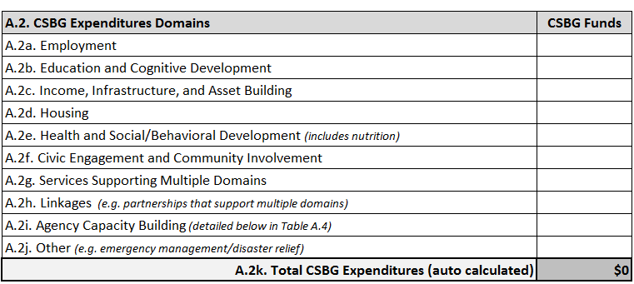
A.2. CSBG Expenditure Domains –CSBG Eligible Entities report only on expended federal CSBG funds. Include carryover funds from the previous fiscal year’s CSBG funds and any CSBG discretionary funds a CSBG Eligible Entity spent during the state’s CSBG Reporting Period as identified under Item A.1. This section should not include any state allocated CSBG funds, only federal CSBG funds. Report all CSBG funds expended regardless of the originating federal fiscal year grant award.
CSBG Domain Classification
Each CSBG Eligible Entity should report all CSBG funds expended by domain. Report the expended funds in the domain that best matches the need identified and the outcome the project is designed to achieve. In the most straightforward situations, a CSBG project will fit in one of the nine domain areas: Employment; Education and Cognitive Development; Income, Infrastructure, and Asset Building; Housing; Health and Social/Behavioral Development (includes nutrition); Civic Engagement and Community Involvement; Services Supporting Multiple Domains; Linkages (e.g. partnerships that support multiple domains); Agency Capacity Building; and “Other” (e.g. emergency management/disaster relief).
Projects funded partially or wholly by CSBG should be reported under A.2. The primary purpose/outcome of a project should be considered in determining in which domain in Section A.2 to enter the CSBG funds. For example, a CAA operates a project designed to provide various services to help individuals obtain and maintain employment. Under this project, some participants receive rent so they are able to maintain employment. The CSBG expenditures on this project could be reported under A.2a. Employment because the primary purpose/outcome of this project is employment or under A.2d Housing because the expenditure supported a housing service.
In another example, a CAA might operate a project designed to help families increase their economic security. The outcomes vary based on family needs and may include employment, education, or housing. In this example, the CSBG expenditures should be reported under A.2.g. Services Supporting Multiple Domains because the outcomes in this project cross multiple domains.
CSBG Eligible Entities should have a documented approach for determining in which domain to report CSBG funds expended. Some examples from the field include reviewing all services rendered during the program year and allocating funding to the domains based on the portion of services to the whole. Another example is using accounting codes and/or associating the domains with timesheets to determine where the efforts should be reported.
The data point A.2j. Other captures expenditures on projects funded by CSBG that are not easily classified in the other nine categories such as disaster relief. In cases where the CSBG Eligible Entities reports funds in “other,” the State CSBG Lead Agency will review what was reported to ensure that the activities cannot be reported in one of the other nine categories, prior to submitting the CSBG Annual Report to OCS.

CSBG Expenditure Domains Definitions
A.2a. Employment: Report all federal CSBG funds expended on employment programs or initiatives, for both individual/family services and community strategies. This might include CSBG funds spent to support staff time operating a job training program or the funds spent to provide services like clothing needed for work or job readiness training.
A.2b. Education and Cognitive Development: Report all federal CSBG funds expended on education and cognitive development programs or initiatives, for both individual/family services and community strategies. Examples include funds spent to support staff time operating a preschool readiness program or the executive director’s time spent sitting on a coalition to build a new school in the community or on services such as providing school supplies to grade schoolers.
A.2c. Income, Infrastructure, and Asset Building: Report all federal CSBG funds expended on income, infrastructure and asset building programs or initiatives, for both individual/family services and community strategies. Examples of Income, Infrastructure and Asset Building activities supported by CSBG that could be reported here include staff time spent operating a free income tax preparation site or the executive director’s time spent on a coalition to bring a new bus line into the community.
A.2d. Housing: Report all federal CSBG funds expended on housing programs or initiatives, for both individual/family services and community strategies. Types of activities that CSBG supported under the Housing domain could be funds used to pay rent for a participant or staff time spent case managing housing participants or advocacy work on housing for people with low-incomes.
A.2e. Health and Social/Behavioral Development (includes nutrition): Report all federal CSBG funds expended on health and social/behavioral programs or initiatives, for both individual/family services and community strategies. Examples of the type of activities that CSBG supported to be reported here could include staff time spent operating a Retired Senior Volunteer Program or CSBG funds spent supporting a food pantry.
A.2f. Civic Engagement* and Community Involvement: Report all federal CSBG funds expended on civic engagement and community involvement programs or initiatives, for both individual/family services, and community strategies. Examples of the type of activities that CSBG supported that could be reported here could be funds spent supporting a leadership training program, funds spent on citizenship classes, or funds spent to support a volunteer training program.
A.2g. Services Supporting Multiple Domains: Report all federal CSBG funds expended under services supporting multiple domains, which are programs that span or support outcomes achieved across the multiple domains (A.2a – A.2f), for both individual/family services and community strategies, such as case management, transportation, and childcare.
A.2h. Linkages* (e.g. partnerships that support multiple domains): Many of the activities that were associated with Linkages are now captured in A.2i. Agency Capacity Building, which narrows the definition of Linkages. Linkages includes the activities that build partnerships related to community initiatives and work on collaborations. For example, staff time spent at regular community resource sharing meetings where the purpose is to inform the community about available programs and resources should be reported here.

A.2i. Agency Capacity Building (detailed below in A.4.): Report all federal CSBG funds expended on agency capacity building, which is detailed in A.4. on this form. For example, if staff are involved in the development of the Community Needs Assessment, Strategic Plan, or time spent in training, it should be reported here.
Agency capacity building is the training, technical assistance, or other activity that helps a Board member or staff person improve their skills, knowledge and understanding of CSBG or other entity programs with the explicit purpose of creating knowledge, understanding and capability of the CSBG Eligible Entity to achieve results. Activities can include, but are not limited to staff development, strategic planning sessions, succession planning, ROMA Activities, Organizational Standards technical assistance, fiscal training, risk assessment, or Board retreats.
A.2j. Other (e.g. emergency management/disaster relief): Report all federal CSBG funds expended on activities not easily classified in the other nine categories. The State CSBG Lead Agency will review any funds reported here to ensure that the activity(ies) cannot be reported in one of the other nine categories prior to submitting the CSBG Annual Report to OCS.
A2k. Total CSBG Expenditures: this item will auto-calculate A.2a.-A.2j.

* Note: The difference between Linkages and Civic Engagement is that Linkages is the work done to build relationships and partnerships. It’s the activities that a CSBG Eligible Entity engages in to connect themselves to other providers and resources in the community. Linkages, while critical to an entity, is a relatively low impact activity. Civic Engagement is the intentional work done to make a difference in the community through political and non-political processes such as advocacy, leadership, or other coordinated efforts.

A.3. Administrative Costs
A.3. Administrative Costs: Enter the amount of the federal CSBG funds reported in A.2 CSBG Expenditure Domains, which were expended for administrative purposes.
NOTE: Information Memoranda 37 (IM 37) contains guidance on reporting CSBG administrative costs. IM 37 describes Administrative Costs, in the context of CSBG statutory reporting requirements, as the equivalent to the familiar concepts of "indirect" costs or "overhead." Administrative costs relate to the general management of the grantee organization, such as strategic direction, Board development, Executive Director functions, accounting, budgeting, personnel, procurement, and legal services. Therefore, direct program costs include expenditures on some activities with administrative qualities, including salaries and benefits of program staff and managers, equipment, training, conferences, travel, and contracts that expressly relate to the delivery of an individual program or service funded by a specific grant source.
It is important to remember that not all indirect expenses are “administrative,” especially if they are paying for the salaries of persons engaged in coordinating programs or any activity or cost that can be directly tied to a program or domain. For example, the Executive Director’s time spent organizing a coalition whose goal is to increase the percent of children in the community who are ready to enter Kindergarten. This work can be specifically tied to the Education and Cognitive Development domain and not considered administration. However, the time the Executive Director spent on Board development or strategic direction are administrative. For example, if an Executive Director holds a Board retreat, that time would be reported in Agency Capacity Building and reported in A.3.
CSBG Eligible Entities who have a federally approved indirect cost rate should those funds in A.2i Agency Capacity. Those CSBG Eligible Entities that do not have an indirect cost rate can use their cost allocation plans to determine how the administrative dollars are allocated within the domains.

A.4 Details on Agency Capacity Building Activities Funded by CSBG
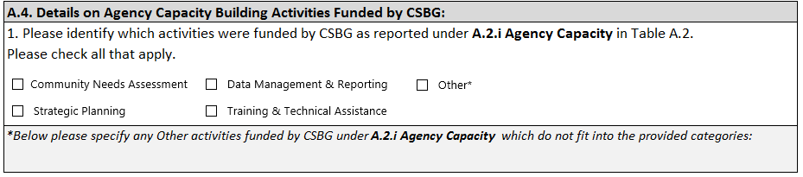
A.4. Details on Agency Capacity Building Activities Funded by CSBG – Under Table A.4., identify which activities were funded wholly or partially by CSBG (as reported under A.2i. Agency Capacity Building). Check all that apply.
Community Needs Assessment (CNA): Select the check box if funds reported in A.2i. supported activities related to the creation of a Community Needs Assessment. This can include any costs incurred to conduct focus groups, surveys, work conducted by consultants, or staff time spent on planning and developing the CNA.
The Community Needs Assessment is the report a CSBG Eligible Entity compiles after conducting research to understand their community and plan for programs. This report includes both quantitative and qualitative data, a summary of key findings, and the identification of needs. It is required by the Organizational Standards (3.1) that CSBG Eligible Entities complete a community needs assessment and issue a report within the past three years.
Strategic Planning: Select the check box if funds reported in A.2i. supported activities related to the development of a Strategic Plan. This can include any staff time or other administrative costs, in addition to any costs incurred to use facilitators or other consultants.
Strategic Planning is the activity a CSBG Eligible Entity engages in to discuss and set the direction of the CSBG Eligible Entity through the implementation of specific programs and initiatives. A strategic plan is required by the Organizational Standards (6.1) to be approved by the Board every 5 years.
Data Management & Reporting: Select the check box if funds reported in A.2i. supported activities related to data management and reporting. This can include any costs incurred to support collecting or reporting data, funds spent to support the implementation and purchase of technology or software or other direct costs, staff time, and/or other administrative costs as they might relate to data and reporting.
Training & Technical Assistance: Select the check box if funds reported in A.2i. supported training and technical assistance. This can include any costs incurred to secure training facilities, travel to trainings, pay consultants or staff time in trainings, or other direct costs, staff time, and/or other administrative costs.
Training activities are those that provide staff development and program support on programs and initiatives operated by the CSBG Eligible Entity, and education on poverty and other topics relevant to the work of the CSBG Eligible Entity.
Other*: Select the check box if funds reported in A.2i. do not fit in any of the four categories above. If this check box is selected, list the activitiy(ies) in the accompanying text box. The State CSBG Lead Agency will review any items reported here to ensure that the activities cannot be reported in one of the already identified categories for agency capacity building prior to submitting the CSBG Annual Report to OCS.

Module 2, Section B: CSBG Eligible Entity Capacity Building
Agency capacity building is a critical activity. It helps entities become and continue to be high-performing. The time and activities staff engages in to increase capacity is important to report in order to show the investment a CSBG Eligible Entity is making in itself.

B.1 CSBG Eligible Entity Reporting Period
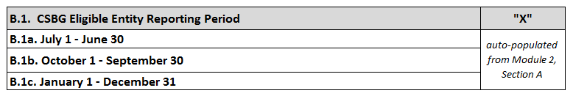
CSBG Eligible Entity Reporting Period will have been previously set in Section A; therefore, no selection needs to be made here.

B.2 Hours of Agency Capacity Building (e.g. training, planning, assessment)
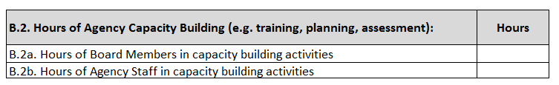
B.2. Hours of Agency Capacity Building: Report the number of hours that Board members and staff spent in agency capacity building activities. For example, if two staff members enroll in and complete the National Peer-to-Peer ROMA Training Program, the total hours that the first person spent in training was 15 and the total hours the second person spent was also 15, the CSBG Eligible Entity should enter 30 hours in B.2b.
B.2a. Hours of Board Members in capacity building activities: enter the total number of hours that all Board members spent in capacity building activities. This item aims to capture the hours Board members spent on activities such as planning, assessing community needs and resources, or participating in training.
Note: Reporting of all hours Board members spent in board meetings should be entered in B.3.
B.2b. Hours of Agency Staff in capacity building activities: enter the total number of hours that all CSBG Eligible Entity staff members combined spent in capacity building activities.

B.3. Volunteer Hours (e.g. program support, service delivery, and fundraising)
B.3a. Total number of volunteer hours donated to the agency: In B.3a report all volunteer hours donated to the CSBG Eligible Entity during the reporting period. This section collects data on hours and not the number of people. Board members, the Head Start Policy council, and parent advisory board members should be included here, in addition to the hours provided by other agency volunteers.
Examples of volunteer activities:
- Serving on the CAA governing Board.
- A volunteer representing the CSBG Eligible Entity on a Board for furthering the CSBG Eligible Entity’s strategic plan.
- Assisting with program activities and logistics.
- Participating in advocacy to influence the policies and practices of government and/or private entities so that they are responsive to the needs of communities where low-income people live.
Examples of how to report:
  - The CAA’s 15 Board members each attend 6 Board meetings, each lasting 2 hours. (Report as 180 hours.)
  - The CAA’s free tax preparation program has 10 volunteers, who each work 3 hours a week for 12 weeks. (Report as 360 hours)

B.3a.1. Of the above, the total number of volunteer hours donated by individuals with low-incomes: B.3a.1 is focused on documenting how people with low-income are supporting the local CSBG Eligible Entity and show that they have a stake in their community. This section provides a snapshot of involvement of individuals with low-incomes in their community by tracking the number of volunteer hours donated by such individuals.
While B.3a. asked for the total number of hours donated by all volunteers, in B.3a.1. report only the hours from the above that were donated by persons with low-incomes. This number for B.3a.1. should never be more than B.3a. To know which volunteers are persons with low-incomes, a CSBG Eligible Entity does not need to complete income verification, but can ask a clarifying question on their volunteer application or complete an anonymous survey of their volunteers. Note: This is where Board members with low-incomes should be reported.
Examples of Applicable Activities:

- Individuals with low incomes volunteering in any Community Action initiatives.
- Individuals with low incomes serving on CAA Boards.
- Individuals with low incomes serving on Head Start Policy Council.
- Community members with low-incomes assist a CAA with poverty simulations.

B.4. The number of staff who hold certifications that increase agency capacity to achieve family and community outcomes, as measured by one or more of the following
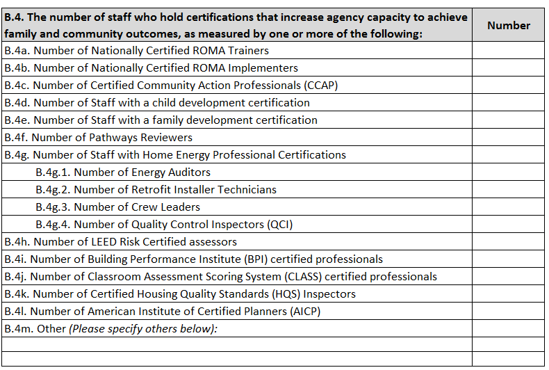
In B.4. report the total number of staff who hold the specific certifications listed during the reporting period. The same person can be reported under multiple certifications and can be reported multiple years in a row while they work with the CSBG Eligible Entity. If a staff member holds a certification, such as those obtained through WIC, Certified Public Accountant, Social Work licensure, or other licensures that are not listed, include them in B.4m. Other. Do not report college degrees, only report certifications obtained related to the work of the CSBG Eligible Entity.
B.4a. Number of Nationally Certified ROMA Trainers: Report the number of ROMA Trainers certified through the Association of Nationally Certified ROMA Trainers. Do not include staff who are in the process of becoming certified.

B.4b. Number of Nationally Certified ROMA Implementers: Report the number of ROMA Implementers certified through the Association of Nationally Certified ROMA Trainers. Do not include staff who are in the process of becoming certified.

B.4c. Number of Certified Community Action Professionals (CCAP): Report the number of CCAPs certified through the Community Action Partnership. Do not include staff who are in the process of becoming certified.

B.4d. Number of staff with a child development certification: Report the number of child development certifications obtained through a credentialing program. Do not include staff who are in the process of becoming certified. For example, report Child Development Associate (CDA) certificate obtained by early childhood education staff.

B.4e. Number of staff with a family development certification: Report the number of family development specialists certified through a participating credentialing program. Do not include staff who are in the process of becoming certified.

B.4f. Number of Pathways Reviewers: Report the number of Pathways Reviewers certified through the Community Action Partnership. Do not include staff who are in the process of becoming reviewers.

B.4g. Number of staff with Home Energy Professional Certifications: Enter the number of staff who have any one of the Home Energy Professional Certifications as outlined in the Job Task Analysis and provided through an accredited training center as described in Department of Energy’s Weatherization Assistance Program.

B.4g.1. Number of Energy Auditors: Report the number of Energy Auditors certified through an accredited training center. Do not include staff who are in the process of becoming Energy Auditors.

B.4g.2. Number of Retrofit Installer Technicians: Report the number of Retrofit Installer Technicians certified through an accredited training center. Do not include staff who are in the process of becoming Retrofit Installer Technicians.

B.4g.3. Number of Crew Leaders: Report the number of Crew Leaders certified through an accredited training center. Do not include staff who are in the process of becoming Crew Leaders.

B.4g.4. Number of Quality Control Inspectors (QCI): Report the number of QCIs certified through an accredited training center. Do not include staff who are in the process of becoming QCIs.

B.4h. Number of LEED Risk Certified assessors: Report the number of LEED Risk Certified Assessors certified through the U.S. Green Building Council. Do not include staff who are in the process of becoming LEED Risk Certified Assessors.

B.4i. Number of Building Performance Institute (BPI) Certified Professionals: Report the number of BPI certified professionals certified through the Building Performance Institute. Include all certifications obtained through BPI that are not already listed above under the Home Energy Professionals (B.4g.1-B.4g.4). Do not include staff who are in the process of becoming BPI certified.

B.4j. Number of Classroom Assessment Scoring System (CLASS) Certified Professionals: Report the number of CLASS Certified Professionals certified through a Head Start Program or similar credentialing. Do not include staff who are in the process of becoming certified.

B.4k. Number of Certified Housing Quality Standards (HQS) Inspectors: Report the number of HQS Inspectors certified through the National Association of Housing and Redevelopment Officials. Do not include staff who are in the process of becoming certified.

B.4l. Number of American Institute of Certified Planners (AICP): Report the number of American Institute of Certified Planners certified through the American Planning Association. Do not include staff who are in the process of becoming certified.

B.4m. Other (Please specify others below): Report the number of staff who hold other certifications. If a number is reported here, specify the types of certifications in the space below. If a staff member holds a certification, such as those obtained through WIC, Certified Public Accountant, Social Work licensure, or other licensures that are not listed, include them here. Do not report college degrees; only report certifications obtained.

B.5. Number of organizations, both public and private, that the CSBG Eligible Entity actively works with to expand resources and opportunities to achieve family and community outcomes.
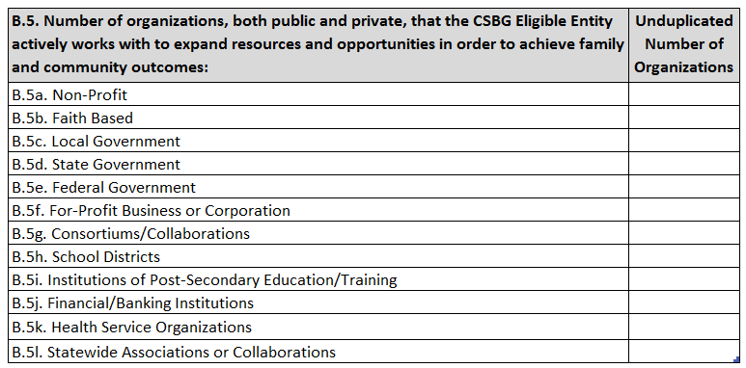
CSBGEligible Entities work with other public and private organizations to expand service opportunities for individuals or families or to achieve community improvement outcomes. B.5. collects information on the number of organizations a CSBG Eligible Entity actively works with as identified by:
- Financial agreements between a CSBG Eligible Entity and one or more business entities or financial institutions to promote individual or community economic development and/or infrastructure investment;
- Formal arrangements, such as memoranda of understanding/agreement or service contracts, to coordinate referral and exchange of program participants;
- Informal working relationships that expand service opportunities for individuals/families with low-income, including routine service referrals and follow-up contacts; and
- Alliances that advocate for expanded services or community opportunities for people with low-income.
Include the number of organizations that make up the types of partnerships mentioned above. Only report the number of organizations the CSBG Eligible Entity is engaged with and not the number of partnerships that the CSBG Eligible Entity has with the organization. For example, a CAA may have a partnership with three different departments within the Department of Education, however the Department of Education is only one organization. As such, the number “one” should be reported to represent the Department of Education. If an organization qualifies within multiple categories, report the organization in only one category, its primary classification. For example, Catholic Charities is a non-profit, faith-based organization. However, their primary mission is faith-based and should be reported under faith-based organizations. Additionally, each CSBG Eligible Entity has a relationship with both their State CSBG Lead Agency and their association. Ensure that those partnerships are represented in this chart.

Module 2, Section C: Allocated Resources per CSBG Eligible Entity
Section C: Allocated Resources per CSBG Eligible Entity data entry form provides data on resources allocated to, and administered through, the CSBG Eligible Entity. This report provides valuable information on how CSBG leverages funds from multiple federal, state, local, and private sources as required in the CSBG Act. Section C characterizes the work of the network and places it within a realistic context.
All reported dollars should be allocated dollars. Allocated dollars are the amount that is available to each CSBG Eligible Entity during a twelve-month period. If a contract covers a three-year period, divide the contract by three and report one year of funding.

C.1. CSBG Eligible Entity Reporting Period
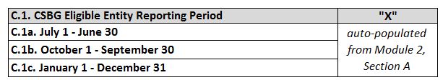
CSBG Eligible Entity Reporting Period will have been previously set in Section A, therefore no selection needs to be made here.

C.2. Amount of FY 20XX CSBG Allocated to Reporting Entity
Enter the amount of FFY 20XX CSBG dollars allocated to the CSBG Eligible Entity for the reporting period. Include any federal CSBG discretionary dollars awarded by the state to the CSBG Eligible Entity during the reporting period.

C.3. Federal Resources Allocated (Other than CSBG)
Report all federal resources allocated to the CSBG Eligible Entity during the reporting period. Many funds received from the state by a CSBG Eligible Entity are federal funds. When responding to this section review all funds a CSBG Eligible Entity receives and report all federal funds here, even if the contract held by the CSBG Eligible Entity is with the state. An example might be funding received from the state to help support senior programs that is Older American Act funding. In this situation, the funding should be reported here and not in the state funding section.
C.3a. Weatherization (DOE) (include oil overcharge $$): Funding from the U.S. Department of Energy. Include Petroleum Violation Escrow (PVE) oil overcharge funds used for this program. Any Bonneville Power Administration funding should be reported under other.

C.3b. Health and Human Services (HHS): Report funding from Health and Human Services using the following categories:

C.3b.1. LIHEAP - Fuel Assistance (include oil overcharge $$): Low-Income Home Energy Assistance Program (LIHEAP) funding from the U.S. Department of Health and Human Services. Include PVE oil overcharge funds used for this program.

C.3b.2. LIHEAP - Weatherization (include oil overcharge $$): Low-Income Home Energy Assistance Program (LIHEAP) funding from the U.S. Department of Health and Human Services used to provide weatherization services.
C.3b.3. Head Start: Head Start funding from the U.S. Department of Health and Human Services.

C.3b.4. Early Head Start: Early Head Start funding from the U.S. Department of Health and Human Services.

C.3b.5. Older Americans Act: Older Americans Act funding from the U.S. Department of Health and Human Services.

C.3b.6. Social Services Block Grant (SSBG): Social Services Block Grant funding from the U.S. Department of Health and Human Services.

C.3b.7. Medicare/Medicaid: Medicare and Medicaid funding from the U.S. Department of Health and Human Services.

C.3b.8. Assets for Independence (AFI): Assets for Independence funds provided by the U.S. Department of Health and Human Services.

C.3b.9. Temporary Assistance for Needy Families (TANF): TANF Funds provided by the U.S. Department of Health and Human Services. This should include all programs funded by TANF to provide services to former welfare recipients including programs that assist families in remaining self- sufficient. It is critical to examine the ultimate source of the funds because often TANF funds are dispersed through other state and county programs.

C.3b.10. Child Care Development Block Grant (CCDBG): Childcare Development Block Grant funds provided by the U.S. Department of Health and Human Services.

C.3b.11. Community Economic Development (CED): Community Economic Development (CED) is a federal grant program funding Community Development Corporations that address the economic needs of people with low-incomes through the creation of sustainable business development and employment opportunities.

C.3b.12. Other HHS Resources: List all other funding from the U.S. Department of Health and Human Services not listed above in Item 3b.12i-3b.12.iv. List in order of largest to smallest. For each program, list the name and the funding source. DO NOT use acronyms and abbreviations. Include the CFDA number.

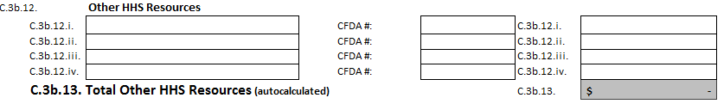

C.3b.13. Total Other HHS Resources (auto calculated): the total of all other U.S. Department of Health and Human Resources will auto-calculate.

C.3c. Department of Agriculture (USDA): Report funding from the United States Department of Agriculture using the following categories:

C.3c.1. Special Supplemental Nutrition for Women, Infants, and Children (WIC): Special Supplemental Nutrition Program for Women, Infants and Children funded by the U.S. Department of Agriculture.

C.3c.2. All USDA Non-Food programs (e.g. rural development): All non-food programs funded by the U.S. Department of Agriculture, such as rural development and housing.

C.3c.3. All other USDA Food programs: All other food programs funded by the U.S. Department of Agriculture, including The Emergency Food Assistance Program (TEFAP) or the Commodity Supplemental Food Program (CSFP).

C.3d. Department of Housing and Urban Development (HUD): Report all funds allocated to the CSBG Eligible Entity from United States Department of Housing and Urban Development using the following categories:

C.3d.1. Community Development Block Grant (CDBG) - Federal, State, and Local: Report all Community Development Block Grant funds from the U.S. Department of Housing and Urban Development received directly or indirectly through contracts with the state or local government.

C.3d.2. Section 8: Section 8 provides housing assistance to families with very low incomes.

C.3d.3. Section 202: Section 202 provides capital supportive housing for the elderly.

C.3d.4. Home Tenant-Based Rental Assistance (HOME TBRA): Home Tenant-Based Rental Assistance provides housing assistance to families with low-incomes.

C.3d.5. HOPE for Homeowners Program (H4H): HOPE for Homeowners is a refinancing program.

C.3d.6. Emergency Solutions Grant (ESG): The Emergency Solutions Grant provides assistance to families to regain stability. It also supports homeless shelters and prevention.

C.3d.7. Continuum of Care (CoC): The Continuum of Care is a community-wide program working towards ending homelessness.

C.3d.8. All other HUD programs, including homeless programs: All other homeless and housing programs funded by the U.S. Department of Housing and Urban Development.

C.3e. Department of Labor (DOL): Report all funds allocated to the CSBG Eligible Entity from U.S. Department of Labor using the following categories:

C.3e.1. Workforce Innovation and Opportunity Act (WIOA) *previously WIA: The Workforce Innovation and Opportunity Act provides funding for employment and training activities from the U.S. Department of Labor.

C.3e.2. Other DOL Employment and Training programs: Other U.S. Department of Labor funding that supports employment and training programs.

C.3e.3. All other DOL programs: All other U.S. Department of Labor programs.

C.3f. Corporation for National and Community Service (CNCS) programs: Funds from CNCS support programs such as the AmeriCorps*VISTA and AmeriCorps*NCCC programs, the Senior Corps (Foster Grandparent, RSVP, or Senior Companion) programs, Learn and Serve, or America Reads. Report all funding and service volunteer equivalent.

C.3g. Federal Emergency Management Agency (FEMA): Emergency funds from the Federal Emergency Management Administration such as food assistance and disaster relief.

C.3h. Department of Transportation: Transportation funding from the U.S. Department of Transportation (US DOT).

C.3i. Department of Education: Education funding from the U.S. Department of Education (US EDU).

C.3j. Department of Justice: Justice funding from the U.S. Department of Justice (US DOJ).

C.3k. Department of Treasury: Treasury funding from the U.S. Department of the Treasury (US TD).

C.3l. Other Federal Resources: List all other federal funding sources not listed above in Items C.3l.i-C.3l.iv. PROVIDE THE FULL NAME OF THE FEDERAL DEPARTMENT. For each program, list the name and the funding source. DO NOT use acronyms or abbreviations. It is important that all programs listed under “Other” in Item 3l. are scrutinized at the state level. Often programs entered here belong on the more specific categories listed in the pre-existing Federal categories. For those programs that are listed in these fields, provide as much detail as possible. Include the CFDA number.

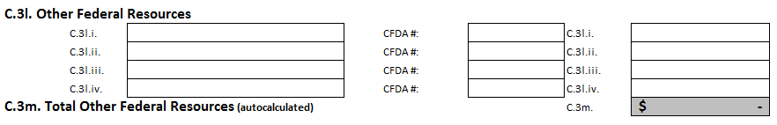

C.3m. Total Other Federal Resources (auto-calculated): The total will auto-calculate from the items listed above.

C.3n. Total: Non-CSBG Federal Resources Allocated (auto-calculated): Item C.3n. will auto-calculate all non-CSBG Federal Resources.

C.4. State Resources Allocated
Report funds allocated to CSBG Eligible Entities from state funds appropriated by the state legislature. The figure reported here should include all the funds allocated to local CSBG Eligible Entities during the reporting period. When reporting state allocations ensure the funds are not federal funds that the state is administering. If they are, then report those funds in the appropriate federal category in C.3.
C.4a. State appropriated funds used for the same purpose as Federal CSBG funds: Include funds that were appropriated by the state legislature to be used in line with the federal criteria for CSBG. This is the only place where state-appropriated CSBG dollars are reported in this report.

C.4b. State Housing and Homeless programs (include housing tax credits): State funds appropriated for housing and homeless programs.

C.4c. State Nutrition programs: State funds appropriated for nutrition programs.

C.4d. State Early Childhood Programs (e.g. Head Start, Day Care): State funds appropriated for Early Childhood programs.

C.4e. State Energy programs: State funds appropriated for State Energy programs.

C.4f. State Health programs: State funds appropriated for health programs.

C.4g. State Youth Development programs: State funds appropriated for youth development programs.

C.4h. State Employment and Training programs: State funds appropriated for employment and training programs.

C.4i. State Senior programs: State funds appropriated for senior programs.

C.4j. State Transportation programs: State funds appropriated for transportation programs.

C.4k. State Education programs: State funds appropriated for education programs.

C.4l. State Community, Rural and Economic Development programs: State funds appropriated for community, rural, and economic development programs.

C.4m. State Family Development programs: State funds appropriated for family development programs. Include Navigator programs here.

C.4n. Other State Resources: For Item C.4n., list all other programs that made use of state funding sources. List the names of all programs and each program’s specific funding source(s) and funding amounts. Write out all acronyms and abbreviations.

It is important all programs listed under the “Other” category are scrutinized. Often programs entered here belong in the more specific categories listed in C.4. For programs listed in C.4n., provide as much detail as possible. This will aid in understanding the information in the Congressional Report. Do not use program acronyms unless the full name of a particular program or funding source is also provided.
C.4.o. Total Other State Resources (auto-calculated): This item will auto-calculate based on the information entered into C.4.i-iv.
C.4.p Total: State Resources Allocated (auto-calculated): This item will auto-calculate based on the information entered into C.4.a-n.

C.5. Local Resources Allocated
Report all resources, including in-kind donations from cities, counties, and other local funders (except foundations which are included in C.6.)
C.5a. Amount of unrestricted funds appropriated by local government: Enter the amount of unrestricted funds appropriated by local government.

C.5b. Amount of restricted funds appropriated by local government: Enter the amount of restricted funds appropriated by local government.

C.5c. Value of Contract Services: Enter the value of contract services. Report contracts with cities, counties, or other local providers. Report the total amount of the executed contract allocated per program period.

C.5d. Value of in-kind goods/services received from local government: Enter the value of in-kind goods/services received from local government.

C.5e. Total: Local Resources Allocated (auto-calculated): This item will auto-calculated based on the information entered in C.5.

C.6. Private Sector Resources Allocated
Report all resources allocated to the CSBG Eligible Entity from the private sector. Include all donated funds, foundation funding, and payments from clients.
C.6a. Funds from foundations, corporations, United Way, other nonprofits: Report funds from foundations, corporations, United Way, and other nonprofits.

C.6b. Other donated funds: Report donated funds that do not fit in any other category.

C.6c. Value of other donated items, food, clothing, furniture, etc.: Report the value of all donated items.

C.6d. Value of in-kind services received from businesses: The State CSBG Lead Agency should provide guidelines for valuing in-kind donations. A consistent, reasonable statewide method should be considered.

C.6e. Payments by clients for services: Amounts entered for this item should include all resources generated by a local CSBG Eligible Entity for direct services to program participants. Examples are income through “sliding scale” fees charged for medical care, mental health services, or housing services where a client is responsible for a portion of their rent.

C.6f. Payments by private entities for goods or services for low income clients or communities: Some CSBG Eligible Entities are paid by private entities, profit or non-profit, to provide services to those corporations. Most such arrangements are contractual. Examples are: outreach for HMO programs, transportation services, public utility contracts for customer services or weatherization, and even rental of space and equipment in the service area. This space is for recording the gross income from such arrangements. Contractual arrangements which are simply direct subcontracts or sub-grants of state, local or federal funds should continue to be reported in the federal, state or local resources, and not reported here.

C.6e. Total: Private Sector Resources Allocated (auto-calculated): This item will auto-calculate based on the information entered for all Private Sector Resources.

C.7. Total Non-CSBG Resources Allocated: (Federal, State, Local & Private)
This item will auto-calculate the total of all federal, state, local and private resources, excluding CSBG.

C.8. Total Resources in CSBG Eligible Entity (including CSBG)
This item will auto-calculate the total of all federal, state, local and private resources, including CSBG, available to the CSBG Eligible Entity during the reporting period.

