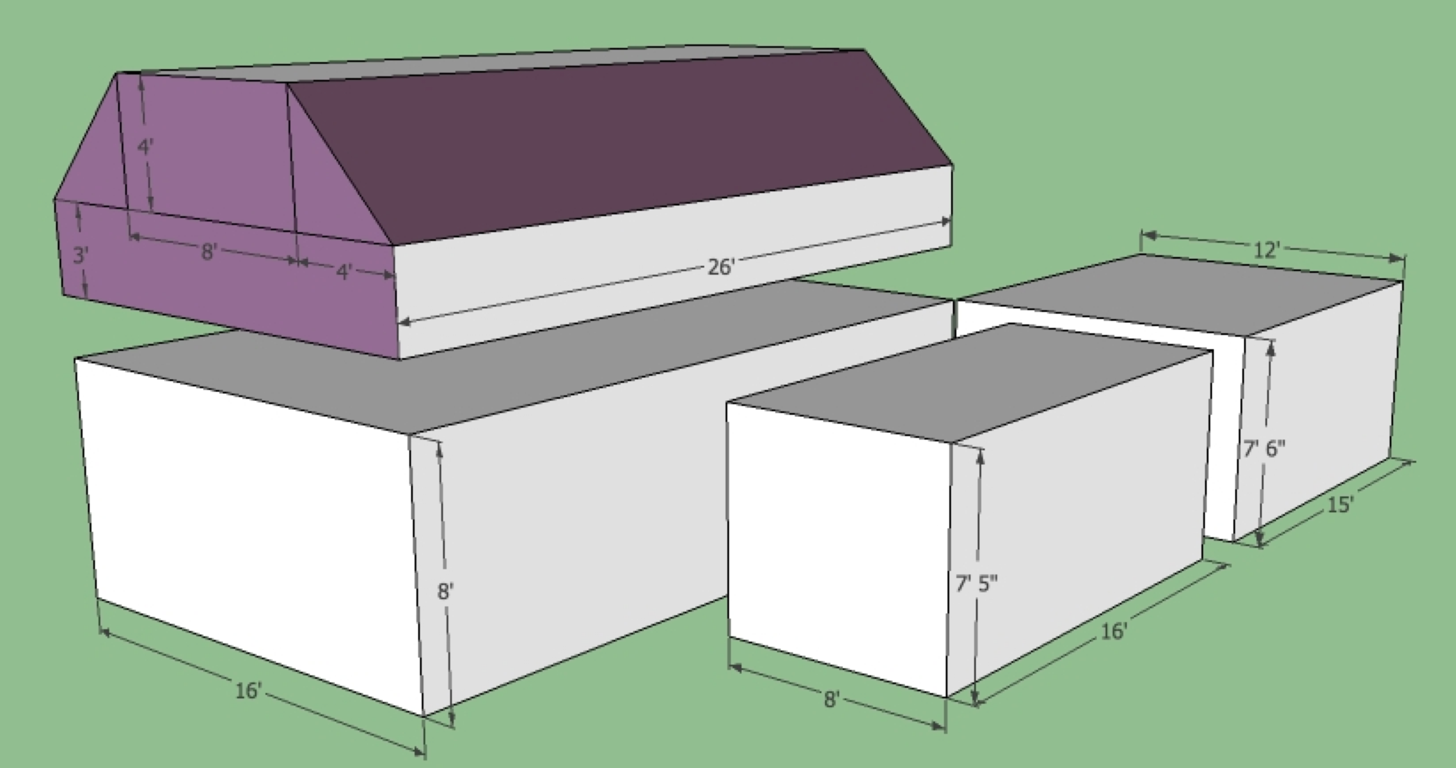

Main House 1st Floor = _______ L x _________ W x __________ H =

Main House 2nd Floor = (Area of 2 triangles (1/2 Base x height) + Area of 2 rectangles) x __________ L =
Main House 2nd Floor = ______________________________________________________________ =

Rear addition = _______ L x _________ W x __________ H =

Ell = _______ L x _________ W x __________ H =

