INCORPORATING WATER HEATER REPLACEMENT INTO THE WEATHERIZATION ASSISTANCE PROGRAM

INFORMATION TOOL KIT

Prepared for:

U.S. Department of Energy
Weatherization and Intergovernmental Program
Office of Energy Efficiency and Renewable Energy
1000 Independence Avenue, S.W., EE-2K
Washington, DC 20585

Please direct questions to:

Jordan Kelso
D&R International, Ltd.
1300 Spring Street, Suite 500
Silver Spring, MD 20910
Phone: (301) 588-9387
Fax: (301) 588-0854
Email: jkelso@drintl.com

TABLE OF CONTENTS

Introduction 5

DOE Requirements for Water Heater Replacement at a Glance 6
Background 7

Factors Affecting Water Heater Energy Use and Savings 7

Hot Water Consumption 7

Housing Location 8

Water Heater Location 9

Water Heater Performance 9

Energy Calculations 11

Fuel Switching 14

Replacing Water Heaters for Health and Safety 14

Replacement with Other Water Heater Types 15

Tankless Water Heaters 15
- Heat Pump Water Heaters 17
- Solar Water Heaters 19

Other Water Heater Issues 20

Installation 21

Codes and Standards 21

Energy Guide 21

Sizing 21

Visual Inspections and Client Education 21

Resources 23

Table 1 8
Table 2 8
Table 3 9
Table 4 10
Table 5 10
Table 6 11
Table 7 14
Table 8 15
Table 9 16

Figure 1 12

Appendix A − Water Heater Anatomy 24

Appendix B − Glossary 26
Appendix C − Energy Guide Label 27
Appendix D − Water Heater Dating Chart 29
Appendix E − GAMA Water Heater Sizing Tool 32

Introduction

On October 6, 2000, the U.S. Department of Energy (DOE) issued Weatherization Program Notice 00-5 to add water heater replacement as an allowable weatherization measure. This information tool kit provides guidance on determining when a water heater may be replaced as a Weatherization Program activity. Although the kit focuses on water heaters for single-family homes, much of the information also applies to mobile home water heaters. However, water heating systems found in multi-family buildings differ significantly from those covered in this tool kit. Information on multi-family water heating systems from a weatherization perspective will be developed in the future.

The following information is limited to replacing existing water heaters in single-family homes in order to reduce household energy bills or address health and safety concerns. Weatherization providers should be well aware of traditional, low-cost measures such as low-flow showerheads and faucet aerators that reduce the demand for hot water. Methods to reduce the energy use of existing water heaters are not included in this tool kit, but can be found in the information listed under Resources.

The Weatherization Program will mostly replace existing tank-type water heaters with new tank water heaters. Therefore, tank water heaters will be the main focus of this tool kit. Much of the information provided for tank water heaters also applies to other allowable retrofit types as well. Weatherization regulations allow the installation of tankless (e.g., instantaneous, flash, demand), heat pump, and solar water heaters. Information specific to these retrofit types is provided in the section, Replacement of Other Water Heater Types.

A one-page summary, At a Glance, outlines DOE requirements regarding water heater replacement. These initial requirements likely will be revised and improved as the program gains more experience with replacements. States that develop effective water heater replacement protocols should share them with DOE and the Weatherization network.

This tool kit includes a Microsoft Excel spreadsheet to help Weatherization providers estimate the energy savings of potential water heater replacements. The spreadsheet tool can evaluate the cost-effectiveness of replacing an existing tank water heater with a new tank, tankless, heat pump, or solar water heater.

The appendices to this tool kit contain other useful water heater information. The components of different types of water heaters are illustrated in Appendix A. A glossary of terms is presented in Appendix B. Appendix C provides a sample water heater Energy Guide label. Appendix D shows how to determine when many water heater models were manufactured from their serial numbers. Appendix E describes a method to properly size a new water heater.
DOE Requirements for Water Heater Replacement at a Glance

When may an existing water heater be replaced?
- Water heaters may be replaced when energy savings justify the replacement cost. As with all energy efficiency measures installed with DOE funds, water heater replacement must result in a savings-to-investment ratio (SIR) of 1.0 or greater.
  - The economic lifetime used in the SIR calculation should not exceed the manufacturer’s guarantee. Water heater replacements are generally not cost effective unless savings accrue for at least 10 years. Therefore, agencies should purchase new replacement water heaters with at least a 10-year guarantee.
- Water heaters may be replaced for energy-related health and safety reasons. DOE reviews and approves state plans, in which states describe their approach for replacing water heaters as a health and safety measure. Local agencies and contractors must follow state policy when replacing water heaters as a health and safety measure.

What new replacement units may be installed?
- While Weatherization Program Notice 00-5 specifically approves replacement electric water heaters, water heaters using other fuels are also allowable weatherization measures.
- Replacement units can be one of four types: (1) standard tank water heater;
(2) whole-house, tankless (also known as demand, instantaneous, and flash) water heater; (3) heat pump water heater; or (4) solar water heater.

What factors indicate that a water heater may be a candidate for cost-effective replacement?
- Energy savings increase with hot water usage. Therefore, large households with many occupants and appliances that use hot water are good candidates for water heater replacement.
- High energy prices make energy savings worth more.

Can I replace water heaters based solely on their age?
- No. The age of the water heater does not provide an accurate indication of whether it should be replaced.

What information is needed to estimate the energy savings from a potential water heater replacement?
- Nameplate information: Energy Factor (EF), Recovery Efficiency (RE, for fossil-fired water heaters), tank size, manufacturer, model number, and serial number.
- Occupants: Use the number of people in the house on a typical day or the number of bedrooms + 1.
- Appliances: Dishwasher or clothes washer
- Usage: Determine the typical frequency of activities that use lots of hot water

Background

Water heaters can be replaced when the energy savings and measure costs result in a savings-to-investment ratio (SIR) ≥ 1.0. The greatest factor driving energy consumption (and savings) is hot water usage. Generally, high water usage is needed to cost-effectively replace a water heater. Inlet water temperature, equipment lifetime, and fuel prices significantly affect the amount and value of energy savings from water heater replacement. These factors are addressed in the next section.

While significant energy cost savings can be achieved by replacing the existing water heater with one that uses a different fuel type, fuel switching must be reviewed on case-by-case basis. Weatherization Program Notice WPN 03-1, Annual Guidance, Section 5.11 does not permit fuel switching as a general practice. The SIR calculation must include the cost of new gas service and venting if applicable. Venting requirements of NFPA 211 and 54 must be followed as well.

Water heaters can also be replaced for health and safety reasons. It can be argued that access to hot water is required to maintain the health of a household. Just as many programs use DOE funding to ensure that every weatherized house has a safe, functional space heating system, states may incorporate water heater replacement into their health and safety plans, which DOE must approve. In light of limited resources and the primary purpose of the Weatherization Program—
energy conservation—states may opt to restrict the circumstances in which water heaters are replaced with DOE funds. Crews and contractors must follow state policy when replacing water heaters as a Weatherization-related health and safety measure.

Factors Affecting Water Heater Energy Use and Savings

The major factors that determine energy savings from replacing water heaters are:
- Hot water consumption
- Housing location
- Water heater location
- Water heater performance

Hot Water Consumption

The number of people per household is a major driver of hot water consumption. In addition to showers and baths, clothes washers and dishwashers are large users of hot water. The remaining household hot water use is primarily attributed to kitchen and bathroom faucets. Table 1 can be used to estimate the average daily hot water use of a household, as shown in the sample calculation in Table 2.

Table 1 − Average Daily Household Hot Water Use
End Use | Average Daily Household Hot Water Use  (gallons/day)
Bathing & Showering | 10.5 per occupant
Clothes Washing | 7.5 (if clothes washer is present)
Dishwashing | 6.4 (if dishwasher is present)
Faucets | 2.6 (if dishwasher is present)
Faucets | 6.3 (if no dishwasher is present)
Sources:
1) Koomey, Jonathan G., Camilla Dunham, and James D. Lutz. 1994. The Effect of Efficiency Standards on Water Use and Water Heating Energy Use in the U.S.: A Detailed End-use Treatment. Lawrence Berkeley National Laboratory (LBL-35475).
2) Lowenstein, Andrew, and Carl C. Hiller. 1998. Disaggregating Residential Hot Water Use-Part II. ASHRAE Transactions 104(1).

Table 2 − Sample Hot Water Consumption Calculation
End Use | Driver | Example | Average Daily Household Hot Water Use per Driver (gallons/day-driver) | Total Daily Household Hot Water Use (gallons/day)
Bathing & Showering | Occupant | 3 | 10.5 | 31.5
Clothes Washing | Clothes Washer  Present | Present | 7.5 | 7.5
Dishwashing | Automatic Dishwasher  Present | Present | 6.4 | 6.4
Faucets | w/ Dishwasher  or  w/o Dishwasher | w/ Dishwasher | 2.6  or  6.3 | 2.6
Total |  |  |  | 48.0

Housing Location

The geographic location of the household dictates the climate and fuel prices. Depending on where the water heater is located, climate can significantly affect the energy use of the water heater, as the next section discusses. Climate also affects the temperature of the water entering the water heater from the well or municipal water supply. The colder the water entering the water heater, the more energy is needed to increase its temperature to the thermostat set point. Annual statewide average groundwater temperatures are used in the energy calculations in the spreadsheet tool since water temperatures from municipal water supplies are difficult to obtain.

High fuel prices increase the value of energy saved by replacing an existing water heater. The decision to replace a water heater should be based on local fuel prices. Using default fuel prices can produce inaccurate estimates of energy cost savings and can lead to inappropriate replacement decisions. However, if local fuel prices cannot be obtained, average prices for electricity, natural gas, and propane are provided for every state in the spreadsheet analysis tool. If actual utility rates are used, seasonal variation in energy prices should be averaged out across the year to simplify the analysis.

Water Heater Location

Energy lost from the storage tank can be significant when a water heater is located in either an unheated space or outside the building. Fortunately, this usually occurs only in warm climates where temperatures rarely drop below 32º F. The higher these standby losses, the more energy can be saved by replacing the water heater with one that has better tank insulation.

The accompanying spreadsheet tool makes certain assumptions about ambient temperatures in order to estimate the standby losses of tank water heaters, heat pump water heaters, and the storage tanks of solar water heating systems. The ambient air temperature assumed for various water heater locations is provided in Table 3. When a water heater is located in a conditioned space, the heating and cooling thermostat set points for estimating energy savings are assumed to be 68° F and 78° F, respectively. Unintentionally conditioned spaces include areas where other mechanical equipment is located and equipment is not exposed to climatic conditions. Temperatures in these spaces are assumed to be within ± 5ºF of the temperatures in conditioned spaces. Unconditioned space is not heated or cooled, but is not exposed to climatic conditions. A water heater in unconditioned space is not near heating or cooling equipment and is assumed to be surrounded by air that is 10ºF warmer than outside temperatures during the heating season and 5° F cooler during the cooling season. When a water heater is located outside the home, the statewide average seasonal air temperatures for winter, spring, summer, and fall are used to estimate standby losses.

Table 3 − Ambient Air Temperatures for Energy Calculations
Water Heater Location | Ambient Air Temperature
Conditioned Space | 68º F (Heating) / 78º F (Cooling)
Unintentionally Conditioned Space | 63º F (Heating) / 83º F (Cooling)
Unconditioned Space | Average Seasonal Temperature + 10º F (Heating) Average Seasonal Temperature - 5 º F (Cooling)
Outside Building | Average Seasonal Temperature

Water Heater Performance

The energy efficiency of water heaters was difficult to gauge until recently. The National Appliance Energy Consumption Act (NAECA), enacted in 1987, required minimum energy efficiencies for water heaters manufactured after 1990. NAECA established an energy efficiency parameter called an Energy Factor (EF) that includes steady-state efficiency, standby losses, and thermal efficiency losses. Minimum EFs required by NAECA for post-1990 water heaters are shown in Table 4. Minimum required EFs are based on water heater tank size and fuel type.

Table 4 − Minimum Energy Factors Required by NAECA* for Post-1990 Water Heaters
Fuel Type | Tank Size [Gallons]
Fuel Type | 30 | 40 | 50 | 75
Natural Gas or Propane | 0.56 | 0.54 | 0.53 | 0.48
Electric | 0.89 | 0.88 | 0.86 | 0.83
Oil | 0.53 | 0.51 | 0.50 | 0.45
* National Appliance Energy Consumption Act of 1987

With the establishment of EFs, NAECA facilitated the efficiency labeling of water heaters mandated by the Energy Policy and Conservation Act in 1980. As a result, water heaters manufactured after 1990 carry a yellow Energy Guide label, shown in Appendix C. The EF and Recovery Efficiency (RE) of units can be found in the Consumers’ Directory of Certified Efficiency Ratings for Heating and Water Heating Equipment available from the Gas Appliance Manufacturers Association (GAMA). GAMA provides the current directory from its Web site, www.gamanet.org. The manufacturer and model number are needed to locate specifications from the GAMA directory.

Detective work is needed to determine the efficiency rating of pre-1990 water heaters. The efficiency rating of a water heater can be estimated from its age. Manufacturers encode the date of manufacture within the serial number. Appendix D contains the serial numbering conventions used by manufacturers to identify the year the water heater was built. This information is also in the water heater spreadsheet tool under the “Dating Reference” tab. Once the year of manufacture is determined, the efficiency ratings in Table 5 should be used to estimate the water heater’s energy efficiency. For example, an electric water heater manufactured in 1984 has an efficiency rating of 0.81. The differences year-to-year are small, but are significant when estimating total energy consumption for water heating.

Table 5 − Pre-1990 Water Heater Energy Factors
Fuel Source | <1982 | 1982-1984 | 1985 | 1986-1987 | 1988-1989
Electric | 0.80 | 0.81 | 0.82 | 0.82 | 0.83
Natural Gas | 0.48 | 0.48 | 0.48 | 0.49 | 0.49
Source: Wenzel, Tom P., Jonathan G. Koomey, Gregory J. Rosenquist, Marla Sanchez, and James W. Hanford. 1997. Energy Data Sourcebook for the U.S. Residential Sector. Lawrence Berkeley National Laboratory (LBL-40297).

A missing or illegible nameplate sometimes makes it impossible to obtain the EF of a particular water heater or determine when it was manufactured. In this case, the minimum NAECA EF from Table 4 should be used in the spreadsheet to evaluate a potential water heater replacement.

Data on the Recovery Efficiency (RE) of existing water heaters is also elusive. The REs in
Table 6 were obtained from the same Lawrence Berkeley National Laboratory report used to develop Table 5. As Table 6 indicates, REs have not improved over the years as EFs have.

Table 6 − Typical Water Heater Recovery Efficiencies
Fuel Source | Recovery Efficiency (RE)
Electric | 98%
Natural Gas or Propane | 76%
Oil | 76%
Source: Wenzel, Tom P., Jonathan G. Koomey, Gregory J. Rosenquist, Marla Sanchez, and James W. Hanford. 1997. Energy Data Sourcebook for the U.S. Residential Sector. Lawrence Berkeley National Laboratory (LBL-40297).

To estimate the energy savings that may result from a potential water heater replacement, the EF and RE of the existing and replacement water heater must be known. The EF and RE of new replacement water heaters should be readily available from the nameplate or GAMA. However, the EF and RE of the existing water heater may be more difficult to determine. The EF and RE can be obtained from the nameplate if it is accessible and legible. If not, use the decision tree illustrated in Figure 1 to determine which values to use.

Energy Calculations

As mentioned, water heaters may be replaced with DOE funds if energy savings result in an
SIR ≥ 1.0 or if health and safety concerns necessitate replacement. This section describes calculations developed by Lawrence Berkeley National Laboratory to estimate water heater energy consumption. WHAM: Simplified Tool for Calculating Water Heater Energy Use (Lutz et al., 1999) presents the Water Heater Analysis Model (WHAM) that estimates total water heater energy consumption, which can then be used to determine the annual operating cost of a particular water heater. Dollar savings from a potential replacement are calculated by estimating the difference in operating cost between the existing and new equipment.

The National Energy Audit Tool (NEAT) and the accompanying spreadsheet analysis tool use WHAM algorithms to estimate the energy savings from water heater replacement. NEAT can evaluate the cost-effectiveness of tank-to-tank water heater replacements and incorporates performance data from the GAMA directory for tank water heaters. The Microsoft Excel spreadsheet tool included in this information tool kit can evaluate replacing an existing tank water heater with a new tank water heater, tankless, heat pump, or solar water heater. The spreadsheet does not include the GAMA directory. While cell-specific, pop-up notes give default values, the EF and RE of the existing and replacement water heater must be entered into the spreadsheet manually.

Figure 1 − Determining the EF and RE of an Existing Water Heater
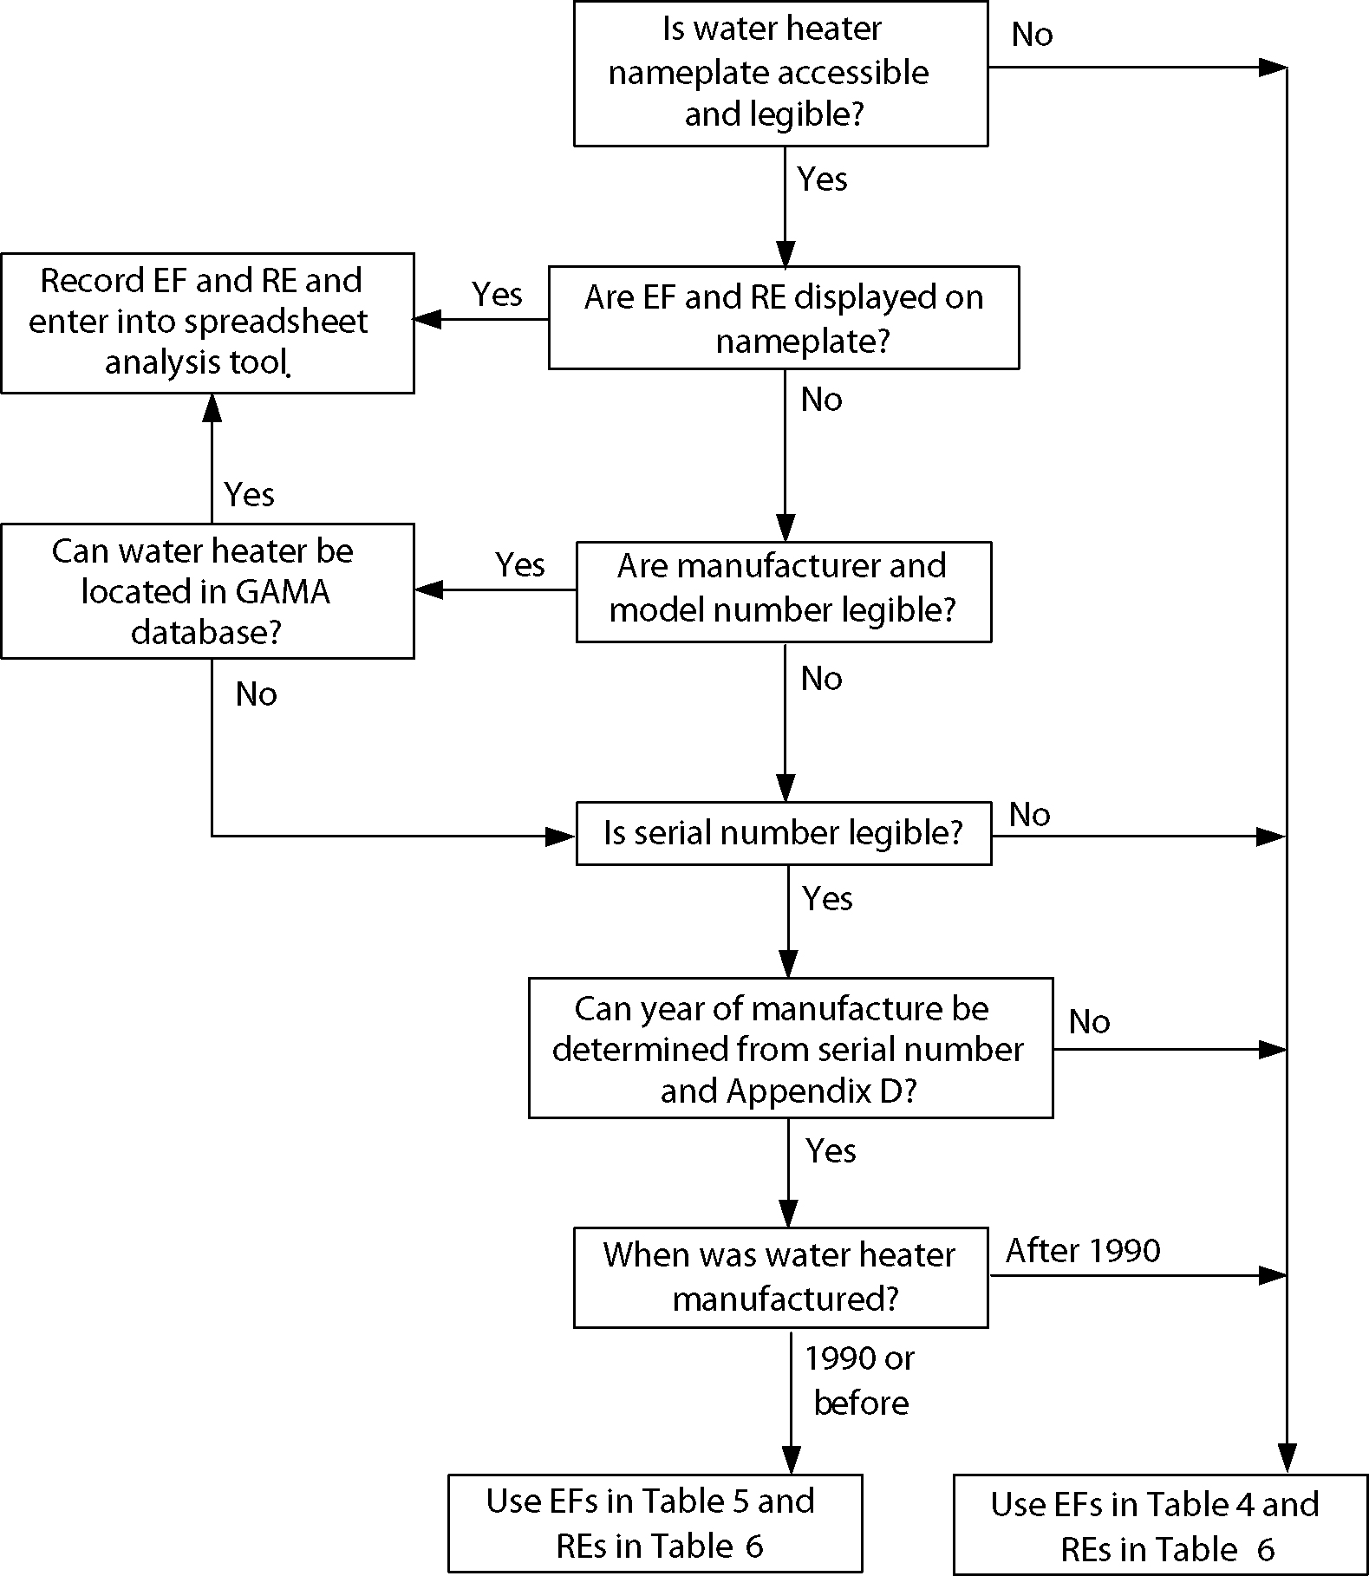

The WHAM equation for daily water heater energy consumption is:

Where:
Q_{in} = total water heater energy consumption [Btu/day]
vol = daily draw volume [gal/day]
den = density of water [lb/gal]
c_{p} = specific heat of water [Btu/lb-°F]
T_{tnk} = tank thermostat setpoint temperature [°F]
T_{in} = inlet water temperature [°F]
RE = recovery efficiency
UA = standby heat loss coefficient [Btu/hr-°F]
P_{on} = rated input power [Btu/hr]
T_{amb} = temperature of ambient air surrounding water heater [°F]

The WHAM equation requires several parameters to estimate the energy use of a water heater. Methods to estimate the daily draw volume (vol) were described in the section on Hot Water Consumption. Default values may be reasonably assumed for many of the parameters, including water density (den), specific heat (c_{p}), and water heater set point (T_{tnk}). The accompanying spreadsheet analysis tool “hard wires” these defaults into the various cell formulae. The spreadsheet also automatically defaults the inlet water temperature (T_{in}) based on which U.S. state the user selects. The spreadsheet also includes assumptions for seasonal ambient air temperature (T_{amb}) that are described in Table 8. Typical recovery efficiency values are presented in Table 6.

This leaves the standby heat loss coefficient (UA) and rated power input (P_{on}). As the following WHAM equation shows, the standby heat loss coefficient can be expressed as a function of EF, RE, T_{tank}, T_{amb} and, P_{on}. Water heater EFs are given in Table 4 for post-1990 units and in
Table 5 for pre-1990 units. Rated input power (P_{on}) for typical tank water heaters are presented in Table 7. The spreadsheet analysis tool included in this tool kit calculates the water heater UA for different water heater locations (i.e., T_{amb}) based on user inputs for EF, RE, and fuel type.

Table 7 − Typical Water Heater Input Power Ratings
Fuel Type | Burner/Element Input (P_{on})
Natural Gas or Propane | 40,000 Btu/h
Electric Resistance | 4.5 kW
Oil | 95,000 Btu/h

Fuel Switching

NEAT and the attached spreadsheet tool can be used to evaluate the cost-effectiveness of replacing an existing water heater with one that uses a different fuel type. While fuel switching can be cost-effective, Weatherization Program Notice WPN 03-1, Annual Guidance, Section 5.11 does not permit fuel switching for water heaters as a routine practice. Fuel switching should be considered on a case-by-case basis. While natural gas is currently the most affordable fuel, future price forecasts of all fuel types should be considered before switching water heater fuel types. The SIR calculation must include the cost of new electrical service, new gas service, and venting if applicable. States are reminded of NFPA 211 and 54 requirements for venting.

Replacing Water Heaters for Health and Safety

Water heaters can also be replaced for health and safety reasons. The exhaust gases of water heaters fueled with natural gas, propane, and oil can contain dangerous levels carbon monoxide, which can be released to conditioned space. It also can be argued that access to hot water is required to maintain the health of a household. Just as many programs use DOE funding to ensure that every weatherized house has a safe, functional space heating system, states may incorporate water heater replacement into their health and safety plans. These states will be required to describe in their state plans their approach for replacing water heaters as health and safety measures, which DOE will approve if found reasonable.

While health and safety measures are not required to have an SIR ≥ 1.0, widespread replacement of water heaters can deplete Weatherization Program funds without a corresponding reduction in clients’ energy bills. Therefore, states may opt to restrict the circumstances in which water heaters are replaced with DOE funds. Similar to replacing furnaces to address health and safety concerns, states may choose to replace water heaters for health and safety with funds from the U.S. Department of Health and Human Services’ Low-Income Heating Energy Assistance Program (LIHEAP). Crews and contractors must follow state policy when replacing water heaters as a Weatherization-related health and safety measure.

Table 8 lists typical health and safety concerns regarding water heaters. Some of these health and safety issues require water heater replacement and some do not.

Client education will play a large part in preventing and remedying some of the hazards associated with water heaters, discussed in the section, Other Water Heater Issues. The provider should look for the mentioned hazards and educate the client about ways of handling each concern.

Table 8 − Health and Safety Hazards Related to Water Heaters
Requires Water Heater Replacement | Does Not Require Water Heater Replacement
- Excessive tank corrosion has caused irreparable water leaks. Prolonged water leaks have caused floor damage that requires repair.  - Missing parts are no longer available. For example, an original equipment replacement cannot be located for a draft hood and the carbon monoxide level cannot be adjusted to acceptable levels with a generic draft hood.  - Water heater is full of corrosion and sediment that cannot be flushed. As a result, the water heater cannot provide an adequate amount of hot water for the household. Upon inspection, the sacrificial anode has corroded away. | - Carbon monoxide readings exceed the threshold because:  - Combustion byproducts are not venting to the outside properly. Blocked chimneys, vents terminating inside the living space, and back-drafting can be identified and remedied without having to replace the existing water heater. The flame is being impinged. The baffle or other parts may have been knocked out of position. These can be adjusted so that the flame is longer impinged.  - The water heater has the wrong burner nozzle for the fuel type. The nozzle can be replaced with one appropriate for the current fuel type.  - Combustion air and gas pressure settings are out of adjustment. Air and pressure can be adjusted to reduce carbon monoxide to acceptable levels.  - Atmospherically vented natural gas, propane, or oil water heater is located in a bedroom, which violates the building code. If the water heater location prohibits the ability to weatherize a dwelling, the crew or contractor could move the existing water heater for a fairly modest cost.

Replacement with Other Water Heater Types

The majority of the information provided thus far has focused on replacing an existing tank water heater with a new tank water heater. This section provides information on other allowable retrofit types: tankless, heat pump, and solar water heaters.

Tankless

Tankless (demand, instantaneous, or flash) water heaters eliminate standby losses because hot water is not stored, but made as needed. These units can be more efficient than standard tank water heaters. An EF over 0.80 is possible for gas-fired tankless water heaters with electronic ignition instead of a standing pilot.

There are two classifications of tankless water heaters: point-of-use and whole house. Whole-house water heaters are more appropriate as weatherization measures. The smaller point-of-use units cannot provide an adequate supply of hot water when more than one appliance requires hot water at the same time. Therefore, multiple point-of-use units would be required to meet the hot water needs of the typical household, which would be prohibitively expensive. As shown in Table 9, whole-house and point-of-use tankless water heaters are typically compared using two specifications: the burner output and the gallons of hot water produced with a temperature increase of 77ºF.

Table 9 − Tankless Water Heater Specifications
Water Heater Type | Burner Output (P_{on})  (Btu/h) | Flow Rate*  (gallons/minute)
Point-of-Use | 40,000 – 100,000 | < 3
Whole House | 140,000 – 180,000 | > 3
* Flow rate assumes a water temperature rise of 77°F.

Tankless water heaters using natural gas or propane are more appropriate for weatherization than electric units. Electric whole-house water heaters can draw over 100 amps of current and may require an expensive “heavy-up” of electrical service.

Since tankless water heaters have no storage and must heat water on demand, burners for gas-fired units must be much larger (up to four times larger) than those of conventional tank water heaters to heat water quickly. These large burners require significant combustion air. Since the new unit likely will be located near the furnace, which also requires combustion air, an opening to bring in outdoor make-up air may be required. If the mechanical room housing the furnace and water heater is sufficiently large, combustion air may be drawn from the indoor space without the need for outdoor air openings. National Fire Protection Association (NFPA) Code 54 describes the calculations to determine the minimum required mechanical room volume to rely solely on indoor air for combustion. If the infiltration rate is unknown, the standard NFPA 54 method is used, which requires 50 cubic feet of mechanical room volume for every 1,000 Btu/hour of appliance input rating. If blower door readings are available, NFPA 54 specifies the “known air infiltration rate method.” For more detail, NFPA 54 (National Fuel Gas Code) can be ordered in book form or electronically as a PDF file from www.nfpa.org.

Some tankless water heaters have a thermostat to control the outlet water temperature. On units without thermostatic control, the outlet water temperature varies inversely with flow. The lower the water flow, the higher the outlet temperature. To ensure client safety, only tankless heaters with thermostatic control should be installed in weatherized homes.

The cost-effectiveness of replacing a water heater with a tankless model depends more on inlet water temperature than a tank-to-tank water heater replacement. The higher inlet water temperatures in warmer climates may allow a smaller water heater to satisfy service demands, thereby reducing equipment costs and improving the measure’s cost-effectiveness.

Selecting an efficient tankless water heater requires knowledge of the burner size, hot water output, and the Energy Factor (EF). The burner size gives the capacity of the water heater; the manufacturer should be able to provide a range over which it operates. The range shows that the water heater provides hot water at both high and low water flow rates. Manufacturers often report only the maximum, but the minimum is needed as well.

Clients must be educated on this new kind of water heater. Tankless water heaters require some simple maintenance. The ability or likelihood of the client to perform the required maintenance should be taken into account when considering the installation of a tankless water heater.

Heat Pump

Heat pump water heaters (HPWHs) are another replacement option, particularly for existing electric resistance water heaters. HPWHs transfer heat from ambient air to water stored in a tank. They use the same vapor-compression cycle as refrigerators, air-conditioners, or space heating/cooling heat pumps. HPWHs are more than twice as efficient as electric resistance water heaters because electricity is used to move heat instead of converted directly into thermal energy.

Various configurations are available, but the best option is a “drop-in” tank. This type looks like a standard tank water heater, but has a compressor and evaporator on top of the tank. Older HPWHs made a significant amount of noise. This problem has been greatly reduced in newer models. The smaller compressors in these newer models make about as much noise as a refrigerator.

Plumbers or HVAC technicians can install a heat pump water heater, whose plumbing is similar to that of a standard water heater. The only difference is the need to install a condensate drain. A HPWH can be located anywhere a standard electric resistance water heater can be installed, such as a basement, crawlspace, unheated basement, or even a closet. However, the airflow across the evaporator coil must be sufficient to allow heat to be extracted from the ambient air.

Engineering calculations and monitoring data from actual installations are combined to estimate the energy consumption of heat pump water heaters. While the following equation may appear somewhat similar to WHAM, standby losses are included in the performance-adjusted efficiency.

Where:
Q_{in} = total water heater energy consumption [Btu/day]
vol = daily draw volume [gal/day]
den = density of water [lb/gal]
C_{p} = specific heat of water [Btu/lb-°F]
T_{tnk} = tank thermostat set point temperature [°F]
T_{in} = inlet water temperature [°F]
PA = performance adjustment

A new term, “PA,” appears in this calculation. PA adjusts the EF depending on operating conditions since the efficiency of HPWHs decreases with the ambient air temperature. Data points from actual installations of ECR International’s Watter$aver HPWH were used to establish the relationship between the EF of HPWHs and ambient air temperature. This relationship can only be used to adjust the EF when the ambient air temperature (or heat source) is above 32°F. Below 32°F, the compressor and evaporator cannot extract heat from the ambient air and water is heated with electric resistance elements. When the ambient air temperature is below 32ºF, the equation for PA given below reflects the performance of a standard tank water heater.

Since HPWHs make hot water by extracting heat from ambient air, the air surrounding HPWHs is cooled and dehumidified. In the summer, HPWHs provide a small space-cooling benefit. However, in cooler months, this effect is a penalty since heated air is used to make hot water. The Excel spreadsheet within this tool kit accounts for these space-conditioning effects using the following equations:

The heating/cooling effect, Q_{reject/in}, from a HPWH is 3,500 Btu/h (the rating of a typical HPWH compressor) when the compressor is operating. To estimate the hours of operation of the compressor, two things must be known:
- The water-heating load
- The relationship between HPWH compressor run-time and the amount of hot water generated

As shown above in the equation for Q_{hwload}, the water-heating load is the energy needed to heat the water consumed by the household from the inlet temperature to 120°F. Data points from actual installations of ECR International’s Watter$aver HPWH were used to establish the relationship between compressor run time and the amount of hot water generated by a HPWH. The equation above for hour_{comp-on} was determined through linear regression of the data points. No economic benefit for space cooling is included in the spreadsheet when a home does not have space cooling equipment.

Solar

Solar water heaters use the sun to heat water in a collector and are typically supplemented by conventional water heaters. Only solar water heaters rated under OG-300 guidelines from the Solar Rating & Certification Corporation (SRCC) should be installed since these systems have been reviewed for durability and performance. SRCC provides an energy rating called the Solar Energy Factor (SEF) that should be used to compare water heaters.

There are two generic classes of solar water heating systems: direct and indirect. In direct systems, potable water heated in the solar collector feeds directly into the household’s hot water piping. In climates where freezing is a concern, indirect systems are used where a secondary fluid, usually ethylene glycol, absorbs heat from the sun. This heat is transferred to the household water through a coiled heat exchanger in the conventional water heater. The secondary fluid is kept in a closed loop so that it does not mix with the household potable water supply.

Which system is most practical for Weatherization clients depend upon location. In warm climates where freezing temperatures are rare, simple Integral Collector Storage (ICS) systems – whose collectors absorb heat from the sun and store the hot water – are appropriate. This direct system is passive so there are no pumps and controls to maintain. These systems cost between $1,500 and $2,500.

In areas where protection from freezing is needed, more expensive indirect systems are required. Costs start at $3,500 due to the increased number of components. Clients must be able to operate the controls for the pump, expansion tank, and an assortment of valves.

Replacing an existing water heater with a solar water heater is cost-effective as a weatherization measure only in limited circumstances. Solar water heaters range in cost from $1,500 to $4,000. To justify the significant expense of solar collectors, controls, and installation, a household must have a large energy-savings potential, which requires high hot water consumption and expensive energy. Typically, a household should contain at least six full-time occupants for a solar water heater to be cost-effective. Obviously, a solar water heater with this heavy load requires a significant solar resource, which limits its application geographically. Further, availability of trained installers is limited to areas where solar water heaters are already prevalent, such as Florida, California, Nevada, and Arizona.

In a field study of solar water heaters in Florida, the energy savings produced an average SIR just under one, which points to the need for high hot water use. In a limited study in New York, energy savings resulting from installation of solar water heaters reduced electricity for water heating by 30%-60%, with an average electricity savings of 43%.

The high cost of a solar water heater leaves few, if any, DOE funds for other weatherization measures in a given house. Also, the cost of many solar water-heating systems exceeds the $2,500 maximum expenditure limit per dwelling. While DOE regulations limit the average expenditures per dwelling on a statewide basis, many states pass this limit on to local agencies on a house-to-house basis.

A solar water heater, particularly an indirect system, requires maintenance throughout its 20-year lifetime. This may limit the suitability of solar water heating to only those households capable of maintaining the equipment. Even then, occupancy turnover must be considered. Further, the roof must be in good structural condition to support the weight of the collector (and integrated water storage, if applicable). Occupants and their neighbors should be amenable to the aesthetics of these systems.

For solar water heaters to achieve an SIR ≥ 1.0, a lengthy equipment lifetime is needed. Twenty years of discounted energy savings is typically required to offset the cost of the measure. With an estimated useful life of 20 years, most solar water heaters will outlive the required supplemental electric or gas-fired water heater. Therefore, the supplemental water heater will need to be replaced approximately 10 years after the original solar installation. The cost of this replacement must be included in an economic analysis of the solar water heater measure. If state policy or re-weatherization restrictions prevent local agencies from returning to replace the supplemental water heater, the SIR may need to be limited to 10 years of energy savings (discounted to present value), which is the economic lifetime of the shortest-lived component of the solar water heating system.

Daily energy use of a solar water heater can be estimated by dividing the daily water-heating load by the SEF. Savings resulting from a solar water heating are estimated as the difference in operating cost between the existing tank water heater and new solar system.

Other Water Heater Issues

If a water heater replacement is justified as either cost-effective or necessary for occupant health and safety, the following issues must be considered.

Installation

The provider should follow all manufacturer instructions regarding the proper installation of the replacement water heater. The water heater should be installed in an area where it is fairly easy to access for maintenance. The following items require clearance to allow for maintenance: proper relief valve operation and drain access, anode replacement (needs overhead clearance), electric element replacement, and thermostat adjustment. Also, drain lines should lead away from the house and downhill so water cannot be trapped where it might freeze or collect at the valve and cause corrosion.

Codes and Standards

The removal and installation of water heaters should comply with all local building codes and permit requirements. Work may need to be performed by a licensed contractor. Replacement electric water heaters must comply with National Energy Appliance Conservation Act (NEACA), ASHRAE 90.1b, and UL-174. Replacement gas water heaters must comply with ANSI Z21.10.1 (≤75 kBtu/hr) and ANSI Z21.10.3 (>75 kBtu/hr).

Energy Guide

The Energy Guide Label, required in the United States since May 1980, shows the estimated yearly operating cost. A scale comparing the unit’s energy consumption to similar models is also shown on the label. The unit’s first hour rating, manufacturer, and model number appear at the top of the label. The Energy Guide is yellow with black lettering. A sample Energy Guide is shown in Appendix C.

Sizing

A water heater should be sized to accommodate the household peak-hour demand, which can be determined by using the tool provided in Appendix E. Peak-hour demand is an estimate of the maximum amount of hot water used by the household in one hour. The first-hour rating of a water heater indicates how well the water heater can accommodate the peak-hour demand for the household. The first-hour rating can be found on the Energy Guide Label discussed above and is determined by the size of the water heater and the time it takes to heat cold water.

Visual Inspections and Client Education

Client education will play an important role in preventing and remedying some of the hazards associated with water heaters. These hazards and methods of prevention are discussed below. The provider should educate the client about ways of handling each concern.

Flammables
Flammable materials should be kept a safe distance from the water heater, particular one fueled by natural gas, propane, or oil. Items such as brooms, mops, rags, cardboard boxes, newspapers, and other combustible materials should not be stored near the water heater.

In areas where flammables might spill, like a garage, the water heater must be raised at least 18” above the floor to prevent a flame or spark from the water heater from igniting low-lying fumes. The platform or stand must be strong enough to support the weight of the water heater and 30 to 50 gallons of water (250 to 417 pounds), plus a safety factor for additional stresses such as those caused by a potential earthquake. Even if the current water heater is on the garage floor, the replacement water heater must be installed in accordance with all codes.

Earthquake Regions and Strapping
In regions that are prone to earthquakes, gas and electric water heaters should be strapped in order to prevent fires in the event an earthquake. All water heaters should be strapped to the wall. Gas water heaters should be fitted with a flexible gas supply line to absorb movement and prevent the gas supply line from breaking and leaking. Securely fasten the vent of the gas heater. California’s Division of the State Architect developed guidelines for earthquake strapping of water heaters, available at the following link:

http://www.documents.dgs.ca.gov/dsa/pubs/waterheaterbracing01.31.02.pdf

Drain Pan
A drain pan should be installed underneath the water heater if it is located where leaks could cause damage. A 1-inch line should be installed between the pan and an appropriate drain. A water alarm can be installed in the pan if there is no place to run a drain line.

Resources

Lutz, James D., Camilla Dunham Whitehead, Alex B. Lehov, Ph.D., Gregory J. Rosenquist, and David W. Winiarski, WHAM: Simplified Tool for Calculating Water Heater Energy Use, ASHRAE Transactions 1999, V. 105, Pt. 1, CH-99-16-1.

Krigger, John. Residential Energy. Saturn Resource Management, Helena, Montana. Third Edition. 2000.

Solar Rating and Certification Corporation. Directory of SRCC Certified Solar Collector and Water Heater System Ratings.

Weingarten, Larry, and Suzanne Weingarten. The Water Heater Workbook: A Hands-On Guide to Water Heaters. Elemental Enterprises, Monterey, California, Sixth Printing. 1992.

Gas Appliance Manufacturers Association. Consumer’s Directory of Certified Efficiency Ratings for Heating and Water Heating Equipment.

Barbour, Edward C., J. Dieckmann, and B. Nowicki. Market Disposition of High-Efficiency Water Heating Equipment. National Technical Information Service. 1996.

Wenzel, Tom P. et al. Energy Data Sourcebook for the U.S. Residential Sector. Lawrence Berkeley National Laboratory. 1997. LBL-40297.

Harrison, John, and Steven Long. Solar Weatherization Assistance Program Final Report. Florida Solar Energy Center. 1998. FSEC-CR-1028-98.

Appendix A − Water Heater Anatomy

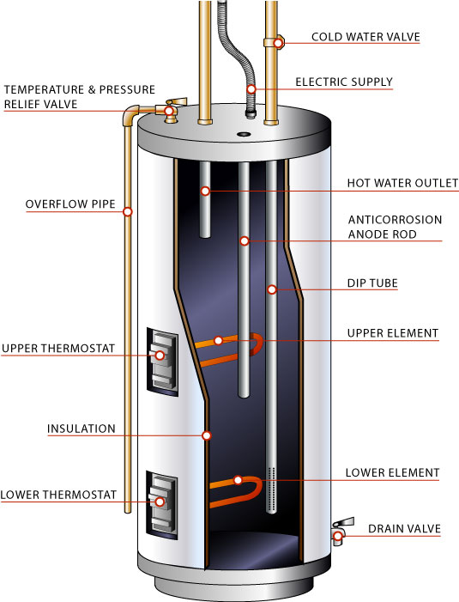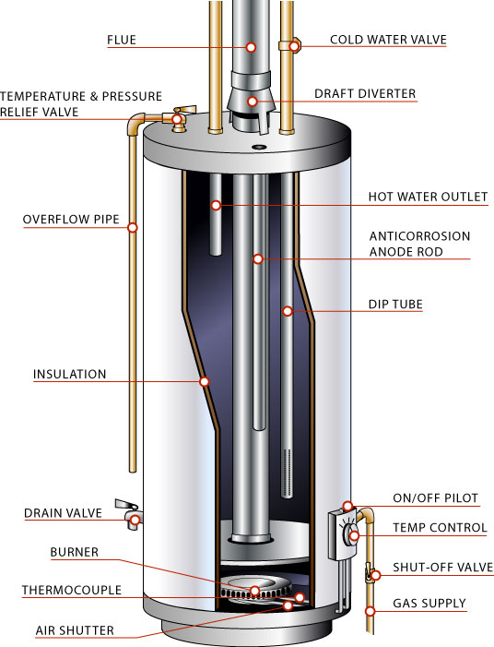

Electric Water Heater Gas Water Heater

Figure A1.1 − Tank Water Heaters

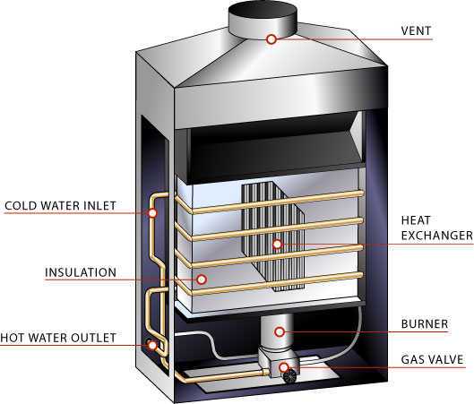

Figure A1.2 − Tankless Water Heater
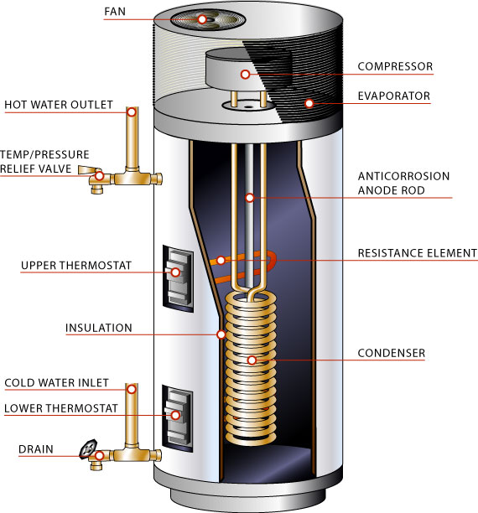

Figure A1.3 − Heat Pump Water Heater

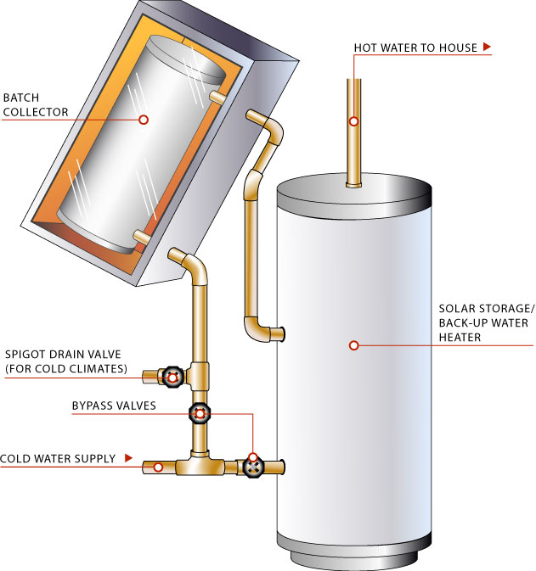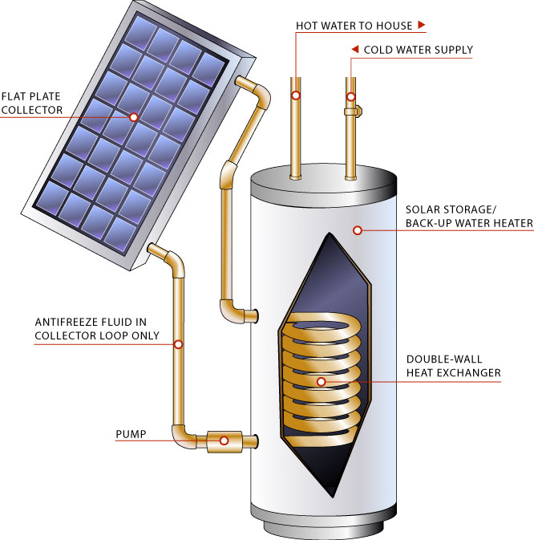
Direct System Indirect System

Figure A1.4 − Solar Water Heaters
Appendix B − Glossary

Active Solar Heating Systems – Solar water or space-heating systems that use pumps or fans to circulate the heat-transfer fluid from the solar collectors to a storage tank subsystem.

Annual Fuel Utilization Efficiency (AFUE) – A laboratory-derived efficiency for heating appliances that accounts for chimney losses, jacket losses, and cycling losses, but not distribution losses or fan/pump energy.

Anti-Scalding Device – Devices to protect occupants from the dangers of scalding by hot water. Some anti-scalding devices are incorporated into the shower and faucet mixing valves, and mix in cold water when a threshold temperature is exceeded. Other anti-scalding controls shut off the gas valve if supply water exceeds the threshold.

Combustion Efficiency – Represents the percentage of fuel that is combusted.
Dip Tube – A tube inside a domestic water heater that distributes the cold water from the cold water supply line into the lower area of the water heater where heating occurs.
Direct Solar Heating Systems – Solar water heaters or space heating systems that heat household potable water directly in the solar collector without the use of a secondary fluid.

Direct Vent Heater – A type of combustion heating system in which combustion air is drawn and the products of combustion are vented directly outside. These features are beneficial in tight, energy-efficient homes because they will not depressurize the home, causing air infiltration and backdrafting of other combustion appliances.

Distribution System – That portion of an electricity supply system used to deliver electricity from points on the transmission system to consumers.

Energy Factor (EF) – The measure of overall efficiency for a variety of appliances. For water heaters, the energy factor is based on three elements: 1) the recovery efficiency, or how efficiently the heat from the energy source is transferred to the water; 2) standby losses, or the percentage of heat lost per hour from the stored water compared to the content of the water; and 3) cycling losses.

First Hour Rating – The ability of a water heater to meet peak demands for hot water.

Flue – A channel within an appliance or chimney for combustion gases.

GAMA – Gas Appliance Manufacturers Association

Heat Trap – Device used on plumbing lines to keep heat where it belongs.

Indirect Solar Heating Systems – Solar water heaters or space heating systems that heat household potable water indirectly through the use of a secondary fluid. In climates where freezing is a concern, indirect systems are used where a secondary fluid, usually ethylene glycol, absorbs heat from the sun and transfers that heat to the household water. The secondary fluid is kept in a closed loop so that it does not mix with the household potable water supply.

Integrated Collector/Storage (ICS) Solar Systems – ICS solar systems are also called "batch" or "breadbox" water heaters. They combine the collector and storage tank in one unit. The sun shining into the collector strikes the storage tank directly, heating the water. The large thermal mass of the water, plus methods to reduce heat loss through the tank, prevent the stored water from freezing.

NAECA – National Appliance Energy Conservation Act

NEAT – National Energy Audit Tool

Passive Solar Heating Systems – Solar water- or space-heating systems in which solar energy is collected, and/or moved by natural convection without using pumps or fans. Passive systems are typically integral collector/storage (ICS; or batch collectors) or thermosyphon systems. The major advantage of these systems is that they do not use controls, pumps, sensors, or other mechanical parts, so little or no maintenance is required over the lifetime of the system.

Peak Hour Demand – The maximum usage of hot water in one hour.

Power Vent Heater – A type of combustion heating system in which combustion air is vented outside with the assistance of a fan. These heaters can be located almost anywhere because they can use a long vent pipe and they cannot backdraft while the burner is firing. However, the fan robs conditioned air from the house. This type of water heater also needs electricity to operate.

Recovery Efficiency – A measure of how efficiently the heat from the energy source is transferred to the water.

Sacrificial Anode – A metal rod placed in a water heater tank to protect the tank from corrosion. Aluminum, magnesium, and zinc are frequently used metals. The anode creates a galvanic cell in which magnesium or zinc will be corroded more quickly than the metal of the tank, giving the tank a negative charge and preventing corrosion.

Savings-to-investment ratio (SIR) – A ratio of the savings over the lifetime of the measure discounted to present worth divided by the cost to implement the measure.

SRCC – Solar Rating and Certification Corporation

Standby Loss – The percentage of heat lost per hour from the stored water compared to the content of the water.

Tankless (Instantaneous or Demand) Water Heater – A type of water heater that has no storage tank thus eliminating storage tank standby losses. Cold water travels through a pipe into the unit, and either a gas burner or an electric element heats the water only when needed.

Temperature/Pressure Relief Valve – A component of a water heating system that opens at a designated temperature or pressure to prevent a possible tank, radiator, or delivery pipe rupture.

Thermal Efficiency – A measure of the efficiency of converting a fuel to energy and useful work. Calculated by dividing the useful work and energy output by the higher heating value of input fuel times 100 (for percent).

Vent – Pipe used to move combustion gases from the water heater to outside.

Vent Damper – An energy-saving device mounted in the vent connector that closes the vent when the heating unit is not firing. This traps heat inside the heating system and house rather than letting it draft out of the vent system. Many states direct crews to remove vent dampers because they can restrict the draft of the venting system.

Venting – The removal of combustion gases through a vent pipe to the outside.

Appendix C − Energy Guide Label

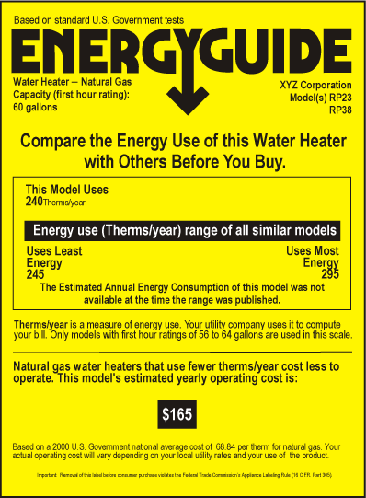

Appendix D − Water Heater Dating Chart

Manufacturer | Trade Names | Where to Look | How to Decode | Example
American | ACE, American, American Hardware, America's Best, Apex, Aqua Temp, AquaTherm, Aquamatic, Best, Best Deluxe, Champion, Craftmaster, De-Limer, Deluxe, Eagle, The Earl's Energy Conservation Water Heater, The Earl's Energy Saver Plus, Envirotemp, Four Most, Hotmaster, Hotstream, King-Kleen, King-Line, Master Plumber, Nationaline, Neptune, Penquin, Premier Plus, Premier Plus Self Cleaning Prestige, ProLine and ProLine Plus, Quaker, Quick-Flo, Raywall, Revere, Riveria, Sands, Sentinal, Servi-Star, Shamrock, Special Deluxe, Standard, Super Eagle, Super-Flo, Supreme, Sure-Fire, Thoro-Clean, Tru-Test, Tru Value, U.S. Supply, Whirlpool, XCL Energy Saver | Serial # – 1st 4 digits | 1st 2 digits = year  2nd 2 digits= week | 8906xxx = made in the 6th week of the year 1989
Apollo Comfort Products | Apollo
Bradford-White | Bradford White, JetGlas | Serial # – 1st 2 letters | 1st letter = year starting with A as 1984,  2nd letter = month with January (A) through December (M) | JMxxx = made in the year 1992 (J) in the month of December (M)
Crispaire | E-tech
GSW Water Heating | John Wood, GSW, Moffat, Superflue, Medal | Serial # – 1st 4 digits | 1st & 2nd number = year,  3rd & 4th number = month | 8901xxx = made in the year 1989 in the first month, January
Heat Transfer Products | Heat Transfer
Lochinvar | Energy Saver, Golden Knight, Knight
Marathon | Marathon | Serial # – 1st 4 digits | 1st & 2nd digit = month,  3rd & 4th digit = year | 0189xxx = made in the year 1989 in the first month, January
Maytag | Maytag

Manufacturer | Trade Names | Where to Look | How to Decode | Example
Rheem | Aqua Therm, General Electric, Hotpoint, Professional, Rheem, Vanguard, Western Auto | Serial # – 1st 4 digits | 1st & 2nd digit = month,  3rd & 4th digit = year | 0189xxx = made in the year 1989 in the first month, January
Richmond | Richmond | Serial # – 1st 4 digits | 1st & 2nd digit = month,  3rd & 4th digit = year | 0189xxx = made in the year 1989 in the first month, January
Ruud | Professional, Ruud | Serial # – 1st 4 digits | 1st & 2nd digit = month,  3rd & 4th digit = year | 0189xxx = made in the year 1989 in the first month, January
Sears, Roebuck and Co. | Kenmore
A.O. Smith Water Products | National, A.O. Smith, Glascote, Perma-Glas | Serial # – 2nd, 3rd, 4th characters | 2nd position (letter) = month (A being January through M being December)  3rd & 4th position (numbers) = year | AJ89xxx = made in October (J) of 1989
State Industries | State | Serial # – 1st 3 characters | first letter = month (A being January through M, being December), 2nd and 3rd position (numbers) = year | J89xxx = made in October of 1989
Summit Manufacturing  Mortex | Sun Therm

Manufacturer | Trade Names | Where to Look | How to Decode | Example
U.S. Craftsmaster  Water Heaters | Ace, American Hardware, America's Best, Apex, Aqua Temp, Aqua Therm, Aquamatic, Best, Best Deluxe, Craftmaster, De-Limer, Deluxe, Eagle, The Earl's Energy Conservation Water Heater, The Earl's Energy Saver Plus, Envirotemp, Four Most, Hotmaster, Hotstream, King-Kleen, King-Line, Master Plumber, Nationaline, Neptune, Penquin, Prestige, Pro-Line, Pro-Line Plus, Quaker, Quick-Flo, Raywall, Revere, Riviera, Sands, Sentinal, Servistar, Shamrock, Special Deluxe, Standard, Supereagle, Super-Flo, Supreme, Sure-Fire, Thoro-Clean, True-Test, Tru Value, U.S. Craftmaster, U.S. Supply, Whirlpool, XCL Energy Saver | Serial # – 1st 4 digits | 1st 2 digits = year  2nd 2 digits= week | 8924xxx = made in the 24th week of the year 1989
Vaugn Manufacturing Corp. | Sepco, Hydrohot, D.W. Whitehead

Appendix E − Gama Water Heater Sizing Tool
PEAK HOURLY HOT WATER DEMAND

Avg. Gallons Times Used Gal. Used
Hot Water in Hour in Hour
Per Usage
________________________________________________________________________
Showering 20 x _________ = _________
Bathing 20 x _________ = _________
Shaving 2 x _________ = _________
Washing hands and face 2 x _________ = _________
Shampooing hair 4 x _________ = _________
Hand dishwashing 4 x _________ = _________
Automatic dishwashing 12 x _________ = _________
Preparing food 5 x _________ = _________
Automatic clothes washing 32 x _________ = _________

For example, if your family’s expected greatest hot water use is in the morning, the total might be:

3 showers 20 x 3 = 60 gallons/hr.
1 shave 2 x 1 = 2 gallons/hr.
Hand-wash dishes 4 x 1 = 4 gallons/hr.

Peak hour demand = 66 gallons/hr.
____________________________________________________________________
Source: Gas Appliance Manufacturers Association and ACEEE estimates.
_____________________________________________________________________

A savings-to-investment ratio is a ratio of the savings over the lifetime of the measure discounted to present worth divided by the cost to implement the measure.

