ROMA Next Generation
Theory of Change – Discussion Guide

This guide is designed to assist in outreach to the CAA Network with the purpose of enhancing understanding of the elements of Theory of Change (TOC). This enhanced understanding will hopefully increase the level of response during the initial comment period.

Contents
Resources and Feedback Method 2
What is a Theory of Change? 2
How was the National Community Action Theory of Change developed? 3
Why does Community Action need a Theory of Change? 3
Why are the National Performance Indicators not enough? 4
How does our proposed national Theory of Change for Community Action help the network? 5
National Theory of Change-- Proposed 6
The Role of National Goals 6
Services and Strategies Section 6
The Core Principles Section reflects assumptions 6
Network Capacity is represented: 7
The Performance Management Section 7
Putting the Theory of Change into Practice 7
Using TOC in Planning 7
Using TOC in the Implementation of Services and Strategies 7
Using TOC to Observe Results 7
TOC Assists in Analysis of Performance 7

Resources and Feedback Method

NASCSP has a variety of resources available to guide discussion, provide support in accessing and understanding the intention and methodology of the proposed changes, and collecting feedback on the components of ROMA Next Generation and the proposed Annual Report.
We encourage you to review The ROMA Next Generation Overview Recording, which provides an introduction to ROMA Next Generation, the clearance process, and what to expect during the Initial Comment Period.
The following resources will support your review and understanding of the proposed material, assist in presentations during webinars or face- to-face meetings.
- Theory of Change

On March 14th, NASCSP hosted a webinar that provided context, background, and additional details on the Theory of Change and National Goals, as well as an opportunity for live questions and answers. We encourage you to review the webinar recording, and the slides of the presentation.

In addition to this discussion document, NASCSP has released surveys intended to collect feedback, gather comments, and guide survey respondents through the Theory of Change to ensure that all the proposals are understood and evaluated. This survey has been posted live, as well as in Word and PDF format, which will allow respondents to review the survey questions in advance, collect responses, and collaborate with others to provide thoughtful and robust feedback. Community Action network staff at State Offices, State Associations, and local agencies can review and submit feedback on ROMA Next Generation as one entity, based on your understanding of the needs of the agencies you represent from a state or regional perspective, or collectively, by gathering multiple responses in an organized fashion (host a webinar, meeting or other virtual or face to face meeting) and create a single response to the surveys that represents the input of the different local agencies.

What is a Theory of Change?

A TOC is the articulation of the underlying beliefs and assumptions of a group that guide a service delivery strategy. It identifies the “why” and the “how” of the activities undertaken by the group members and it identifies the “what” of change and improvement produced.
“Stakeholders can benefit from using theory-based frameworks because they make explicit the links between ideas or theories of change, the strategies they plan to implement, and the outcomes they hope to achieve. Theory-based frameworks support implementation efforts as well as strategic planning and evaluation processes by helping stakeholders reach consensus about the populations they plan to serve, strategies they implement, and the results they expect to achieve.” Quote from the Theory of Change Development Tool Manual, International Network on Strategic Philanthropy, May 2005

How was the National Community Action Theory of Change developed?

The National Community Action Theory of Change is meant to articulate the beliefs and assumptions that guide the service delivery strategy of the national Community Action Network. It also provides a framework for the development of more agency and community specific local theories of change. The National Community Action TOC captures the essence of many conversations with people throughout the Network.

- A team from the ROMA Next Generation Center of Excellence, NASCSP, reached out to the network to gather information about the foundational beliefs that drive Community Action.
- These included gathering information from
  - In person sessions, webinars, interviews
  - ROMA NG Work Group

Guided by research on the development of theories of change, we listened to identify the following elements about the foundations on which we have built our network:
- What do we (Community Action network) believe about poverty?
- What do we believe about our mission as it is related to our anti-poverty designation? In other words what is it that Community Action is supposed to do – or to accomplish?
- What will happen (change) because of the efforts of CAAs? What is our impact?
- What is unique about the structure of our network?
- How do we believe we can address our mission?
  - How does change happen?
    - Are there preconditions needed for success that we must address first, before moving to overarching goals?
    - Identification of Systems and Agency Capacity
    - Identification of strategies and activities in which we are engaged (some common to many CAAs and some unique responses to community needs)

Why does Community Action need a Theory of Change?
To have a clear understanding of what we believe we are doing as a network. This means not just what we do with CSBG funding, but what we do with all the funding that we leverage.

There are big questions being asked about the community action network. They include:

- How can we be sure Community Action is doing what works?
  - Do the services provided by Community Action result in outcomes for the people we serve?

- What makes Community Action unique from other social service networks?
- Is this accurately reflected in the Core Principles section of the National Theory of Change?

- How does the flexibility to address locally identified community needs inform the selection of Community Action services and strategies?
- How does Community Action evaluate the selection and implementation of its service strategies?
- How do we demonstrate that CA strategies have been effective in addressing community needs?

- What’s your impact on the lives of individuals and families? On communities?
- What has changed?
- Are people better off as a result of Community Action intervention?

- Do we believe that community conditions and family success influence/rely on each other?

- How do we report the community level work done by Community Action?

- Do we really believe that Community Action is about moving families to economic security?
- If so, how many families have achieved economic security?

As a network, we do not have a unified, standardized understanding of the changes that we expect to achieve – so it is hard for us to answer these kinds of questions as a network.

Why are the National Performance Indicators not enough?
- The NPIs document the numbers of individuals, families and communities that achieved INDICATORS but not the number who achieved the actual GOAL.
- The current process of reporting on NPIs does not ask for evidence of how the indicators are connected to the goals (why do we think these things indicate success in the National Goals?)
- Do not connect the services provided with the outcome indicators reported. Is it one service for one outcome? Many services for one outcome? Many outcomes from one service?
- Do not describe the population that is achieving the indicators.

The National Community Action Theory of Change demonstrates the network’s assumptions regarding the connection between services, indicators and outcomes. Together with proposed National Performance Indicator updates, the network will now have a common framework for explaining not only the changes it hopes to achieve but also evidence that those changes occur.

How does our proposed national Theory of Change for Community Action help the network?
- The TOC will help us describe the elements of a common framework CAAs have to produce change across the country (regardless of the specific nature of poverty in each community, which requires specific responses).
- The TOC aims to give a broad picture of the Long-Term Goals, Services and Strategies, Core Principles, System Capacity and Performance Management across the network.
- It identifies the assumptions that guide the design of services and strategies to reach the long-term goals it hopes to achieve.
- The TOC shows the connections between what was done and what changed.
- It provides a sampling of the services and strategies Community Action uses to address poverty issues, in an effort to demonstrate the wide range of issues addressed by the network.
- The TOC reflects accountability at the local, state and federal level.

Initially we found it difficult to talk about a single “Theory of Change” that would encompass the work of over 1000 different local Community Action Agencies. This is in part due to the mandate for the network’s unifying funding source to “meet local needs.” This mandate means that each local CAA identifies the specific needs that face individuals and families with low income and the communities in which they live. It means that each CAA must identify the resources that are available, through funding support, partnerships, etc. – and this mix of resources varies dramatically across the country. Once the needs and resources are identified, the Board of Directors and agency management staff consider what they want to change in the community – and this is different in each community.

We heard many different and diverging concepts and practices from local agencies, and developed several iterations of a National Theory of Change to try to capture this. We are now proposing a simple, one page graphic, to help articulate all the many different elements.

National Theory of Change-- Proposed
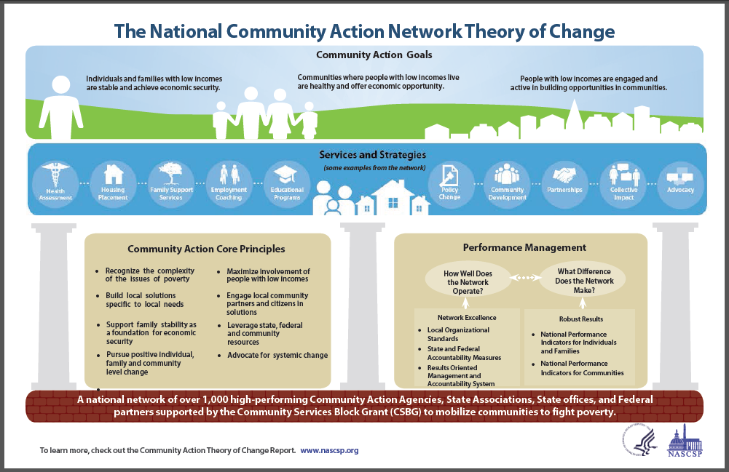

The Role of National Goals
The proposed goals express what Community Action hopes to achieve over the long-term for individual, families and communities of low-income.

Services and Strategies Section
Services and Strategies implemented by local agencies are HOW we get to our goals. The icons show our work on two levels (family/individual and community). They are designed to show that we address a wide range of issues related to poverty (which may be the preconditions for success in one or more of the national goals). The icons shown are a sampling of the services/strategies employed by Community Action.

The Core Principles Section reflects assumptions about:
- The nature of poverty
- Importance of local determination
- Continuum of needs (stability to security)
- Individual change and community change are interrelated
- It takes a village (people with low income, partners, citizens)
  - And a range of resources (local, state, federal)
- Direct service alone will not produce systemic change

Network Capacity is represented:
The Community Action network is a system. Information about the Network Capacity is contained in the bar at the bottom of the graphic and in the Performance Management section. The bar includes local CAAs, State Associations, State Offices, National Partners, reference to CSBG support, and mobilized communities.

The Performance Management Section

- The Performance Management section provides information about how we use performance measures to manage our programs and hold ourselves accountable for results.
  - Organizational Standards for local CAAs
  - State and Federal Accountability Measures
  - Results Oriented Management and Accountability used at all levels
  - NPIs to measure OUTCOMES (results, changes) at both the individual and family level and at the community level

Putting the Theory of Change into Practice
In this section we provide an overview of how agencies can use a TOC as a practical planning and evaluation tool.

Using TOC in Planning
The TOC helps agencies sort through all the Community Needs Assessment data using a formally articulated set of assumptions and approaches that are common across the network.
- Helps to focus on specific data elements that will aid in the development of the plan.
- Helps to set goals for the agency that are strategic.

Using TOC in the Implementation of Services and Strategies
The TOC allows local agencies to consider how their anti-poverty role is carried out in their services and strategies. Comparing implementation effectiveness to the overall TOC provides a more comprehensive look at network performance. Do the activities of the network support change?

Using TOC to Observe Results
The TOC helps identify what will be observed and measured. It leads to the identification of a set of performance indicators and makes the connection for how the indicators actually demonstrate progress toward the established outcomes – and to one or more of the CAA National Goals.

TOC Assists in Analysis of Performance
Once services are completed and outcomes observed, the TOC will help guide the analysis.
- Did the services do what was expected?
- Did the outcomes achieved validate the original assumptions behind the selection of the services and strategies?
- How effective is the performance of our team?
This analysis will then lead into the re-assessment and next planning process.

Other uses of the TOC
- To describe Community Action’s mission, vision and purpose
- To educate local or state legislators
- To inform funders about the national framework
- To inform local board members
- To use in messaging and communications with the community

Discussion Prompts
- How well does the National TOC serve as a national framework for what Community Action represents?
- How well does it reflect the three national goals?
- How well does the National TOC reflect the Core Principles of Community Action?
- How well does is reflect the Services and Strategies of Community Action?
- How well does the National TOC reflect the Performance Management of Community Action?
- How well is the foundation of Community Action reflected?
- Describe how you would use this National Theory of Change.

