Understanding the Work Order, Exercise #1
Sample Work Order

Anytown CAP
Anytown, USA
Purchase Order
To: Anytown Weatherizers
Anytown, USA

Anytown CAP Contact: Andy Auditor
(XXX) XXX-XXXX

Client: John Homeowner
92 Norton Hill Road
Anytown, USA
(XXX) XXX-XXXX (Call after 8:00 AM)
Turn right onto Norton Hill Rd from Main Street @ Anytown Post Office. Yellow house, 0.6 mile on right.
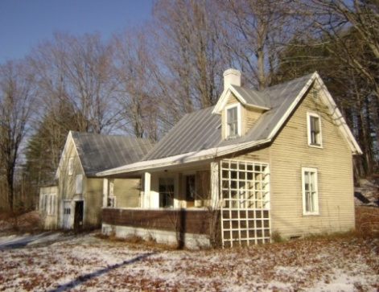
#92 on porch post

Tasks:
- Carefully air seal wall between kitchen and shed by stuffing large holes with scrap fiberglass and sealing over with spray foam. Seal wire penetrations with spray foam. Install weatherstrip and door sweep on door.
Materials: Scrap batt fiberglass, two cans expanding one-part foam, one Porta Seal weatherstrip, one flexsteel door sweep, two tubes silicone caulk.
- Install continuous 6-mil poly groundcover under kitchen and den.
Material: 300 sq. ft. 6-mil poly.
- Install ENERGY STAR qualified 1.5-sone bath fan vented to gable end per State Technical Manual (STM) using 4” metal duct sloped slightly to exterior. Insulate duct. Seal all joints.
Materials: 1 bath fan, 8’ of 4” metal duct, one 4” elbow, 1 quart RDC#6 mastic, 1 exterior vent hood, 10’ of 4” duct insulation.
- Seal around main house chimney flashing per STM.
Material: 1 quart plastic roof cement.
- Seal all furnace duct work.
Material: 1 gallon RDC#6 mastic, two rolls web-type drywall tape.
- Air seal all penetrations from living space to attics per STM.
Materials: 1 can one-part foam for plumbing vent stack and around new bath fan, 2 tubes caulk for all wire penetrations, 4 sq. ft. galvanized steel, and 1 tube high-temperature caulk for chimney chase.
- Replace existing hatch with new, airtight, insulated attic hatch per STM.
Materials: 4 sq. ft. ¾” AC plywood, 20’ #2 pine 1” x 4”, 8’ weatherstrip, two 3” hooks & eyes, 8 sq. ft. 2” rigid foam insulation (2 layers), miscellaneous fasteners.
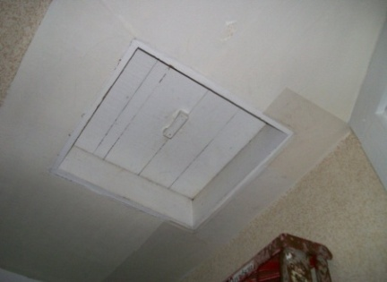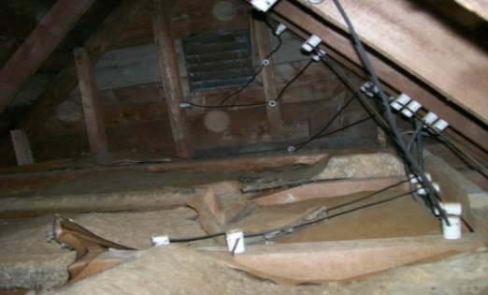
- Tag location of any knob and tube wiring to be buried by attic insulation.
- Dense pack main house slopes with cellulose per STM.
Material: 416 sq. ft. x 6” of cellulose.
- Install 12” cellulose on attic flats per STM.
Materials: Main house = 204 sq. ft. of cellulose, kitchen ell = 180 sq. ft. of cellulose, rear addition = 128 sq. ft. of cellulose.
- Dense pack all walls with cellulose per STM.
Material: 945 sq. ft. x 4” of cellulose.
- Install weatherstrip and door sweep on front and rear doors per STM.
Materials: Two Q-lon weatherstrips, two Flex-steel door sweeps.
- Close off uphill basement window.
Materials: 3 sq. ft. of ¾” CDX, 1 quart wood primer, necessary caulk and fasteners.
- Insulate box sills in basement and crawl space per STM using two-part foam. Be sure that two-part foam seals to 6-mil poly groundcover and first floor sub-flooring.
Materials: One 200 board ft. two-part foam kit.

