Interpreting Infrared Quiz

Quality Control Inspector
DISCLAIMER: This quiz is intended for use as an interim review. Distribute to students after training the associated curriculum chapter, or the next day, to refresh the lesson. Being publicly available renders this specific quiz invalid for use as a formal assessment tool for accreditation. See Tier 2.14(b) IREC 01022 ISPQ accreditation standard.
Learning Objectives
By attending this session, participants will be able to:
- Explain of the benefits and limitations of infrared (IR) thermography.
- Interpret infrared images as they relate to weatherization opportunities.
- Demonstrate how to assess the quality of weatherization measure installation using IR images.
- Utilize IR imaging in conjunction with the blower door to track infiltration and guide air sealing activities.
Questions

1. Which of the following is NOT an example of an IR advantage?
- Validates the thoroughness and effectiveness of both insulation and air sealing.
- Provides visual feedback, both positive and negative, to crews for work improvement.
- Provides x-ray images so crews can see what’s going on inside the walls and ceiling.
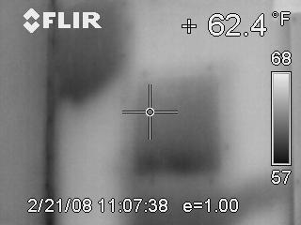
2. This picture indicates which of the following:
- The upper left corner has a void from settling insulation.
- The middle of the wall needs insulations.
- The darker areas of the image are hotter than the lighter ones.

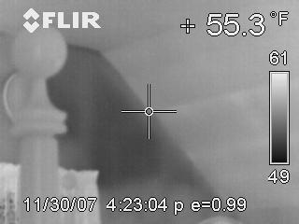
3. Why does the bedpost appear warmer than the back wall?
- The bedpost is painted white, appearing lighter in the photo.
- It is the same temperature as the room air, which is warmer than the wall.
- The bedpost is painted black, making it warmer than the white walls.

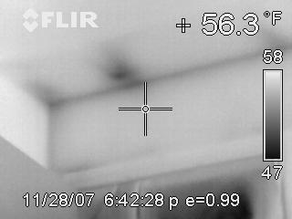

4. A blower door is depressurizing the home. The feathery edges near the ceiling indicate:
- Air exfiltration patterns
- Air Infiltration patterns
- Paint irregularity patterns

5. The use of the blower door in conjunction with IR provides which of the following?
- Verifies and speeds up understanding of air leakage.
- Doesn’t provide anything, they are separate tests.
- Proper diagnosis of electrical problems without load readings.
6. Temperature differentials between the outside and inside temperatures are called?
- Emissivity
- Thermal sensitivity
- Delta-T

7. __________ surveys allow a thermographer to compare results with future inspections to determine if there is a problem.
- Quantitative
- Baseline
- Thermal

