Appendix A: Math Pre-Test

KEY

You may use a calculator to answer the following questions. Answers may be expressed in decimal or fraction form. (15-minute time limit)

You must score 73% or higher, answering at least 11 out of 15 correctly. Failure to do so will require additional training in basic math skills.

1. 8 1/2” 2. 23 1/4” 3. 23.25
17 3/4” - 7 1/8” - 12.75
+ 23 3/8” 16 1/8 10.5
49 5/8
or 4’1 5/8”

4. 350/40 = __8.75__ 5. 3/8 x 120 = __45______

- 6. How many inches are in 5 feet? _60_______

7. One square foot equals how many square inches? _144_______

- 8. What is the perimeter of the house diagramed below? ___148_____feet.

9. What is the area of the house diagramed below? _1,032_______square feet.

- 10. What is the volume of the house diagramed below? _8,256_______cubic feet.

- What is 75% of 2400? _1,800_______.

42’

20’ (one story with 8’ ceiling height)

32’

26’

12’

16’

Write in the measurement indicated by the arrow pointing at the tape measure.

12.__5/8 ____ 13._2 3/8_____ 14._3 3/8_____ 15._5 3/16____
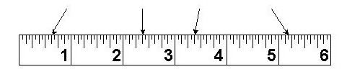

Adapted from the U.S. Department of Energy, “National Weatherization Training & Technical Assistance Plan,” December 2009, http://www1.eere.energy.gov/wip/pdfs/wap_tta_plan.pdf.

