Handout #2
Whole-house fan cover I – 6-mil. poly and duct tape
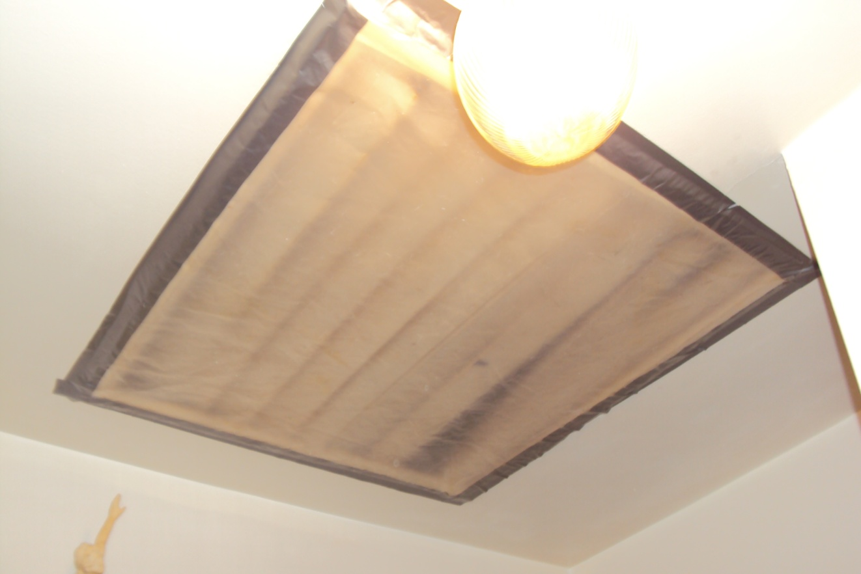
Whole-house fan cover II − Flexible foil-faced insulating board and duct tape
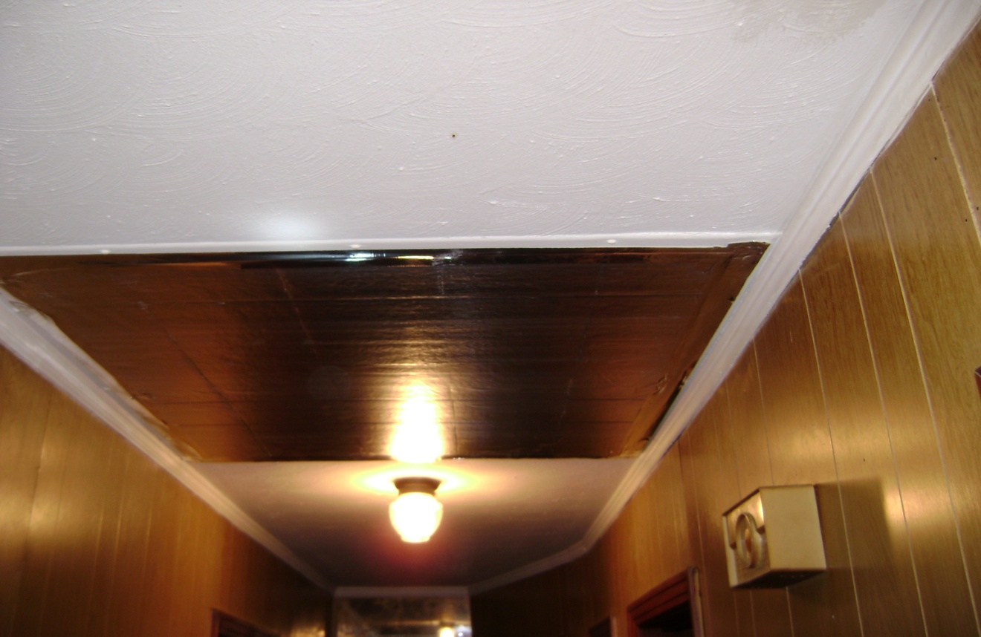

Whole-house fan cover III − Flexible foil-faced insulating board and Velcro™

