ASHRAE 62.1 MVR Calculation Worksheet

Select the appropriate n-factor based on climate zone map and table (see below):
Enter blower door reading:
1. Divide blower door reading by n-factor to get CFM natural: |  |  |  |  |  | 1
2. Calculate:
a. | #Occupants * 15 CFM: |  | # People | * 15 = |  | 2a
b. | (Bedrooms + 1) * 15 CFM: |  | # Bedrooms + 1 | * 15 = |  | 2b
c. | ((Volume * .35)/60)): |  | Volume of House | * .35/60 = |  | 2c
If the result of #1 is greater than the highest of 2a, 2b, and 2c, STOP. No additional ventilation is needed.
If #1 is not greater than the highest of 2a, 2b, or 2c, go to step 3.
3. Enter the highest of 2a, 2b and 2c. |  |  |  |  |  | 3
4. Subtract #1 from #3 to get the MVR. This must be made up with mechanical ventilation. |  |  |  |  |  | 4
5. Enter existing mechanical exhaust ventilation (Operable only):
 |  |  | Bathroom
 |  |  | Kitchen
 |  |  | Other
 |  |  | Other
 | Total existing mechanical exhaust ventilation: |  |  |  |  | 5
If #5 is less than #4, add mechanical exhaust ventilation equal to the difference.
If #5 is GREATER than #4, add passive intake vents to balance existing exhaust.

N Factor
Climate Zone | # of Stories > | 1 | 1.5 | 2 | 3
1 | Well-shielded | 18.6 | 16.7 | 14.9 | 13.0
 | Normal | 15.5 | 14.0 | 12.4 | 10.9
 | Exposed | 14.0 | 12.6 | 11.2 | 9.8
2 | Well-shielded | 22.2 | 20.0 | 17.8 | 15.5
 | Normal | 18.5 | 16.7 | 14.8 | 13.0
 | Exposed | 16.7 | 15.0 | 13.3 | 11.7
3 | Well-shielded | 25.8 | 23.2 | 20.6 | 18.1
 | Normal | 21.5 | 19.4 | 17.2 | 15.1
 | Exposed | 19.4 | 17.4 | 15.5 | 13.5
4 | Well-shielded | 29.4 | 26.5 | 23.5 | 20.6
 | Normal | 24.5 | 22.1 | 19.6 | 17.2
 | Exposed | 22.1 | 19.8 | 17.6 | 15.4

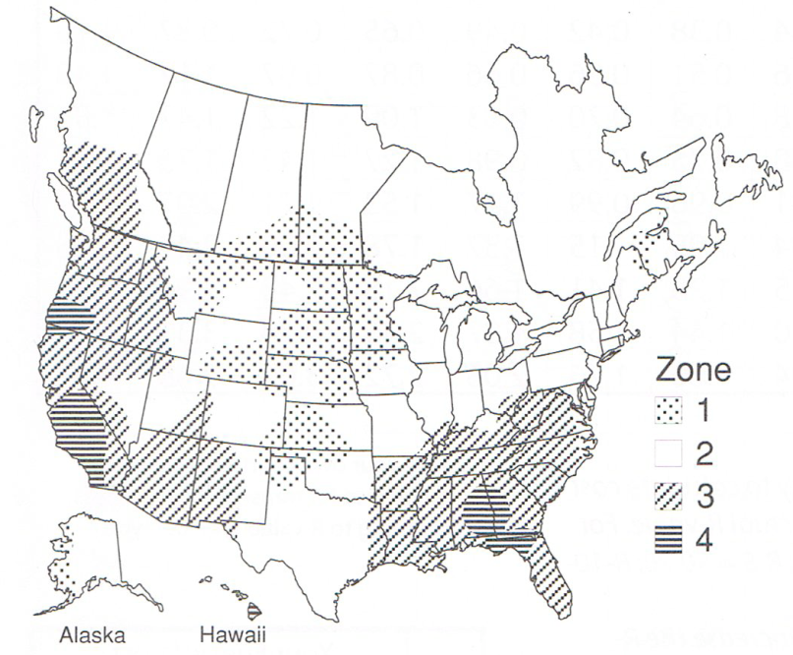

Minimum of 75 CFM answer.

